CEPC Detector R&D Project

6.1 LumiCal Prototype

|  |  |
| --- | --- |
| Document Responsible: | Suen HOU |
| Last saved by on | 05/7/20 2:02:00 AM |
| Revision number: | 2 |

Change history

|  |  |  |
| --- | --- | --- |
| **Revision** | **When** | **What changed and why** |
| 1 | 12/29/2019 | First draft based on 2019 workshop materials |
| 2 | 05/05/2022 | Design with beampipe and vacuum flange accounted |

Readme first

1. Please do not delete or modify this section or its structure.
2. Only change text enclosed by (and including) angled brackets “< … >”.
3. Don’t change field directly, instead modify the document options, under File🡪 Properties (or similar)
   * Enter name of person that wrote the document in Document:Summary: Author
   * The project ID number, should follow the rules provided to you earlier. The number should be changed in Document:Custom: PBS.
   * The project name should be changed in Document:Summary: Subject.
4. In Section *Project Objectives* provide a brief description of the project goals, i.e. why and what is being produced, for PBS item **1.1Vertex Prototype**.If this project includes identifiable sub-projects you can indicate them in the *Sub-projects Description* Section, otherwise submit a separate document for each of them. The sub-project IDs are free for you to define.
5. Finally, remember to update the *Change History*.

6.1 LumiCal Prototype: Project Objectives

The luminosity of electron-positron collisions can be measured with high statistics and precision through the Bhabha scattering process e+e− → e+e− with the scattered electrons detected in forward direction. At CEPC, the luminosity measurement is aimed for a precision of 10-4 at the Z-pole, which corresponds to the spatial resolution of 1 mRad on the fiducial edges of the Bhabha angular distribution.

Bhabha events are detected for 1) elastic scattering of beam particles back-to-back in the center-of-mass frame, 2) energies of each particles consist with beam energy. The challenge to the luminosity detector is to identify electrons with the spatial resolution in θ-angle reaching 1 mRad. The readout electronics readout is also required to sustain radiation damage and the high event rate at beam crossing interval of 32 ns.

The design of Luminosity Calorimeter (LumiCal) has been studied with GEANT simulation for a sandwiched Silicon-Tungsten assembly with upstream silicon wafers surrounding beam-pipe. The measurables on electron impact position and lateral shower profiles are evaluated. We envision that the silicon wafers of LumiCal is positioned surrounding the beam-pipe within the inner tracker volume. An event display is illustrated in Fig. 1.

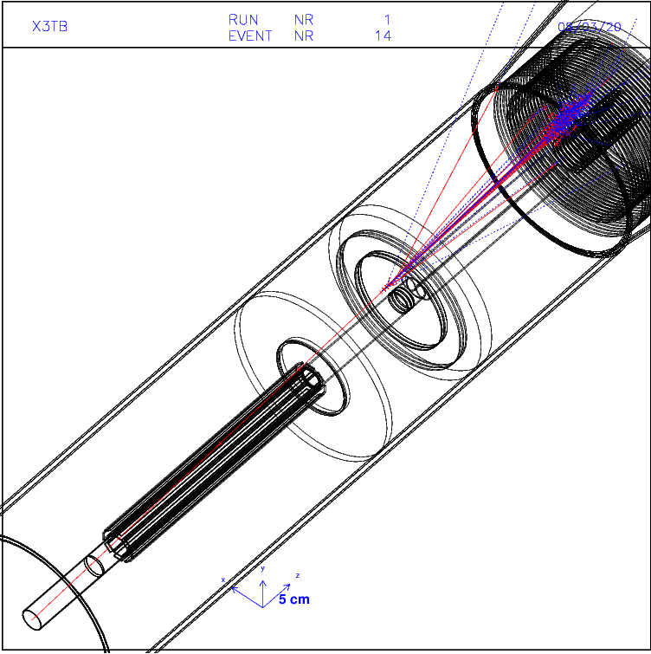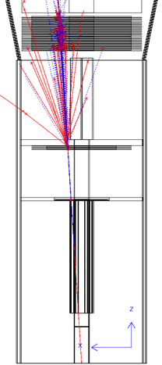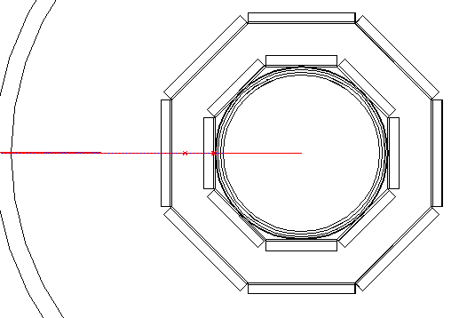

Figure 1: GEANT simulation the beam-pipe of 1 mm thick Al tube, flange layers at z=520 mm and z=700 mm. The LumiCal Si-wafers include two octagon rings at z=150-520 mm, disks of circular wafers between the flange layers, and a Si-W sandwich at z=1000 mm. The multiple scattering and electro-magnetic shower is investigated for 50 GeV electrons.

6.1 Vertex Prototype: Sub-projects Description

|  |  |  |
| --- | --- | --- |
| **Project ID** | **Title** | **Description** |
| 6.1.1 | Silicon Strip detector | Assembly of single sided Si-Strip sensor in 50 or 100 μm pitch, with AVP25 readout ASIC. |
| 6.1.2 | Crystal calorimeter | LYSO crystal in strip (>50mm) of diameter as small as 2x2 mm2 with SiPM readout electronics |

6.1 LumiCal Prototype: CEPC Relationship

The LumiCal prototyping is proposed for fabrication of detector modules and readout electronics. The detector modules of interests are the Silicon Strip wafer assembled with APV25 readout chip and the LYSO crystal with SiPM readout electronics.

**1) single-side silicon wafer assembled with AVP25 chip.**  The silicon sensor is planned for 20x20 mm2 or larger, with the pitch of 50 μm or 100 μm. The AVP25 chip is manufactured for the Belle-II experiments. We shall consult our colleague at KEK for suggestion acquiring chips and readout facility.

The assembly of Si-strip detector will be conducted at the IHEP detector shop, or elsewhere capable for detector alignment and fine-pitch wire bonding. Alignment will be practiced for a few micron precision.

The charge collection of Si-strip sensors shall be investigated in beam tests, for the scenario that the electrons traverse at very low angle (30 mRad) to the wafer surface. The traversing distance is up to 1 mm for a wafer thickness of 300. The analysis for impact position differs from a perpendicular track to the wafer.

**2) fine-strip LYSO crystal with SiPM readout.** We have allocated LYSO samples in dimension of 3x3x50mm3. The Hamamatsu SiPM and front-end test kits are purchased. The R&D will be conducted for characteristics of LYSO crystal and electronics. The readout chain is planned to first making a DAQ board using commercial ADC chips. ASIC design for the SiPM is also being planned for pre-amplifier and ADC functions.

The advantage with a Crystal Calorimeter for LumiCal is for the compactness of electronics saving the service volume. The length in z may be a concern for shower containment, which may be optimized with the beam-pipe layout.

6.1 LumiCal Prototype: Project Schedule

The prototype silicon detector with AVP25 readout will be assembled with components collected off-the-shelf in 2020. Depending on the components available, the detector circuit board will be prepared for assembly at Silicon bonding facility at IHEP. The readout modules will be acquired from KEK or other institutes using AVP25. By the end of 2020, we shall have installed a complete readout chain for prototype Si-strip detectors.

The laboratory setup for tests of LYSO with SiPM can be quickly assembled with the Hamamatsu front-end test kits and digital oscilloscope. We have allocated an ADC board made by the CCNU that may be investigated for application in data acquisition. The ASIC design implementing signal input, ADC and TDC for digitized output, will require longer schedule, with the first version of design ready in late 2020.

6.1 LumiCal Prototype: Funding Availability

The funding requirement includes items for

1. Silicon wafer, AVP25 chips, Belle II DAQ modules
2. Scintillation crystal and SiPM components
3. SiPM readout chip, ASIC submission to CMOS of .25 um or .13 technology

The total budget is estimated for 1000k RMB. The Academia Sinica group has an annual budget of 200k RMB for the detector R&D. A small amount of LYSO and SiPM components are purchased. The fabrication of Silicon wafer and SiPM readout modules will depend on mutual agreement with the IHEP groups.

6.1 LumiCal Prototype: Leadership Arrangement

<Indicate who is leading the project and the leadership arrangement within the project. Should identify names and institutions.>

6.1 LumiCal Prototype: Manpower Resources

<Briefly summarize the manpower resources available for the project, including type (student, faculty, engineer, etc) and FTEs for each type. >

|  |  |
| --- | --- |
| **Type** | **Average FTE Expected** |
| Faculty | 1 FTE |
| Postdoc | 1 FTE |
| Students | 2 FTE |
| Engineers | 1 FTE |