CEPC Detector R&D Project

1.2 ARCADIA CMOS MAPS

|  |  |
| --- | --- |
| Document Responsible: | Manuel Rolo |
| Last saved by on | 29/04/2020 5:00:00 PM |
| Revision number: | 1 |
|  |  |

Change history

|  |  |  |
| --- | --- | --- |
| **Revision** | **When** | **What changed and why** |
| 1 | 29/04/2020 | First draft |
|  |  |  |
|  |  |  |
|  |  | < Add further lines to table as required > |

Readme first

1. Please do not delete or modify this section or its structure.
2. Only change text enclosed by (and including) angled brackets “< … >”.
3. Don’t change field directly, instead modify the document options, under File🡪 Properties (or similar)
   * Enter name of person that wrote the document in Document:Summary: Author
   * The project ID number, should follow the rules provided to you earlier. The number should be changed in Document:Custom: PBS.
   * The project name should be changed in Document:Summary: Subject.
4. In Section *Project Objectives* provide a brief description of the project goals, i.e. why and what is being produced, for PBS item **1.1** **Vertex Prototype**. If this project includes identifiable sub-projects you can indicate them in the *Sub-projects Description* Section, otherwise submit a separate document for each of them. The sub-project IDs are free for you to define.
5. Finally, remember to update the Change History.

1.2 Vertex Prototype: Project Objectives

Since about two decades, the HEP community has actively worked on the development of monolithic active pixel sensors. MAPS offer significant advantages at the price of a reduced signal-over-noise ratio, essentially due to the reduction of the sensitive layer to the low resistivity epitaxial layer. Typically, these solutions are embodied in a silicon detector with thickness not exceeding 20 μm, even in the “opto” technologies, and charge collection by diffusion.

Several solutions have been proposed to overcome this initial limitation. The ARCADIA (Advanced Readout CMOS Architectures with Depleted Integrated sensor Arrays) collaboration is targeting the integration of pixel arrays on high resistivity fully depleted substrates, with the following main features:

* active sensor thickness in the range 50 μm to 500 μm;
* operation in full depletion with fast charge collection only by drift;
* small charge collecting electrode for optimal signal-to-noise ratio;
* scalable readout architecture with ultra-low power capability;
* compatibility with standard CMOS fabrication processes.

The main goal of the project, started in 2019 with a timescale of 3 years, is the design, production and commissioning of an arrays of 512x512 pixels with a pitch of 25 x 25 μm2 (total matrix area 1.28x1.28 cm2), embedded electronics ​performing sparsified readout and power consumption at the level of 20 mW/cm2.

This test vehicle is expected the be a viable prototype for applications at the next generation lepton colliders. The reticle for the first tape-in, due to mid-2020, will also include smaller test matrices featuring pixel pitches down to 15 μm2 and exploratory geometries and front-end electronics circuitry.

The project has been retained for funding within a competitive call by INFN-CSN5, with a budget around 1 MEUR. The extension of the ARCADIA program, towards the development of a chip with 4096x4096 pixels, has been the core of an Expression of Interest submitted to the managing team in charge of preparing the AIDA project phase III draft, in the framework of which IHEP is proposed as associated partner.

1.2 ARCADIA: Sub-projects Description

|  |  |  |
| --- | --- | --- |
| **Project ID** | **Title** | **Description** |
| 1.2.1 | Sensor&Technology | Simulation and design of CMOS sensors |
| 1.2.2 | CMOS IP & Chip Design | Design of CMOS IP Cores and MAPS Chip Integration |
| 1.2.3 | Data Acquisition | Development of DAQ HW/FW/SW for the full-chip ARCADIA-MD1 MAPS |
| 1.2.4 | Application and System | Characterisation and system-grade validation, test beam and data reconstruction |
| 1.2.5 | Radiation Hardness | Radiation hardness characterisation |
| 1.2.6 | Space Applications | Characterisation and qualification for space applications |

1.1 Vertex Prototype: CEPC Relationship

Reconstructing with the highest precision the perigee parameters of charged particle trajectories in a dense environment is essential for flavour tagging and secondary vertex reconstruction, fundamental tools in the exploitation of the physics program at current and future accelerators. This can only be made possible by using pixel detectors in the layers closer to the interaction point, as long as high spatial resolution, speed, low power and radiation & fault tolerance can be guaranteed.

1.1 Vertex Prototype: Project Schedule

The plan of the activities over the three year INFN project, started officially on January 1st, 2019, are summarized in the following Gantt chart:

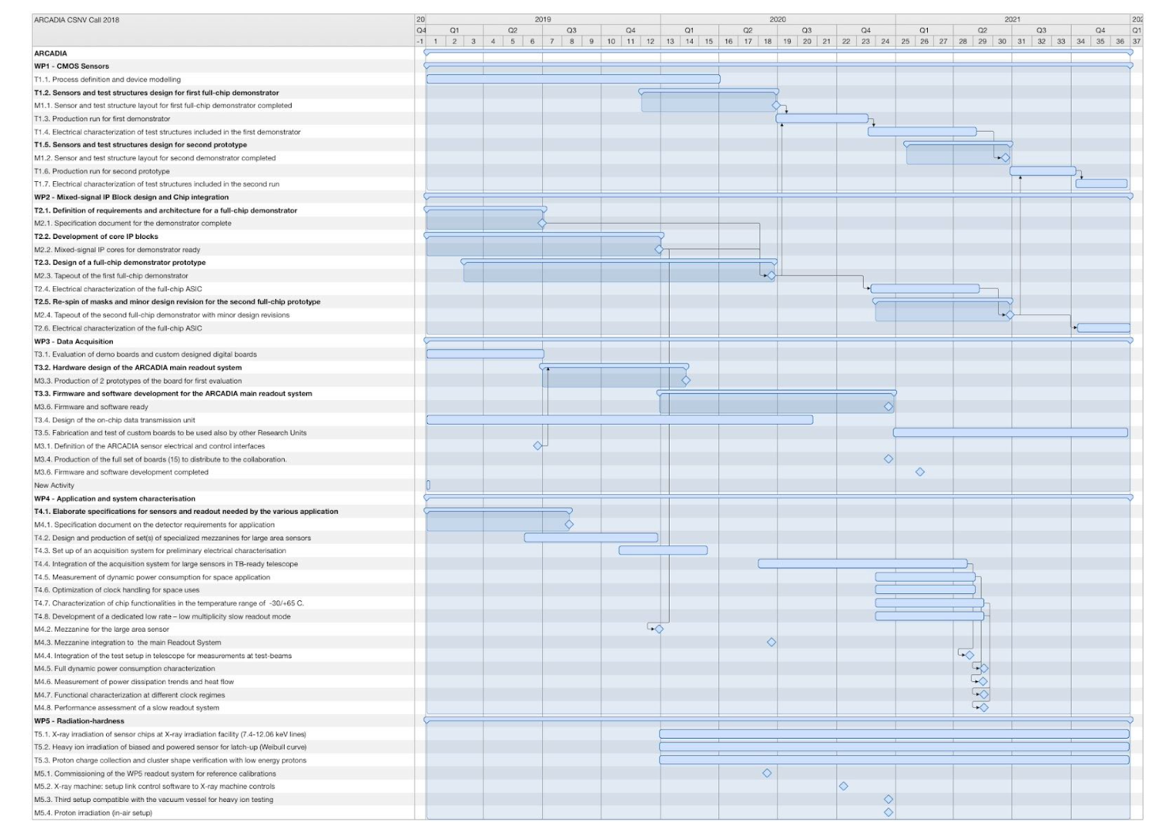

At the time of writing (April 2020) the project is keeping track, targeting the tapeout of the first full chip and test structures in July 2020. A first test-chip featuring relevant CMOS IP cores was sent to production in November 2019, and the Collaboration is currently collecting data from pseudo-matrixes and a 2x2mm2 small-scale MAPS, which demonstrate the ability to fully deplete the CMOS sensors in 100 and 300µm thick sensors.

1.1 Vertex Prototype: Funding Availability

The total cost of the project has been estimated to be 950 kEUR, largely dominated by the CMOS maskset and production runs. The full budget has been granted after the project was retained for funding, following a selection based on independent evaluators and a final discussion with a panel of INFN referees. Additional external funding, up to 400 kEUR, were secured by the Collaboration at the end of 2019 and will allow for extra silicon fabrication, back-end and stitching R&D.

1.1 Vertex Prototype: Leadership Arrangement

The management board of the ARCADIA project includes experts on CMOS and Sensor design, DAQ development, radiation hardness and application of innovative silicon tracker and sensors to frontier detectors in HEP, medical and space applications: Manuel Rolo (PI), Lucio Pancheri, Alessandro Gabrielli, Romualdo Santoro, Jeffery Wyss, Roberto Iuppa, Gianluca Traversi, Massimo Caccia.

1.1 Vertex Prototype: Manpower Resources

A total of 7 INFN Divisions contribute to the ARCADIA program, and the Collaboration active participants list is 55 people, mostly staff INFN and University Associates. The allocated manpower corresponds to an average value of 15 FTE/year, with about 3 FTE/year funded on the project budget.