Rapid inversion method of radiation field distribution based on neural network and detection data
Ran Zhang^{1,2}, Guomin Sun² , Zihui Yang², Wen Zhou², Wenyi Li², Taosheng Li², Jianye Wang²
¹Institute of Physical Science and Information Technology, Anhui University, Hefei 230601, China
²Key Laboratory of Neutronics and Radiation Safety, Hefei Institutes of Physical Science, Chinese Academy of Sciences, Hefei, Anhui, 230031, China
Abstract. In order to reduce the radiation hazards of workers, it is necessary to know the distribution of the radiation field to optimize the operation plan. The traditional method—Monte Carlo calculation process takes a long time, and the point-kernel method always has a large deviation. The result of radiation dosimeters for field detection is closer to the real situation, but repeated detection will increase accumulated absorbed doses of workers. This paper proposed a rapid inversion method of radiation field distribution, which based on neural network and a small amount of radiation detection point data under the condition of shielding. This method uses the Monte Carlo method to calculate the radiation field distribution of the work space under the conditions of multiple different custom sources. The detector data are used as the input, and the entire radiation field distribution data are used as the output to train and test the 3-layer fully connected neural network. Through several tests, the error of the inversion result of this method is within the acceptable range, and the time-consuming is greatly reduced.
Key words. Radiation distribution inversion; Neural network; Monte Carlo; SuperMC; Radiation detection data

- Background and significance
With the rapid development of nuclear technology utilization, radiation protection has become increasingly significant. Operations in the radiation field must follow the principle of As Low As Reasonably Achievable(ALARA)[1]. Pre-simulation calculation and radiation dosimeter detection can be used to evaluate the accumulated absorbed dose of workers during the operation, and provide a reference for optimizing the operation plan and reducing the accumulated absorbed doses of workers.
The traditional methods of calculating radiation distribution mainly include Monte Carlo method and deterministic method. The Monte Carlo method calculates the entire radiation distribution by randomly simulating the particle transport process[2], but it needs to know the information of source and takes a long time. Deterministic methods include point-kernel method and discrete ordinate method. The point-kernel method is an analytical calculation method based on buildup factors[3], the discrete ordinate method approximately solves the transport equation by discretizing the variables in the transport equation[4]. The deterministic method has a rapid calculation speed but the ability to handle complex scenes is insufficient, moreover, the deviation is large. It is not applicable to the situation where the internal structure and information of the radioactive source is unknown. Fudan University Shanghai Cancer Center used a deep learning model based on residual neural network to predict the radiation distribution of the patient's specific geometric shape and prescription dose[5]. Hefei Institutes of Physical Science, Chinese Academy of Sciences has studied a radiation field reconstruction method based on BP neural network and multiple sampling points, using sampling data in places where the flux gradient changes drastically to reconstruct the entire radiation field[6].
This paper proposes a rapid inversion method of radiation field distribution, which based on 3-layer fully connected neural network and a small amount of radiation detection point data under the condition of shielding. When the detection data is insufficient, the Monte Carlo calculation data can be used to simulate the detection data for neural network training.
- Inversion method
In this paper, we first build 3D geometric and physical model on the shielding conditions of the fixed space, and then use the Monte Carlo method to calculate the radiation distribution of different custom source terms, which are used as training and testing samples for the

Fig. 1. Method flow

neural network. Training a neural network corresponding to the work area under the current shielding conditions. In subsequent practical applications, the radiation distribution can be inverted through a small amount of detector data.
The main process is as follows:
a. Monte Carlo calculation. We build the model of the spatial structure of the radiation field and calculate the radiation distribution of multiple different source. According to actual conditions, we select the number and location of detectors.
b. Preprocessing and splitting the dataset. We take the base 10 logarithm of the distribution data and normalize it. The radiation distribution data is split into training set and test set at the ratio of 8:2 according to the source term conditions.
c. Building and training the neural network. The detector data is used as the network input, and the entire radiation distribution is stretched into a one-dimensional vector as the network output. Selecting the number of hidden layers, the number of nodes, the activation function and other hyperparameters, training the network on the training set.
d. Testing and tuning the neural network. Testing the accuracy of the model on the test set, if the accuracy is insufficient, change the hyperparameters and repeat step d.
e. Saving and applying the network. Saving the neural network model. Preprocessed the real detection and input it ,through the neural network and output it. De-preprocessed the final result and calculates the radiation distribution.
According to the inverse square law of distance, the dose rate D of a certain point in the radiation field is inversely proportional to the square of the distance R between the point and the source. D decreases rapidly as R increases.
(1)
In addition, the presence of the shield will greatly affect the dose rate D, therefore the radiation dose distribution in the entire radiation field is very different, the maximum value and the minimum value are several orders of magnitude different. Such data distribution brings huge difficulties to neural network learning. Therefore, we take the base-10 logarithm of the data, shrink the data distribution between -20 and 0, at the same time make the dose change between adjacent points more gradual. Normalization can make the data scale between [0,1], which can speed up the convergence of the network.
(2)
Through the test and adjustment, a 3-layer fully connected neural network is used with a hidden layer, the number of nodes in the output layer is S and the number of nodes in the hidden layer is S/4.
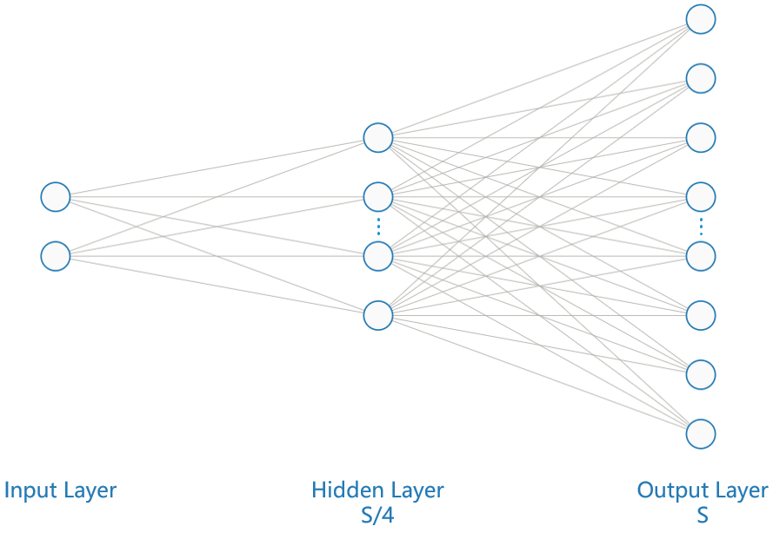
Fig. 2. Neural network structure
The activation functions of the input layer and the hidden layer is Rectified linear unit (Relu)[7],The non-linear activation function makes the neural network have the ability to fit the non-linear function.
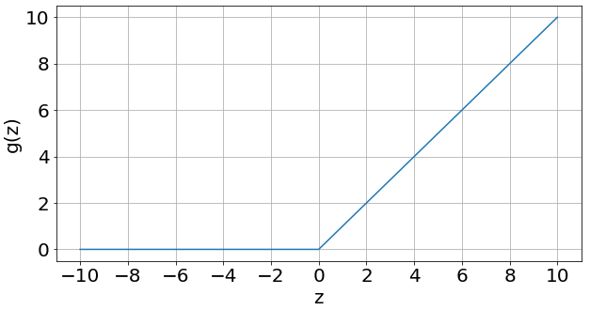
Fig. 3. Relu function
The optimizer is Adaptive Moment Estimation (Adam)[8], and the learning rate is 0.001. Adam is one of the most widely used optimization algorithms. It combines the advantages of other optimization algorithms, can adjust the learning rate adaptively, and has the advantages of rapid convergence and rapid calculation speed.The loss function is Mean Squared Error(MSE),
(3)
The final evaluation index is Mean Absolute Percentage Error(MAPE). Due to the randomness of the neural network results, each experiment was repeated 10 times and the average value was taken.
(4)
- Experimental analysis
According to the above method, we use the Monte Carlo software SuperMC[9], and based on the deep learning framework Pytorch, use the python language to independently develop the radiation distribution inversion program.
This article carries out multiple experimental verification methods, and the test results of different scenes are as follows:

3.1 Single point source scene
This scene is a square area of 10×10m. The point source is located at the bottom left (100,0). There is a point source whose source strength varies between 1-10MeV. There is a circular shield with a radius of 1m in the central area. The shielding material is Zr. Using 100 million particles to calculate the radiation distribution, and outputting the grid distribution data of 100×100. Radiation distributions with source strength equal to 1,2,...8 MeV were used as the training data set. Radiation distributions with the source strength equal to 2.5 and 3.5 MeV were used as the test data set. Preprocessing the data according to the above method.
We chose detectors near the source (80, 20) and behind the circular shield (30, 70). Taking the radiation field distribution with a source intensity equal to 2.5MeV as an example, the Monte Carlo calculation result is as follows:
Fig. 3. Single point source structure
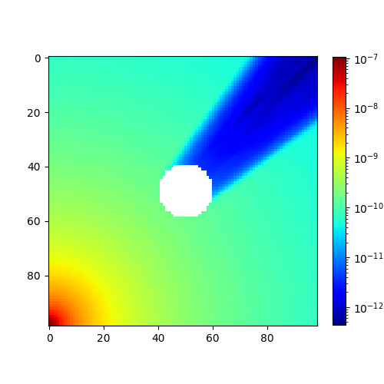
Fig. 4. Single point source radiation distribution
In order to test the influence of different detector positions and numbers on the results, we carried out single detector and two detector tests respectively. For single detector, only detector 1 was selected. The inversion distribution is as follows:
Fig. 5. Single detector inversion distribution 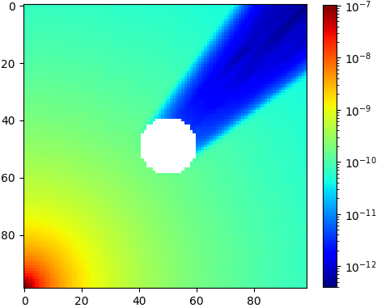
Fig. 6. Two detector inversion distribution
On the test set, the single detector inversion error is 4.609%, and the two detector inversion error is 4.417%. Calculating the error rate of each point based on the original radiation distribution, the error distribution is as follows. It shows that the error mainly exists behind the shield, and the error of the two detector result is slightly lower than that of the single detector.
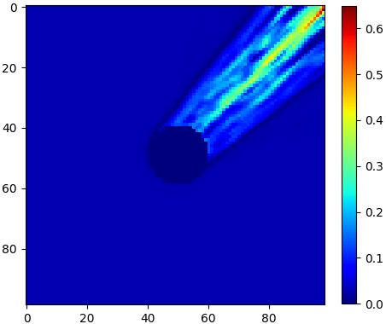
Fig. 7. Single detector error distribution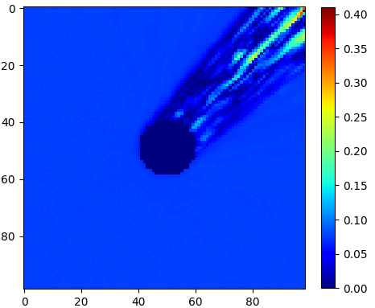
Fig. 8. Two detector error distribution

3.2 Multipoint source scene
This scene is a 10×10m square area. The point source is located at the bottom left (100, 0) and bottom right (100, 100). In the central area, there is a circular shield with a radius of 1m, and the shielding material is Zr. Performing a Monte Carlo simulation using 100 million particles for each source, outputting 100×100 grid distribution data. The 16 radiation distributions with two point source strengths equal to 2, 4, 6, 8 MeV were used as a training data set. The four radiation field distributions with two point source strengths equal to 3,5 MeV were used as the test data set. This scene has two point sources, so we first used the data of detector 1 and detector 2, and then added the data of detector 3.
We chose detectors near the source (80,20), (80,80) and the right rear of the circular shield (30,70). Taking the radiation field with the left source intensity of 3MeV and the right source strength of 5Mev as an example, the Monte Carlo calculation distribution is as follows:
Fig. 9. Two point source structure
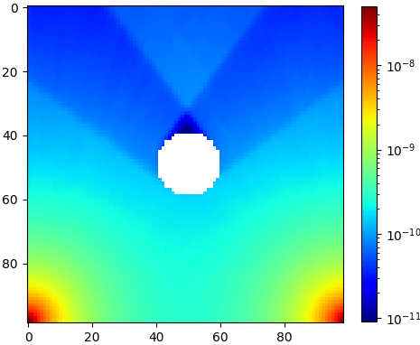
Fig. 10. Two point source radiation distribution
The inversion distribution is as follows:
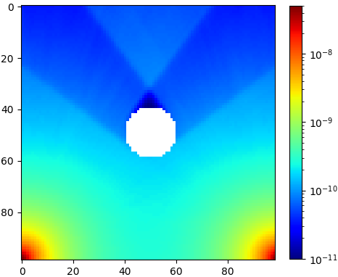
Fig. 11. Two point source and two detector inversion distribution
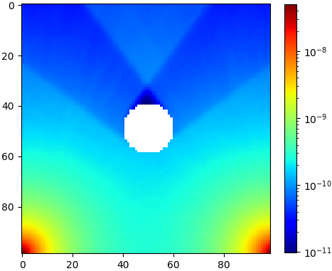
Fig. 12. Two point source and three detector inversion distribution
Through the test, the overall error of the double detector is 2.059%, and the overall error of the three detectors is 1.985%. It shows that the error in the right half of the three detectors is significantly reduced.
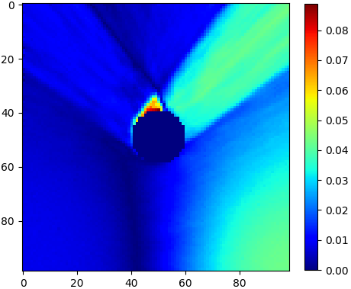
Fig. 13. two point sources and two detectors Error distribution
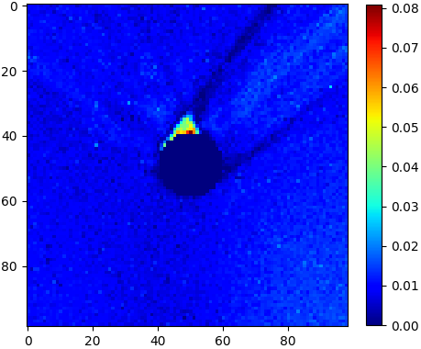
Fig. 14. two point sources and three detectors Error distribution

3.3 Multi-volume source scene
This scene is a rectangular area of 20×10m. There are 6 cuboid sources numbered 1-6, and the remaining red cuboids are concrete shields. To simplify the model, the fixed volume source strength of No.1, 4, and 6 remains unchanged at 2MeV, the volume source strength of No.2 and 3 varies between 2-8 MeV, and the source strength of No.5 varies between 4-10 MeV. Performing a Monte Carlo simulation using 100 million particles for each source, outputting 200×100 grid distribution data. The 64 radiation distributions with the source strength of No. 2, 3 equal to 2, 4, 6, 8 MeV, and No. 5 body source strength equal to 4, 6, 8, 10 MeV were used as the training data set. The 16 radiation distributions with the source strength of No. 2 and No. 3 being equal to 3, 5 MeV and No. 5 body source being equal to 5 and 7 MeV were used as the test data set. Performing logarithm and normalization preprocessing on the data.
We chose detectors near sources No.2, No.3, and No.5 (25, 20), (90, 60) and (70, 170).
Fig. 15. Multi-volume source shielding structure
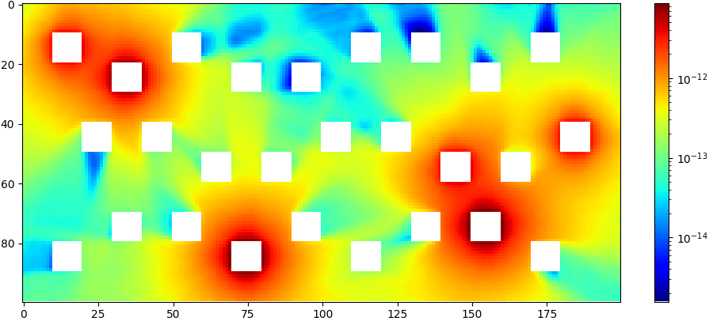
Fig. 16. Multi-volume source radiation distribution
The inversion distribution is as follows, The overall error of three detectors is 1.781%.
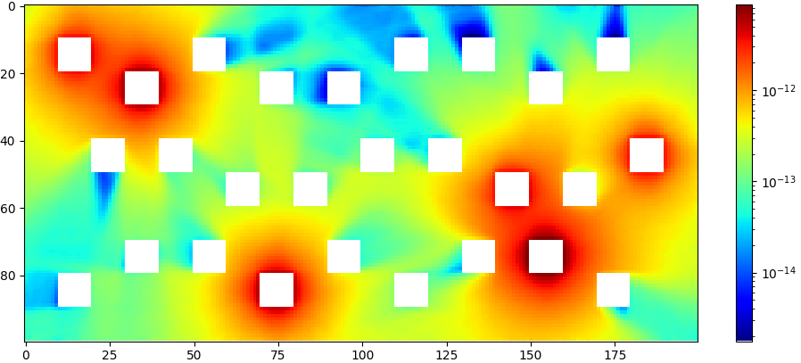
Fig. 17. Multi-volume source three detector inversion distribution
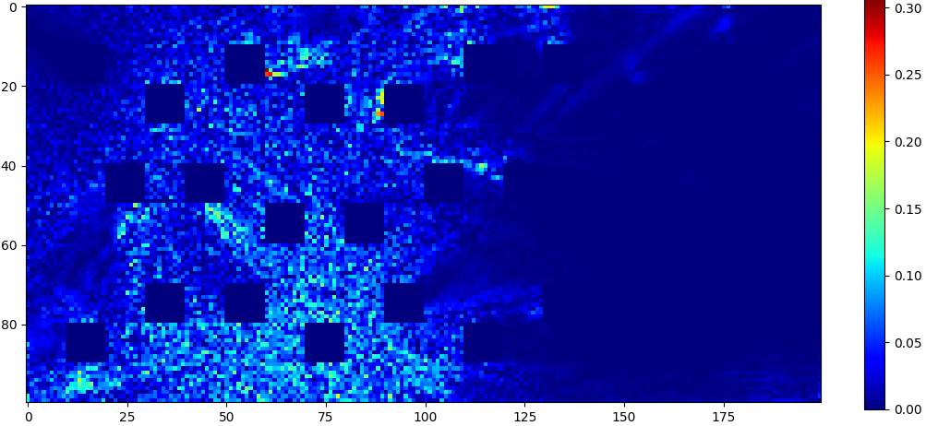
Fig. 18. Multi-volume source and three detectors error distribution

Table1. Case error with different hidden layer node numbers
Case Error | S | S/2 | S/4 | S/8 | S/16 | S/32
Single point source  single detector | 4.146% | 4.536% | 4.609% | 4.804% | 7.423% | 17.418%
Multi-point source  two detector | 0.585% | 1.130% | 2.059% | 4.112% | 7.812% | 13.083%
Multi-volume source  three detectors | 1.987% | 1.835% | 1.781% | 1.890% | 2.027% | 2.081%

3.4 Neural network structure parameter test
We tested the influence of different neural network parameters on the results based on different scenes. The network structure used above is the three-layer neural network. Setting the number of nodes in the output layer to S and the number of nodes in the hidden layer to S/4. According to our test, increasing the number of hidden layers does not improve the result, it could even cause overfitting to increase error. The impact of changes in the number of hidden layer nodes is shown in Table 1.
Based on the error distribution results of different cases, increasing the number of hidden layers will not improve the effect. When the number of hidden layer nodes>S/4, the effect will not be improved significantly. The number of nodes<S/4 will increase different degrees of error.
- Conclusion
This paper proposed a rapid inversion method of radiation field distribution based on neural network and detection data. The Monte Carlo calculation results under the conditions of custom sources were used to train a neural network corresponding to the operating scene under the current shielding condition. Combined with a small amount of detector data, the radiation field distribution could be inverted quickly, and the overall distribution error is acceptable, which verifies the feasibility of the method. The uneven distribution of the radiation field is the main source of error. This method only needs to train and save the neural network once for the existing operating scenes, and can quickly perform inversion calculations in actual work, which is of great value for ensuring the radiation safety of workers. It’s available in the research of nuclear facilities in the decommissioning scene and solving the rapid distribution inversion of the radiation field in the process of shield dynamic changes.

References
- Valentin, J. . "The 2007 Recommendations of the International Commission on Radiological Protection." Ann Icrp 37.2(2007):1-332.
- Dubi, A. "Monte Carlo calculations for nuclear reactors." CRC handbook of nuclear reactors calculations 2 (1986): 2.
- Prokhorets, M. I., et al. "Point-Kernel method for radiation fields simulation." Вопросы атомной науки и техники (2007).
- Adams, Marvin L., and Edward W. Larsen. "Fast iterative methods for discrete-ordinates particle transport calculations." Progress in nuclear energy 40.1 (2002): 3-159.
- Fan, Jiawei, et al. " Automatic treatment planning based on three‐dimensional dose distribution predicted from deep learning technique." Medical physics 46.1 (2019): 370-381.
- Zhou, Wen, et al. "BP neural network based reconstruction method for radiation field applications." Nuclear Engineering and Design (2021): 111228.
- Agarap, Abien Fred. "Deep learning using rectified linear units (relu)." arXiv preprint arXiv:1803.08375 (2018).
- Kingma, Diederik P., and Jimmy Ba. "Adam: A method for stochastic optimization." arXiv preprint arXiv:1412.6980 (2014).
- Wu, Yican, et al. "CAD-based Monte Carlo program for integrated simulation of nuclear system SuperMC." Annals of Nuclear Energy 82 (2015): 161-168.

Supported by National Key Research and Development Program of China (2019YFE0191700), the Natural Science Foundation of Anhui Province (2008085MA23), the Informatization Project of the Chinese Academy of Sciences (XXH13506-104), National Basic Science Data Sharing Service Platform (DKA2017-12-02-XX) First author: Ran Zhang, male, master's degree, Mainly engaged in computer application and radiation protection Corresponding author: Zihui Yang，zihui.yang@inest.cas.cn

