A method to improve the measurement accuracy of CEPC alignment

Wang xiaolong1,2

1(*Institute of High Energy Physics, Chinese Academy of Sciences (CAS)，Beijing 100049, China*)

2(*Spallation Neutron Source Science Center, Dongguan 523803, China*)

Abstract: In order to realize CEPC large range high precision point position control, a three levels control network scheme was designed used for step-by-step control from global to local. Although the surface control network and backbone control network can realize large range position control, but the distance between two adjacent backbone control network points is still too large, when use laser tracker carry out the measurement, significant error accumulation will appear. This paper put forward a measuring method which combining laser tracker and laser alignment system. By obtaining the distance observations between the measuring points and the straight-line datum, it can use the distance observations as constraint to carry out adjustment and suppression the error accumulation. The measurement method that combing laser tracker and laser alignment system was introduced, the adjustment model with distance constraint was derived. A 100m Linac tunnel control network was designed and the observations were obtained by simulation. Using the adjustment method in this paper, the adjustment result is obtained. By comparation the difference between the result and the design coordinate of the control points, the effect of this adjustment model is verified.

1. Introduction

CEPC physics design has put forward a very high position accuracy requirement, such as the magnets in arc area are required to be better than 0.1mm in X Y Z directions and the components in IR area are required to be better than 0.05mm. In order to realize high accuracy alignment in CEPC such a large area, it needs on one hand the position accuracy of components should be controlled within a certain range in the global coordinate system, on the other hand much more important is to realize high accuracy relative position alignment between the components in a certain local area. A big challenge of CEPC alignment is that the area needs to be measured is very big, with the distance between station and known point increasing the error accumulation will increasing too. In order to achieve the absolute position control of the component in the global range and the relative position control in a local range, a three levels control network was designed to be used as a position reference. The first level is a surface control network, to realize global position control. The surface network will be measured by GPS, then can get the control points’ coordinates in the global coordinate system. The second level is a backbone control network, used to strengthen the error accumulation control ability of the tunnel control network. Backbone control network is composed by the control points mounted in tunnel floor, it is a kind of straight line triangulation network，the short line is 300m and the long line is 600m. The backbone control network will be measured by total stations, and use the points in the surface network as known points to provide position information The third level is a tunnel control network, used as the position reference for components installation. The tunnel control network will be mounted along the tunnel by section, each section includes four points which will be mounted in the floor or on the walls. The tunnel control network will be measured by laser tracker and use the backbone network control points as knowns points to provide position information.

Although the surface network and the backbone network can provide the position control in global and large ranges, but the distance between two adjacent control points of the backbone network is still 300m length. When use laser tracker to carry out the measurement in so long distance, there will be error accumulation. The position accuracy of tunnel control network and the components is limited by the position accuracy of the backbone network and the distance between two adjacent control points of the backbone network, so how to control the move station measurement error accumulation in long area and improve the point measurement accuracy is a basic research topic.

The laser alignment system can provide a long straight line datum, it is often used to carry out the component alignment in the straight line of an accelerator[1,2]. Compared with the tunnel control network it does not generate error accumulation, so it can realize long distance high accuracy position control. Based on this advantage of laser alignment system, it can be considered to carry out the measurement by combination of laser trackers and laser alignment systems. By this method, the laser alignment system can provide position constrains for laser tracker measurement, realize long distance measurement error accumulation control, improve the measurement accuracy and reliability. The following will introduce the measurement method and the data process method respectively.

2. Measurement scheme

Install an as long as possible laser alignment system in the tunnel, to the linac tunnel when the tunnel length is longer than a laser alignment system, it can use overlap method to install more than one system to realize the extension of laser alignment system as shown in figure 1. To the circular tunnel, the same method can be used that is to install several laser alignment systems by overlap method. The position of the laser alignment system can be installed freely, no strict position requirement.

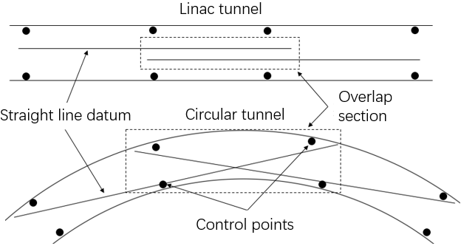

Fig. 1 Laser alignment system layout

There are several measurement boxes in each laser alignment system used to draw the laser beam center position out. The structure of a measurement box is shown in figure 2, there are several fiducials on the surface of the box, in the box, there is a beam center detector. The position relation between the fiducials and the detector can be determined by fiducialization, then through measure the fiducials and combine the measurement of detector, the coordinate of the center pint in the beam line can be gotten.

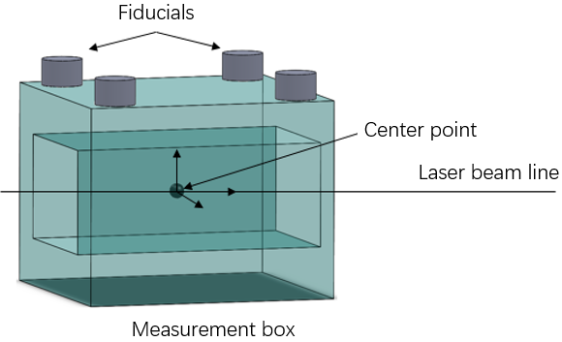

Fig.2 Measurement box

By measurement the fiducials of any two boxes in each laser alignment system, the position of the beam line can be determined by the two center points, as shown in figure 3.

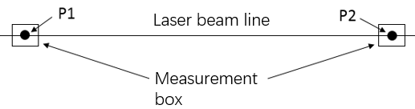

Fig. 3 Determine the position of a laser beam line

When use the laser tracker to carry out a 3D measurement, in each station, besides measurement the general points, two measuring boxes in a nearby laser alignment system should also be measured then wo center points Pl and P 2 can be gotten. When the station is in the overlap section, the laser tracker should measurement two center points of each beam line respectively. According to each station measurement the distances between the measurement points and the straight-line datum can be calculated, as shown in figure 4.

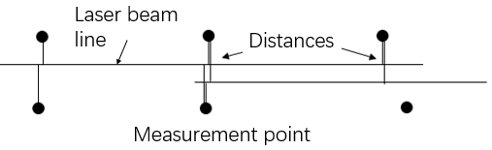

Fig. 4 Distances between points and straight-line datum

3. Adjustment model with distance constraint

Using the observations to do adjustment calculation, the error equation can be obtained according to the classical indirect adjustment formula.

 (1)

the V is the corrections vector of observations, B is the coefficient matrix, is the corrections vector of all the parameters to be found,  is the constant term vector.

Construct the constraint equation, suppose the coordinates of two end points of a straight-line datum in the global coordinate system is  and , then the equation of the straight line is , the  is the coordinate in the global coordinate system of any point on the straight line. The distance between point i  and the straight line is



where the parameters to be solved is: 、、. Linearized can get , where  is the coefficient matrix,  is the approximate value corrections vector of the parameters to be solved,  is the constant term vector.

To all of the distance observation equation, there is

 (2)

where ,  is the coefficient matrix, ,,  is the observation error vector.

according to the classical indirect adjustment formula, from (4) the error equation (5) can be derived

 (5)

where  is the correction vector of distance observation,  is the constant term vector.

Construct the distance constraint equation, the objective is to minimize the correction of  in the adjustment: . According to (5), it can be derived: , the constraint equation is . For the is usually a nonrow full rank matrix, to meet the later calculation requirement, it should be transformed to a full row rank matrix  by Gauss completely selected principal element elimination method elementary transformation. The constraint equation is changed to . Let , , the constraint equation can be rewritten to . The  is a subset of  in (3), to unify the parameter items, the constraint equation can be rewritten to

 (6)

For the parameters not found in (5), we can let the corresponding element in  and to be 0.

By (3) and (6) the adjustment model with distance constraint is

 （7）

According to the classical indirect adjustment formula with constraint conditions, the solution of (7) is , where , P is the weight matrix of the observations, , . Finally, the optimal estimation of the parameters to be solved can be obtained: , where  is the approximate value of the parameters to be solved.

4. Simulation

Because in reality measurement, it is always accompanied by errors, so the truth value of the measurement object can not be gotten. In order to intuitively compare the different between the adjustment result and the truth value of the measurement object, the simulation method can be used. Using the simulation, we can compare the different between the adjustment result and the designed value of the measurement object. The implementation scheme is according to the common layout of accelerator tunnel network to design the control points’ coordinates, according to the measurement method of laser tracker to generate the simulated observations of each measurement station, using the simulated observations to do adjustment, comparing the different between the adjustment result and the designed coordinates.

Design a linac tunnel control network, the control network is installed by sections along the tunnel. In each section there are 4 control points as shown in fig. 5, the distance between two floor points is 2.5m, the distance between two wall points is 6m, the distance between the floor point and wall point is 1.8m. The interval of adjacent sections is 6m, totally 18 sections, the length of control network is 102m. The XY plane of the control network coordinate system is the horizontal plane, the Y is the beam direction and Z is the vertical direction. A 100m laser alignment system is installed on the floor along the tunnel.

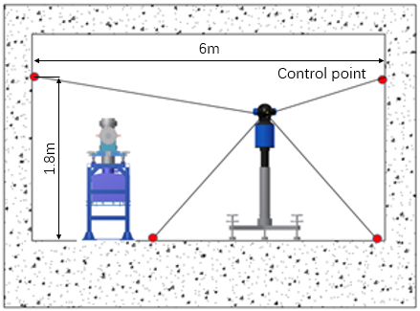

Fig. 5 Tunnel control network

Using laser tracker to carry out the tunnel network measurement by move station method, measurement stations is set in the middle of adjacent sections in turn and in each station the three front sections and the three back sections was measured. The coordinates of all of the stations was designed, 17 stations in total. The simulated observations of each station were generated by Monte Carlo method. According to the research of Yang fan[3], Yang zhen[4], Liang jing[5], the measurement precision is set as follow: distance precision 0.015mm+2μm/m, horizontal angle precision 2″, vertical angle precision 3″.

In order to verify the effect of the adjustment model on improving the accuracy of data processing, a same group of observations are calculated by common 3D adjustment and the adjustment method introduced by this paper respectively and the results were compared with the designed coordinates. For these two calculations, they all use the XYZ coordinates of a control point in the first section, the Z coordinate of another control point in the first section and the XZ coordinates of a control point in the 18th section as the known data. Fig.6 shows difference of the common 3D adjustment result subtract the designed coordinates.



Fig. 6 Coordinate different of common 3D adjustment result and the designed coordinates

From the figure it can be found, the X differences are between -0.08mm~0.15mm, Z differences are between -0.17mm~0.2mm and the Y differences is very small.

Applying the 3D adjustment with distance constraint method to carry out the calculation. Firstly, using the observations of each station to calculate the distances from each point to the straight-line datum. Then, according to the (7) to carry out the adjustment. Fig. 8 shows the difference of 3D adjustment with distance constraint result subtract the designed coordinates.

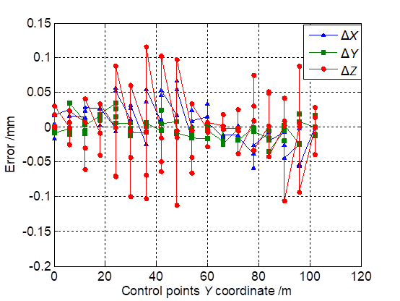

Fig. 7 Coordinate different of 3D adjustment with distance constraint result and the designed coordinates

From the figure it can be found, the coordinates accuracy of the adjustment result were improved in all of the directions, where the X error is reduced to - 0.06mm~0.7mm, Z error is reduced to -0.12mm~0.12mm。

5. Summary

Although the laser tracker can realize high accuracy measurement in a small range of single station measurement, but in the long narrow accelerator tunnel circumstance, when it carry out move station measurement the error accumulation in the transverse and elevation directions will occur. Laser alignment system can provide a unified long straight-line datum for each station measurement, when use laser tracker to carry out a measurement, as long as the laser tracker measurement two points on the straight-line datum at each station, it will be able to calculate the high accuracy distances from all measuring points of this station to the straight-line datum. The simulation measurement experiment shows that using the distances value of each station as the constraint for adjustment, it can effectively control the error accumulation of move station measurement in long distance measurement. The reason may be that there are not only the common points of adjacent stations transmitting the spatial geometric position relationship between stations, but also the distances from measuring points to the unified straight-line datum providing a constraint. Due to the high accuracy in small range characteristic of laser tracker, it can ensure the high accuracy distance values from measuring points to the straight-line datum can always be obtained during measurement in a long range. This makes the distance values from the measuring points to the straight-line datum independent to the range to be measured, so using the distances as constraint can control the error accumulation.

Surface control network and backbone control network can provide position control in global and large range, long straight-line datum can provide position control in a relatively short distance between control points. A cording to the rule of from the global to the local multiple levels control, a combination of several control methods can be applied for CEPC alignment to realize the large range high accuracy measurement.

Reference:

[1] Suwada T , Enomoto Y , Kakihara K , et al. Real-time observation of dynamic floor motion of the KEKB injector linac with a laser-based alignment system[J]. Phys.rev.accel.beams, 2017, 20(3).

[2] J. Prenting, in the mini workshop on laser based alignment systems, CERN, Switzerland, 2014, <https://indico.cern.ch/event/285495/timetable/#20140130>.

[3] YANG Fan. Research on precise survey of high energy particle accelerator project[D]. Zhengzhou: PLA Information Engineering University, 2011.

[4] YANG Zhen. Study of high-precision positon & pose measurement technique based on laser tracker[D]. Zhengzhou: PLA Strategic Support Force Information Engineering University, 2018.

[5] LIANG Jing, DONG Lan, LUO Tao, et al. Precision statistics of laser tracker in BEPCII storage ring and calculation of mean square error of unit weight[J]. Science of Surveying and Mapping, 2013, 38(6): 182–184. DOI: 10.16251/j.cnki.1009-2307.2013.06.026.