3D-adjustment based on horizontal distance constraints

Wang Xiaolong1,2

1.Institute of High Energy Physics, Chinese Academy of Sciences (CAS)

Beijing, 100049, China

2.Spallation Neutron Source Science Center

Dongguan , 523803, China

**Abstract**

**Background** The circumference of Circular Electron Positron Collider (CEPC) reaches 100km, in such a large range to carry out the alignment measurement will encounter serious error accumulation problem. Traditionally, large accelerator alignment mainly using a surface network to provide the global absolute position control, however, due to the low accuracy of the surface network control points, it is only applicable to long-distance measurement where the error accumulation exceeds the accuracy of the control point. How to further control the error accumulation occurred in a relatively short distance measurement between the control points and improve the accuracy of accelerator alignment measurement is a problem needs to be solved.

**Purpose** In order to control the error accumulation and further improve the measurement accuracy of accelerator alignment, research introduce the stretched wire into the activity of measurement and data processing.

**Methods** A measurement scheme combining laser tracker and stretched wire is proposed. Using the horizontal offsets from the measuring points to the stretched wire to construct the constraint condition. Using the laser tracker observations to carry out the three-dimensional adjustment with horizontal offset constraint.

**Results** A three-dimensional adjustment function model of laser tracker observations is given. The construction method of the constraint equation is researched and the calculation formulas of the three-dimensional adjustment with horizontal offset constraint is derived. A 300m linac tunnel control network is designed, using simulation measurement method, the measuring data of laser tracker and the horizontal offsets from the measuring points to the stretched wire were generated. The simulated data is calculated by the method given by this paper and the result is analyzed.

**Conclusion** Simulation result shows introducing the stretched wire into laser tracker measurement and applying the three-dimensional adjustment with horizontal offset constraint can effectively inhibit the error accumulation caused by long distance move station measurement.

**Keywords** Accelerator alignment. CEPC. Error accumulation. Stretched wire. Laser tracker. Three-dimensional adjustment. Horizontal offset constraint. Simulation measurement

Expected number of pages: 12

**Introduction**

In order to improve the beam strength and reduce the beam loss, accelerator physics requires higher and higher alignment accuracy of the component position. The Circular Electron Positron Collider (CEPC) proposed by Chinese physicist demands the accuracy of the magnets in the arc areas should be better than 0.1mm and the magnets in the interaction region should be better than 0.05mm, meanwhile, the circumference of CEPC reaches to 100km, this brings great challenge to the high accuracy alignment work. In order to realize high accuracy alignment in CEPC such a large area, it needs on the one hand the position accuracy of the components should be controlled within a certain accuracy in the global coordinate system, on the other hand which is much more important is to realize high accuracy relative position alignment between the components in a certain local area. In order to achieve the absolute position control of the component in the global range and the relative position control in a local range, a three levels control network system consisting of a surface control network, a backbone control network and a tunnel control network will be used as a position reference. The first level is a surface control network, composed by 14 control points distributed in the CEPC area, to realize global absolute position control. The surface control network will be measured by GPS, then can get the control points’ coordinates in the global coordinate system. The second level is a backbone control network, used for strengthen the error accumulation control ability of the tunnel control network. The backbone control network is composed by the control points mounted in the tunnel floor, it is a kind of straight line triangulation network, the length of the short line and the long line are 300m and 600m respectively. The backbone control network will be measured by total station, and use the points in the surface control network as known points to provide the position information. The third level is a tunnel control network, used for provide position reference for components installation. The tunnel control network will be mounted along the tunnel by section, each section includes four control points which will be mounted on the floor and walls. Presently, the position of the tunnel control network and the components are mainly measured by using laser tracker[1-2]. Laser tracker carries out a three-dimensional measurement, theoretically, three-dimensional measuring data processed by three-dimensional adjustment is more rigorous[3], however, error accumulation was found in practice. Along with the measurement length increases, the measuring station number increases, the three-dimensional adjustment result will deviate from the reasonable values obviously[4].

To control the error accumulation, in large scale accelerator alignment scheme the surface control network and the backbone control network are usually used to provide the known control point data for the laser tracker measuring data adjustment[5]. Although this is an effective error accumulation control method, but because of the accuracy of the known control points’ coordinates provided by the surface control network and the backbone control network is not high, normally only millimeter or submillimeter level, so it can only be used for the large range measurement which error accumulation is significantly larger than the error of the known coordinates. For the small range measurement which error accumulation generally is small, the accuracy of the known control point is obviously not enough.

By tensioning a wire between two fixed point, the stretched wire can provide a straight-line datum in horizontal for accelerator alignment. By measuring the horizontal offset from the components to the wire, the relative position information of the components can be gotten. Stretched wire technology has a long history in accelerator alignment, in the 1960s, CERN and SLAC already began to use the stretched wire in accelerator alignment[6-7]. DESY[8] and IHEP[9] had also every used the stretched wire to realize the accelerator component alignment. Presently, the stretched wire technology still been used a lot in CERN[10] and LANL[11]. The measuring method of the stretched wire has changed from the optical artificial reading to the photoelectric automatic reading through many years development[12].

Compared with the control network, the stretched wire has the advantage that it can realize higher relative alignment accuracy of the components in a certain local range. The length of a stretched wire can be more than 100m[13], in this range all of the components can be aligned relative to a unified straight-line datum and no error accumulation occur. The disadvantage of the stretched wire is its shape is a catenary by gravity, the projection of this catenary in level plane is a straight-line, using this straight-line as a datum it can only control the transversal position of the component but can not control the vertical and the longitudinal position along the line, and can not provide the three-dimensional coordinate of a point in the global coordinate system. So the stretched wire is generally used for the straight-line section’s component relative position alignment[14] or smooth alignment[15]. Accelerator complexes have various lay out, including linac, ring, beam transport line and so on, the stretched wire cannot meet the global various lay out alignment requirement. Although the accuracy of a control network is relatively low, but it has the advantages of easy layout, can cover the whole accelerator facility, can provide the global unified coordinate system for all components, and can realize the global unified position control. How to combine these two methods effectively to solve the error accumulation problem occurred in the long area measurement between two known control points and improve the coordinate measurement accuracy of the point in the global coordinate system is a worthy research direction.

Accelerator component position is generally measured by using laser tracker. Although laser tracker is a typical high precision instrument for large size space measurement, but the measuring range of a single station is still very limited. In order to realize the position measurement of all components in the whole accelerator, laser tracker has to carry out a move station measurement, when does this, it relays on the common points between adjacent stations to transfer spatial position relations and easy produce error accumulation[16]. If introduce the stretched wire into the measurement, it can provide an unified datum for the local stations, this unified datum can be applied to constraint the positions and orientations of these stations. Considering the above reasons, in the work of accelerator alignment measurement and data processing, according to the principle of control from global to local, the following strategy can be applied that using the known control points to realize large range long distance absolute position control, using the stretched wire to realize local relative position control of the laser tracker measurement, and carry out a three-dimensional adjustment with constraint for the laser tracker observations. By doing these, the purpose of control error accumulation and improve the accuracy and reliability of the alignment measurement will be realized. Next, this paper will introduce the measurement scheme and the three-dimensional adjustment model separately.

**1. Measurement scheme design**

In acceleration tunnel along the tunnel direction install a stretched wire system as long as possible. To the linac tunnel when the tunnel length is longer than a stretched wire, it can use overlap method to install more than one stretched wire to realize the extension of the stretched wire system as shown in figure 1. For the circular tunnel, the overlap method can also be used to realize the stretched wire system extension. The position of the stretched wire can be installed freely, no strict position requirement.

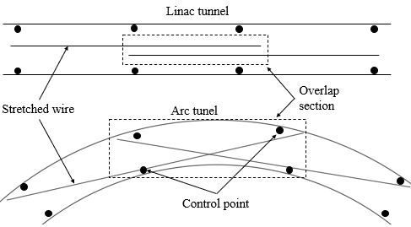

**Fig. 1** layout of a stretched wire system

The wire’s position can be measured by using a wire position sensor. Take the capacitive wire position sensor as an example, it is composed by up down and left right two groups parallel metal plate which form a two-dimensional plate capacitor[17]. Using a wire through the capacitor as shown in figure 2, when the wire’s position changing, it will induce the dielectric constant between the poles changes, then the wire’s position change can be translated into the capacitance change. There are several fiducials on the outside of the sensor, by fiducialization, the position relation between the fiducials and the sensor center can be determined. When measuring the wire, according to the wire position sensor measurement result the sensor’s center can be adjusted to the wire, by measuring the fiducials and combining with the fiducialization result, the sensor’s center coordinate in the measuring station coordinate system can be gotten, then the coordinate of a point on the wire in the measuring station coordinate system can be gotten.

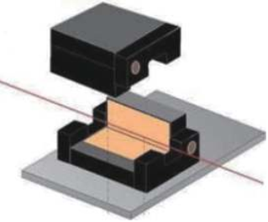 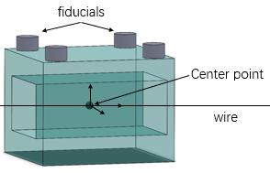

(a) Capacitive wire position sensor (b) Fiducials and center point of a sensor

**Fig. 2** Wire position sensor

When using a laser tracker to carry out measurement in tunnel, in each station it should establish a level coordinate system according to the local vertical direction. In each station, besides measuring the general points, two or more points on a nearby stretched wire should also be measured by using the wire position sensor as shown in figure 3. When the measuring station is in the overlap region, it needs to measure two or more points on the two wires respectively.

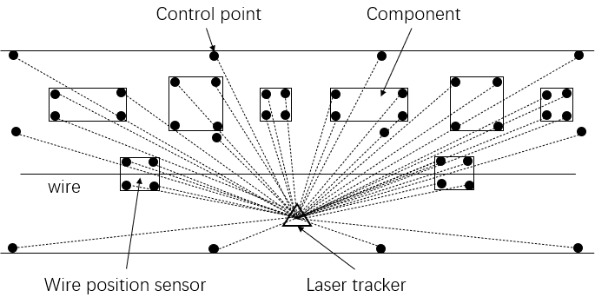

**Fig. 3** The combine measurement of a laser tracker and a stretched wire

Projecting the measuring points on the wire to the horizontal plane of the measuring station coordinate system and using these projection points best-fit a straight-line, then the projection of the stretched wire on the level plane can be gotten. This line can be used as a straight-line datum. According to the observations of the measuring points, the horizontal offsets from these measuring points to the straight-line datum in each station can be calculated.

**2. Three-dimensional adjustment with horizontal offset constraint model**

Based on the laser tracker three-dimensional measuring data adjustment, and adding the horizontal offsets from the measuring points to the straight-line datum as a constraint condition, a three-dimensional adjustment model with horizontal offset constraint will be formed. This model includes two parts, one is the three-dimensional adjustment function model, the other is the constraint function model, in the following, the construction method and the related formula deduction will be introduced.

**2.1 Three-dimensional adjustment function model**

Take a laser tracker measurement an accelerator tunnel control network as an example to illustrate the construction method of the three-dimensional adjustment model. As shown in figure 4, there is a control network which has n control points, using the move station measurement method, a laser tracker measured m stations, between the adjacent stations there are several common measuring points. Suppose a control point i which coordinate in the global coordinate system and in the kth station coordinate system is  and  respectively. The origin of the kth station coordinate system in the global coordinate system is . ***M*** is the rotation matrix which transform the global coordinate system to the kth coordinate system and  is the angle parameters of ***M.***

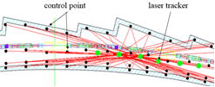

**Fig.4** Laser tracker measurement a tunnel control network

Laser tracker applying the spherical coordinate measurement principle, by measuring the horizontal angle *H*, the vertical angle *V* and the distance *S*, the coordinate of control point *i* in the measuring station coordinate system can be gotten, as shown in figure 5.

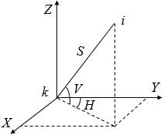

**Fig. 5** Laser tracker coordinate measuring principle

then the following functional relationship can be gotten

 (1)

 (2)

Where is the distance from origin *k* to point *i* , is the horizontal angle, is the vertical angle.

take equation (1) into (2) the observation equation of point *i* can be gotten, and the parameters to be solved are , and .

For the distance, horizontal angle and vertical angle observations of all the stations, the observation equation can be abstracted as , where is the observation value vector,  is the truth value vector of the parameters to be solved in the global coordinate system.  is the error vector of the observations. Suppose is the approximation of ,let , according to the Taylor formula the linearization result is , where , then the error equation is

 (3)

where is the observation correction vector,  is the coefficient matrix,  is the approximation correction vector of the parameters to be solved,  is the constant vector.

**2.2 Constraint function model**

Suppose and are two points on a wire, and their coordinates in the global coordinate system are  and , then the equation of the straight-line L determined by these two points in the global coordinate system is

 (4)

Where  is the coordinate of an arbitrary point on L in the global coordinate system. Let ，，，then the point-direction equation of the straight-line L is

 (5)

Its parameter equation is

 (6)

Suppose the direction definition of the axis of the measuring station coordinate system is : *Z* is the elevation direction, *X* and *Y* is in the level plane. For the geoid is not a plane, so the level plane of each measuring station is no same. The process of transform the *Z* direction of the global coordinate system to the *Z* direction of the s-measuring station coordinate system is: firstly, rotate the global coordinate system around its *X* axis (marked as ) , then, continue rotate this coordinate system around its *Y* axis (marked as ). After the *Z* axis direction of the global coordinate system changed into the same direction of the *Z* axis of the s-measuring station, for an arbitrary point on L in the global coordinate system, its corresponding coordinate in the transformed coordinate system is



Let  ， ，then can get

 (7)

So the projection of L in the s-station XY plane is

 (8)

For an arbitrary point *i*in the global coordinate system, let its coordinate in the coordinate system which *Z* direction is same with s-station is , there is

 (9)

The horizontal offset  from i to L in the s-station coordinate system is

  (10)

The parameters to be solved in (10) are coordinate system rotation transformation parameters 、，point coordinate ， and . After Linearized can get

 (11)

Where  is the coefficient matrix,  is the approximation correction vector of the parameters to be solved,  is the constant term. For all of the horizontal offsets from the measuring points to the stretched wire, the observation equation is

 （12）

Where  is the horizontal offset observation vector ,  is the coefficient matrix,  is the observation error vector ,  is the constant vector,  is the approximation correction vector of the parameters to be solved .

According to the classical indirect adjustment equations, from equation (12) the error equation can be derived.

 （13）

Where  is the horizontal offset observation correction vector,  is the constant vector.

Construct the horizontal offset constraint equation, the objective is to minimize the quadratic sum of the horizontal offset observation corrections in the adjustment: . According to (13)  can be derived, and the constraint equation is

 (14)

For the  is usually a nonrow full rank matrix, to meet the later calculation requirement, it should be transformed to a full row rank matrix. Suppose there is an elementary row transformation matrix ***p*** and an elementary column transformation matrix ***q***，then

 (15)

Where  is a full row rank matrix. Take the non-zero rows  and let , then get . Let  and , the constraint equation (14) is transformed to

 (16)

Where  is a subset of the  in equation (3), to unify the parameter items, using  substitute and let the elements in  and corresponding to the parameters which are not in the  to be zero, then equation (16) can be rewritten to

 (17)

Combine equation (3) and equation (17), the adjustment model with horizontal offset constraint is

 （18）

According to the classical indirect adjustment with constraint conditions formulas, the solution of

(18) is

 (19)

Where,  is the weight matrix of the observations, ，.

**3. Simulation analysis**

Taking a laser tracker measurement an accelerator control network as an example to verify the effect of the three-dimensional adjustment with horizontal offset constraint. Because in reality measurement it is always accompanied by measuring errors, so the truth value of the measurement object can not be gotten. In order to intuitively compare the difference between the adjustment result and the truth value of the control network, the simulation method can be used, that is to compare the difference between the adjustment result and the designed values of the control network.

In the simulation the shape of the geoid is considered, the method is to simplify the geoid and the earth's surface into a sphere. To highlight the curvature of the geoid, the radius of the sphere is designed to 2000km. Along the sphere surface a linac tunnel control network is designed. The control network is distributed by sections along the tunnel. In each section there are 4 control points as shown in figure 6, the distance between the two floor points is 2.5m, the distance between the two wall points is 6m, the height of the wall point is 1.8m. The interval of adjacent sections is 6m, totally 51 sections, and the length of the control network is 300m. The origin of the control network coordinate system is located at the floor point near the component in the first section. The XY plane is the level plane which tangent to the geoid at the origin. The Z axis direction is same with the geoid normal at the origin, and the Y direction is same with the beam, X is perpendicular to the Y, right hand coordinate system. The coordinates of all control points in the control network coordinate system are designed. In the tunnel, 3 overlapped stretched wires are designed, the first wire’s start and end points’ coordinates in the control network coordinate system is (500,0,1000) mm and (500, 100000,1000) mm. The second wire’s start and end points’ coordinates in the control network coordinate system is (1000,90000,1000) mm and (1000, 210000,1000) mm. The third wire’s start and end points’ coordinates in the control network coordinate system is (500,200000,1000) mm and (500,300000,1000) mm.

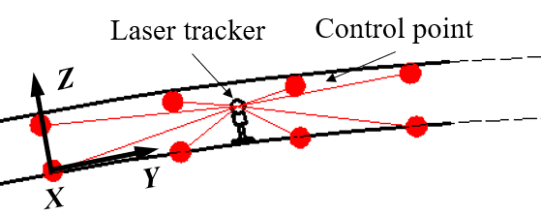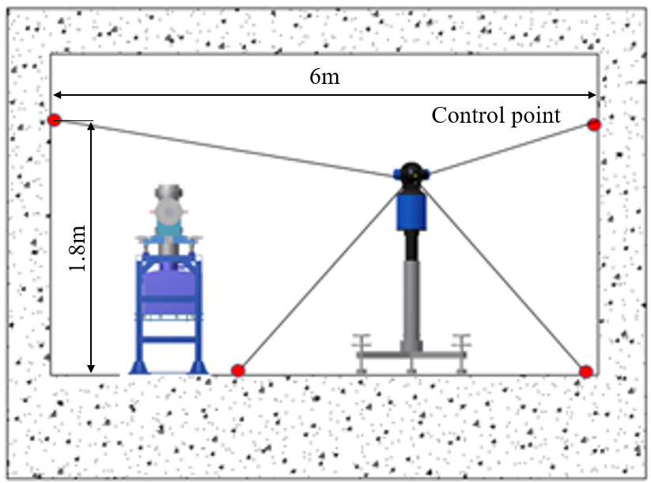

(a) Linac tunnel control network profile (b) Control network cross-section

**Fig.6** Linac tunnel control network

Using a laser tracker to carry out the tunnel control network measurement by move station method, measuring stations are set in the middle of each adjacent sections in turn, in total 50 stations and the coordinates of all the station points in the control network coordinate system are designed. In each station the three front sections and the three back sections was measured and the nominal observations of distance and angles of each measuring point in the station coordinate system are calculated. The simulated observations of each station were generated by Monte Carlo method. According to the research of Yang fan[18], Yang zhen[19], Liang jing[20], laser tracker measuring precision is set as follow: distance precision 0.015mm+2μm/m, horizontal angle precision 2″, vertical angle precision 3″.

In order to verify the effect of the adjustment model on improving the accuracy of data processing, a same group of simulated observations was calculated by the three-dimensional adjustment without horizontal offset constraint and the three-dimensional adjustment with horizontal offset constraint respectively and the results were compared with the designed coordinates of the control network. For these two calculations, they all use the XYZ designed coordinates of the floor control point near the components in the first section, the Z designed coordinate of another floor control point in the first section and the XZ designed coordinates of the floor control point near the components in the 51th section as the known data. Figure 7 shows the XYZ errors of the result calculated by the three-dimensional adjustment without horizontal offset constraint compared with the designed coordinates of the control network.



**Fig.7** Result of three-dimensional adjustment without horizontal offset constraint

It can be found, the error of X coordinates is between -0.6mm and 0.14mm, the error of Y coordinates is between -0.1mm and 0mm, and the error of Z coordinates is between -1.6mm and 0.2mm. There are obvious error accumulations in the X and Z adjustment result.

Applying the three-dimensional adjustment with horizontal offset constraint method to do the calculation. Firstly, using the simulated coordinates of measuring points i (i=1,2, …) of each station to calculate the horizontal offset which are from the point i to the designed stretched wire. Here test only use the control points in the front and back two sections which are closest to the laser tracker to calculate the horizontal offset for each station. Among them, the control points in the 16th 17th 34th 35th and 36th sections located at the overlap area of two stretched wire, so the horizontal offsets from these points to the two adjacent wires are calculated respectively. Then, according to the equation (18) to do the adjustment, and the result is shown in figure 8.



**Fig.8** Result of three-dimensional adjustment with horizontal offset constraint

From figure 8 it can be found, although the errors in X direction is getting smaller, but the errors in Z direction almost unchanged. Using the first time adjustment result as the approximation and take it into the adjustment program to do iterative computations, it can be found the error of the adjustment results will increase sharply. This shows when introduce the horizontal offset constraint to the adjustment, if the adjustment parameters cannot be effectively controlled, the error accumulation will not be effectively controlled and even the robustness of the adjustment will be destroyed. Analyzing the construction process of the horizontal offset constraint it can be found in equation (14) the parameters  and  can not be controlled by the horizontal offset constraint itself, if the reliable known values of  and  can be provided it will be possible to improve the robustness of the adjustment.

When the model of the geoid in the control network coordinate system is known, according to the approximate coordinate of the station point the approximate vertical vector direction at the station point can be calculated. As shown in figure 9, suppose XYZ is the control network coordinate system, Z’ is the vertical direction at the station point, the projection of Z’ in YZ plane has a included angle *α* with Z, the included angle between Z’ and YZ plane is *β*, then the transformation process of rotating XYZ coordinate system to make the elevation axis Z direction same to Z 'is: XYZ coordinate system rotate *α* around X, then rotate *β* around Y of the transformed coordinate system.

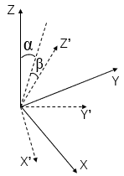

**Fig.9** Vertical direction and the control network coordinate system

From above it can be known, if the model of the geoid in the control network coordinate system is known, the approximations of  and  in (18) will be able to be calculated. When the geoid model is very accurate, the approximations can be used as reliable known values in the adjustment. As this paper uses simulated method to generate the measuring data, so the designed values of all  and used to transform the control network coordinate system to the measuring station S(S=1,2,3…) coordinate system are known. To improve the robustness of adjustment, test taking the designed values of  and as their known values into the adjustment calculation, and compare the results of the three-dimensional adjustment without horizontal offset constraint and the three-dimensional adjustment with horizontal offset constraint. Figure 10 shows the errors of the result calculated by the three-dimensional adjustment without horizontal offset constraint compared with the designed coordinates of the control network. From figure 10 it can be found, given the reliable known values of  and  can significantly improve the accuracy of the elevation coordinates of the adjustment results, but the X coordinates still have obvious error accumulation.



**Fig10** Result of three-dimensional adjustment without horizontal offset constraint,  and is known

Figure 11 shows the errors of the result calculated by the three-dimensional adjustment with horizontal offset constraint compared with the designed coordinates of the control network. The errors of *X Y Z* are almost all within -0.1mm to 0.1mm and no obvious error accumulation can be found.



**Fig11** Result of three-dimensional adjustment with horizontal offset constraint,  and is known

Compare figure 10 and figure 11, it can be found applying the three-dimensional adjustment with horizontal offset constraint can effectively inhibit the generation of error accumulation.

**4. Conclusion**

Using three-dimensional adjustment method to calculate laser tracker three-dimensional observations easy generate error accumulation, to inhibit the error accumulation can introduce the stretched wire into accelerator alignment measurement. Combine the stretched wire with laser tracker to carry out the measurement, it can give full play to the advantages of the high measuring accuracy of a laser tracker in a small range and the long-distance high accuracy relative position control of a stretched wire system. By carrying out a measurement in this way, it will provide a solution for how to control the error accumulation of the laser tracker move station measurement. The stretched wire will sag under the action of gravity, but its projection on the horizontal plane is a straight-line. Use the horizontal offsets from the measuring points to the stretched wire to construct the constraint equation, it will make the measuring stations have a unified straight-line datum in transforming the spatial position relationships beside the common points between adjacent stations. The horizontal offset from the measuring point to the stretched wire is not affected by the size of the whole measurement area, and does not generate error accumulation with the increasing of measurement range.

Simulation results show that adding the horizontal offset constraint to the three-dimensional adjustment will increase the instability, to make the adjustment stable, it needs to provide the reliable known values for parameters  and . When  and are known, the three-dimensional adjustment with horizontal offset constraint method can effectively control the error accumulation. For the widely used horizontal direction two-dimensional adjustment, as it uninvolved  and , so this method also suitable for the error accumulation control of the two-dimensional adjustment.

The surface control network and backbone control network can realize global and large range position control, the stretched wire can provide local relatively small range position control between the known control points, this from global to local multiple levels control strategy can provide a solution for improving alignment accuracy of the large accelerator complex.

**References**

1. G. Yinggang, L. Zongchun，L. Guangyun et al., Progress and Prospect of Engineering Control Network for Particle Accelerator[J]. Bulletin of Surveying and Mapping. 2020(01):136-141.DOI:10.13474/j.cnki.11-2246.2020.0029.

2. Dupont M, Missiaen D, Winkes P. THE LASER TRACKER: A MAJOR TOOL

FOR THE METROLOGY OF THE LHC[C]. IWAA2004, CERN, Geneva, 4-7 October

2004.

3. B. Zhipeng. Introduction to three-dimensional geodesy[J]. Journal of Geomatics, 1981, (Z1): 31−44.

4. G. Yinggang, L. Zongchun, Z. Wenbin, et al. Application of laser tracker three-dimensional traverse in measurement of accelerator control network[C]//The 6th National Symposium on Alignment Installation and Mechanical Design of Particle Accelerators. 2019

5. W. Tong, D. Lan, L. Tao, et al. The Surveying Scheme and Data Processing of the Primary Control Net for China Spallation Neutron Source[J]. Geospatial Information, 2016,14(11):55-57+9. DOI: 10.11884/HPLPB202133.210096

6. Yuan Jiandong. Summary of application of stretched wire technology in accelerator alignment and survey[J]. High Power Laser and Particle Beams, 2020,32(04):22-31.

7. Jean P Q, Hélène M D, Thomas T. Stretched wire offset measurements: 40 years of practice of this technique at CERN[C]//Proceedings of the 11th International Workshops on Accelerator Alignment. 2010, 11(2): 23-29.

8. Loffler F. Referencing the magnetic axis for HERA’s superconducting magnets[C]//Proceedings of the 1st International Workshops on Accelerator Alignment.1989, 1(3): 13-19.

9. Pan Zhengfeng. Precision measurement of the linac installation of Beijing Positron-Negative Collider[J]. Journal of Wuhan University of Surveying and Mapping Science and Technology, 1991, 16(1):13-18

10. Fuchs J F, Rude V, Duquenne M, et al. Validation of wire measurements in the LHC tunnel[C]//Proceedings of the 15th International Workshops on Accelerator

Alignment. 2018, 15(2): 24-29

11. Liska D, Daue1sberg L B, Spalek G, et al. Precision alignment of permanent magnet drift tubes[C]//Proceedings of the 1986 International Linac Conference. 1986, 12(2): 17-28.

12. Hélène M D, Bestmann P, Herty A, et al. oWPS versus cWPS[C]//Proceedings of the 12th International Workshops on Accelerator Alignment. 2012, 12(11): 71-79.

13. Dominique Missiaen. Recent developments for a photogrammetric system to measure offsets to stretched wires at CERN[C]// 15th International Workshop on Accelerator Alignment. 2018.

14. Hiroaki Kimura. Construction and alignment of test half-cell of SPring-8-II[C]// 15th International Workshop on Accelerator Alignment. 2018.

15. Jean-Frederic FUCHS - Engineering Specification - The smoothing of the LHC cryo-magnets, 2016, LHC-GES-0010

16. W. Xiaolong, K. Ling, D. Lan, et al. Study on accelerator alignment control network data processing error accumulation[J]. Nuclear Techniques, 2021,44(09):25-33.

17. Hyojin C, Sangbong L, Hong-Gi Lee, et al. 2D WPS system for measuring the location changes in real time of PAL-XFEL devices[J]. Journal of the Korean physical society, 2018, 73（8）: 1034-1041.

18. Y. Fan. Research on precise survey of high energy particle accelerator project[D]. Zhengzhou: PLA Information Engineering University, 2011

19. Y. Zhen. Study of high-precision positon & pose measurement technique based on laser tracker[D]. Zhengzhou: PLA Strategic Support Force Information Engineering University, 2018

20. L. Jing, D. Lan, L. Tao, et al. Precision statistics of laser tracker in BEPCII storage ring and calculation of mean square error of unit weight[J]. Science of Surveying and Mapping, 2013, 38(6): 182–184