# Executive Summary

# Introduction

# Machine Layout and Performance

# Operation Scenarios

# Collider

# Booster

# Linac, Damping Ring and Sources

## Main Parameters

## Linac and Damping Ring Accelerator Physics

### Linac Design – Optics and Beam Dynamics

### Damping Ring Design

The Linac system includes a Damping Ring (DR) with a small 1.1 GeV ring and two transport lines. The main purpose of the DR is to reduce the transverse emittance of the positron beam at the end of the Linac, which will lead to reduced beam loss in the Booster.

The Linac system operates at a repetition rate of 100 Hz, and a one-bunch-per-pulse scheme is used. However, for the high luminosity mode at the Z pole, a double-bunch scheme is also considered.

To generate the positron beam, a 4 GeV electron beam is directed at a tungsten target. The resulting positron beam is then captured by an AMD flux concentrator. Each positron bunch is injected into the damping ring every 10 ms, and two bunches are stored in the ring, resulting in a storage time of 20 ms for each bunch. An upgrade to increase the number of bunches in the ring to four would increase the storage time for each bunch to 40 ms.

The DR system is expected to reduce the normalized emittance of the positron beam from 2500 mm-mrad to 166 mm-mrad with 20 ms storage. If the storage time is increased to 40 ms with four bunches in the ring, the extracted normalized emittance will be 97 mm-mrad.

#### Parameters

The Damping Ring (DR) operates at an energy of 1.1 GeV and has a circumference of 147 m. The size of the DR was doubled after the CDR to achieve a lower emittance in the Linac and support the higher luminosity goal in TDR. The DR has a racetrack shape, and the arcs were designed with a 60-degree FODO cell and reversed bending magnets.

The injected emittance (normalized) for DR is 2500 mm-mrad, and the injected energy spread is smaller than 0.2%. The positron beam is stored in the DR for either 20 ms or 40 ms, depending on the 100 Hz repetition rate and the multi-bunch storage scheme. The extracted emittance is 166 mm-mrad for the horizontal plane and 75 mm-mrad for the vertical plane, which can be further reduced by storing more bunches.

To ensure injection efficiency, the transverse acceptance of the DR should be larger than five times the injection beam size. Table 6.2.2.1 summarizes the main parameters of the DR.

**Table 6.2.2.1:** Main Parameters of CEPC Damping Ring

|  |  |
| --- | --- |
|  | DR V3.0 |
| Energy (Gev) | 1.1 |
| Circumference (m) | 147 |
| Number of trains | 2 (4)* |
| Number of bunches/trian | 1 (2)# |
| Total current (mA) | 12.4 (24.8)* |
| Bending radius (m) | 2.87 |
| Dipole strength B0 (T) | 1.28 |
| U0 (keV/turn) | 94.6 |
| Damping time *τx*/*τy*/*τz* (ms) | 11.4/ 11.4/ 5.7 |
| Phase/cell (degree) | 60/60 |
| Momentum compaction | 0.013 |
| Storage time (ms) | 20 (40)* |
| Natural energy spread (%) | 0.056 |
| Norm. natural emittance (mm.mrad) | 94.4 |
| Inject bunch length (mm) | 4.4 |
| Extract bunch length (mm) | 4.4 |
| Norm. Inject emittance (mm.mrad) | 2500 |
| Norm. Extract emittancce *x*/*y* (mm.mrad) | 166(97)* / 75(3)* |
| Energy spread inj/ext (%) | 0.18 / 0.056 |
| Energy acceptance by RF (%) | 1.8 |
| *fRF* (MHz) | 650 |
| VRF (MV) | 2.5 |
| Longitudinal tune | 0.0387 |

* The numbers in parenthises refer to the case of 40 ms storage.

# The number in the parentheses is for the Linac double-bunch operation at Z pole.

#### Optics

For the DR arc, we have chosen a 60°/60° FODO cell and a reversed bending magnet scheme. The natural emittance of the ring is 44 nm. The DR twiss parameters of the arc cell can be seen in Fig. 6.2.2.1. The length of the FODO cell is 3 m, and the strength of the dipole magnets is 1.28 T.

We have adopted the reversed bending magnet scheme to increase synchrotron radiation damping and reduce the emittance. Each cell contains two dipoles with the same strength but different bending angles. The bending angle of the shorter dipole is less than the longer one, and the angle ratio of these two dipoles is 0.355.

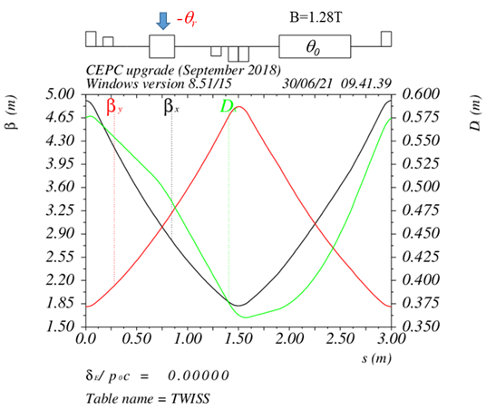

**Figure 6.2.2.1:** The DR twiss parameters for the arc FODO cell.

The dispersion suppressor has the function of canceling out the dispersion induced in the arc section and facilitating a smooth transition between the arc section and the straight section. The straight section is composed of the RF section and the injection/extraction section, where the septum and kicker will be inserted. The twiss parameters for the RF and injection/extraction section can be found in Fig. 6.2.2.2. To address the issue of injection efficiency, the horizontal beta function at the injection point has been designed to be larger than 9 m.

The twiss parameters for the entire ring can be seen in Fig. 6.2.2.3.

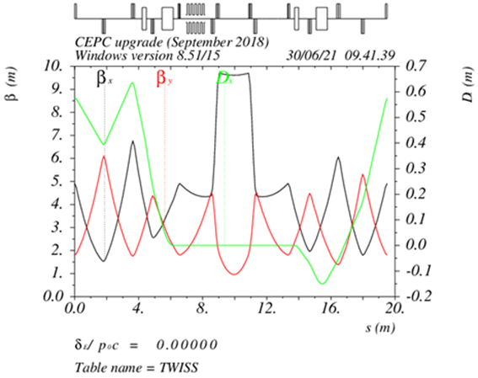

**Figure 6.2.2.2:** The DR twiss parameters for the RF and injection/extraction section.

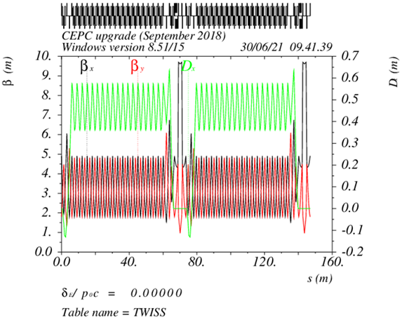

**Figure 6.2.2.3:** The DR twiss parameters for the entire ring.

In addition to the damping ring itself, there are two transport lines connecting the Linac and the DR. The layout of the Damping Ring system can be seen in Fig. 6.2.2.4.

On the transport line entering the DR, the energy spread of the positron bunch is reduced to match the RF acceptance of the Damping Ring. After passing through the DR, the longitudinal bunch size is reduced to minimize the energy spread during the following acceleration in the Linac.

The design of the transport lines can be found in Sec. 6.2.3.

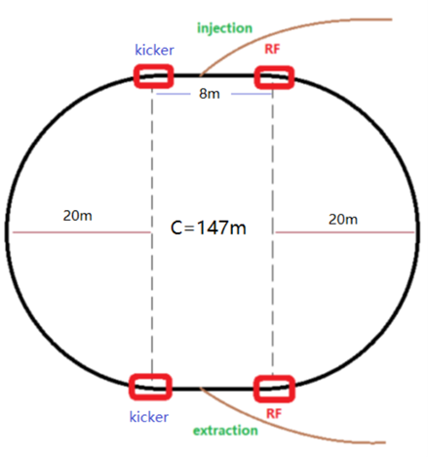

**Figure 6.2.2.4:** Layout of the Damping Ring system.

#### Dynamic Aperture and Error Study

For the linear chromaticity correction, we have adopted an interleave scheme and two sextupole families. The dynamic aperture of the Damping Ring has been tracked with 100,000 turns by SAD, and the results for the bare lattice can be seen in Fig. 6.2.2.5.

For the error study, the misalignment errors, magnet field errors and BPM errors are included. The error settings for the damping ring are listed in Table 6.2.2.2, Table 6.2.2.3 and Table 6.2.2.4. With only orbit correction, the residual errors for the closed orbit and optics distortion are tolerable (shown in Fig. 6.2.2.6 and Fig. 6.2.2.7). The dynamic aperture of the Damping Ring with errors and orbit correction is shown in Fig. 6.2.2.8.

**Table 6.2.2.2:** Error settings for the magnets.

|  |  |  |  |
| --- | --- | --- | --- |
| Parameters | Dipole | Quadrupole | Sextupole |
| Transverse shift X/Y (μm) | 100 | 100 | 100 |
| Longitudinal shift Z (μm) | 100 | 150 | 100 |
| Tilt about X/Y (mrad) | 0.2 | 0.2 | 0.2 |
| Tilt about Z (mrad) | 0.1 | 0.2 | 0.1 |
| Nominal field | 1×10-3 | 2×10-4 | 3×10-4 |

**Table 6.2.2.3:** BPM errors.

|  |  |
| --- | --- |
| Parameters | BPM (10 Hz) |
| Accuracy (m) | 1×10-7 |
| Tilt (mrad) | 10 |
| Gain | 5% |
| Offset after beam based alignment (BBA) (mm) | 30×10-3 |

**Table 6.2.2.4:** Multipole field errors (unit: 1×10-4).

|  |  |  |
| --- | --- | --- |
| Dipole | Quadrupole | Sextupoles |
| B1 ≤ 2 |  |  |
| B2 ≤ 3 | B2 ≤ 3 |  |
| B3 ≤ 0.2 | B3 ≤ 2 | B3 ≤ 10 |
| B4 ≤ 0.8 | B4 ≤ 1 | B4 ≤ 3 |
| B5 ≤ 0.2 | B5 ≤ 1 | B5 ≤ 10 |
| B6 ≤ 0.8 | B6 ≤ 0.5 | B6 ≤ 3 |
| B7 ≤ 0.2 | B7 ≤ 0.5 | B7 ≤ 10 |
| B8 ≤ 0.8 | B8 ≤ 0.5 | B8 ≤ 3 |
| B9 ≤ 0.2 | B9 ≤ 0.5 | B9 ≤ 10 |
| B10 ≤ 0.8 | B10 ≤ 0.5 | B10 ≤ 3 |

As we can see from Fig. 6.2.2.5 and Fig. 6.2.2.8, the dynamic aperture of the damping ring is sufficient to meet the injection requirements for the Damping Ring.

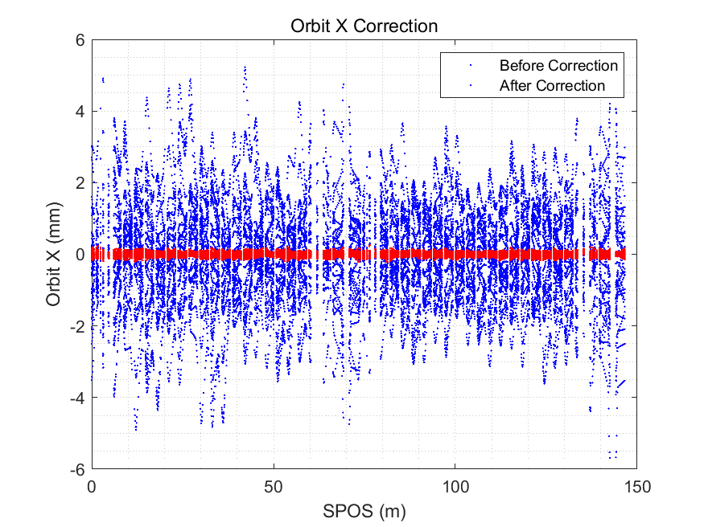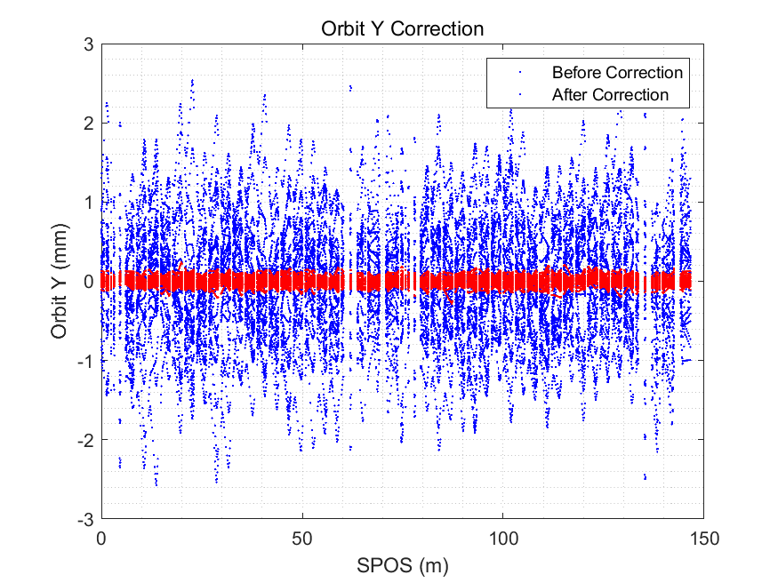

**Figure 6.2.2.6:** Damping Ring closed orbit before and after COD correction.

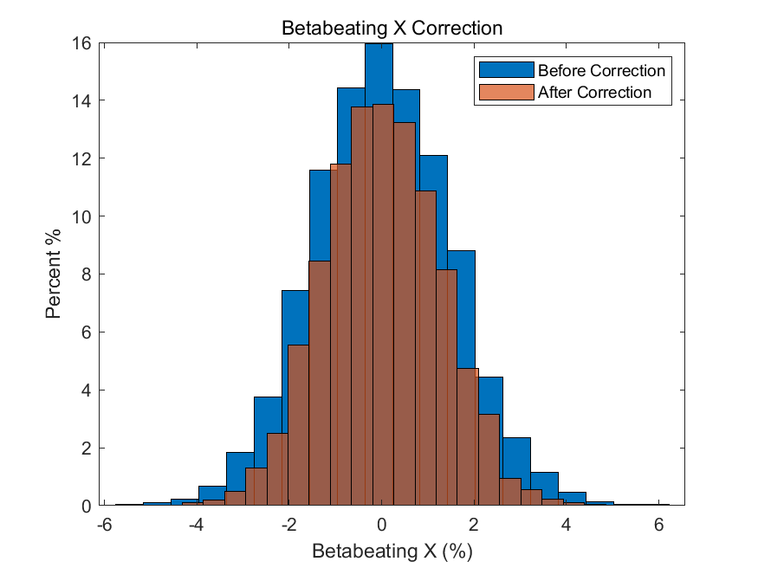 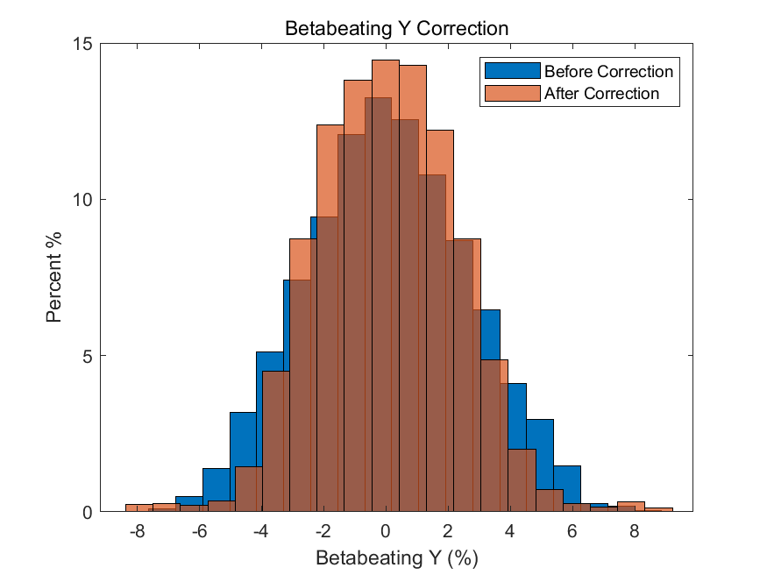

**Figure 6.2.2.7:** Damping Ring beta beating before and after COD correction.



**Figure 6.2.2.8:** Dynamic aperture of the Damping Ring with errors and orbit correction (*BSCx,y*=5*σinj_x,y*+5mm). ±1.5% energy deviation corresponds to ±8.3 times of injected energy spread.

#### Impedance and Beam Instability

To reduce the emittance of the positron beam from the S-band Linac, a damping ring (DR) with an energy of 1.1 GeV and a circumference of 147 m is installed between the S-band and C-band Linac. With lower stored beam currents and only 2-4 bunches being filled in the DR, a higher impedance threshold can be achieved. The impedance thresholds are estimated analytically using the same criterion as in Sec. 5.2.2.1, which provides a rough impedance requirement [1-3].

The threshold for microwave instability is estimated using either the Boussard or Keil-Schnell criteria, which implies that the limit on the effective broadband impedance is 55.75 mΩ. The transverse mode coupling instability (TMCI) sets a limit on the transverse impedance threshold of approximately 33.85 MΩ/m. Limitations on narrow band impedance can lead to coupled bunch instabilities. A conservative assumption is that the growth rate of the coupled bunch instability for equally spaced bunches should be less than the damping time, which can be expressed as:

. (6.2.2.1)

This sets the limit of the impedance at any resonance frequency of the higher-order-modes (HOMs) as follows:

(6.2.2.2)

Similarly, in the transverse case, this gives the following limit:

(6.2.2.3)

The impedance requirements for the DR are summarized in Table 6.2.2.5. The main sources of impedance come from vacuum chambers, RF cavities, BPMs, bellows, masks, ports of vacuum pumps, injection kickers, valves, and flanges. The components number in the damping ring can be estimated by scaling the circumference of the collider and booster, so the impedance budget for different components can be found in Table 6.2.2.6.

**Table 6.2.2.5:** Impedance threshold in the Damping Ring

|  |  |
| --- | --- |
| **Parameter** | **Value** |
| Broadband ZL | 55.75 mΩ |
| Broadband ZT | 33.85 MΩ/m |
| Narrowband ZL | 239.62 kΩ |
| Narrowband ZT | 2.36 GΩ/m |



**Table 6.2.2.6:** Impedance budget of different components in the Damping Ring

|  |  |  |
| --- | --- | --- |
| **Components** | **Z||/n** (mΩ) | **|Z⊥|** (MΩ/m) |
| Resistive wall | 30.70 | 18.94 |
| RF cavities | -4.95 | 0.50 |
| Flanges | 13.86 | 4.69 |
| BPMs | 0.59 | 0.50 |
| Bellows | 10.89 | 4.86 |
| Pumping ports | 0.10 | 1.01 |
| kickers | 0.60 | 2.52 |
| Taper transitions | 3.96 | 0.84 |
| Total | 55.75 | 33.85 |

The resistive wall impedance varies with different vacuum pipe radius. After comparing the impedance with stainless steel, copper, and aluminum, an aluminum chamber with an aperture of 30 mm has been chosen for the Damping Ring vacuum chamber. The dominant factor limiting the bunch current is the transverse mode coupling instability (TMCI) caused by the transverse resistive wall impedance [4], as shown in Fig. 6.2.2.9. However, for the Damping Ring, the resistive wall impedance is well below the instability threshold.

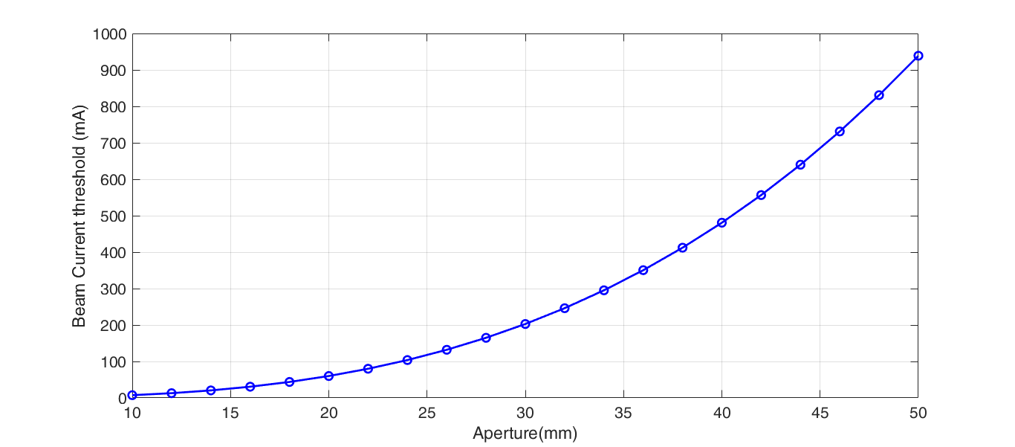

**Figure 6.2.2.9:** Beam current instability threshold *vs.* the beam pipe aperture of the DR.

#### References

1. R. D. Kohaupt, “Transverse Instabilities in PETRA”, DESY M-80/13.
2. D.V. Pestrikov, “Simple model with damping of the mode-coupling instability”, Vol. 373, Issue 2, 21 April 1996, P. 179-184.
3. V. Balbekov, “Transverse modes of a bunched beam with space charge dominated impedance”, *Phys. Rev. Accel. Beams*, 12, 124402 (2009).
4. L. Wang, K.L.F. Bane, T. Raubenheimer and M. Ross, “Resistive-wall Instability in the Damping Rings of the ILC”, Proceedings of EPAC 2006, 2964-2966.