Executive Summary

Introduction

Machine Layout and Performance

Operation Scenarios

Collider

Booster

Linac, Damping Ring and Sources

Main Parameters

Linac and Damping Ring Accelerator Physics

Linac Technical Systems

Electron Source

Positron Source

RF System

RF Power Source

Magnets

Magnet Power Supplies
(Warning! – The CEPC Linac would be the world’s second longest linac. Such a short section cannot meet the requirement of TDR, which is a construction-ready document.)

The total length of the Linac is about 1200meters. The length of bypass transport line is about 350 m.The Linac comprises 37 solenoids, 15 dipoles, 364 quadrupoles, and 275 correctors, all the magnets are excited by DC current. The layout of the Linac system can be seen in Fig. 6.3.6.1.
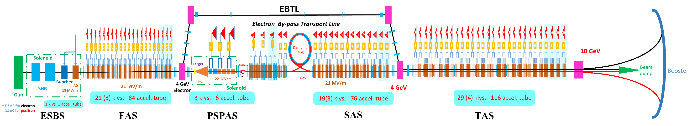
Figure 6.3.6.1: Layout of the Linac.

Types of Power Supplies
The solenoids of the Linac are classified into four families based on their apertures. SOL-I comprises four solenoids with an aperture of 90 mm, SOL-II has 17 solenoids with an aperture of 210 mm, SOL-III has one solenoid with an aperture of 90 mm, and SOL-IV has 15 solenoids with an aperture of 400 mm. All the solenoids are powered independently.

The Linac contains 15 dipole magnets that are classified into five families. AM1 has one, AM2/AM5 has two, AM3/CB1 has five, AM4/CB2 has four, and AM6/AM7 has three. Among them, AM3 and AM4 are powered in series, and other magnets are powered independently.

The Linac contains 364 quadrupole magnets that are classified into nine families. LA-24Q-300L has 104, LA-24Q-600L has 52, LA-34Q-100L has 20, LA-34Q-200L has 80, LA-34Q-400L has 45, LA-60Q-100L has 3, LA-60Q-200L has 6, LA-150Q-300L has 36, and LA-150Q-600L has 18. Among them, LA-24Q-300L, LA-34Q-100L, LA-34Q-200L LA-60Q-200L, and LA-150Q-300L are powered by two magnets in series, while other magnets are powered independently.

In the CEPC Linac, there are six types of correctors. C1 is a combination magnet consisting of two sets of horizontal and vertical coils that require two power supplies. Other magnets are powered independently.

So, there are 37 solenoid power supplies, 7 dipole power supplies, 342 quadrupole power supplies, and 276 corrector power supplies. All the solenoid, dipole and quadrupole power supplies are unipolar, and the corrector power supplies are bipolar. In order to reduce cable losses, the power supplies are installed along the Klystron gallery near the magnet load. The total power for the Linac power supply system is 1.81 MW. Table 6.3.6-1 presents the specifications of the main magnet and correction magnet power supplies for the Linac.

Because the magnet parameters will change in the future, we have not communicated with the magnet system to optimize the magnet parameters in order to reduce the types of power supplies.

Table 6.3.6.1: Magnet power supply requirements for the Linac
Magnet | Quantity | Stability /8hours | Output Rating
SOL-I | 4 | 100 ppm | 12A/10V
SOL-II | 17 | 100 ppm | 12A/110V
SOL-III | 1 | 100 ppm | 11A/30V
SOL-IV | 15 | 100 ppm | 350A/190V
AM1 | 1 | 100 ppm | 220A/11V
AM2/AM5 | 2 | 100 ppm | 280A/210V
AM3/CB1 | 5 | 100 ppm | 330A/250V
AM4/CB2 | 4 | 100 ppm | 230A/330V
AM6/AM7 | 3 | 100 ppm | 350A/190V
LA-24Q-300L | 104 | 100 ppm | 200A/13V
LA-24Q-600L | 52 | 100 ppm | 200A/13V
LA-34Q-100L | 20 | 100 ppm | 150A/6V
LA-34Q-200L | 80 | 100 ppm | 150A/6V
LA-34Q-400L | 45 | 100 ppm | 170A/10V
LA-60Q-100L | 3 | 100 ppm | 170A/10V
LA-60Q-200L | 6 | 100 ppm | 250A/55V
LA-150Q-300L | 36 | 100 ppm | 250A/45V
C1 | 1 | 300 ppm | ±3A/±1V
C2 | 2 | 300 ppm | ±3A/±1V
C3-H | 1 | 300 ppm | ±7A/±5V
C4-V | 1 | 300 ppm | ±7A/±5V
L100-150C | 25 | 300 ppm | ±11A/±2V
L100-35C | 100 | 300 ppm | ±11A/±2V
L200-30C | 146 | 300 ppm | ±33A/±5V
Total | 663

Design of the Power Supply System
The design criteria are the same as for the Collider supplies. The power supplies for the Linac are primarily DC supplies that use switched mode as the main topology. Each power supply is designed based on the specific parameters and ratings of the magnet, with a safety margin of 10-15% in both current and voltage. To facilitate easy maintenance and repair, all power supplies for the Linac are designed as modules and feature digital control.

The power supply of the Linac will adopt two structural frameworks based on Figure. 6.3.6.2 (a) and (b).

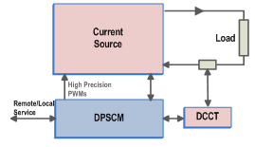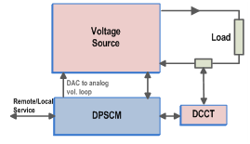
Figure 6.3.6.2: the structural frameworks of the Damping Ring power supply.
Fig. 6.3.6.2. (a) Adopting the all-digital + all-switch structure, the digital controller of the power supply realizes the digital adjustment and control of all control loops, and generates ultra-high precision PWM signal through the hardware (minimum variation is 150ps) to realize the ultra-high precision switching power supply.

Fig. 6.3.6.2. (b) Adopting the structure of partial digital + arbitrary topology, the power supply digital controller realizes the high-precision digital adjustment and control of the current closed-loop. The output of the current closed-loop control is passed through the digital-to-analog conversion (DAC) circuit, which serves as the reference of the voltage loop. The power part provides the voltage source, which can be any topology. This control mode not only gives play to the advantages of digital control, but also overcomes the dependence of digital control mode on topological structure and the limitation of digital PWM control precision.

Digital power supply control module design
The digital control module of power supply is the executive element to realize the digital control of power supply, and it is the key component to achieve high precision control.

The CEPC's power supply system will adopt the second generation of the digital power supply control module (DPSCM-II) will be utilized, which is developed for HEPS. The DPSCM-II will continue to use the overall architecture designed by the first generation of DPSCM, and take field-programmable gate array (FPGA) as the data processing core, and adopt the SOPC to realize the digital control of power supply. Figure 6.3.6-3 shows the block diagram of the power supply structure embedded in DPSCM-II.

Figure 6.3.6.3: Digital power block diagram embedded in DPSCM-II

The main hardware of DPSCM-II includes the main board DPSCM_MB, the high precision ADC control board DPSCM_AD, the digital-to-analog conversion between the digital current closed-loop and other analog control loops of the power supply DAC DPSCM_DA and the power supply monitoring interface circuit DSPCM_MDA composed of multi-channel DAC. The main board includes a number of interface circuits between the power supply and other systems, including the optical fiber interface of the remote control system, the optical fiber interface with the timing system, the control interface for the display of power supply parameters, the PWM synchronization signal with other power supply and the Man-machine interface for local debugging.
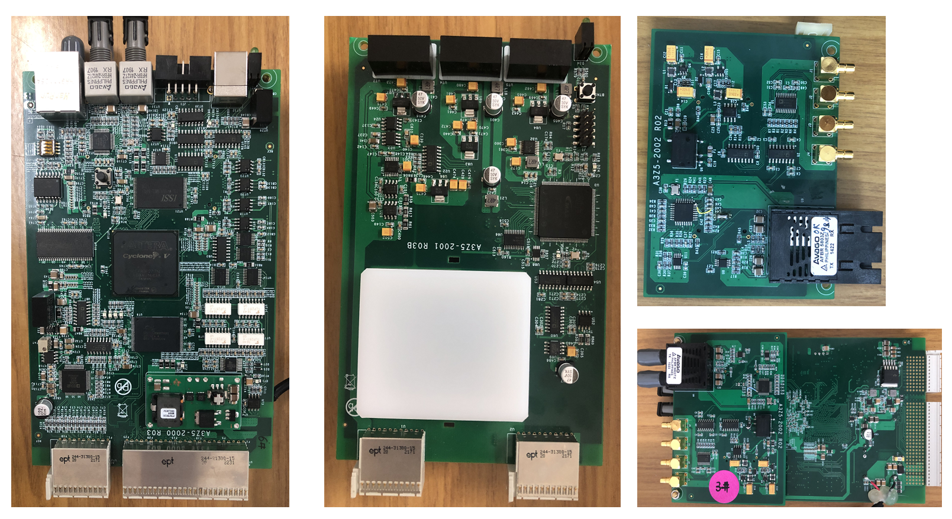
Figure 6.3.6.4: The main hardware of DPSCM-II

Topology of Power Supplies
The power supply design basically adopts DC source + Switched-mode. The DC source uses a multiplicative equivalent 12-pulse rectifier, which can reduce the harmonic current, to provide the front-end stable DC voltage. A buck or booster is implemented to control the input power fluctuations. The swithched-mode convertor realizes output current control.

The unipolar power supply will adopt modular design. Figure 6.3.6.4 displays the block diagram of two modules in parallel with 300A/50V output, which is developed for HEPS. This topology can increase the equivalent switching frequency through the multiple processing of PWM signal after the modular series and parallel. It can improve the response speed, simplified output filter design, and reduced switching loss. The modular structure can improve the production technology and maintainability.

The modular designe use PWM control to achieve constant frequency regulation, which optimizes filter design. Based on zero conversion converter technology, a "soft switching" PWM DC/DC full-bridge converter controlled by phase shift is designed. It uses the leakage inductance of the high-frequency transformer or primary-side inductance in series and the parasitic capacitance of the switching tube to realize zero-voltage switching of the switching tube. This converter is especially suitable for middle-power DC power supplies.

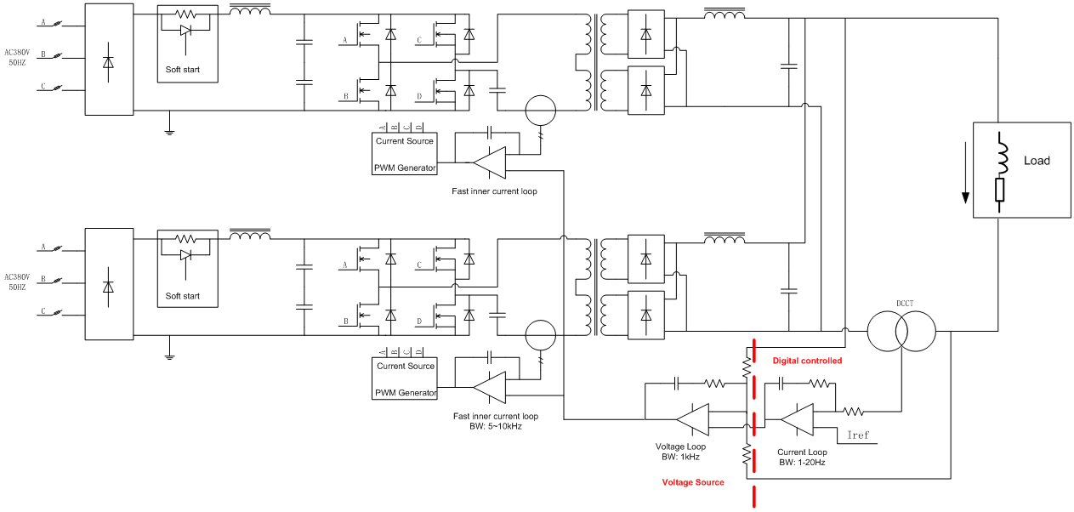
Figure 6.3.6.4: Structure diagram of double - module phase - shifted zero - voltage switching full - bridge converter.
The digital controller ensures stability and accuracy of the output current through analog sampling, AD conversion, algorithms and control parameters.

The CEPC corrector magnet power supply uses a two-stage control topology. The first stage is a DC voltage regulator that ensures a stable output DC voltage. The second stage is a bidirectional high-frequency H-bridge structure that has two functions: a) the output current can be positive or negative; b) The regulate loop adopts the current feedback mode, which can ensure the output current stability. The circuit of the topology consists of four high-frequency power switching tubes that form a full-bridge chopper circuit, and two diagonal bridge arm switching tubes are complementary each other to switch on and off. This topology can guarantee the accurate zero-point output and smooth positive and negative current commutation.
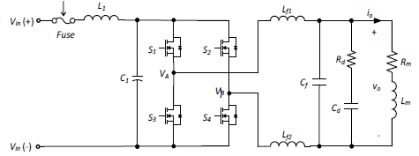
Figure 6.3.6.5: Structure diagram of bipolar power supply.

