Executive Summary

Introduction

Machine Layout and Performance

Operation Scenarios

Collider

Booster

Linac, Damping Ring and Sources

Main Parameters

Linac and Damping Ring Accelerator Physics

Linac Technical Systems

Damping Ring Technical Systems

RF System

RF Power Source

Magnets

Magnet Power Supplies
(Warning! – this section needs to be re-written. The numbers of magnets are all different from the magnet section 6.4.3. Talk to Kang Wen before you re-write. Also, this is too simple and csnnot meet the requirement of TDR, which is a construction-ready document.)
The Damping Ring (DR) operates at an energy of 1.1 GeV and has a circumference of 147m. Additionally, there are two transport lines connecting the Linac and the DR. The damping ring and transport lines comprise 86 dipoles, 130 quadrupoles, 72 sextupoles, and 275 correctors, all the magnets are excited by DC current. The layout of the Linac system can be seen in Fig. 6.3.6.1.The layout of the Damping Ring system can be seen in Fig. 6.4.4.1.

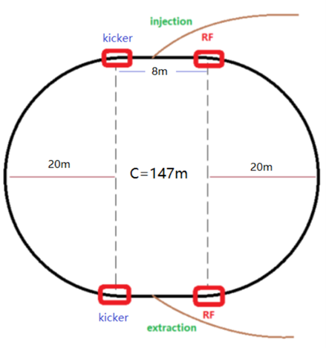
Figure 6.4.4.1: Layout of the Damping Ring system.

Types of Power Supplies
There are 80 dipole magnets in the Damping Ring (DR-38B0 and DR-38Br), and there are 6 dipole magnets for the DR transport line (LTD-44B). The DR-38B0 and DR-38Br are arranged into 8 families, each comprising 10 series-connected magnets that are powered by an individual power supply. The LTD-44B are arranged into 2 families, each comprising 3 series-connected magnets that are powered by an individual power supply.

The damping ring contains 104 quadrupole magnets that are classified into two families. DR-44Q has 96, DR-38Q has 8. And there are 26 quadrupole dipole magnets for the DR transport line (LTD-54Q). All the quadrupole magnets are powered independently.

There are 72 sextupole magnets in the Damping Ring (DR-38S). The DR-38S are arranged into 2 families, each comprising 36 series-connected magnets that are powered by an individual power supply.

There are 60 correctors in the Damping Ring (DR-40C). All the correctors are powered independently.

So, there are 10 dipole power supplies, 130 quadrupole power supplies, 2 sextupole power supplies and 60 corrector power supplies. All the dipole, quadrupole and sextupole power supplies are unipolar, and the corrector power supplies are bipolar.The total power for the DR power supply system is 0.65 MW. Table 6.4.4-1 presents the parameters of the main magnet and correction magnet power supplies for the damping ring.

Table 6.4.4.1: Magnet power supply requirements for the Damping Ring
Magnet | Quantity | Stability /8hours | Output Rating
DR-38B0 | 4 | 100 ppm | 460A/200V
DR-38B0 | 4 | 100 ppm | 460A/110V
LTD-44B | 2 | 100 ppm | 300A/80V
DR-44Q | 96 | 100 ppm | 180A/7V
DR-38Q | 8 | 100 ppm | 180A/7V
LTD-54Q | 26 | 100 ppm | 160A/14V
DR-38S | 2 | 100 ppm | 11A/23V
DR-40C | 60 | 300 ppm | ±11A/±3V
Total | 202

Design of the Power Supply System
The Damping Ring power supplies are DC. All the power supplies have a 10 ~ 15% safety margin in both current and voltage. All power supplies will be based on switching-mode topology with high efficiency, reduced size and weight, easy interface to digital controller, and higher order voltage ripple components with less influence on magnet current. For convenient maintenance and repair, all power supplies are module-based and digitally controlled.
The power supply of Damping Ring will adopt two structural frameworks based on Figure. 6.4.4.2 (a) and (b).

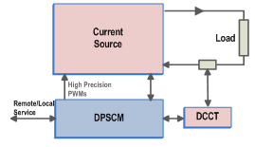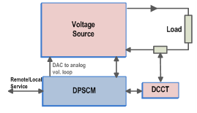
Figure 6.4.4.2: the structural frameworks of the Damping Ring power supply.
Fig. 6.4.4.2. (a) Adopting the all-digital + all-switch structure, the digital controller of the power supply realizes the digital adjustment and control of all control loops, and generates ultra-high precision PWM signal through the hardware (minimum variation is 150ps) to realize the ultra-high precision switching power supply.

Fig. 6.4.4.2. (b) Adopting the structure of partial digital + arbitrary topology, the power supply digital controller realizes the high-precision digital adjustment and control of the current closed-loop. The output of the current closed-loop control is passed through the digital-to-analog conversion (DAC) circuit, which serves as the reference of the voltage loop. The power part provides the voltage source, which can be any topology. This control mode not only gives play to the advantages of digital control, but also overcomes the dependence of digital control mode on topological structure and the limitation of digital PWM control precision.

Topology of Power Supplies
The power supply design basically adopts DC source + Switched-mode. The DC source uses a multiplicative equivalent 12-pulse rectifier, which can reduce the harmonic current, to provide the front-end stable DC voltage. A buck or booster is implemented to control the input power fluctuations. The swithched-mode convertor realizes output current control.

The modular design of the unipolar power supply as show in Figure 6.4.4.3. The module is split in three stages. First stage is a phase-shift parallel-connected PFC, which provide a stabale DC voltage. The second stage is designed using PWM control to achieve constant frequency regulation, which optimizes filter design. Based on zero conversion converter technology, a "soft switching" PWM DC/DC full-bridge converter controlled by phase shift is designed. It uses the leakage inductance of the high-frequency transformer or primary-side inductance in series and the parasitic capacitance of the switching tube to realize zero-voltage switching of the switching tube. Combining the advantages of resonant and PWM power supplies, this converter is especially suitable for middle-power DC power supplies. Output stage includes 2-Q chopper, LC filter to achieve the stability current.
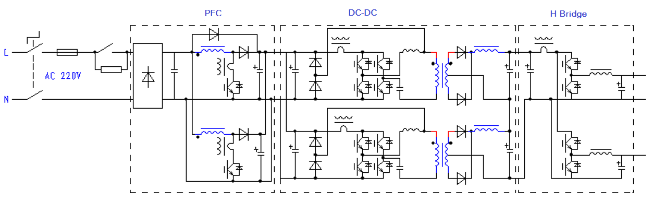
Figure 6.4.4.3: Structure diagram of unipolar power supply.
The CEPC corrector magnet power supply uses a two-stage control topology. The first stage is a DC voltage regulator that ensures a stable output DC voltage. The second stage is a bidirectional high-frequency H-bridge structure that has two functions: a) the output current can be positive or negative; b) The regulate loop adopts the current feedback mode, which can ensure the output current stability. The circuit of the topology consists of four high-frequency power switching tubes that form a full-bridge chopper circuit, and two diagonal bridge arm switching tubes are complementary each other to switch on and off. This topology can guarantee the accurate zero-point output and smooth positive and negative current commutation.
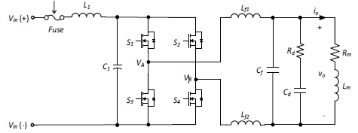
Figure 6.4.4.4: Structure diagram of bipolar power supply.

