Executive Summary

Introduction

Machine Layout and Performance

Operation Scenarios

Collider

Booster

Linac, Damping Ring and Sources

Main Parameters

Linac and Damping Ring Accelerator Physics

Linac Technical Systems

Electron Source

Positron Source

RF System

RF Power Source

Magnets

Magnet Power Supplies

Vacuum System

Diagnostics and Instrumentation

Control System

Mechanical Systems
(Warning! – The CEPC Linac would be the world’s second longest linac. Such a short section cannot meet the requirement of TDR, which is a construction-ready document.)

The mechanical system supports the Linac's various devices, including the bunching system, accelerator structures, magnets, vacuum system components, and BPMs. A list of this information is shown in Table 6.3.10.1.
Table 6.3.10.1: Mechanical supports in the Linac
Supports | Quantity (set) | Remarks
Bunching system support | 1 | Supports of subharmonic buncher, buncher, accelerating structure, solenoid and instruments
EBTL support | 2
Positron accelerating structure support | 1 | Supports of positron source, solenoid, accelerating structure and positron acceleration section
Triple support unit | 101 | Support of the quadruples, correctors and instruments in the triple unit
Dipole support | 19 | Supports of 6 kinds of dipoles
Accelerating structure support | 579 | Supports of S band and C band accelerating structures
Vacuum device support | 7125 | Supports of vacuum chambers, valves and ion pumps
BPM support | 260

The supports for the Linac devices are fixed to the ground. There are many types of Linac devices which have small batch size, so flexible steel frames are adopted at the bottom instead of the concrete-steel pedestals similar to those in Collider. The adjusting mechanisms are designed above the steel frame pedestals for the position adjustment and alignment similar to that used in the Collider. The requirements for the support structure are also outlined in Section 4.3.10.
Figure 6.3.10.1 shows the bunching system support. The bunching system consists two subharmonic bunchers, one buncher, one accelerating structure, twenty-two solenoids and related instruments. The total length is about 5.82 meters. Similar to the bunching system and its support of HEPS, the buncher system of CEPC are divided into three groups. Each group has a common steel frame pedestal mounted to the ground and a common girder for integral adjusting. There are two guide rails on the top of the girder for longitudinal movement during assymbing. Besides, each element can be adjusted individually. For each element and the girders, they are adjusted by screws in vertical direction and push-pull bolts in horizontal direction.

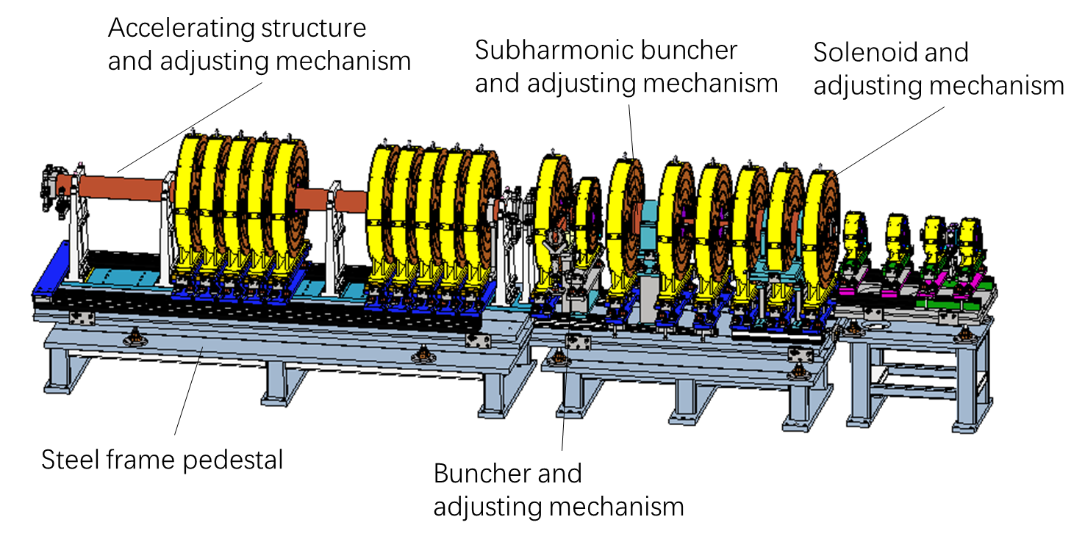

Figure 6.3.10.1: Support of bunching system
Figure 6.3.10.2 illustrates the support structure for an S-band accelerating structure. The accelerating tube itself has several vertical supports to increase the stiffness. Then the assembly is supported by a steel frame pedestal mounted to the ground with two adjusting mechanisms on it.

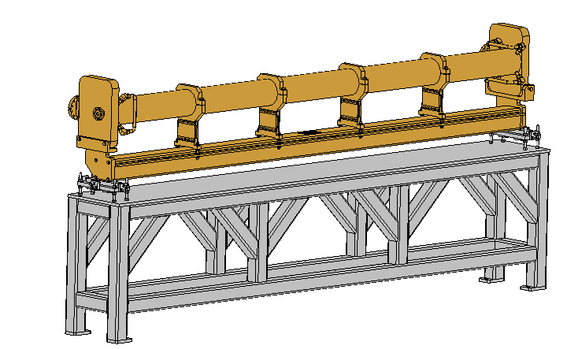
Figure 6.3.10.2: Support of S-band accelerating structure.
Each triplet unit consists three quadrupoles, two correctors and relative instruments. There are three types of triple units, with the apertures of 35 mm, 30 mm, and 24 mm. The unit lengths are 1.6 meters, 2 meters and 3.1 meters, respectively. Similar to the design of HEPS, each triplet unit has a common steel frame pedestal mounted to the ground with several adjusting mechanisms on it. Each element can be adjusted individually, by screws in vertical direction and push-pull bolts in horizontal direction. Figure 6.3.10.3 is the support of triplet 1.6 meters long.

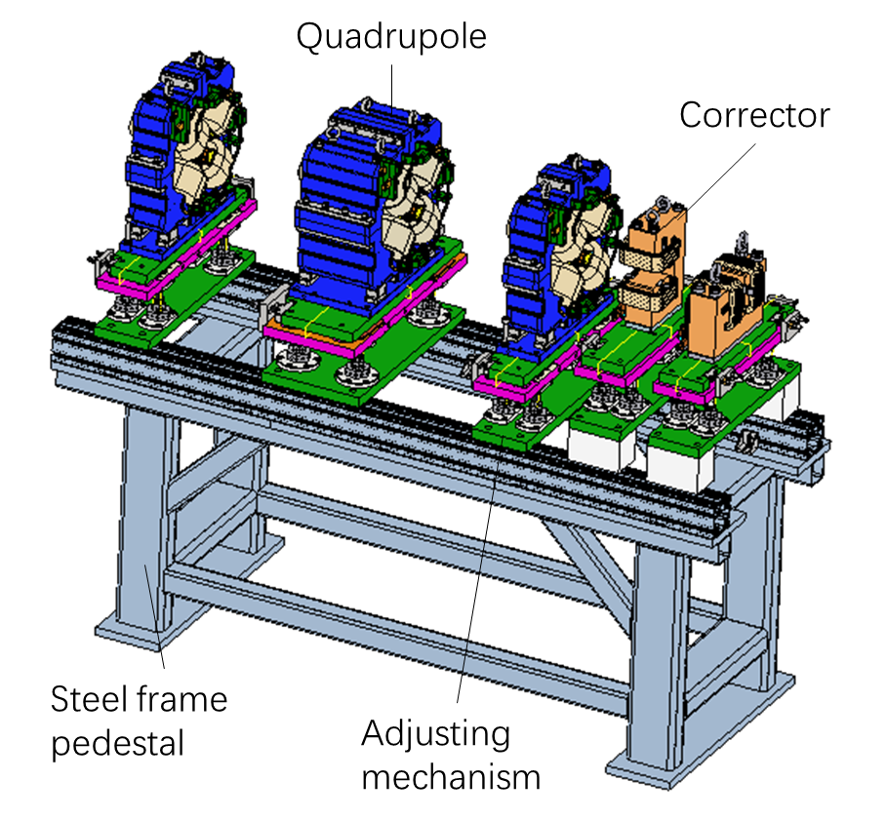

Figure 6.3.10.3: Support of 1.6m-long triplet.

Unlike the Collider and Booster, which are situated deep underground in tunnels, the Linac tunnel is located close to the ground. The beam is 1.2 meters from the tunel ground. For the preliminary design, the Linac gallery is situated above the Linac tunnel, as illustrated in Figure 6.3.10.4. The tunnel has a width of 3.5 meters, and at the bypass location, the width is increased to 5.5 meters.
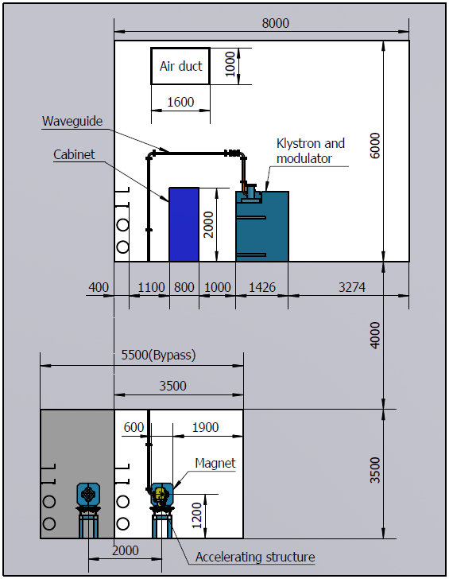
Figure 6.3.10.4: Cross section of the Linac and its gallery.

