Executive Summary

Introduction

Machine Layout and Performance

Operation Scenarios

Collider

Booster

Linac, Damping Ring and Sources

Main Parameters

Linac and Damping Ring Accelerator Physics

Linac Technical Systems

Damping Ring Technical Systems

RF System

RF Power Source

Magnets

Magnet Power Supplies

Vacuum System

Instrumentation

Injection and Extraction System

Control System

Mechanical Systems

(Warning! – this section is too simple and cannot meet the requirement of TDR, which is a construction-ready document.)

The mechanical system provides support for the devices in the Damping Ring (DR), as listed in Table 6.4.9.1. The supports are fixed to the ground. Steel frame pedestals are adopted at the bottom with adjusting mechanisms on it, similar to those in the Linac. The beam has the same height as Linac, which is 1.2 meters from the tunel ground. The requirements for the support structure are also outlined in Section 4.3.10. (Error! – the numbers of magnets do not seem correct. Check with Kang Wen.)
Table 6.4.9.1: Supports in the Damping Ring
Supports | Quantity (set) | Remarks
Quadrupole & sextuple support | 72 | Common girder for one quadrupole and one sextuple
Quadrupole support | 32 | Supports of 2 kinds of quadrupoles
Dipole support | 80 | Supports of 2 kinds of dipoles
Lambertson support | 2
Kicker support | 2

There are 36 FODO cells in the arc of Damping Ring, with two dipoles, two quadrupoles and two sextupoles. Each Dipole is supported individually. While the adjacent quadrupole and sextupole are supported together, as shown in Figure 6.4.9.1. The thirty-two quadrupoles and eight dipoles in the RF of Damping Ring are supported separately as the distance between each other is relatively long. There are also two Lambertson and two kickers, all of them are supported separately.
Figure 6.4.9.1: Support method of FODO cell
Figure 6.4.9.2 shows the support of adjacent quadrupole and sextupole. The common steel frame pedestal is mounted to the ground. The magnets are adjusted individually, by screws in vertical direction and push-pull bolts in horizontal direction. Figure 6.4.9.3 shows the support of the quadrupole in RF section. It has a similar structure but only one magnet to be supported. Figure 6.4.9.4 shows the support of the dipole with the length of 700 mm, also has a similar support structure.
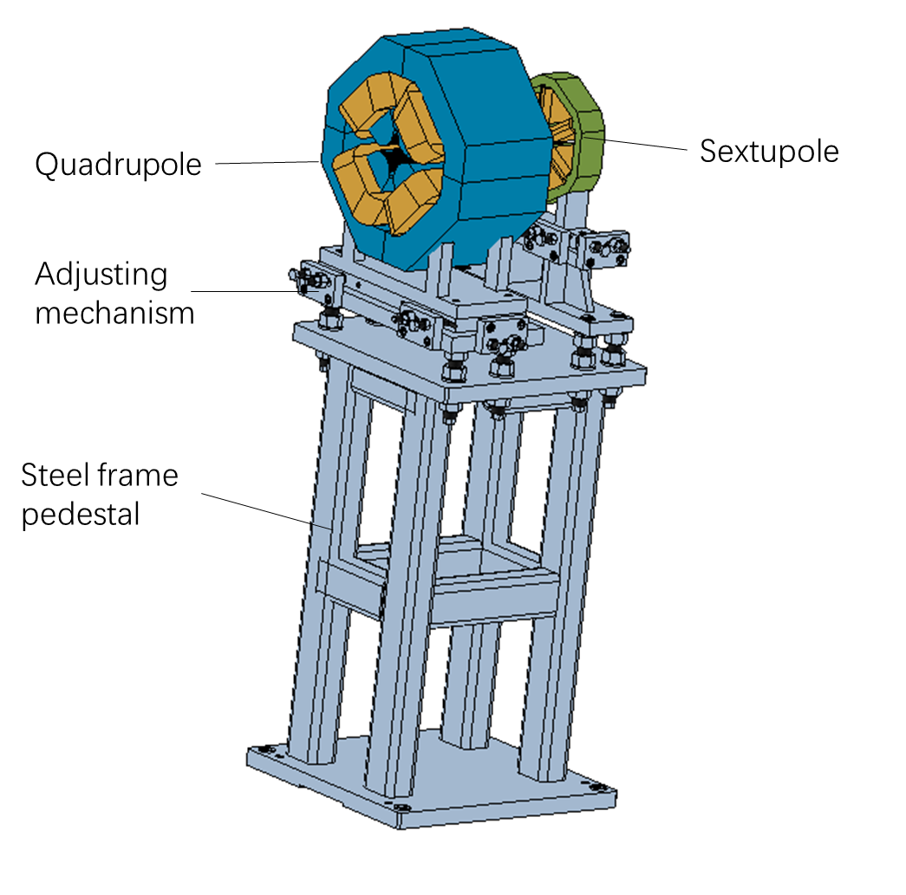
Figure 6.4.9.2: Support of adjcent quadrupole and sextupole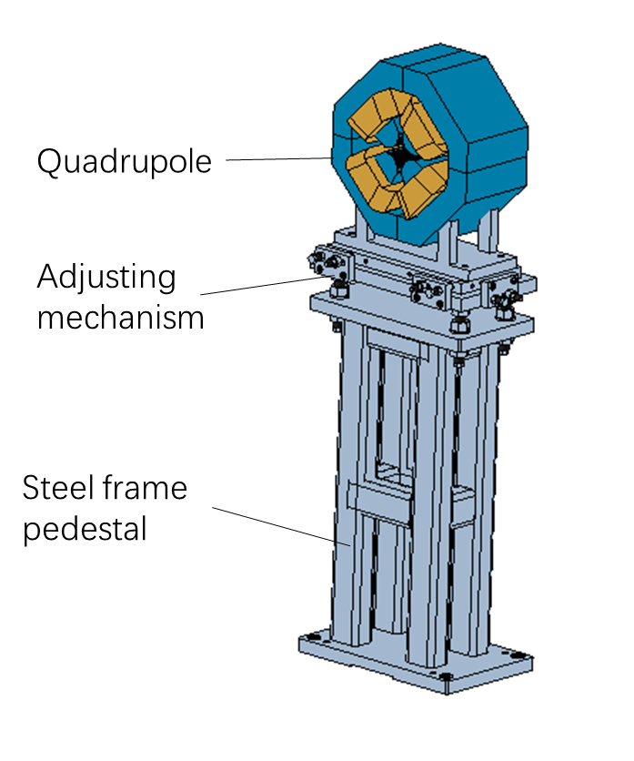
Figure 6.4.9.3: Individual support of quadrupole magnet
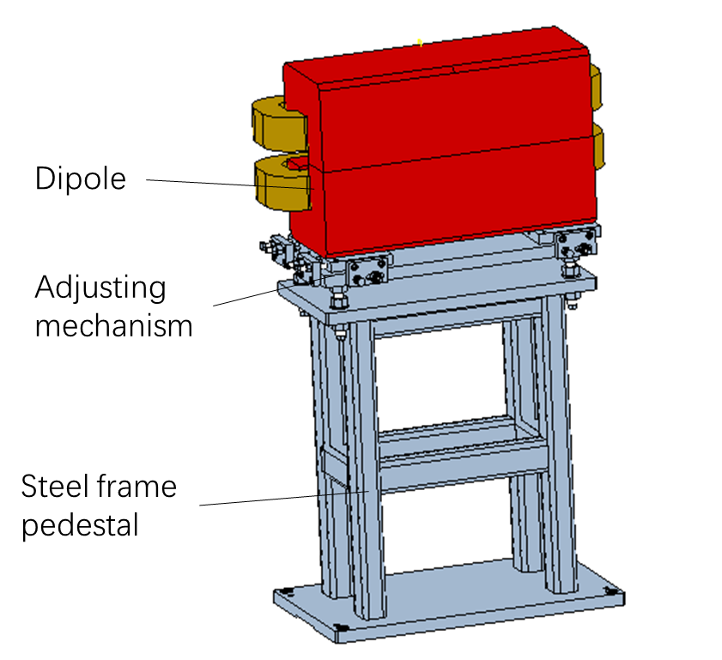
Figure 6.4.9.4: Individual support of dipole magnet

