Executive Summary

Introduction

Machine Layout and Performance

Operation Scenarios

Collider

Booster

Linac, Damping Ring and Sources

Main Parameters

Linac and Damping Ring Accelerator Physics

Linac Technical Systems

Electron Source

Positron Source

RF System

RF Power Source

Magnets

Magnet Power Supplies

Vacuum System

Diagnostics and Instrumentation

Introduction
The required instrumentation for the Linac includes beam position monitors, beam profile monitors, and beam current monitors. It is important to note that there are significant differences in the diagnostic signals between electrons and positrons, so the instruments that work well for positrons may be saturated with electrons.
To measure beam positions and angles and determine the beam trajectory, a stripline BPM will be utilized. Additionally, measuring the beam profile can provide information on beam emittance, energy, and energy spread. The integrated charge detectors (ICT) will be used to measure the bunch charge, and the beam diagnostics system will have sufficient dynamic range to accommodate the minimum to maximum single-shot bunch charge.
Table 6.3.8.1 outlines the type, quantity, and function of linear beam detectors required for this project.
Table 6.3.8.1: Instrumentation for the Linac.
Sub-system | Method | Parameter | Amounts
Beam position monitor | Stripline BPM | Resolution: 10 µm | 150
Beam current monitor | ICT | 2.5% @ 1 nC–10 nC | 63
Beam profile measurement | YAG/OTR | Resolution: 30 µm | 30

Beam Position Measurement
There are a total of 150 stripline BPMs in the Linac and its transport lines, which are divided into two groups based on the size of the beam-stay-clear area [1]. The first group of BPMs has a beam-stay-clear area with a diameter of 30 mm, while the second group has a diameter of 20 mm.
Figure 6.3.8.1 displays the primary mechanical parameters of the stripline BPM, including the coverage angle α, distance h between the strip and pipe, strip thickness t, inner radius r_{in}, and longitudinal length L_{strip}. The inner radius of the stripline has been designed to be equal to the radius of the beam-stay-clear area.
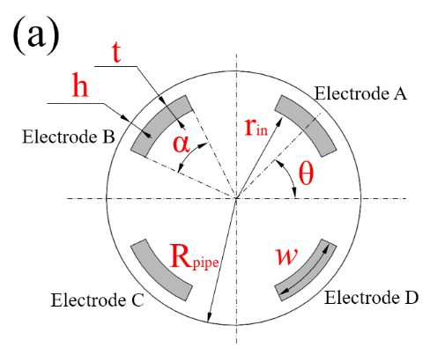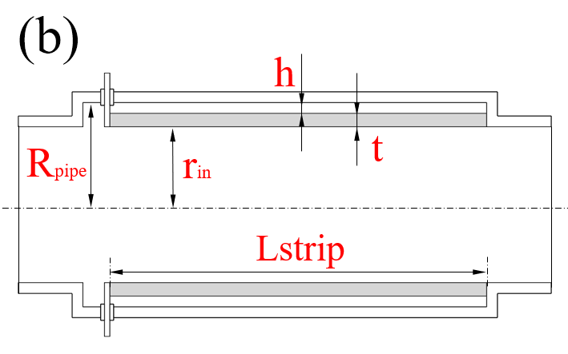
Figure 6.3.8.1: Schematic of a stripline BPM: (a) Front view; (b) Side view.
The feedthroughs and coaxial cable used in this design have a characteristic impedance of 50 Ω. To minimize signal reflection, the impedance of the strip electrode was also designed to be 50 Ω. Electromagnetic simulation software such as CST is often utilized to compute the impedance of the stripline [2]. In addition to using simulation software, relevant formulas can also be applied in stripline design.
The characteristic impedance of a single stripline can be calculated using the following formula [3]:
${\text{Z}}_{\text{single}}\text{ = 60}\frac{\text{2}\text{π}}{\text{φ}}\text{ln}{\frac{{\text{r}}_{\text{in}}\text{ + h + t}}{{\text{r}}_{\text{in}}\text{ + t}}}, \text{φ=}\frac{\text{w}}{{\text{r}}_{\text{in}}}\text{+}\frac{\text{2}\text{πh}}{\text{2×(}{\text{r}}_{\text{in}}\text{ + h + t) - h}}\text{,}\text{ w = α }\text{× (}{\text{r}}_{\text{in}}\text{+}\frac{\text{1}}{\text{2}}\text{t}\text{)}$ (6.3.8.1)
Table 6.3.8.1 presents the preliminary design parameters of the Linac. However, further optimization is currently underway due to the fact that the distance h in the Linac-2 is only 0.6 mm to meet the requirement for an impedance equal to 50 Ω.
Table 6.3.8.1: Mechanical parameters of the Linac stripline BPM.
Location | r_{in} | t | h | α | θ* | Z_{single} | L_{strip} | Z_{CST}
 | mm | mm | mm | degree | degree | Ω | mm | Ω
ESBS/EBTL/FAS/PSPAS/SAS | 15 | 1.5 | 2.2 | 30 | 0 | 50.8 | 150 | 50.3±0.5
TAS | 10 | 1.5 | 0.6 | 30 | 0 | 49.9 | 150 | 50.4±0.5
* The angle between adjacent electrodes is 90°, the four strips are located at 45°, 135°, 225° and 315°, respectively.

The same beam position monitor electronics utilized in the Collider will be used for the Linac, and further details can be found in Chapter 4, Section 4.3.7.2. The algorithm developed for the Collider will also be adopted for the linac beam.

Beam Current Measurement
Due to the variability of the pulsed beam length (FWHM) ranging from picoseconds to nanoseconds along the Linac in accordance with the physics design, traditional Beam Current Transformers are not suitable due to their bandwidth limitations and bunch length dependency [4]. Instead, an Integrated Charge Transformer (ICT) is selected to measure beam current, as it is non-intercepting and insensitive to bunch length. Bergoz Instrumentation [5] offers an In-Flange ICT sensor, which has a compact structure and shielding and can be directly mounted in the beam line.
In total, there are 42 ICTs installed in the Linac to monitor beam intensity and calculate transmission efficiency. An in-house signal processing electronics system is designed to adjust the signal from the ICT, performing the functions of filtering and amplification. This regulated signal will reduce the sample rate and dynamic range requirements of the data acquisition system. Through post-level electronic system processing, the bunch charge can be accurately calculated. Figure 6.3.8.2 shows the In-Flange ICT sensor from Bergoz.

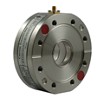
Figure 6.3.8.2: In-Flange ICT sensor from Bergoz.
The sensitivity of the ICT sensor must take into account the attenuation caused by the transmission cable to ensure accurate measurement results. For this reason, an on-line functional examination and re-calibration can be carried out using the Cali-winding within the sensor.

Beam Profile Measurement
The beam profile monitor will be a crucial diagnostic tool during the commissioning of CEPC experiments. The most commonly used method for determining the transverse beam profile is based on the interaction of beam particles with a fluorescent screen. When the beam particles interact with the screen, a portion of the deposited energy results in excited electronic states, which partially de-excite via light emission. Therefore, the beam profile can be observed using a CCD camera [6]. In the CEPC Linac, YAG/OTR screens will be used as the beam profile monitors in the straight sections.

Mechanical Detector
Our beam profile monitors typically consist of a screen, an insertion mechanism, an illumination system, and a video camera for detection, as shown in Fig. 6.3.8.3. The screen is installed at a 45° angle to the beam, while the camera is positioned at a 90° angle. This setup is advantageous because it minimizes the longitudinal space required for the monitor, and a round beam will appear round in the image.
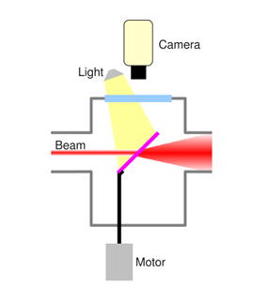
Figure 6.3.8.3: Schematic of a scintillating screen monitor.

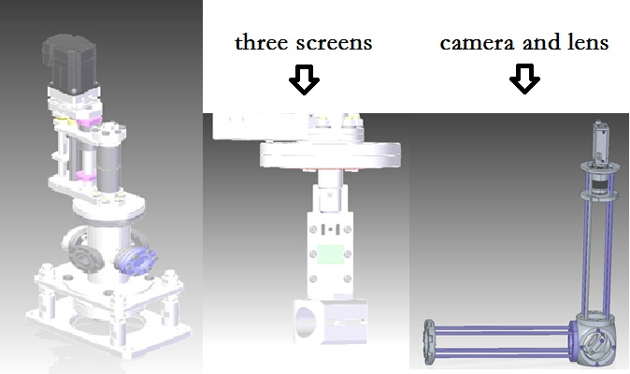
Figure 6.3.8.4: Design of the mechanical detector.
The beam profile monitor is designed with three position screens for testing, as shown in Figure 6.3.8.4. During initial commissioning and low beam charge situations, a YAG:Ce crystal plate is used. For high beam charge situations, another screen made of 100 nm aluminum deposited on a polished silicon wafer is used to generate optical transition radiation (OTR) when electrons hit it [7]. This is because OTR represents a linear radiation source, while YAG screens have saturation problems. The last screen is the calibration screen, used to calibrate the optical relay and CCD image acquisition system. The beam image can be obtained from the backside viewport, and the camera is located 1 meter below the beam pipe through a planar-mirror optical relay to reduce radiation damage.

Mover Controlling System
We have selected a new type of motor for the HEPS beam profile monitor design, specifically the SSM24Q-3RG produced in China. An overview of the integrated step servo motor is shown in Figure 6.3.8.5.
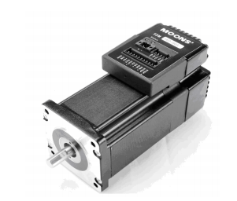
Figure 6.3.8.5: Integrated step-servo motor.
Calibration marks on the screen are essential in identifying errors and developing correction algorithms. They can improve the accuracy of the beam profile measurements and help maintain the performance of the beam profile monitor over time.
The high stiffness of the stepper motor, combined with the responsive servo control and 5000-line high-resolution encoder, results in smooth and quiet operation, especially at low speeds. The SSM24Q motor integrates the motor, driver, controller, encoder, and IO, making the mover controlling system very concise. The motor can start working with just DC 24V and DC 48V and RS485 bus. The output torque of 2.4 N-m allows the motor to quickly pull the screen out of the beam line without the need for a deceleration mechanism. The mover works smoothly and stably with low noise to prevent the screen from stopping the beam line [8].

Optical Set-up
The optical system used to capture the YAG/OTR light onto the CCD camera consists of a mirror that deflects the OTR light downwards, a focusing lens, and a CCD camera. These components will be mounted on two rails on a stainless-steel plate, which will be fixed to the machine's support structure. The optical system is protected from stray light, and the CCD camera is shielded with lead to reduce radiation damage. The camera chosen for this purpose is a digital CCD camera (HIKVISION CE-50GM, as shown in Fig. 6.3.8.6) with an Ethernet interface. The camera sensor size is 1280 × 960 pixels, with a pixel dimension of 4.65 µm × 4.65 µm.
The GigE Vision camera was chosen for the image acquisition subsystem due to two main advantages. Firstly, digital signals can be transmitted more reliably than analog signals over long distances. Secondly, the gain parameter of the GigE CCD camera can be remotely adjusted according to the beam intensity during beam commissioning. The HIKVISION CE-50GM CCD cameras were selected as the primary devices for image acquisition. With a 1:1 lens, the system can achieve a spatial resolution of 10 microns. External trigger mode is crucial for the system since capturing the beam images must synchronize with the timing signal of the entire system.

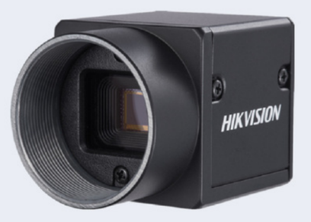
Figure 6.3.8.6: HIKVISION CE-50GM CCD camera.

Control System
The control system of the beam profile monitors is designed to be simple and flexible, using two separate field buses. The first is an industrial Ethernet bus used for communication between the control room and cameras, while the second is a 485 serial bus used for communication between the control room and the integrated step-servo motor (as shown in Figure 6.3.8.7). The control system software for the beam profile monitors is based on EPICS, allowing each control system to be designed as a standard software IOC. This design provides greater flexibility for system integration and control, and ensures compatibility with other EPICS-based systems.
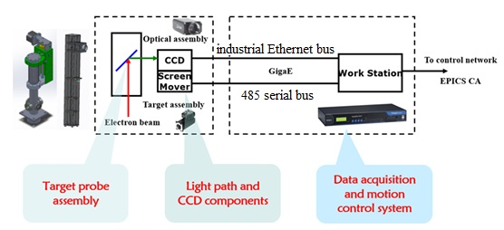
Figure 6.3.8.7: The beam profile monitor control system.

Beam Energy and Energy Spread
Beam energy and energy spread can be measured by deflecting the beam with a dipole and using the spot position and size on a fluorescent screen. The measurement are based on the beam profile measurement.

Beam Emittance
Beam emittance is measured using an upstream quadrupole and observing the changes in the beam profile as a function of quadrupole strength (Q-scan).

References
- H. Wiedemann, Particle Accelerator Physics. Fourth Edition, Chapter 11.4.4 (2016). Springer, Cham.
- CST Studio Suite®, Version 2017, CST AG, Darmstadt, Germany.
- C. Zhang and L. Ma, Design and development of BEPCII (2015, Published in Chinese), Shanghai Scientific & Technical Publishers, Ch. 2. Page 132.
- D. Belohrad, M. Krupa, L. Søby, J. Bergoz, F. Stulle. “A New Integrating Current Transformer for the LHC.” Proceedings of IBIC2014, Monterey, CA, USA
- https://www.bergoz.com/

