Executive Summary

Introduction

Machine Layout and Performance

Operation Scenarios

Collider

Booster

Linac, Damping Ring and Sources

Main Parameters

Linac and Damping Ring Accelerator Physics

Linac Technical Systems

Damping Ring Technical Systems

RF System

RF Power Source

Magnets

Magnet Power Supplies

Vacuum System

Instrumentation

The damping ring (DR) is a 1.1 GeV ring with a circumference of 147m. A beam instrumentation system is necessary to diagnose various beam properties. Three major beam parameters must be measured: beam position, beam current, and beam tune factor. These correspond to the beam position monitors, beam current monitors, and tune measurement, respectively. For position measurement, a button-type BPM will be used. For damping ring current, a DC current transformer will be utilized. And for betatron tune measurement, the Direct Diode Detector method will be adopted.
Table 6.4.6.1: Parameters of the damping ring beam instrumentation systems
Item | Method | Parameter | Amounts
Average current | DCCT | Resolution :50uA@0.1mA-30mA | 1
Beam position | Button BPM | Resolution : 20um @ 5mA TBT | 40
Tune | Direct Diode Detection method | Resolution:0.001 | 1

the damping ring beam instrumentation system includes 40 beam position monitors (BPMs), 1 DC current transformer, and 1 tune measurement. The design of the beam current measurement and tune monitor is almost identical to that of the Collider, as described in Section 4.3.7.

Beam position monitor
Beam position monitor (BPM) is an indispensable key system of modern accelerator. It can not only measure beam position and monitor beam orbit, but also be used to calculate other important physical parameters. The beam position monitor is including pick ups, cables and signal processing electronics. The pick ups are button type and its diameter is the same as that of Collider. Due to the different beam pipe size, The characteristic of the beam position monitor pick-ups differs from that in the Collider slightly.
The transfer impedance and signal power for a current of 100 mA are shown in Table 6.4.6.2. The electronics of the BPM are also designed the same as those in the Collider.

Table 6.4.6.2: Parameters of the damping ring button- type BPMs
 | Transfer impedance | Signal power  (I=100 mA) | Sensitivity  (in the pipe center)
Collider (b = 28 mm) | 0.093 Ω | –30.6 dBm | 19.82 mm
Booster (b = 27.5 mm) | 0.095 Ω | –30.4 dBm | 19.46 mm
Damping ring (b = 15mm) | 0.169 Ω | –25.3 dBm | 10.68 mm
The basic hardware structure and function block diagram of digital BPM electronics is shown in figure 6.4.6.1. It is mainly composed of two parts, one is Analog Frontend Electronics (AFE), which mainly implements amplitude adjustment, frequency filtering, clock reception and processing and ADC sampling of analog signals. The other part is Digital Front-end Electronics (DFE), which mainly completes the data processing and data transmission functions of AFE data reception and digital BPM algorithm, and the algorithm logic is implemented in the FPGA of DFE circuit.
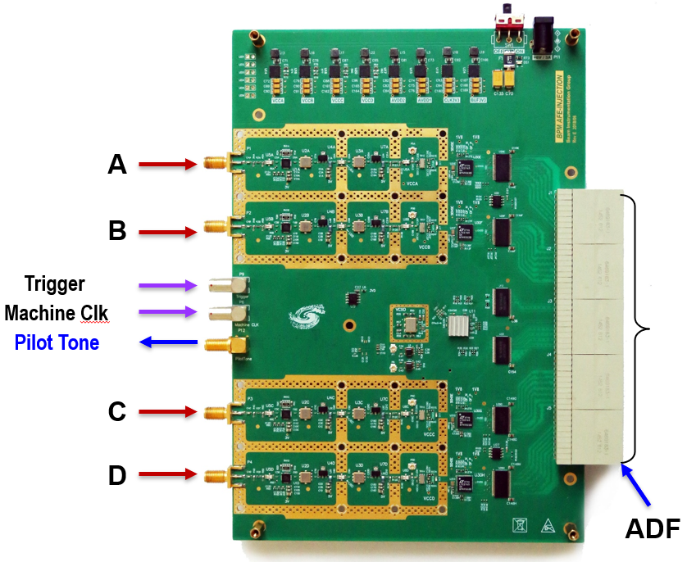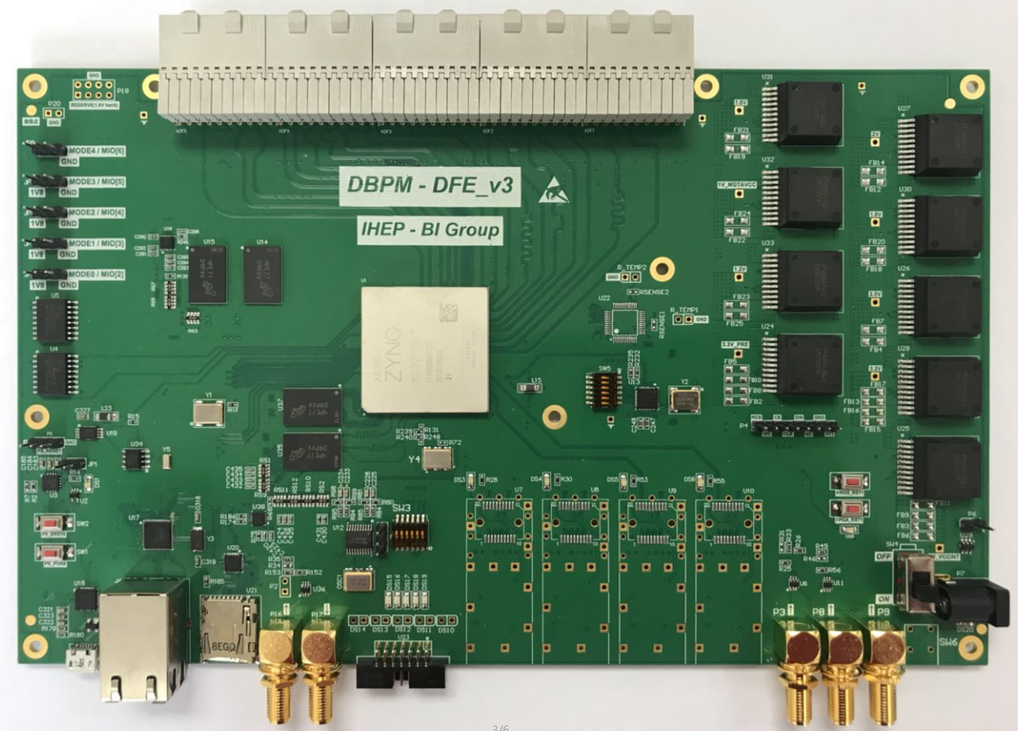
Fig. 6.4.6.1 Basic hardware structure and function block diagram of digital BPM electronics (top) ,AFE physical diagram (bottom left) ,DFE physical diagram (bottom right).
Relying on the development of large scientific projects, the Accelerator Center of the Institute of High Energy Physics of the Chinese Academy of Sciences organized a self-developed team of digital BPM. Over the past eight years, with the joint efforts of more than a dozen backbone scientific researchers and postgraduates, the self-developed digital BPM electronics has been tested in laboratory (the electronics resolution can reach 10 nanometers) and actual beam flow. The test results show that the main performance indicators have reached or surpassed those of similar foreign commercial products. In 2019, self-developed digital BPM Electronics was first successfully used in BEPCII linac accelerator. In 2020, self-developed digital BPM electronics was also successfully applied in BEPCII storage ring and had been decided to be applied in the HEPS project under construction.
The R&D team solves the problem of large measurement error caused by inconsistency of signal processing due to ambient temperature changes in four signaling channels in digital BPM electronics by means of thermostat cabinets and crosslink switches. The method of "full channel calibration" and "channel automatic baseline removal" are used to solve the flow intensity dependence problem in BPM measurement. Improving the performance of clock jitter in ADC sampling by using the dual-lock-loop clock de-jitter technology, and further improve the signal-to-noise ratio of original ADC sampling data, so as to achieve high-precision measurement of BPM. Through the research of "real-time channel calibration" technology, the error of BPM dynamic measurement caused by temperature, isolation, device and other factors in BPM measurement is compensated, thus solving the problem of slow drift in digital BPM measurement and improving the long-term stability of BPM measurement.

Beam current monitor
A Bergoz type DC current sensors will be installed in the damping ring to measure the average beam current. The In-flange NPCT sensor from Bergoz Instrumentation is selected for its low linearity error and high resolution. Figure 6.4.6.3 shows the sensor and front-end electronics. As the beam current is only 24.8 mA, the full scale ranges 200mA NPCT will be chosen for the damping ring. The linearity error of this sensor is smaller than 0.1%.

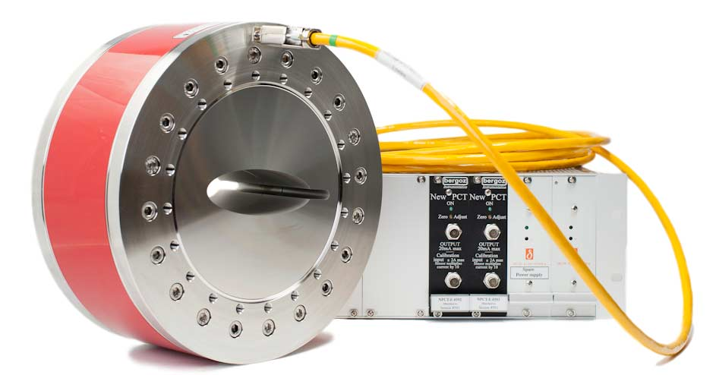
Figure 6.4.6.3: Bergoz in fange NPCT senor and front-end electronics
The Keithley DMM7500 7½-Digit multimeter has been selected for A/D conversion in order to achieve high precision measurements. It offers a resolution of 10 nV for DC voltage, with noise and one-year stability that can reach 14 ppm.

Tune measurement
Measuring and optimizing the betatron tune throughout the operational cycle of a circular accelerator is crucial for ensuring beam quality and longevity, making it one of the most fundamental tasks in the control room. There are several possible solutions for measuring the tune, listed as the kick or excitation eystem based method and the direct diode detection method. Because there is no kicker or other excitation eystem in the damping ring layout, the best choice is the direct diode detection method for the tune measurement.
A new technology, known as Direct Diode Detection (3D), developed at CERN for LHC tune measurement, will be considered. The fundamental concept behind 3D is to time-stretch the beam pulse from the pickup to increase the betatron frequency content in the baseband. This can be achieved using a simple diode detector, followed by an RC low pass filter.
We have tested the 3D method on the BEPCII, and its validity has been demonstrated in a lepton machine. The test result shows in the figure 6.4.6.4.The technique offers many advantages, including simplicity and low cost, robustness against saturation, flattening out the beam dynamic range, and independence from filling patterns. However, it also has a disadvantage, operating in the low-frequency range, which is susceptible to noise.
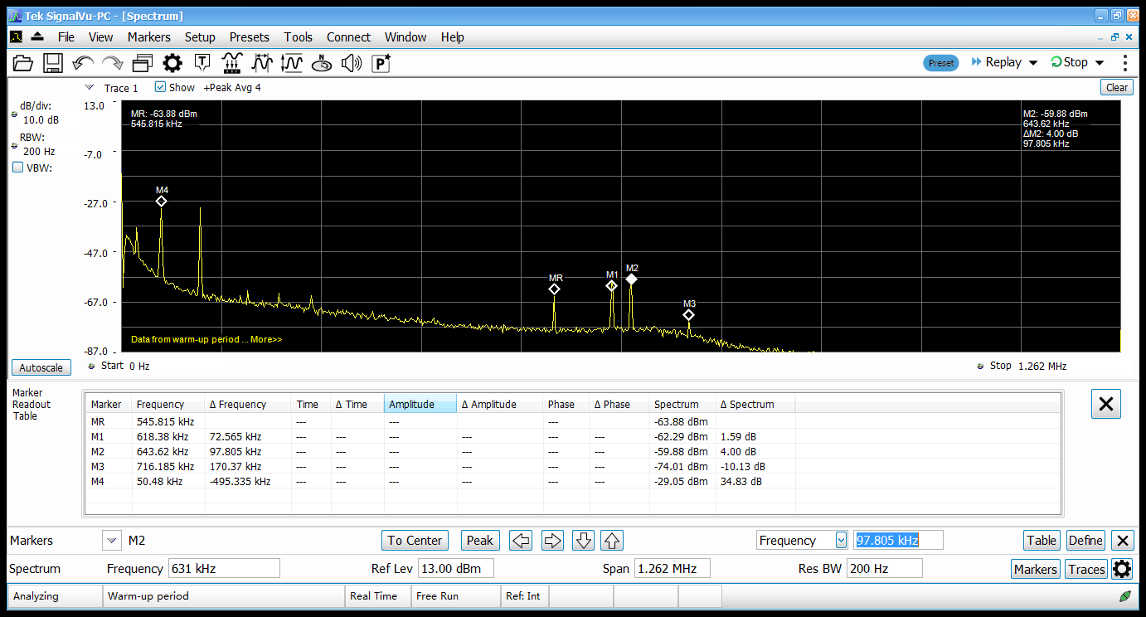
Figure 6.4.6.3: The beam test result of the BEPCII 3D tune measurement system

