CEPC Detector R&D Project

2.3 Drift Chamber Activities
Document Responsible: | Franco Grancagnolo  Mingyi Dong  Linghui Wu
Last saved by on | 8/4/22 12:37:00 AM
Revision number: | 3

Change history
Revision | When | What changed and why
1 | 13/12/2019 | First draft
2 | 28/04/2020 | Update on funding availability
3 | 05/01/2021 | Update on scheduling and funding
4 | 06/04/2022 | Update on the drift chamber for the CEPC 4th detector conceptual design
5 | 08/04/2022 | Update on IDEA drift chamber
 |  | < Add further lines to table as required >

Readme first
- Please do not delete or modify this section or its structure.
- Only change text enclosed by (and including) angled brackets “< … >”.
- Don’t change field directly, instead modify the document options, under File Properties (or similar)
  - Enter name of person that wrote the document in Document:Summary: Author
  - The project ID number, should follow the rules provided to you earlier. The number should be changed in Document:Custom: PBS.
  - The project name should be changed in Document:Summary: Subject.
- In Section Project Objectives provide a brief description of the project goals, i.e. why and what is being produced, for PBS item 1.1 Vertex Prototype. If this project includes identifiable sub-projects you can indicate them in the Sub-projects Description Section, otherwise submit a separate document for each of them. The sub-project IDs are free for you to define.
- Finally, remember to update the Change History.

2.3 Drift Chamber Activities: Project Objectives

The proposed Cluster Counting/Timing technique, which consists in measuring the arrival times on the sense wires of each individual ionization cluster generated in a drift cell, offers the possibility of greatly improving both the momentum resolution and the particle identification capabilities of this kind of gas sampling detectors (separation powers of better than a factor two with respect to the traditional method of dE/dx have been demonstrated experimentally). The drift chamber proposed for the IDEA detector exploits the peculiarities of such a tracking system.
The technique is also being studied for the drift chamber of the CEPC 4th conceptual detector. A drift chamber between the silicon inner tracker (SIT) and silicon external tracker (SET) is expected to provide excellent particle identification on charged hadrons for flavor physics and jet study, and also benefit the tracking.
The objectives of the R&D projects are relative to the four different tasks listed as follows.

2.3 Drift Chamber Activities: Sub-projects Description

Project ID | Title | Description
2.3.1 | Development of new wire materials. | Find suitable proposals for new wire materials together with the corresponding technologies for anchoring the wires to the endplates.
2.3.2 | Development of a DAQ board specific to Cluster Counting/Timing for data reduction and pre-processing of drift chamber signals sampled at high rates. | Implement, within a single FPGA board, peak finding algorithms on a large number of analog to digital conversion channels (128 being the ultimate goal), for parallel pre-processing, to reduce costs and system complexity, and to gain on flexibility in determining proximity correlations among hit cells for track segment finding and triggering purposes.
2.3.3 | Construction of a full length drift chamber prototype. | Full mechanical test of the proposed innovative technologies on the new types of wires and of the new concepts for the design of the drift chamber wire structure placed inside a light gas-tight envelope.
2.3.4 | Simulation and prototype studies on the PID performance of the drift chamber in the CEPC 4th conceptual detector | Simulation study of the PID performance for optimizing the design of the drift chamber.  Prototype test for validating the cluster counting technique.
2.3.5 | Beam test of drift tubes, aimed at optimizing cluster counting algorithms, and relative analysis and at measuring the cluster density in the relativistic rise region | Test of different size drift tube equipped with different diameter sense wires exposed to a muon beam of 165 GeV/c. Data taken in Nov. 2021.  Development of dedicated peak counting algorithms.  Definition of the parameters for a beam test during summer 2022 to study particle identification in the relativistic rise region.
 |  | < Add further lines to table as required >

2.3 Drift Chamber Activities: CEPC Relationship

The first three activities are strictly (almost exclusively) related to the design of the central tracking chamber of the IDEA detector, for both the CEPC and the FCC-ee.
The fourth activity is related to the design of the drift chamber of the CEPC 4th detector.

2.3 Drift Chamber Activities: Project Schedule

Project 2.3.1 has received funds from INFN CSN1. Activity was expected to start in 2020 and to be completed by the end of 2022. In the meantime, we are currently engaged in tests of light polymeric fibers and Carbon monofilaments and in different technologies for anchoring such wires to the endplates. Because of the unexpected situation due to the COVID-19, this project will suffer a delay, currently estimated in approximately 9 months.
Most of the activity and of the successful results were obtained in strict collaboration with colleagues from Budker Institute of Nuclear Physics at Novosibirsk, Russia. The current world political situation imposes a temporary halt to this project, however, we are in the process of finding a different strategy for pursuing the sought objectives. Clearly, the time scale of this project will need to be readjusted accordingly.
Project 2.3.2 has received funding from INFN/CSN1 for the design of a FPGA board with two RO channels, which should be completed by the end of 2020. Here again, we expect a six months delay due to the COVID-19. Moreover, in the framework of the AIDAinnova project, we have been funded for the extension of this FPGA board from 2 to 4 channels, to be completed by the middle of 2024.
A simple cluster counting algorithms has been implemented on the FPGA (Electronics Engineering Master Thesis) to compare different models of data processing and storage. ”Slow" signals on a single channel ADC have been used for these tests. A comparison of different models has shown that creating a buffer inside the FPGA (even with a faster external memory) worsens the peak finding efficiency and the most efficient model is to have small buffers and to send the peak information directly.
We have started a collaboration with engineers from CAEN, who will provide us with their latest developed digitizer for implementing our peak finding algorithms and testing their architecture as a possible implementation of our final board.
We have initiated also an exchange program with Nalu Scientific for the test of a new, compact, high performance, digitizer equipped with the ASOC V3 chip. An evaluation board is being delivered to us.
A post-doc position and a support fellowship for a perspective PhD student have been granted by INFN and will start, respectively, in fall 2022 and in spring 2022.

Project 2.3.3 is staged in three different steps.
The first one includes the construction of small drift tube prototypes to test the new wire types and the RO scheme with FPGA board prototype of project 2.3.2. For this step, we have received funds from INFN CSN1. We expect to complete these prototypes by the middle of 2022.
The second step, which is supposed to start during spring 2020, with funds secured by the already financed CREMLINplus program, foresees the construction of a drift chamber for the CMD-3 experiment at the Budker Institute for Nuclear Physics at Novosibirsk, Russia. This chamber will exploit the same technology, including the new concept for the wire support structure, as the CEPC/FCCee prototype and, therefore, will act as a full system test of the IDEA drift chamber, except for the reduced dimensions. Commissioning of this chamber will occur at during 2024. Once more, due to the unexpected COVID-19 situation, this step will suffer a delay of approximately 9 months.
The current world political situation imposes a necessary modification of our initial plans. We are in the process of converting the funded CREMLINplus program into a new program EURIZON, no longer addressed to collaborations with Russian Institutes and with the objective of building a drift chamber prototype for the next generation of lepton colliders: FCC-ee and CEPC.
In summary, the second step of project 2.3.3 has been canceled and, hopefully, the secured funds will be addressed to the fulfillment of the third step.
The third, more ambitious step concerns the construction of a full-scale prototype, 4 m long, to fully demonstrate the mechanical and electrostatic stability of the proposed solutions, together with the capability of data reduction and pre-processing of the multichannel RO board. Funds for this step will need to be secured.
Project 2.3.4 has received the Science and Technology Innovation Project fund from IHEP, which aims to support the R&D efforts for the drift chamber in the CEPC 4th conceptual detector. Both simulation study and prototype test will be carried out. A waveform-based full simulation chain will be developed, which includes realistic waveform generation with electronics and noise effects and waveform analysis by utilizing effective cluster counting algorithms. The design of the drift chamber will be optimized based on the simulation study. A prototype including electronics boards will be designed and developed to validate the cluster counting technique and further optimize the design of the drift chamber.
Project 2.3.5 An ambitious test campaign has started on different configurations of drift cells to establish the optimal operating parameters for an efficient application of the cluster counting/timing techniques, aimed at separating particles in the relativistic rise region up to the Fermi plateau. A first test has been performed in Nov. 2022 at the H8 beam line of CERN, Geneva, Switzerland, with beams of muons of different momenta, to cover up a range of βγ as wide as available, impinging on an experimental setup constituted of drift tubes of different size, instrumented with sense wires of different diameter and supplied with different gas mixtures, in order to establish the limiting parameters for an efficient cluster counting with respect to gas gain saturation, cluster density and space charge effects. Essential tool for demonstrating the ability to efficiently count clusters is a proper peak finding algorithm to isolate the ionization electrons in the digitized signals coming from the drift tubes.
The expected number of ionization electrons, found by the algorithm, follows a Landau distribution. The association of electrons in clusters is then performed according to their relative time delay (electrons belonging to the same primary cluster are separated in time by no more than the spread due to their diffusion, which, in our configuration, amounts to about 2.5 ns). The distributions of the number of clusters must then follow a Poisson distribution, as shown in the following figure.
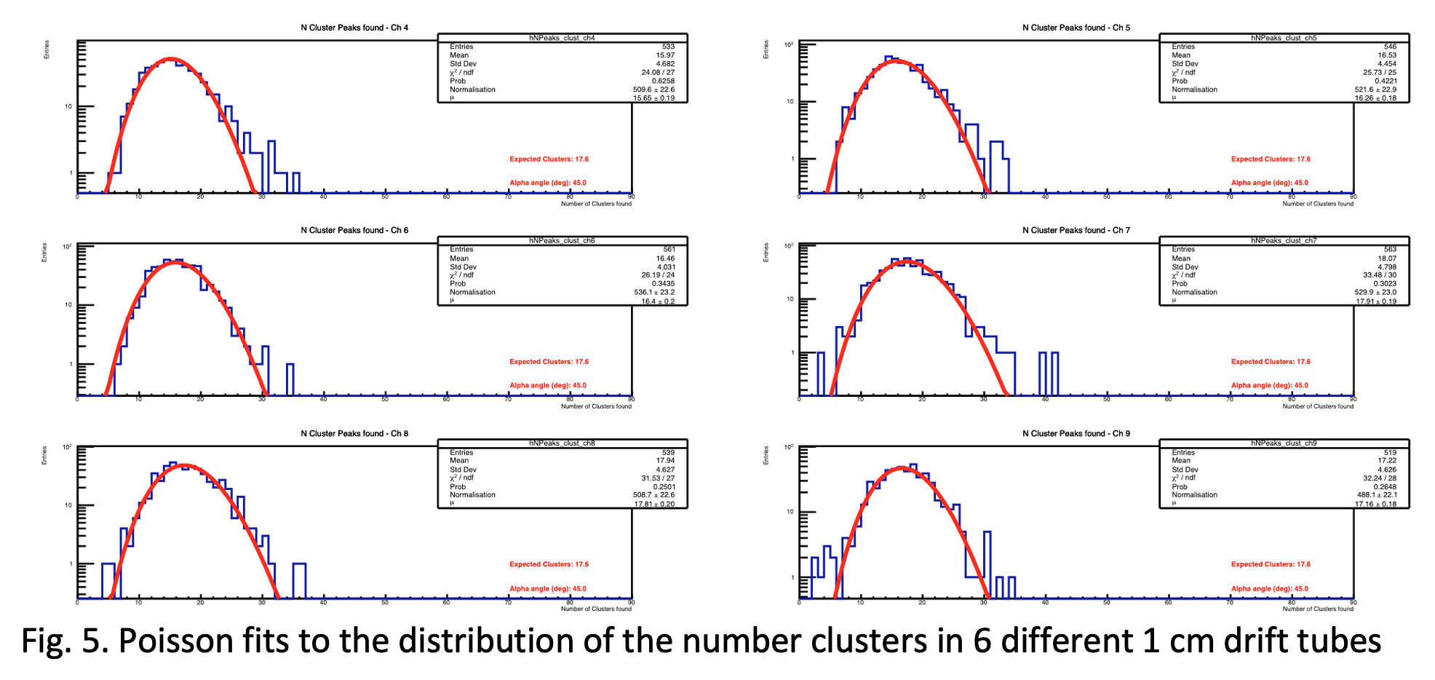
Poisson fits to the distribution of the number of clusters in 6 different 1 cm drift tubes.
We are currently in the process of defining the optimal parameters for a beam test during summer 2022 to study in detail the particle identification in the relativistic rise region.

2.3 Drift Chamber Activities: Funding Availability

During 2019, we have been funded from INFN-CSN1 with 4.5 keuro for the first phase of project 2.3.2 and, for the years 2021-2024, 70 keuro for its continuation from the AIDAinnova project.
During 2020, we have been funded from INFN-CSN1 with 16.5 keuro for studies on new wire materials and for small drift tubes prototypes.
During 2021 and 2022, we have received funds from INFN-CSN1 for about 30.0 keuro.
We are in the process of converting the funds assigned under CREMLINplus (364 keuro) in funds for EURIZON for realizing Projects 2.3.1, 2.3.2 and 2.3.3.
We are going to ask for support for the beam test of summer 2022.
We can count on adequate support for travel to China according to the MISE-FEST agreement.
IHEP group has been funded from IHEP (Science and Technology Innovation Project) with 1.5 million RMB for years of 2022-2024.

2.3 Drift Chamber Activities: Leadership Arrangement

Leading institute for the first three projects will be INFN-Lecce (coordinated by F. Grancagnolo). Given the geographic proximity, INFN-Bari (coordinated by N. De Filippis) will actively participate in all phases of the R&D, although common tasks will be clearly differentiated and each unit will autonomously contribute to the whole project.
Significant support will be given by the industrial companies EnginSoft (coordinated by M. Perillo), for what concerns simulations and finite element analysis of the mechanical structures, and by CAEN (coordinated by A. Iovene) for what concerns industrialization of the different versions of RO boards.
Leading institute for the fourth project is IHEP (coordinated by Mingyi Dong and Linghui Wu)

2.3 Drift Chamber Activities: Manpower Resources

For each of the 4 years of the R&D program

Type | Average FTE Expected
10 Faculty | 2.5
3 Postdoc | 2.4
3 PhD Students | 1.8
4 Engineers | 0.8

For IHEP 3 years of the R&D program

Type | Average FTE Expected
9 Faculty | 2.7
3 PhD Students | 1.6
2 Engineers | 0.6

