**Certificate of Attendance**

**This is to certify that:**

Prof./Dr. Your Full Name

has attended and presented an oral presentation at the

The 16th International Conference on Accelerator Mass Spectrometry (AMS-16)

held on Oct 20-26, 2024 at Guilin, China.

Conference Chair: Prof. Hongtao Shen

Date: 20/11,2024

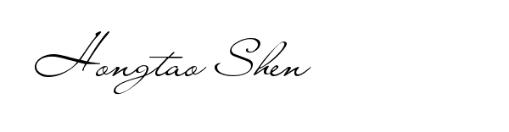

Hongtao Shen

Department of Physics,

Department of Physics,

Guangxi Normal University

15 Yucai Road,Guilin 541004, P. R. China

Mobile:+86 13207735516

Tel(O):+86 0773 5857096

Email: shenht@gxnu.edu.cn