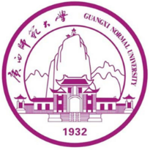
The 16th International Conference on
Accelerator Mass Spectrometry (AMS 16)

Invitation
Dear Prof./Dr. Your Full Name
Gender：
Nationality：
Date of Birth：
Passport Number：
Affiliation：
Address：

You are officially invited to attend the 16th International Conference on Accelerator Mass Spectrometry (AMS16) which will be held at Guangxi Normal University, Guilin, China, from October 20 to 26th, 2024. AMS16 will bring together the leading experts in the field of AMS technique development and leading-edge applications. We hope that you will accept our invitation to present your recent work at this international gathering of world experts on Accelerator Mass Spectrometry and its applications. The submission of abstracts will be open until June 15, 2024. Early registration at reduced rates is available until July 15, 2024. For more information on the conference, please visit our conference website: https://indico.ihep.ac.cn/event/20503/.
We look forward to hosting you in Guilin in October. If you have any questions, please feel free to contact us.
Sincerely Yours,
Hongtao Shen
On behalf of the Organizing Committee of AMS-16
Director of the GNU-AMS Lab
Prof. Hongtao Shen
Department of Physics,
Guangxi Normal University,
15 Yucai Road,Guilin 541004, P. R. China
Mobile:+86 13207735516
Tel(O):+86 0773 5857096
Email: shenht@gxnu.edu.cn

