**A home-made compact multi-isotope AMS system at CIAE**

He Ming, Bao Yiwen, Zhao qingzhang, Zhang wenhui, Li Kangning, Su Shengyong, You Qubo, Kan Chaoxin,Hu Pan

China Institute of Atomic Energy(CIAE), P.O.Box275(50), Beijing, China

Developing the compact AMS system for multi-isotope measurement is the tendency for AMS system development. After developing single stage 0.2MV-AMS system dedicated for 14C measurement and air-insulated 300KV-AMS system used for heavy nuclei measurement, A compact multi-isotope AMS system which can be used for 14C,26Al, 236U,239Pu etc. measurement has been developed at CIAE. Utilizing the compact design of the AMS system, The floor space of the compact AMS system is about 25m2 which is half of the air-insulated 300KV AMS system.

The structure of the AMS system is shown in Figure 1. The ion source is 40-sample negative sputter ion source. The injection system consists of a 90◦ double focus spherical electrostatic analyzer (ESA) and a double focus 90◦ injection magnet with a deflection radius of 650 mm for both the ESA and the injection magnet. The accelerator is a compact accelerator with a total length of 1.1 m and a terminal voltage of 260 kV. An electrostatic quadrupole was installed after the accelerator for beam focusing. After that, a double focus 90◦ analyzing magnet and a 90◦ double focus ESA and with a deflection radius of 650 mm for both the ESA and the analyzing magnet. In order to improve the mass resolution, another 70◦ analyzing magnet with deflection radius of 700 mm is equipped behind the ESA ,finally, a gas detector with 30 nm silicon nitride membranes as entrance windows is used.

The performances of the AMS system have been tested with 129I and 239Pu. The transmission efficiency of 127I for charge state of 2+ is more than 50% at accelerator’s terminal voltage of 0.2 MV, and the sensitivity of 129I/127I=1.5×10-14 has been obtained; The detection limitation of better than 0.1fg for 239Pu at accelerator’s terminal voltage of 0.23 MV has been achieved. The performances of 14C, 26Al, 236U etc. are under developing.

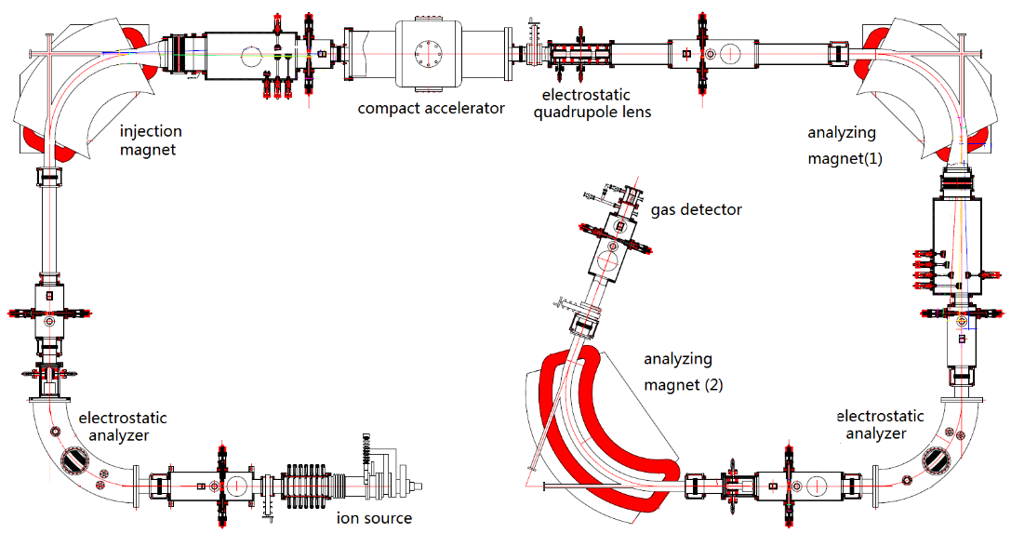

Fig.1 The schematic diagram of the AMS system