Guide to Add and Use International Cards with WeChat Pay
Step 1: Download or Update your WeChat app
On your mobile phone, Download or Update your WeChat app to the latest version. Register with your phone number or sign in.

Step 2: Where to find WeChat Pay
Tap Me - Services – Wallet
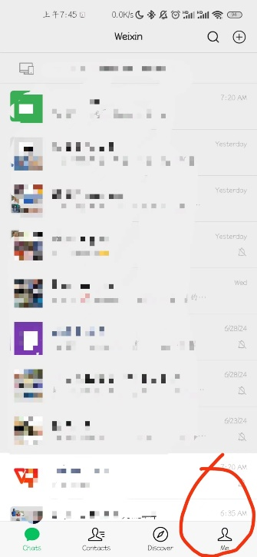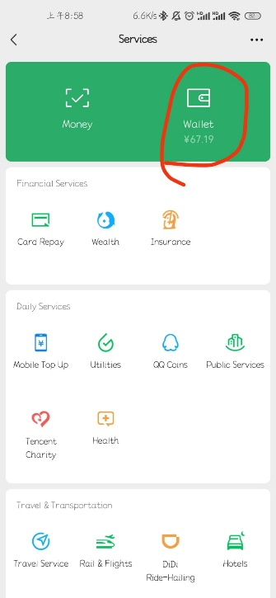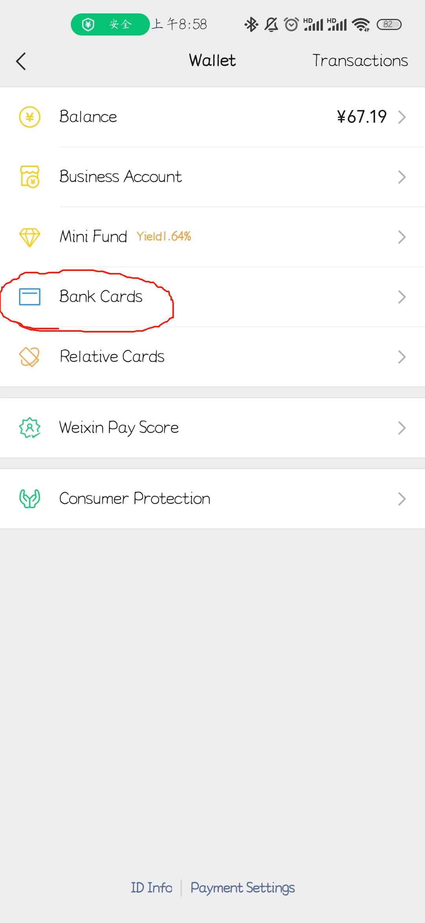
If you cannot find the options above, you can activate WeChat Pay in one of the following way.
• At the bottom, tap Me - Settings - General - Tools - Wexin Pay. Tap Enable.
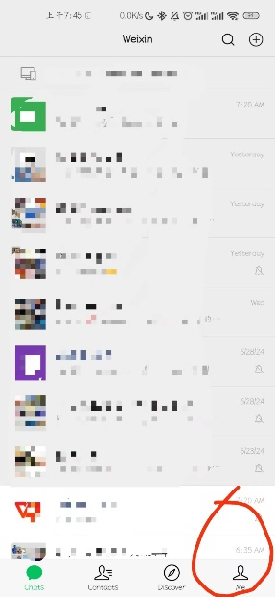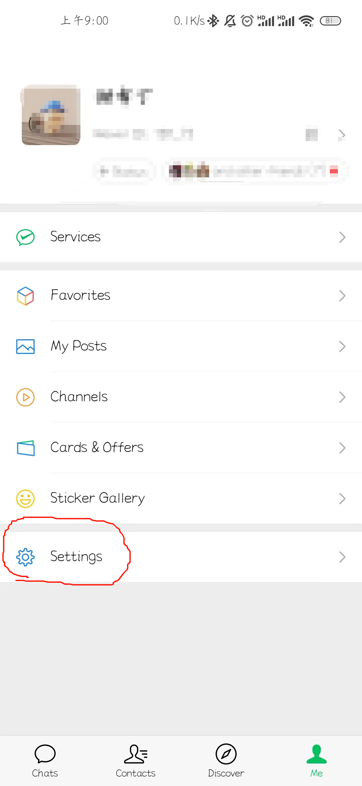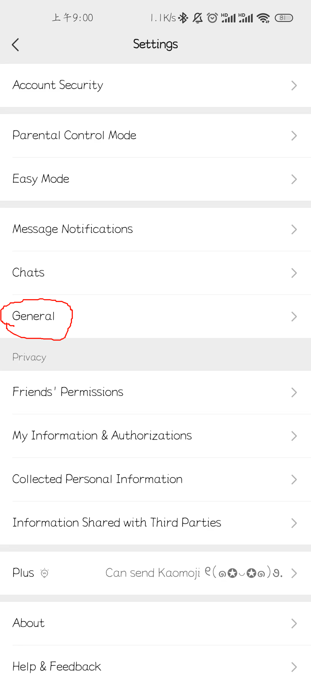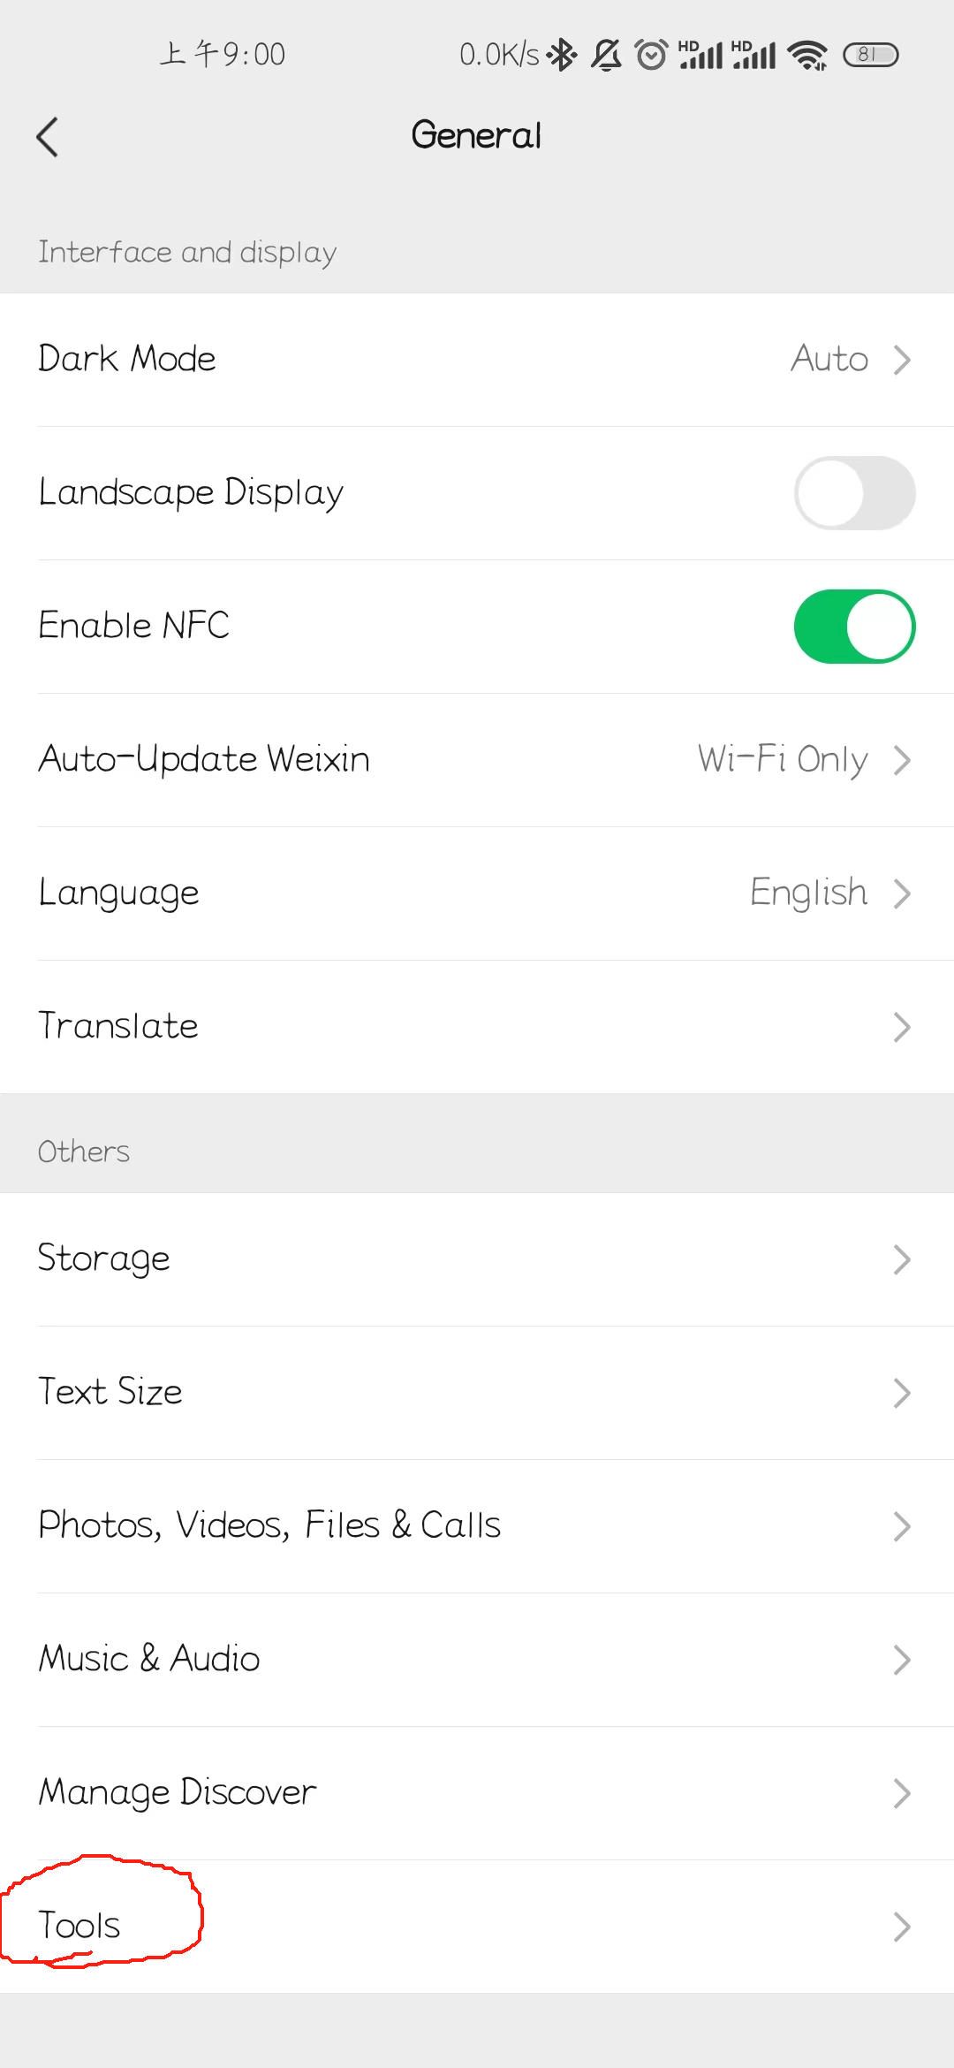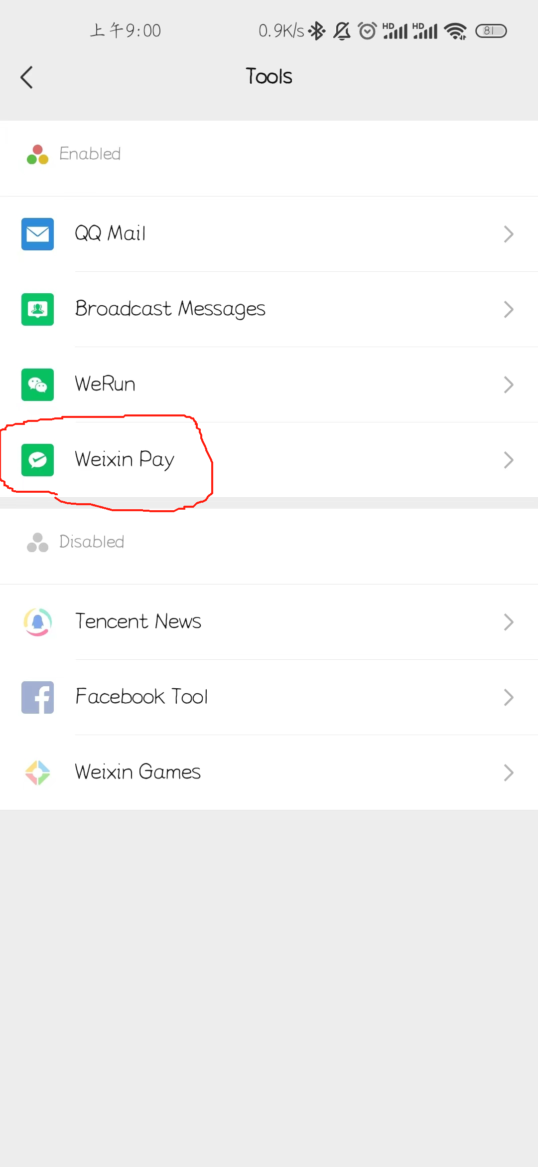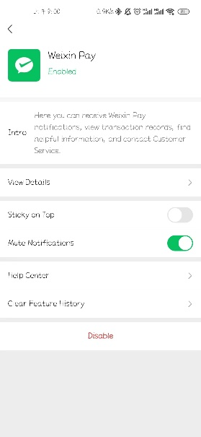
Step 3: Fill in your identity information and add a card
In Wallet, tap Add a Card. Read the WeChat Pay User Service Agreement and Privacy Policy and tap Agree.
Follow the steps on the screen to fill in your identity information. Tap Next to add your card. Follow the instructions on the screen to complete the process.
Tips: If you use your passport to verify your identity, you will get a notification asking you to upload a copy of your passport.
Frequently Asked Questions

How to use WeChat pay

1.Quick Pay
The Chinese Payer shows their bar code or QR Code on WeChat's Quick Pay page to the Vendor to scan in order to pay directly.
This mode applies to offline payment scenarios.
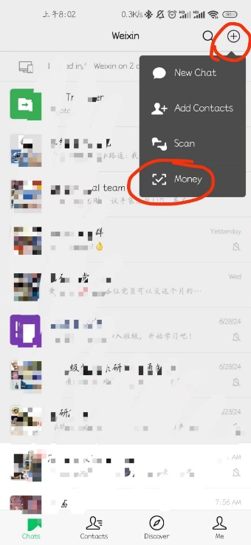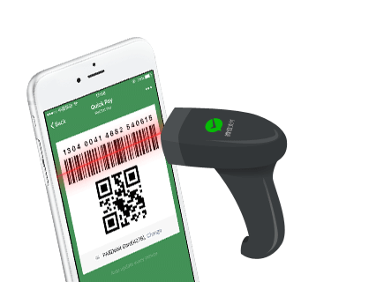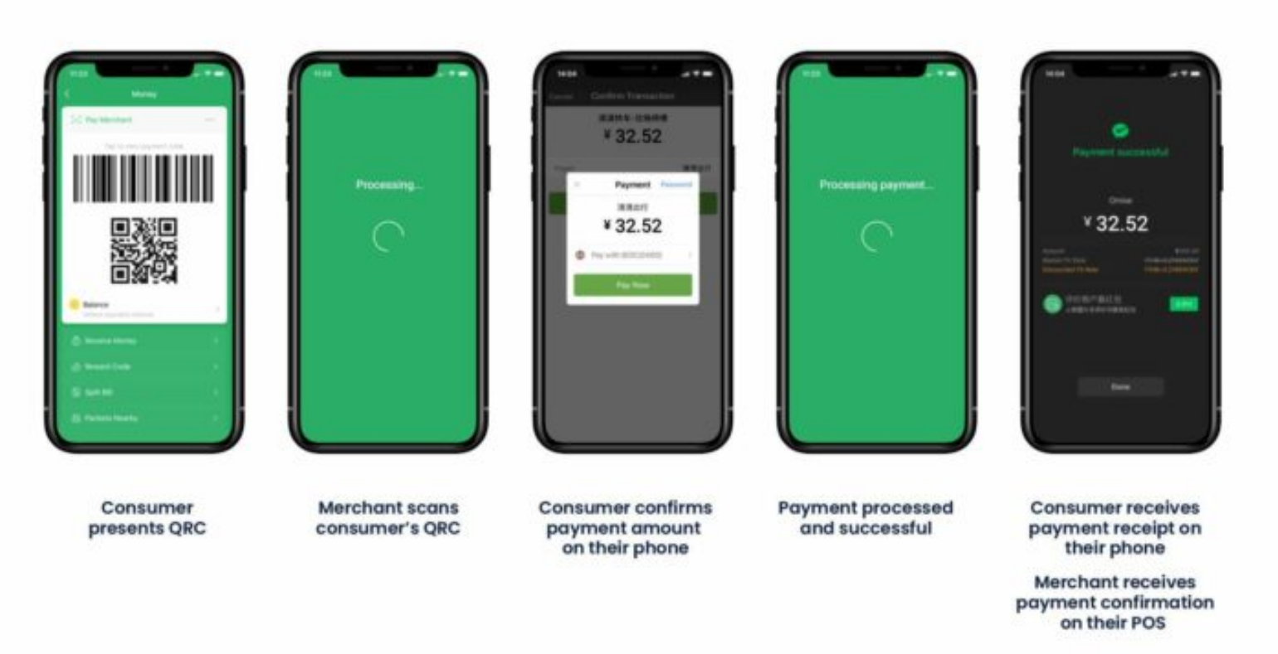

Settlement

1. Supported currencies
GBP，HKD，USD，JPY，CAD，AUD，EUR，NZD，KRW，THB，SGD，RUB，DKK，SEK，CHF，NOK

2. Settlement Model
Settlement per amount:The minimum amount of transfer to Merchant by Tenpay is 800 USD or its equivalent in other currencies. If the settlement payment to Merchant is less than 800 USD or its equivalent in other currencies in any settlement period, such settlement payment will not be remitted to Merchant and will be accrued to the next settlement period.
Settlement Period: Settlement shall be made based on T+1, which means a transaction on T day shall be settled on T+1 (in case of a statutory public holiday at the place where Tenpay is located, settlement shall be made on the day following the statutory public holiday).
The Handling Fee of Transfer shall be shared between the Parties, means that the Handling Fee for transfer of settlement payment receivables by Merchant from the PRC banks to a foreign bank shall be borne by Tenpay, and all other charges such as the costs of intermediary banks or receiving banks shall be borne by Merchant.

2.QR Code Payment
The Vendor generates a transaction QR Code according to the WeChat Payment Protocol and the Chinese Payer goes to "Scan QR Code" in their WeChat in order to complete payment.
This mode is applicable to payments made on websites, physical stores, media advertising, or other scenarios.
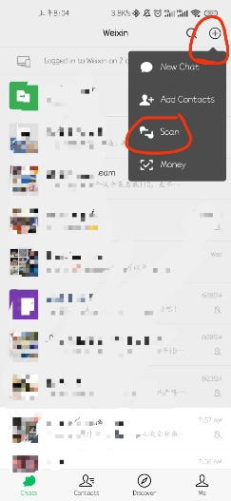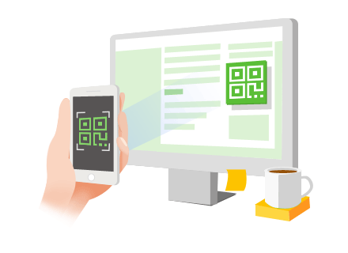
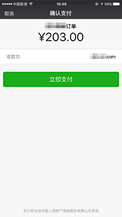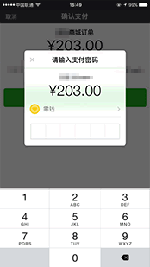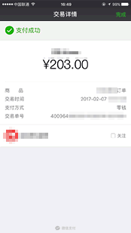

Settlement

1. Supported currencies
GBP，HKD，USD，JPY，CAD，AUD，EUR，NZD，KRW，THB，SGD，RUB，DKK，SEK，CHF，NOK

2. Settlement Model
Settlement per amount:The minimum amount of transfer to Merchant by Tenpay is 800 USD or its equivalent in other currencies. If the settlement payment to Merchant is less than 800 USD or its equivalent in other currencies in any settlement period, such settlement payment will not be remitted to Merchant and will be accrued to the next settlement period.
Settlement Period: Settlement shall be made based on T+1, which means a transaction on T day shall be settled on T+1 (in case of a statutory public holiday at the place where Tenpay is located, settlement shall be made on the day following the statutory public holiday).
The Handling Fee of Transfer shall be shared between the Parties, means that the Handling Fee for transfer of settlement payment receivables by Merchant from the PRC banks to a foreign bank shall be borne by Tenpay, and all other charges such as the costs of intermediary banks or receiving banks shall be borne by Merchant.

3.In-App Payment
In-App payment also refers to a mobile-based payment in which the Vendor calls the WeChat payment module by using the open SDK integrated in their mobile-based app to pay for transactions.
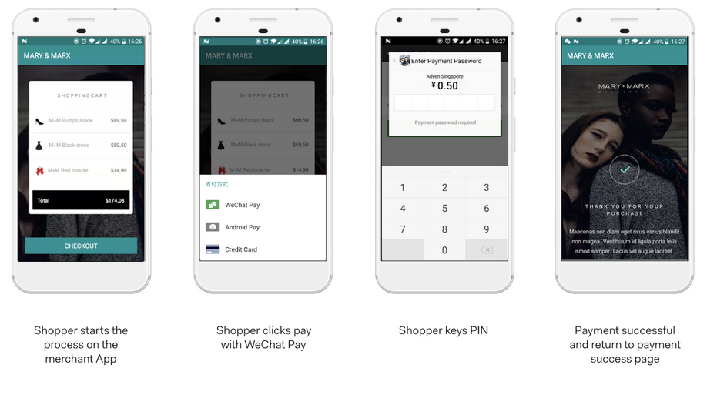

Settlement

1. Supported currencies
GBP，HKD，USD，JPY，CAD，AUD，EUR，NZD，KRW，THB，SGD，RUB，DKK，SEK，CHF，NOK

2. Settlement Model
Settlement per amount:The minimum amount of transfer to Merchant by Tenpay is 800 USD or its equivalent in other currencies. If the settlement payment to Merchant is less than 800 USD or its equivalent in other currencies in any settlement period, such settlement payment will not be remitted to Merchant and will be accrued to the next settlement period.
Settlement Period:Settlement shall be made based on T+1, which means a transaction on T day shall be settled on T+1 (in case of a statutory public holiday at the place where Tenpay is located, settlement shall be made on the day following the statutory public holiday).
The Handling Fee of Transfer shall be shared between the Parties, means that the Handling Fee for transfer of settlement payment receivables by Merchant from the PRC banks to a foreign bank shall be borne by Tenpay, and all other charges such as the costs of intermediary banks or receiving banks shall be borne by Merchant.

4.In-App Web-based Payment
The Chinese Payer opens the Vendor's HTML5 pages on their WeChat and calls the WeChat payment module via the JSAPI interface to pay their transaction.
This mode is applicable in the following scenarios:
• The chinese Payer enters the Vendor’s official account and completes their payment on the transaction page;
• The chinese Payer’s friend shares the Vendor's payment URL in a chat or in Moments and the payer clicks the link to complete their payment;
• The Payer scans the payment QR Code displayed within the Vendor’s page and opens it in a browser to complete their payment.
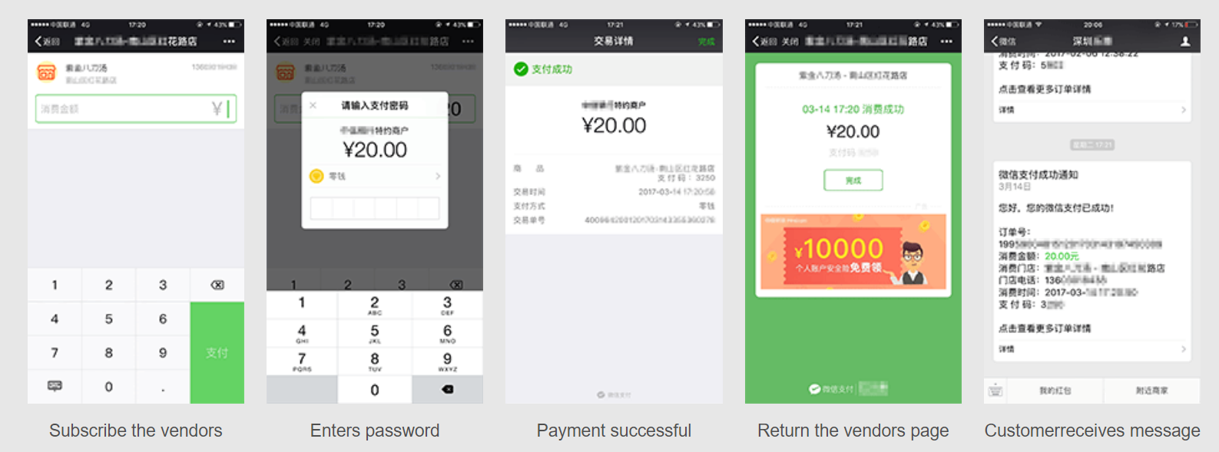

Settlement

1. Supported currencies
GBP，HKD，USD，JPY，CAD，AUD，EUR，NZD，KRW，THB，SGD，RUB，DKK，SEK，CHF，NOK

2. Settlement Model
Settlement per amount:The minimum amount of transfer to Merchant by Tenpay is 800 USD or its equivalent in other currencies. If the settlement payment to Merchant is less than 800 USD or its equivalent in other currencies in any settlement period, such settlement payment will not be remitted to Merchant and will be accrued to the next settlement period.
Settlement Period:Settlement shall be made based on T+1, which means a transaction on T day shall be settled on T+1 (in case of a statutory public holiday at the place where Tenpay is located, settlement shall be made on the day following the statutory public holiday).
The Handling Fee of Transfer shall be shared between the Parties, means that the Handling Fee for transfer of settlement payment receivables by Merchant from the PRC banks to a foreign bank shall be borne by Tenpay, and all other charges such as the costs of intermediary banks or receiving banks shall be borne by Merchant.

