**Minutes: Follow-up discussions on CEPC calorimeter option down-select**

Friday, February 23, 2024, 2-6 PM

Indico page: <https://indico.ihep.ac.cn/event/21619/>

Participants: Jianbei Liu (chair), Yong Liu, Yunlong Zhang, Huaqiao Zhang, Haijun Yang, Jinfan Chang, Fangyi Guo (minutes), Peng Hu, Manqi Ruan, Mingshui Chen.

**Overview: Jianbei & Yong**

Last meeting: criteria have been discussed: performance, cost and technical readiness.

This time: every option introduces the status.

**Discussions**:

Criterion: BMR as global detector criterion. It’s preferable to be provided in calorimeter study as part of project progress. Key criteria should focus on calorimeter system only.

**Conclusion: add separation power (gamma-pi, gamma-gamma. Require 50% eff. @ 1.5 cm) and intrinsic energy resolution (EM, hadronic. w/o clustering as basic, w/ clustering as optional) as calorimeter key criteria.**

**Details in Manqi’s doc [**[**link**](https://indico.ihep.ac.cn/event/21619/contributions/149902/attachments/76094/94025/Requirements_manqi.docx)**] and Appendix.**

**Plastic scintillator ECAL & HCAL: Yunlong**

Review the studies of plastic scintillator ECAL and HCAL. Estimation of power are provided.

**Discussions**:

Simulation & performance status need to be validated. AHCAL has full mature results in CEPCsoft. Scintillator strip ECAL needs SSA for full PFA reconstruction. Now H->diphoton BMR is available.

Power estimation only considered the SPIROC/DIF. Jinfan: this might be under-estimated.

Detector dimensions: need to be consistent with “the baseline geometry” (details below).

**Conclusion for the boundary conditions:**

**Fix the inner boundary: R_inner(ECAL)=1.9m, Z(barrel)=6.1m (cosTheta=0.85, end-cap covers the barrel).**

**ECAL Depth: 24X0**

**Every ECAL option needs to determined the outer boundary, considering the its own material and geometry for each option (i.e. X0, polygon shape).**

**Solenoid: outside of HCAL**

**TODO:**

Validate the status of simulation and performance tools.

ECAL: Re-calculate the channel number, power in the new size, provide outer boundary. (default depth 24X0, but better to set flexible).

HCAL: Calculate power with ECAL size. Fix depth as 6 lambda (need to validate the lambda calculation: material and particle).

(For Peng Hu): provide the optimized layer number in 6 lambda. Every option fix to this layer number.

(For coordinators) coordinate with mechanism: end-cap ECAL should cover the barrel. Better design for cabling. Need to specify the space for cables with first estimates of the power dissipation and data throughput. Solenoid is better to be placed outside of HCAL.

The schematics was provided by Quan Ji to collect further feedback from the calorimetry group, corresponding to the latest design (in Feb. 23) after discussions with the tracker group.

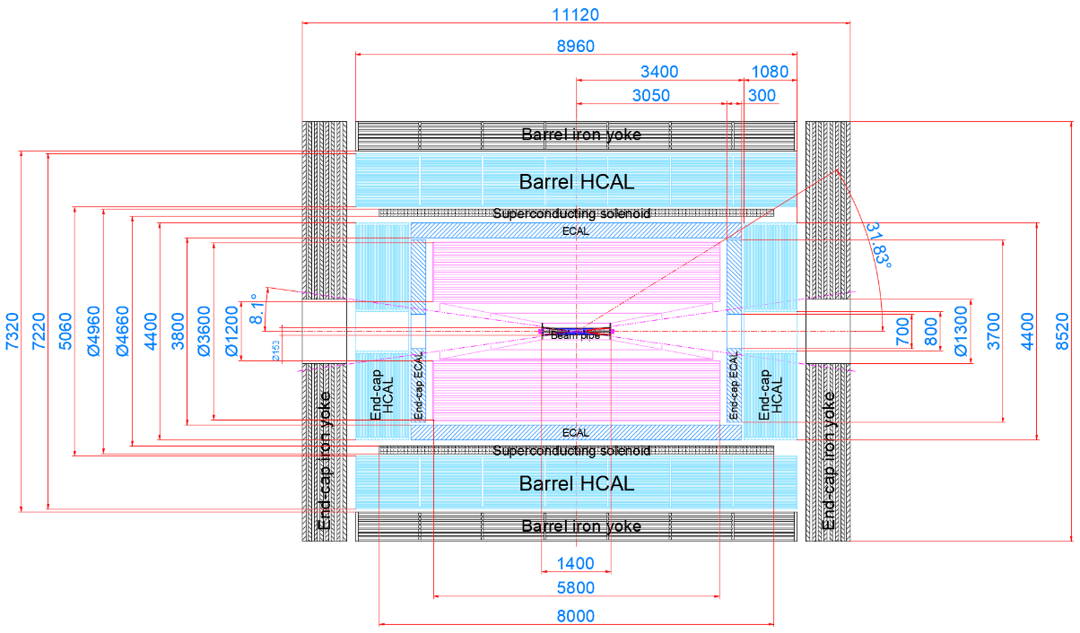

**SiW ECAL + GPRC SDHCAL: Haijun**

Introduced the progress, including prototypes developed by French colleagues and performance studies.

ECAL performance: 30 layers, intrinsic resolution 17.1%+1%, BMR 3.75% for gluon jets.

HCAL performance: 3-thresholds for high energy detection, energy resolution 68%.

Cost and #channels are estimated.

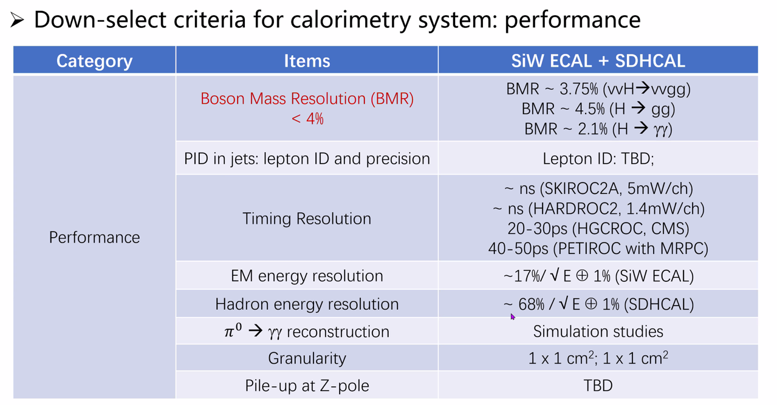

（Manqi: PID potentials in this Ref: [Lepton identification performance in jets at a future electron positron Higgs Z factory - IOPscience](https://iopscience.iop.org/article/10.1088/1748-0221/16/06/P06013)）

**Discussions**:

Costs:

Jianbei and Manqi: absorber cost should be part of material cost + manufacture fee (normally raw material cost * 2).

Jinfan: chip cost could be reduced in the future

Electronic cost: estimated with digital readout, in which case the performance might be influenced.

About involving international-wide colleagues’ efforts in Ref-TDR:

Haijun and Manqi: SDHCAL should be fine, SiW ECAL needs discussion.

Consider: invite international colleagues into discussion & include their results, consider the combined test and combined performance.

About the definition of timing performance:

**Harmonize to system-level shower timing performance.**

**TODO**:

Update the estimations in new boundary conditions.

**Crystal ECAL: Yong**

Introduced the status for two major designs: (1) long crystal bars and (2) short crystal bar.

Cost and power are estimated with experiences of CMS HGCAL: front-end electronics in CMS HGCAL: 1 EUR/ch. Front-end+back-end: 2.5 CHF/ch.

**Discussions**:

Jinfan: ASIC cost might be over-estimated. Power may vary with design, depending on the functions of ASIC.

Huaqiao: HGCAL power: 6M channels ~ 220 kW (30mW/ch), all included. ASIC ~20mW/ch.

Reference on timing studies on scintillating glass cubes from the Crystal Clear Collaboration: [[2212.03368] Sub-10 ps time tagging of electromagnetic showers with scintillating glasses and SiPMs (arxiv.org)](https://arxiv.org/abs/2212.03368)

**TODO:**

Jianbei: suggest to clarify 3 major options: long crystal bar vs. short bar vs. short glass.

Update results with new boundary condition.

**Stereo crystal ECAL: Huaqiao.**

Performance, preliminary cost and power estimation are shown.

**Discussions**:

Yong and Jianbei: BGO cost of 1k CNY/kg seems not very reliable and needs more investigation. (Huaqiao: ref from [高纯锗酸铋晶体 ---锗酸铋闪烁晶体价格-鑫康科研材料生产厂家 (xk-materials.cn)](https://www.xk-materials.cn/goods_687.html))

Jianbei: Is SiPM response considered in the full simulation?

(Huaqiao: No. Digitization is not considered.)

About dynamic range of SiPM in this option: not considered. Same critical issue as other crystal options.

**TODO**:

Address the key criteria in simulation. (Huaqiao: Progress of separation: expect to be improved after adding the energy info)

Future plan: focus on software algorithm for separation and BMR. Hardware test is under consideration.

**Glass HCAL: Peng**

Introduced the progress on glass HCAL, including the performance of H->gg simulation, glass sample production and test.

**Discussion and TODO:**

**(For coordinators and the HCAL group) Need to define a good criterion for HCAL performance: separation is not appropriate.**

Peng: to add ces for this option.

Future plan: target a meter-level large scale prototype, but need cooperate with collaboration.

**Others**:

Weekly group meeting: need to fill the doodle.

ICHEP abstracts:

2 abstracts for MOST2 prototype. Submitted.

Propose to submit: 1 or 2 for each.

Crystal bar ECAL concept;

Glass concept + simulation + performance.

**Appendix: requirements on calorimeter**

**Intrinsic energy resolution:** wi/wo Clustering – Hit/Energy collection efficiency.

Requirement:

EM resolution: ~ 3%/sqrt(E) \conv 0.5%

Ref: JHEP12(2022)135

Had resolution: ~ 50%/sqrt(E) \conv 2%

Ref: CDR baseline performance

**Di-particle separation power.**

Di photon; requirement: ~ 1.5 cm. eff. ~ 50%

Pion + Photon; requirement: ~ 1.5 cm. eff. ~ 50%

Pion + Neutral Hadron; ~ ? cm. (TBD)

Ref: 2018 JINST 13 P03010

Ref: CDR baseline performance

Shower Profile -> Pid potential (e, mu, hadron).

Requirement:

eff ~ 99% & mis-id ~ 1% for isolated charged particle with E > 2 GeV

Ref: Eur. Phys. J. C (2017) 77:591

Ref: 2021 JINST 16 P06013

Ref: CALICE TB data analyses

Differential Eff (long-term).

Requirement: Energy threshold ~ o(50) MeV, |cos(theta)| < 0.995

Ref: CDR baseline performance