**BESIII Inner Tracker Upgrade Meeting**

**(Sep.2, 2024) 14:00 - 16:00pm (Beijing Time)**

**Meeting agenda and minutes**

* Indico page: <https://indico.ihep.ac.cn/event/23251/>
* Participants:
  1. Present in the meeting room

Haibo Li, Zheng Wang, Qun Ouyang, Mingyi Dong, Xiaoyan Shen, Tingxuan Zeng, Giulio Mezzadri, Antonio Amoroso, Stefano Graminia,Yinghong Zhang, liangchenglong Jin, Jing Dong, Wenxuan Gong, Jinyu Fu, Jingzhou Zhao

* 1. Online at ZOOM

Gianliugi Cibinetto, Michela Greco, Yunhua Sun, Jinfang Chang, Hongliang Dai, Huirong Qi, Liangliang Wang, Fei Li, Xiaolu Ji, Si Ma, Linghui Wu

**Report of Gas system: Xiaolan Luo**

* **Summary of the report：** ( **Slides by Xiaolan Luo:** [**Slides**](https://indico.ihep.ac.cn/event/23251/contributions/166378/attachments/81639/102737/20240903MDC-Cgem%20gas%20replacement.pdf))

**Preliminary work on the gas system during the replacement of the Cgem chambers**

* Motivation
  + Avoid flammable gas leakage into the hall when the inner chamber of the MDC detector is pulled out
* Method and plan
* In early September, before the MDC inner chamber is pulled out，use argon to completely replace the original MDC internal gas mixture
* Monitor flammable gas and oxygen when disconnect the gas pipe for the inner chamber and remove the connection screws of inner chamber
* After installation of the new inner CF cylinder and gas sealing, first check the gas leakage of outer chamber with argon. Then check the gas leakage again after replacing argon with MDC working gas (He/C3H8)
* **Questions during the slides or planning:**

1. Purity of Ar/Nitrogen (Mingyi)?: 99.95% (Xiaolan) at least;
2. Difference of them (Zheng Wang): Argon is heavier and costs a bit more;
3. Which period? or future operation (Stefano): only during the period of Changing inner chamber to avoid the flammable gas. (Mingyi);
4. How much time needed to change?(Stefano): 2-3 days, start on Monday or Tuesday (Xiaolan);
5. Which gas we use for checking the leakage? (Zheng Wang): firstly we may check the leakage by argon, then we use the working gas for the detector. (Xiaolan)

**Schedule and Progress last week: Mingyi Dong**

* **Summary of the report：** ( **Slides by Mingyi Dong:** [**Slides**](https://indico.ihep.ac.cn/event/23251/contributions/164586/attachments/81554/102589/progress%20and%20plan_20240902.pdf))

1. Progress last week
2. Wire tension check after glue cleaned, done. The wire tension is roughly consistent to the original one
3. Laser measurement of the original position of the MDC (step and outer parts), done
4. Preparation of installation of the tools for inner MDC removal, being in progress
5. Plan for the next week
6. Installation of the tools for inner MDC removal
7. Change MDC operation gas
8. Final preparation before pulling out iMDC
9. Final check before pulling out iMDC

* **Questions during the slides or planning:**

1. The time to pull out iMDC and time cost (Xiaoyan Shen).Some time in next week, few hours are needed (Mingyi).

2. What’s the reference points for measuring the position of MDC?(Stefano)

Zheng Wang: do we have the original results?

Mingyi: The reference measurements was just finished. Data analysis are on going.

There are many reference points on the walls and the magnets used to determine the center of the detector. On the inner part, step part and big endplates of MDC, some target bases have been glued for leaser measurement to determine the position of each part.

**Progress and plan in CGEM: Stefano Gramigna**

* **Summary of the report:** ( **Slides by Stefano:** [**Slides**](https://indico.ihep.ac.cn/event/23251/contributions/164587/attachments/81553/102588/Update%20from%20CGEM%20Mechanics%20Group.pdf))

Update from CGEM Mechanics Group

* 1. Cabling Test has been Completed
  2. Consideration on the CGEM Shielding

1. 0.5 to 1 mm thick aluminum sheet or 0.25 to 0.5 copper sheet.
2. 2 half-cones 190° (2x5° overlap).
3. Held in place with either aluminum duct tape or copper tape.
4. Either fully rigid and pre-shaped to spec or semi-rigid, pre-shaped, and finalized on-site.
   1. Insertion Procedure
5. Insertion procedure finalized (Attached).
6. Detector fixing solution finalized.
7. Risk assessment report completed.
8. Parts production initiated (before 09/21).

* **Questions during the slides or planning:**

Stefano mentions some points still to be clarified:

1. 1) When to install the shielding plates of CGEM ? Before or after installing the BP?
2. 2) What’s the recommended clearance w.r.t the SCQ and the BP?
3. 3) Request for a Laser Survey of the Cavity: A geometrical survey of the cavity is advised, with the east flange mounted, before CGEM insertion, Flanges parallelism and perpendicularity w.r.t. the cavity’s axis.
4. 4) Are windows/holes needed in the shielding of CGEM detector?
5. 5) How to keep cables in place while inserting the SCQ?

Mingyi replied as below:

1. Before installing the BP.
2. We can keep the present one, please check the drawing.
3. It is already planned. We will first measure the connection flanges themselves and glue some target bases on it. Stefano said the flanges are not in IHEP, and they are in Italy for modifications
4. No holes are needed in the shielding of CGEM detector.
5. We will discuss this issue after the meeting. Jingyu will help for this issue.

**CGEM final transport: Antonio Amoroso**

* **Summary of the report:** ( **Slides by Antonio:** [**Slides**](https://indico.ihep.ac.cn/event/23251/contributions/166138/attachments/81563/102605/CGEM%20final%20transport%20.pdf))
* The transport route has been well considered and for the more stable route, it has been planned as the photo below, the test was done.
* The detector equiped with vibration sensors is seperated with the cart in order to reduce the vibration.
* If it is carried by persons’ hands, it is more stable, during the all transport , the detector sensor give the feedback up to 4g vibration! It is very safe for the CGEM by hand.
* The wheels will be changed these days.We will do more tests.

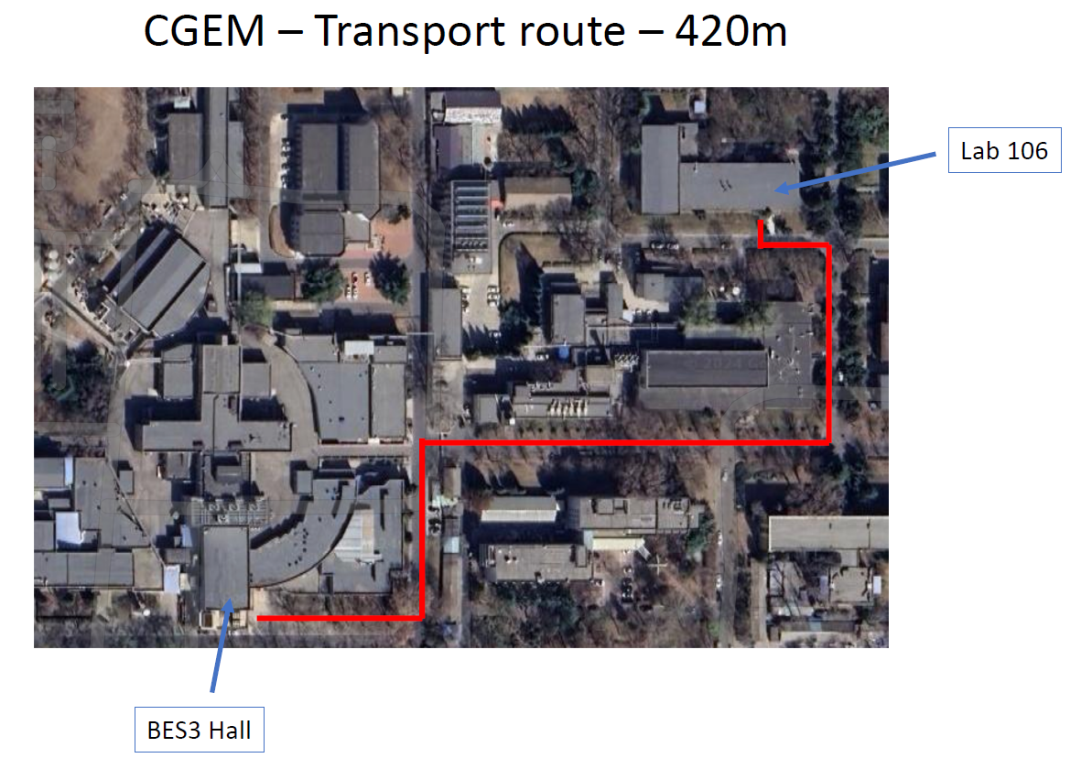

* **Questions during the slides or planning:**

1). Weight of the detector (Zheng Wang): 35kg including the cables

2). Antonio: We will report the results of the more tests.

**CGEM DAQ status: Tingxuan Zeng**

* **Summary of the report：**

1. Progress last week
2. DC firmware has been updated twice, I have tested with new firmware in DAQ lab.
   1. Interrupt issue has been solved.
   2. Remaining some data format issues.
3. Draft a FEE configuration procedure to let the FEE expert confirm.
4. The HV test was successfully completed this morning:
   1. With the high voltage setting to a safe value of 10V.
   2. All HV control and monitoring functions were tested without any errors.
5. Plan for the next week
6. Flash the other 2 DC boards in Hall 3;
7. Test new firmware in Hall 3;
8. Set up the system and take data with real trigger in experiment hall.

* **Questions during the slides or planning:**
  1. Zheng Wang: you mean the firmware issue is solved?

Tingxuan: interrupt solved, but data format issue still need to debug. I alreay send feedback to Pawel, especially for the event rate.

* 1. If use the standard bandwidth, is the present buffer enough?

Giulio: Yes, the program is designed using the dummy data by Angelo.

Michela: in any case we can use the BES trigger setup system for the real test.

**DAQ/SC plan: Michela Greco**

* **Summary of the report:**

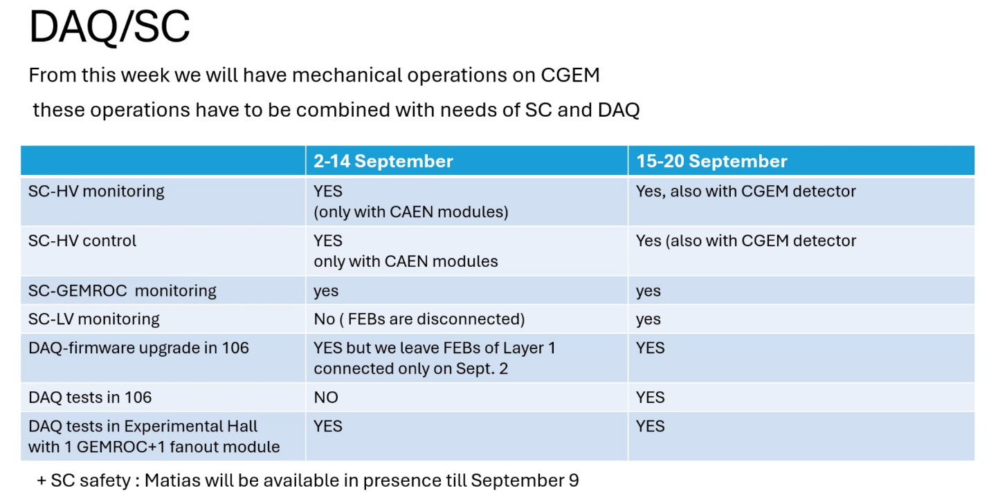

* **Questions during the slides or planning:**

1. Zheng Wang: Did you check powering on the HV for the detector? Please confirm the operation stability of CGEM with operating HV.

Michela: During the period of 2-14 September, we are having mechanical operations on CGEM, but it can be tested by the CAEN crate. Then during the period of 15-20 September, the detector is available.

1. Zheng Wang: how much time cost for powering on the HV?

Michela: The time for the final power on from power off is 90 seconds. We send all the procedures to Si Ma

1. Zheng and Haibo asked Michela to give a report on the operation of CGEM in the last few months, including stable HV running and gas flow with long time data taking (say a few days non-stopping data taking). (by Email after meeting)