**BESIII Inner Tracker Upgrade Meeting**

**(August 26, 2024) 14:00 - 16:00pm (Beijing Time)**

**Meeting agenda and minutes**

* Indico page: https://indico.ihep.ac.cn/event/23329/
* Participants:
  1. Present in the meeting room

Zheng Wang, Qun Ouyang, Tingxuan Zeng, Mingyi Dong, Haibo Li ,Liangchenglong Jin

* 1. Online at ZOOM

Dai Hongliang，Chang Jinfan, Fei Li, Gianliugi Cibinetto, Giulio Mezzadri, Gong Wenxuan, Huirong Qi, Jinyu Fu, Junguang Lv, Ma Si, Michela Greco, Stefano Gramigna, Sun Yunhua, Wu Linghui, Ji Xiaolu, Zhang Yinhong

**Schedule and Progress last week: Mingyi Dong**

* **Summary of the report：**

1. The progress in the week before last week (8.12-18)
2. Installed the shielding plates for protection (east end)
3. Started to remove the glue on first step (east end)
4. Prepared the support structure for operation at MDC on West side
5. Removed the shielding plates, and support structure for shielding plates on west side
6. Removed the cables and preamps of inner chamber on west side
7. The Progress in last week (8.19-26)
8. Finished removal of the glue on the screws and the feedthroughs of the first step (east side)
9. Install the shielding plate for protection(west side);
10. Removal of the glue on the flanges, screws and dowels (west side );
11. Preparation of wire tension check after glue cleaned;
12. Discussion and Preparation of laser measurement of the original position of the MDC (step and outer parts);
13. Preparation of installation of the support legs (Draw the center line);

All of the tasks have been done.

3. Plan for the next week

1. Wire tension check after glue cleaned;
2. Laser measurement of the original position of the MDC (step and outer parts);
3. Preparation of installation of the tools for inner MDC removal.

* **Questions during the slides or planning:**
  + - 1. Stefano: it is useful to polish the long rail for CGEM insertion.

1. Stefano: Because the moving process is very precise, it is helpful to polish the scratch on long rail for CGEM insertion.
2. Ouyang: your requirement is not very clear, we can discuss it after you come to IHEP.
3. Mingyi agreed with Ouyang, and suggested that sandpaper can be used for polishing.

**Review Report for the Removal Scheme of the BESIII Inner Drift Chamber: Zheng Wang**

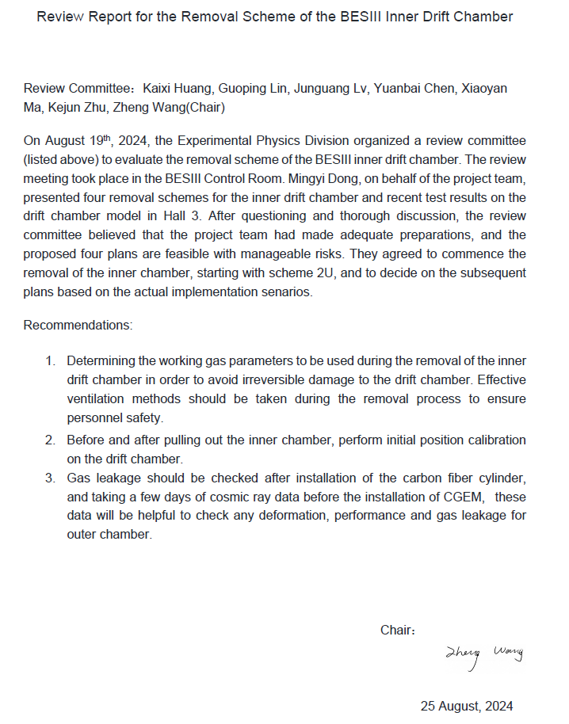

**CGEM operation (Week 12-26 in August): Michela**

* **Summary of the report：**

1. About CGEM detector.

1. Powered on at operation values；
2. H from 35% to 65% ( also depending on the weather outside)；
3. Thanks for changing Ar bottle on Friday 23.
4. Isobutane bottle seems to be empty.

2. About CGEM DAQ

1. The firmware of the upper FPGA has changed and the firmware has flashed on the DC board by Pawel. The first test was fine.
2. The spare FANOUT module has a malfunction of the JTAG interface. Then we will retrieve the spare FANOUT for the second phase.

3. About CGEM slow control

1. I distributed a document with the update of HV power on/off procedure
2. Work in progress with Si MA: remote operation next days as soon as the Isobutane bottle is replaced

**Questions during the slides or planning:**

1. Mingyi: Do you remember when the Isobutane bottle was changed last time. We will order the new bottles.
2. Ouyang: The last time was probably on July 15th.
3. Michela: The previous bottle lasted for about one month and 10 days.

**CGEM DAQ Status: Tingxuan Zeng**

* **Summary of the report：**

1) Last week, DC firmware is updated by Pawel, and the throughput of single board test can reach 9.5MB/s.  
 2) Combing of the FEE configuration ducuments based on the code.

* **Next to do**

1. After the update, Test with two DC boards will be done in room 106, Hall 3.
2. After the trigger signal test (L1/CHK/CLOCK/FULL) was completed, we will do the test of data taking in experiment hall with real trigger.
3. Confirm and implement FEE configuration procedure. And ensure that the system can run for at least 1 hour with two DC boards.