**BESIII Inner Tracker Upgrade Meeting**

**(Oct.14, 2024) 14:00 - 16:00pm (Beijing Time)**

**Meeting agenda and minutes**

* Indico page: https://indico.ihep.ac.cn/event/23870/
* Participants:
  1. Present in the meeting room

Haibo Li, Qun Ouyang, Mingyi Dong, Jing Dong, Fu Jinyu, Zeng Tingxuan, Ma Si, Liangchenglong Jin, Stefano Graminia, Giulio Mezzadri, Michela Greco

* 1. Online at ZOOM

Gong Wenxuan, Ji Xiaolu, Linghui Wu, Liangliang Wang, Fei Li, Huirong Qi, Yunhua Sun, Zhang Yinhong

**Schedule and Progress last week: Mingyi Dong**

**Summary of the report：** ( **Slides by Mingyi Dong:** [**Slides**](https://indico.ihep.ac.cn/event/23870/contributions/169422/attachments/82797/104758/progress%20and%20plan_202401014.pptx))

1. Progress last week

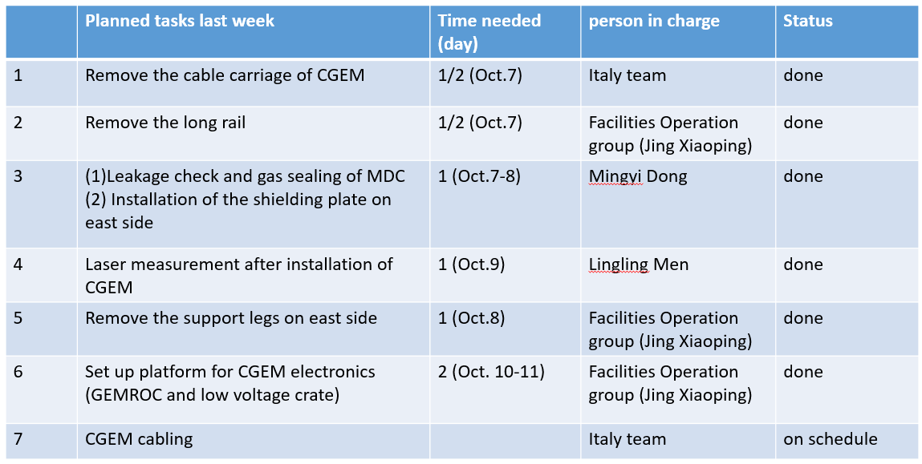

1. Plan for the next week

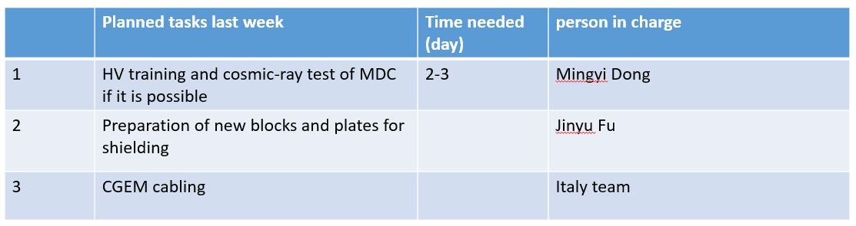

Question and discussion:

Haibo: Check the leakage of MDC after gas sealing. If any leakage are found, the high priority is to fix the gas leakage of MDC as soon as possible.

**CGEM installation report: Giulio Mezzadri, (**[**Slides**](https://indico.ihep.ac.cn/event/23870/contributions/169425/attachments/82796/104753/cgem_20241014.pdf)**)**

* **Summary of the report：**

1. Activities of CGEM detector installation last week

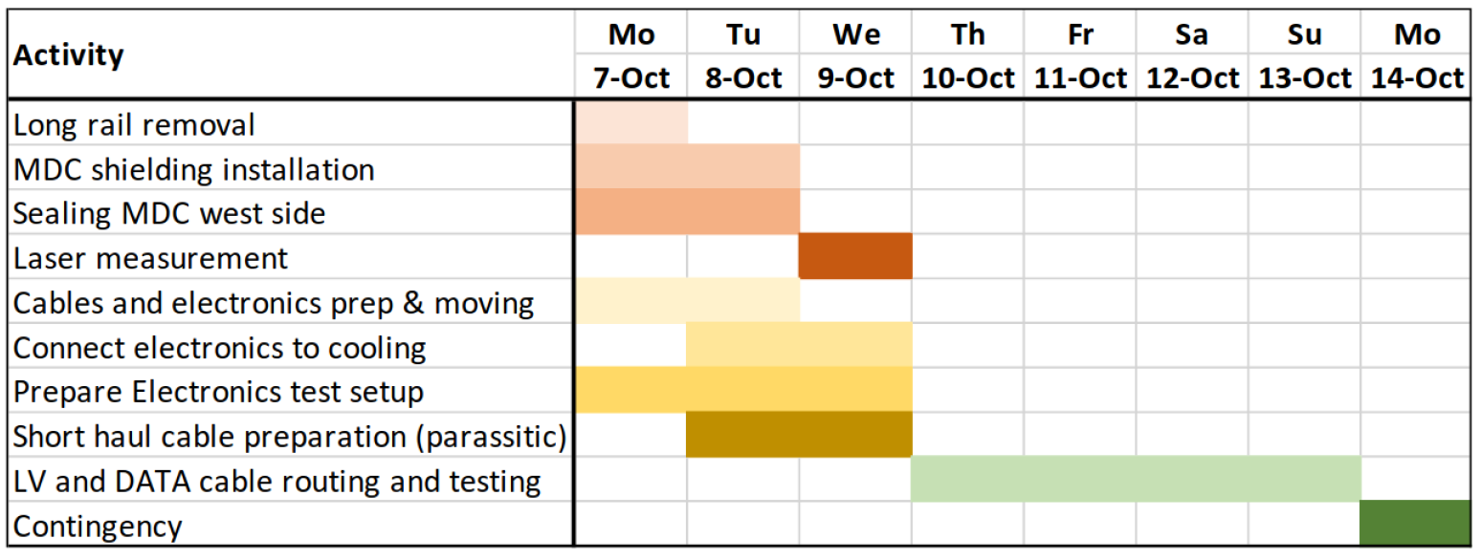

Summary: Every task have been completed on schedule.

3. Plan in next week

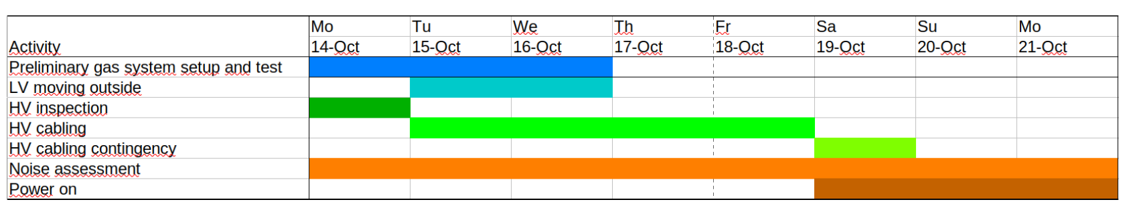

3. About the gas system

1) At present, the system is setup as if there were only one gas volume (original design)

2) We want to run each detector separately, i.e. three independent gas volume (new requirement). Some additional work (also buy material) is needed

**Gas system: Xiaolan Luo, (**[**Slides**](https://indico.ihep.ac.cn/event/23870/contributions/169657/attachments/82833/104833/20241014-CGEM-gas.pptx)**)**

* **Summary of the report：**

1. Currently the gas system has been completed according to the original requirements

* All unit gas, gas mixture buffer tank pipes have been connected
* Gas mixture ratio, pressure and flow rate were set to the nominal value.
* Ready to connect to CGEM

2. New mass flow meters

Regarding the requirement to replace the existing float flow meter with four mass flow meters, I investigated such mass flow meter last week. Two companies responded that it will take at least three months to deliver after payment.

I suggest the Italian team purchase from Europe, and I can assist in installing and debugging these flow meters.

Question and discussion:

1. Michela: it also takes at least three months to purchase from Europe.

**(The issue of new flow meter was also discussed at the EM meeting on Oct.16. EB suggest that the flow meters should be booked as soon also possible from both Italian and Chinese sides, since tight schedule. The first arrival will be used firstly, and later one will be for backup.)**

2. We cannot wait for CGEM testing with the new mass flow meters. The solution is to use a temporary gas system during CGEM testing. After we obtain the mass flow meters, we will use them in data collection.

3. Which temporary gas system will be used currently (the one in lab106 or the one in gas room)? Michela said they will make a decision and let us know tomorrow.

**Progress and plan of DAQ or SC: Tingxuan Zeng, (**[**Slides**](https://indico.ihep.ac.cn/event/23870/contributions/169424/attachments/82792/104746/Progress%20and%20plan%20of%20DAQ%20or%20SC.pptx)**)**

* **Summary of the report：**

1. DAQ test

* Optimized the data file parsing code, the time difference between adjacent events' timestamps matches the event rate of Hall 3.
* Familiarize with the BESIII framework code to prepare for further development.
* Can test with the system once it is ready.

2. Test of full signals

* Electrical tests confirmed that the hardware and optical fiber link have no issues.
* A software configuration bug was identified and resolved. Previously, the full signal was always masked (a historical issue).
* Now, the ZDD full signal can be detected by the back-end electronics and functions as expected, such as blocking L1.
* Verify the full output of the GEM ROC once it is ready.

3. slow control

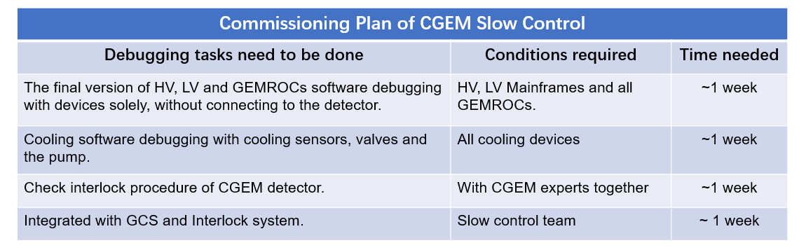

* Gigi confirmed the automated process of HV control after the trip occurred, with 5V/s ramping up at once to injectable.
* For other undefined abnormal situations, just turn off the detector.
* For slow control, to ensure the software is delivered on schedule, CGEM experts will take into account the time required for debugging.