**BESIII Inner Tracker Upgrade Meeting**

**(Oct.21, 2024) 14:00 - 16:00pm (Beijing Time)**

**Meeting agenda and minutes**

* Indico page: https://indico.ihep.ac.cn/event/23953/
* Participants:
  1. Present in the meeting room

Zheng Wang, Qun Ouyang, Mingyi Dong, Jing Dong, Fu Jinyu, Zeng Tingxuan, Ma Si, Xiaolan Luo, Liangchenglong Jin, Giulio Mezzadri, Gianliugi Cibinetto

* 1. Online at ZOOM

Stefano Graminia, Michela Greco, Gong Wenxuan, Ji Xiaolu, Linghui Wu, Liangliang Wang, Fei Li, Huirong Qi, Yunhua Sun, Zhang Yinhong

**Progress last week: Mingyi Dong**

**Summary：**

1. Checked MDC leakage on both sides. Leakage was found around the connecting screws on west side and east side.
2. After gas sealing, the leakage on west side was fixed. The leakage on the east side will take relative long time to fix, we will seal it next week.

**CGEM installation report: Giulio Mezzadri, (**[**Slides**](https://indico.ihep.ac.cn/event/23953/contributions/170114/attachments/83618/106128/20241021_CGEMreport.pdf)**)**

* **Summary of the report：**

1. Activities of CGEM detector installation last week

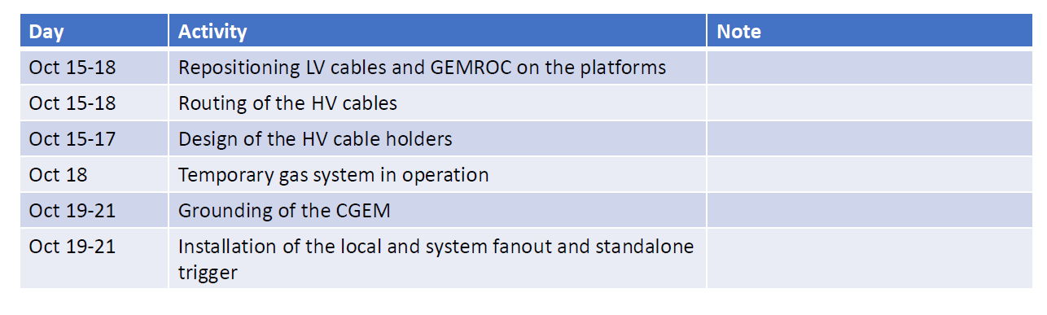

Summary: On Oct. 19 we powered on the electronics and all the high voltage channels at nominal values

3. Plan in next week

1. Begin the commissioning of the CGEM
2. Operate the detector as much as possible to
   1. Spot any possible issue
   2. Check the running conditions
   3. Eventually, improve grounding
3. Improve the cabling tidiness

4. Overall schedule

Due to several unexpected variations of the work flow we ask for few more days of commissioning before closing the EMC endcaps Until November 15th (included).

Mingyi: It is basically impossible because the installation and recovery time is already insufficient, and the accelerator people also hopes to start the recovery work in early November. I will raise this demand at the accelerator operation meeting, and see if it's possible. I will report the discussion decision on next Monday.

5. Needs

1. Noise test with both MDC and CGEM on

Mingyi: will be tested in the following several days

1. TOF trigger and VME crate

Mingyi: we will provide trigger signals in the following several days. VME crates for CGEM are already prepared. You can use them anytime.

1. New shield for the pre-amplifiers board

Mingyi: they will be modified next week

1. Cable holders for HV

Jinyu: Some components are currently being manufactured, while others have already arrived. I have already pushed the company.

1. Have the exact (daily) schedule of EMC endcaps, beam pipe, final focus, and other operations in order to coordinate the mechanical team for the cable routing

Mingyi: The detailed schedule will be discussed and finalized with the accelerator systems. I will give a report on next Monday.

1. Final gas system : New requirements for three independent gas volume need to order three mass flow meters

Mingyi: **EB suggested that the flow meters should be booked as soon also possible from both Italian and Chinese sides, since tight schedule. The first arrival will be used firstly, and later one will be for backup.**

Xiaolan: I will start to order the mass flow meters if you send me the specification of the mass flow meters, but I am not sure if the flow meters can arrive at the beginning of the data taking.

Mingyi: Our Italy colleagues should also start the purchase as soon as possible.

GG.: It is also difficult for us to buy the mass flow meters. We have two flow meters on hand. They can be used in the final system.

Mingyi: If it is possible to borrow one from other Italy group? GG: It is not easy.