**BESIII Inner Tracker Upgrade Meeting**

**(Oct.28, 2024) 14:00 - 16:00pm (Beijing Time)**

**Meeting agenda and minutes**

* Indico page: https://indico.ihep.ac.cn/event/24013/
* Participants:
  1. Present in the meeting room

Jing Dong, Zeng Tingxuan, Liangchenglong Jin，Damiano Cabiati

* 1. Online at ZOOM

Qun Ouyag, Mingyi Dong, Michela Greco, Gong Wenxuan, Fu Jinyu, Ma Si, Sheng Dong, Ji Xiaolu, Liangliang Wang, Fei Li, Giulio Mezzadri, Dai Hongliang, Gianluigi Cibinetto

**Schedule of the MDI installation: Mingyi Dong (**[**Slides**](https://indico.ihep.ac.cn/event/24013/contributions/170779/attachments/83687/106264/progress%20and%20plan_202401028.pptx)**)**

Preliminary schedule for MDI installation

**East side:**

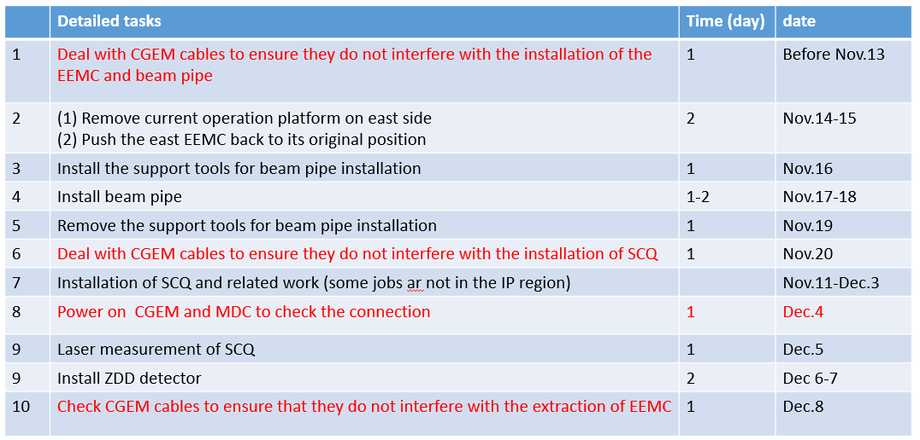

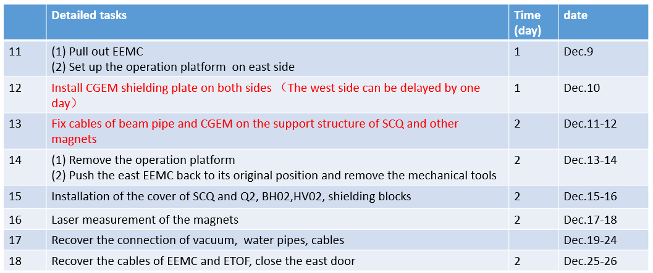

**West side:**

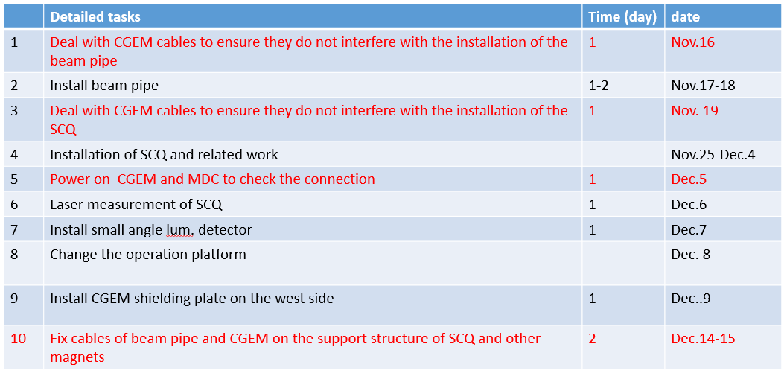

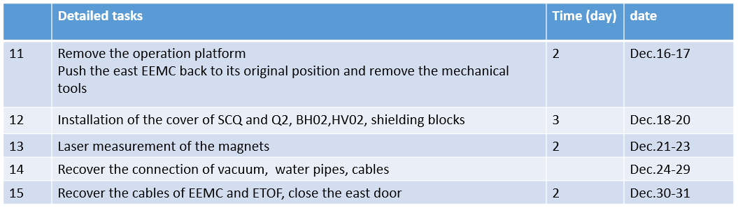

**Summary：**

1. Based on discussions with the accelerator systems, a preliminary schedule for MDI installation in the next two months was reported.
2. According to the requirements of Italy group, we postponed the recovery work on east side by two days (will start from Nov.14), and on west side by 5 days (will start from Nov.17).
3. According to the actual implementation situation, the schedule may be slightly adjusted.

**CGEM installation report: Giulio Mezzadri, (no slides)**

* **Summary：**

1. Activities of CGEM detector installation last week

Summary: Damiano Cabiati did some tests with help of IHEP colleagues.

1) CGEM noise test was conducted with MDC crates powered on, and there was no difference in CGEM noise before and after powering on the MDC crates

2) CGEM was tested with BESIII trigger system (cosmic rays). The trigger module needs to be moved from the first floor to the third floor.

3) CGEM grounding test and improvement of grounding

Mingyi: The new fibers are preparing. If they are ready, we will move the trigger module from the first floor to the third floor. In noise test with both MDC and CGEM on, one of MDC crates had problem. Now the crate can work normally, we will do further tests next week.

2. Needs

1. Modification of the CGEM shielding plates

Jinyu: The plates have been sent to the factory for processing

1. Cable holders for HV

Jinyu: The remaining parts are currently being processed by the factory and will be completed soon.

**Progress and plan of DAQ and SC: Tingxuan Zeng, (**[**Slides**](https://indico.ihep.ac.cn/event/24013/contributions/170781/attachments/83662/106213/CGEM%20TDAQ%20progress%2020241028.pptx)**)** the slides were not reported at the meeting

**Progress of**  **CGEM DAQ**

* Helped Damiano to install CGEM VME crates.
* Ordered the serial cable and Ethernet cables for the PPC connection.
* Started the cable connection and configuration of the crate and PPC.
* Clarified the requirement further and started the code integration of the FEE configuration.
* The trigger signal (L1) based on EMC has been tested and applied in the CGEM readout system.

**Question:**

* When will we start the commissioning of the CGEM DAQ and slow control?