The 3rd Conference on Physics under Synergetic Extreme Conditions

held jointly with the Summer School of SECUF

**Summer School**

**Host Institutions:**

*Institute of Physics, Chinese Academy of Sciences*

*Center for High Pressure Science, State Key Laboratory of Superhard Materials,*

*Jilin University*

Huairou, Beijing

July 16 - 19, 2024

**Conference Chairs:**

Zhong Fang (IOP, CAS) Li Lu (IOP, CAS) Bingbing Liu (Jilin Univ.)

**Head of Organizing Committee：**

|  |  |  |
| --- | --- | --- |
| Li Lu (IOP, CAS) | Jinguang Cheng (IOP, CAS) | Jianlin Luo (IOP, CAS) |
| Zhiyi Wei (IOP, CAS) | Guangtong Liu (IOP, CAS) | Qiang Zhou (Jilin Univ.) |
| Zhaodong Liu (Jilin Univ.) |  |  |

**Coordinators of Parallel Sessions:**

|  |  |  |
| --- | --- | --- |
| **Parallel Sessions 1** | **Parallel Sessions 2** | **Parallel Sessions 3** |
| Jinguang Cheng (IOP, CAS) | Jianlin Luo (IOP, CAS) | Li Lu (IOP, CAS) |
| Liling Sun (HPSTAR) | Qingming Zhang (IOP, CAS) | Changli Yang (IOP, CAS) |
| Xiaohui Yu (IOP, CAS) | Tian Qian (IOP, CAS) | Guangtong Liu (IOP, CAS) |
| Jing Guo (IOP, CAS) | Zhiguo Chen (IOP, CAS) | Jie Shen (IOP, CAS) |
| Bosen Wang (IOP, CAS) | Rui Zhou (IOP, CAS) | Kai Xu (IOP, CAS) |
|  | Gang Li (IOP, CAS) | Peiling Li (IOP, CAS) |
|  | Rui Wu (IOP, CAS) |  |
|  | Xinbo Wang (IOP, CAS) |  |

|  |  |
| --- | --- |
| **Parallel Sessions 4** | **Parallel Sessions 5** |
| Zhiyi Wei (IOP, CAS) | Zhaodong Liu (Jilin Univ.) |
| Jianqi Li (IOP, CAS) | Pinwen Zhu (Jilin Univ.) |
| Yutong Li (IOP, CAS) | Xinyi Yang (Jilin Univ.) |
| Bingbing Wang (IOP, CAS) | Qiang Zhou (Jilin Univ.) |
| Hao Teng (IOP, CAS) |  |
| Xin Lu (IOP, CAS) |  |
| Xuan Wang (IOP, CAS) |  |
| Jun Li (IOP, CAS) |  |
| Shuo Dong (IOP, CAS) |  |

**International advisory board:**

|  |  |
| --- | --- |
| Yoichi Ando | Universität zu Köln |
| Jim Cao | Florida State University |
| Fabrizio Carbone | École Polytechnique Fédérale de Lausanne |
| Xianhui Chen | University of Science and Technology of China |
| Ruirui Du | Peking University |
| Klaus Ensslin | Eidgenössische Technische Hochschule Zürich |
| David J. Flannigan | University of Minnesota |
| Mladen HORVATIC | Laboratoire National des Champs Magnétiques Intenses |
| Hiromitsu KIRIYAMA | Kansai Institute for Photon Science |
| Maciej Koperski | National University of Singapore |
| Philip J.W. Moll | Max-Planck-Institute for the Structure and Dynamics of Matter |
| Zoran V. Popovic | Serbian Academy of Sciences and Arts |
| Zewei Quan | Southern University of Science and Technology |
| Chong-Yu Ruan | Michigan State University |
| Shunqing Shen | University of Hong Kong |
| Yuping Sun | High Magnetic Field of Chinese Academy of Sciences |
| Haohua Wang | Zhejiang University |
| Jigang Wang | Iowa State University |
| Ke Wang | University of Minnesota |
| Xijie Wang | University of Duisburg-Essen |
| Xincheng Xie | Peking University/Fudan University |
| Hongqi Xu | Peking University |
| Dingshyue (Jerry) Yang | University of Houston |
| Jianting Ye | University of Groningen |
| Guoqing Zheng | Okayama University |
| Xiaobo Zhu | University of Science and Technology of China |

Dear Participants,

Welcome to the 3rd Conference on Physics under Synergetic Extreme Conditions held jointly with the Summer School of SECUF (SECUF-2024). In this manual, we would like to present you some of the basic information on the summer school.

1. **Dates:**

July 16 – 19, 2024

1. **Venue:**

MA 505, Huairou Campus, IOP, CAS

1. **Hotel:**

Hotel Name: Swan Lake View Hotel (北京中建雁栖湖景酒店)

Address: No. 1 Yanxiu Road, Huairou, Beijing. (北京市怀柔区雁秀路1号)

Phone: +86-10-69663366

1. **Registration:**

|  |  |
| --- | --- |
| **Time** | **Location** |
| July 16 | Lobby, 1st Floor, Swan Lake View Hotel |
| July 17-18 | Lobby, 5th Floor, Building MA, Huairou Campus, IOP, CAS |

1. **Meals:**

Lunch & Dinner: Building X9, Synergetic Extreme Condition User Facility

Breakfast: Yanming Hall (雁鸣厅), 1st Floor, Swan Lake View Hotel

1. **Secretaries:**

Registration, Accommodation and Venue: Yuwen Li李玉雯 (IOP, CAS) +86-13522150222

Transportation, Meal: Yufei Han 韩宇飞 (IOP, CAS) +86-18237115917

Coordination: Cui Yang 杨翠 (IOP, CAS) +86-18801495015

1. **Transportation:**

**Shuttle bus arrangements between Beijing South Railway Station** (北京南站)**, IOP Zhongguancun Campus** (物理所中关村园区)**, and Swan Lake View Hotel** (北京中建雁栖湖景酒店)**:**

Shuttle buses with a sign of SECUF-2024 in the front will be arranged to transport between the sites mentioned above, with the time table and estimated travelling time to the destination (Swan Lake View Hotel) in the table below.

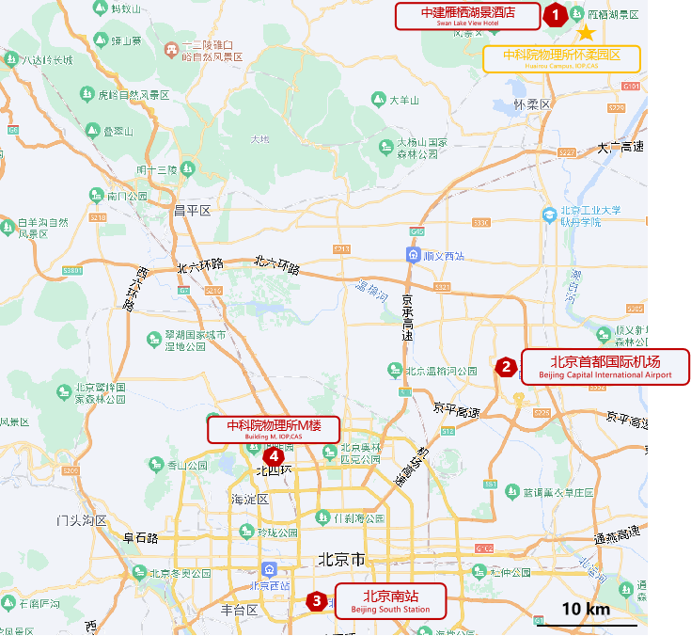

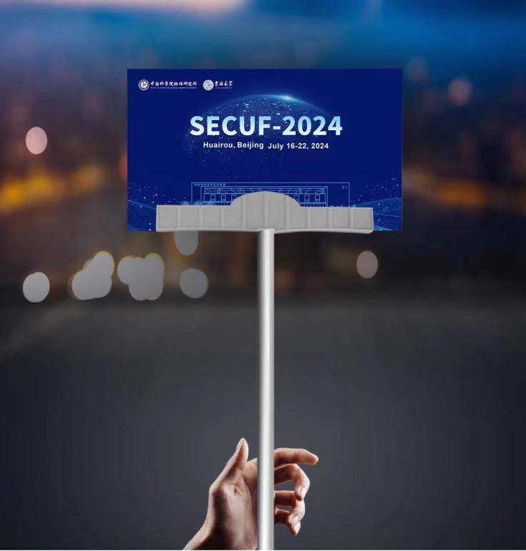 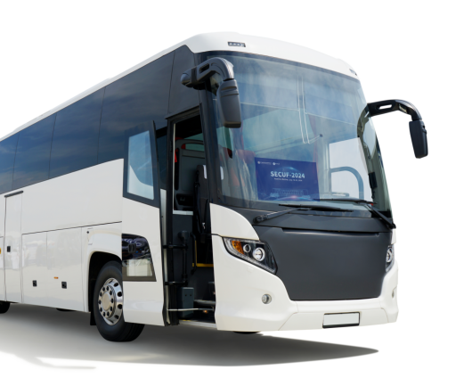

|  |  |  |  |  |
| --- | --- | --- | --- | --- |
| **Date** | **Time** | **Departure** | | **Destination** |
| **16, July** | 14:00 | Beijing South Railway Station (北京南站)  (Volunteer Contact: Weizhen Zhuo 卓威震  +86-13919065214) | | Swan Lake View Hotel (中建雁栖湖景酒店) |
| Building M, Zhongguancun Campus, IOP, CAS(物理所中关村园区)  (Volunteer Contact: Mingtai Xie 谢铭泰  +86-15007534571) | | Swan Lake View Hotel (中建雁栖湖景酒店) |
| 16:00 | Beijing South Railway Station (北京南站)  (Volunteer Contact: Xiang Li 李想  +86-18013383442) | | Swan Lake View Hotel (中建雁栖湖景酒店) |
| Building M, Zhongguancun Campus, IOP, CAS(物理所中关村园区)  (Volunteer Contact: Wenbo Sang 桑文博  +86-15293179579) | | Swan Lake View Hotel (中建雁栖湖景酒店) |
| **17, July** | 08:30 | **Swan Lake View Hotel** (中建雁栖湖景酒店) | | Building MA, Huairou Campus, IOP, CAS  (物理所怀柔园区) |
| 18:30 | Building X1, Huairou Campus, IOP, CAS  (物理所怀柔园区) | | Swan Lake View Hotel  (中建雁栖湖景酒店) |
| **18, July** | 08:30 | **Swan Lake View Hotel**  (中建雁栖湖景酒店) | | Building MA, Huairou Campus, IOP, CAS  (物理所怀柔园区) |
| 18:30 | Building X1, Huairou Campus, IOP, CAS  (物理所怀柔园区) | | Swan Lake View Hotel  (中建雁栖湖景酒店) |
| **19, July** | 08:30 | **Swan Lake View Hotel**  (中建雁栖湖景酒店) | | Building MA, Huairou Campus, IOP, CAS  (物理所怀柔园区) |
| 15:30 | Building X1, Huairou Campus, IOP, CAS  (物理所怀柔园区) | | Swan Lake View Hotel (中建雁栖湖景酒店) |
| 15:30 | **Building X1, Huairou Campus, IOP, CAS**  (物理所怀柔园区) | **Stop by:**  Anhuiqiao East Bus Station (near HuiXin XiJie BeiKou Subway Station)  安慧桥东公交站  (近惠新西街北口地铁站) | Building M, Zhongguancun Campus, IOP, CAS  (物理所中关村园区) |

**Using Public Transportation:**

1. **Suburban Railway Train**

Get off at Huairoubei Railway Station (怀柔北站), then take a taxi to Swan Lake View Hotel (北京中建雁栖湖景酒店), 2 km and 6 minutes.

In case of special weather conditions, please follow the WeChat public number "Beijing Suburban Railway" (北京市郊铁路) to check the operation adjustment announcement.

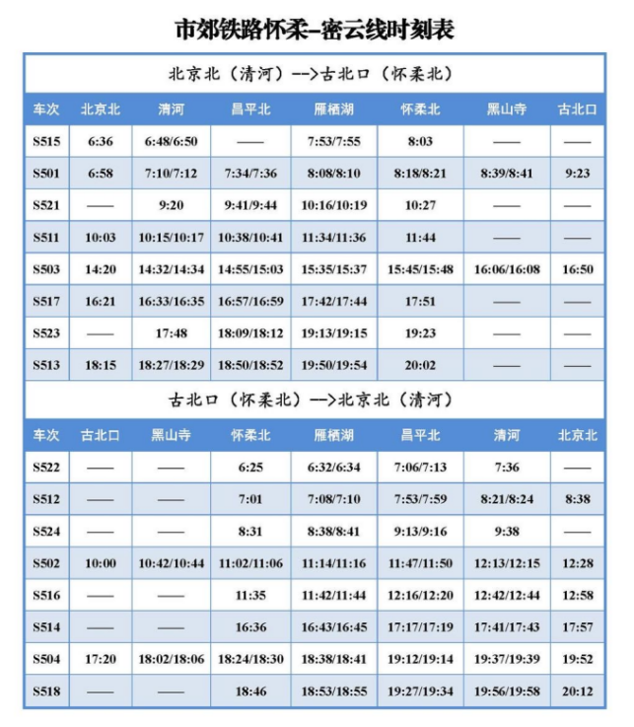

1. **High-speed Train**

Take the High-speed Railway Train from Beijing Chaoyang Station (北京朝阳站) and get off at Huairou South Station (怀柔南站), then take a taxi to Swan Lake View Hotel (北京中建雁栖湖景酒店), 17 km and 26 minutes.

1. **Fast Direct Bus Line 197**

This bus line is 60 kilometers long, starting from Wangjing West Subway Station (地铁望京西站). and ending at University of Chinese Academy of Sciences, Huairou (中国科学院大学东区). The one-way ticket fare is RMB 25.

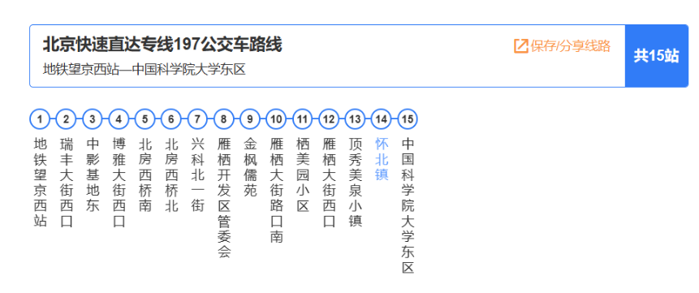

**Scientific Program**

**Summer School (Day 1)**

**Wednesday Morning, July 17, 2024 MA 505, Huairou Campus, IOP, CAS**

|  |  |  |
| --- | --- | --- |
| **Time** | **Speaker & Talk Title** | **Chair** |
| 09:00-09:10 | Opening | |
| 09:10-10:00 | **Shuheng Pan** (Institute of Physics, Chinese Academy of Sciences)  LT/HMF STM ─ a powerful real-space microspectroscopic tool for materials research | **Jianlin Luo**  (IOP, CAS) |
| 10:00-10:50 | **Xin Lu** (Zhejiang University)  Introduction to point-contact spectroscopy under extreme conditions and its application |
| Break (10 minutes) | | |
| 11:00-11:50 | **Wei Wang** (University of Science and Technology of China)  UED study on electron-phonon coupling in Verwey transition | **Jianlin Luo**  (IOP, CAS) |
| 11:50-13:00 | Lunch (Building X9, Synergetic Extreme Condition User Facility) | |



Abstracts Collection - Summer School

**Wednesday Afternoon, July 17, 2024 MA 505, Huairou Campus, IOP, CAS**

|  |  |  |  |
| --- | --- | --- | --- |
| **Time** | **Station** | **Speaker & Talk Title** | **Chair** |
| 13:30-13:45 | A1 | **Yazhou Zhou** (Institute of Physics, Chinese Academy of Sciences)  Electrical property under extreme condition (Diamond Anvil Cell) | **Qingming Zhang**  (IOP, CAS) |
| 13:45-14:00 | A2 | **Bosen Wang** (Institute of Physics, Chinese Academy of Sciences)  Cubic Anvil cell apparatus for precise physical-property measurements under hydrostatic pressure conditions |
| 14:00-14:15 | A3 | **Gang Li** (Institute of Physics, Chinese Academy of Sciences)  Introduction of A3 substation: Superconducting magnet systems focusing on quantum oscillation measurements |
| 14:15-14:30 | A4-1 | **Chengpu Lv** (Institute of Physics, Chinese Academy of Sciences)  Infrared spectroscopic measurements at high magnetic fields and low temperatures |
| 14:30-14:45 | A4-2 | **Xinbo Wang** (Institute of Physics, Chinese Academy of Sciences)  Table-top laser-based Terahertz high harmonic generation spectroscopy under magnetic fields and low temperatures |
| 14:45-15:00 | A5 | **Feng Jin** (Institute of Physics, Chinese Academy of Sciences)  Raman scattering under extreme conditions |
| Break (10 minutes) | | | |
| 15:10-15:25 | A6 | **Jun Luo** (Institute of Physics, Chinese Academy of Sciences)  High magnetic field nuclear magnetic resonance station | **Jing Guo**  (IOP, CAS) |
| 15:25-15:40 | A7 | **Xin Yu** (Institute of Physics, Chinese Academy of Sciences)  An ultra-low temperature (10 mK) and high magnetic field (20 T) scanning tunneling microscopy facility in A7 station |
| 15:40-15:55 | A8 | **Jiali Zhao** (Institute of Physics, Chinese Academy of Sciences)  Introduction of low-temperature in-situ STM-ARPES experimental station |
| 15:55-16:10 | A9 | **Fang Hong** (Institute of Physics, Chinese Academy of Sciences)  High-pressure synergetic measurement station and research output |
| 16:10-16:25 | F2 | **Xu Chen** (Institute of Physics, Chinese Academy of Sciences)  Introduction of the sample preselection and characterization station |
| Group Photo **(**in front of Building X1, Synergetic Extreme Condition User Facility**)** | | | |
| 16:40-17:40 | Lab Tour **at Synergetic Extreme Condition User Facility (SECUF)** | | |
| 17:40-18:30 | Dinner (Building X9, SECUF)  ***\*Shuttle bus between*** *Swan Lake View Hotel* ***and SECUF (Building X1) will be arranged.*** | | |

**Summer School (Day 2)**

**Thursday Morning, July 18, 2024 MA505, Huairou Campus, IOP, CAS**

|  |  |  |
| --- | --- | --- |
| **Time** | **Speaker & Talk Title** | **Chair** |
| 09:00-09:50 | **Ruirui Du** (Peking University)  Some illustrative topics of quantum transport | **Li Lu**  (IOP, CAS) |
| 09:50-10:40 | **Haifeng Yu** (Beijing Academy of Quantum Information Sciences)  Direct evidence for cosmic-ray-induced correlated errors in superconducting qubit array |
| Break (10 minutes) | | |
| 10:50-11:40 | **Luca Poletto** (National Research Council – Institute for Photonics and Nanotechnologies)  Photon handling of extreme-ultraviolet ultrashort pulses: monochromatization and focusing | **Li Lu**  (IOP, CAS) |
| 11:40-13:00 | Lunch (Building X9, Synergetic Extreme Condition User Facility) | |

**Thursday Afternoon, July 18, 2024 MA 505, Huairou Campus, IOP, CAS**

|  |  |  |  |  |  |
| --- | --- | --- | --- | --- | --- |
| **Time** | **Station** | **Speaker & Talk Title** | | **Chair** | |
| 13:30-13:45 | C1 | **Guangtong Liu** (Institute of Physics, Chinese Academy of Sciences)  A brief introduction to the sub-millikelvin experimental station | | **Guangtong Liu**  (IOP, CAS) | |
| 13:45-14:00 | C2 | **Kai Xu** (Institute of Physics, Chinese Academy of Sciences)  Quantum computation and simulation based on superconducting qubits | |
| 14:00-14:15 | C3 | **Ziwei Dou** (Institute of Physics, Chinese Academy of Sciences)  Exploring novel quantum devices using low temperature transport techniques with wide range of frequencies | |
| 14:15-14:30 | C4 | **Peiling Li** (Institute of Physics, Chinese Academy of Sciences)  Introduction to the low-temperature and strong magnetic field spectroscopy station | |
| 14:30-14:45 | F1 | **Zhongshan Zhang** (Institute of Physics, Chinese Academy of Sciences)  Micro/nano fabrication laboratory | |
| Break (10 minutes) | | | | | |
| 14:55-15:10 | D1 | | **Hao Teng** (Institute of Physics, Chinese Academy of Sciences)  Femtosecond laser station | | **Bingbing Wang**  (IOP, CAS) |
| 15:10-15:25 | D2 | | **Shiyang Zhong** (Institute of Physics, Chinese Academy of Sciences)  Attosecond laser station for ultrafast spectroscopy and imaging | |
| 15:25-15:40 | D3 | | **Xin Lu** (Institute of Physics, Chinese Academy of Sciences)  Introduction to the operation of the Ultrafast X-ray-dynamic experimental station | |
| 15:40-15:55 | D4 | | **Jun Li** (Institute of Physics, Chinese Academy of Sciences)  Development of ultrafast electron microscopy at SECUF | |
| 15:55-16:10 | D5 | | **Xuan Wang** (Institute of Physics, Chinese Academy of Sciences)  Ultrafast electron diffraction | |
| 16:10-17:20 | Lab Tour at **Synergetic Extreme Condition User Facility (SECUF)** | | | | |
| 17:20-18:30 | Dinner (Building X9, SECUF)  ***\*Shuttle bus between*** *Swan Lake View Hotel* ***and SECUF (Building X1) will be arranged.*** | | | | |

**Summer School (Day 3)**

**Friday Morning, July 19, 2024 MA 505, Huairou Campus, IOP, CAS**

|  |  |  |
| --- | --- | --- |
| **Time** | **Speaker & Talk Title** | **Chair** |
| 09:00-09:50 | **Alexander Eaton** (University of Cambridge)  High magnetic field measurements and spin-triplet superconductivity | **Hao Teng**  (IOP, CAS) |
| 09:50-10:40 | **Kang Lin** (Zhejiang University)  Ultrafast Kapitza-Dirac effect and more |
| Break (20 minutes) | | |
| 11:00-11:30 | **Mingxing Li** (Institute of Physics, Chinese Academy of Sciences)  Electronic laboratory for material science (MatElab) | **Hao Teng**  (IOP, CAS) |
| 11:30-13:00 | Lunch (Building X9, Synergetic Extreme Condition User Facility) | |

**Friday Afternoon, July 19, 2024 MA 505, Huairou Campus, IOP, CAS**

|  |  |  |  |
| --- | --- | --- | --- |
| **Time** | **Station** | **Speaker & Talk Title** | **Chair** |
| 13:30-13:45 | B1 | **Qiang Tao** (Jilin University)  Solid environment high pressure and high temperature (SEHPHT) station of SECUF | **Xiaohui Yu**  (IOP, CAS) |
| 13:45-14:00 | B2 | **Shuqing Jiang** (Jilin University)  Introduction of liquid environment high-pressure state and its technical developments and applications |
| 14:00-14:15 | B3 | **Zhaodong Liu** (Jilin University)  Introduction of non-equilibrium high-pressure state and its technical developments and applications |
| 14:15-15:30 | Lab Tour **at Synergetic Extreme Condition User Facility (SECUF)**  ***\*Shuttle bus between*** *Swan Lake View Hotel* ***and SECUF (Building X1) will be arranged.*** | | |

**Notes**

**Notes**

**Notes**