**BESIII Inner Tracker Upgrade Meeting**

**(Nov.4, 2024) 14:00 - 16:00pm (Beijing Time)**

**Meeting agenda and minutes**

* Indico page: https://indico.ihep.ac.cn/event/24070/
* Participants:
  1. Present in the meeting room

Wang Zheng, Mingyi Dong, Jing Dong, Zeng Tingxuan, Liangchenglong Jin, Michela Greco

* 1. Online at ZOOM

Qun Ouyag, Gong Wenxuan, Fu Jinyu, Ma Si, Sheng Dong, Ji Xiaolu, Liangliang Wang, Fei Li, Giulio Mezzadri, Dai Hongliang, Gianluigi Cibinetto

**Progress and plan: Mingyi Dong (**[**Slides**](https://indico.ihep.ac.cn/event/24070/contributions/171503/attachments/83964/106726/progress%20and%20plan_20241104.pptx)**)**

**Progress of MDC last week**

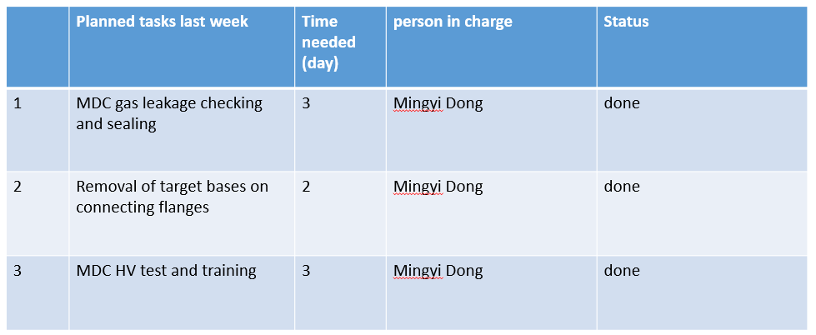

**Summary：**

1. After sealing, the average leakage rate is about 3 ×10 -5 pa m3/s on both sides. The leakage rate of special point (-X axis on east side, +Y on west side ) is about 2 ×10 -4 pa m3/s, which is acceptable
2. Removed the target bases on the connecting flanges on both sides
3. Large leakage current was found on two preamplifier boards ( W13-12, and W19-16) during MDC HV training. They will be fixed in this week

**Plan for next week**

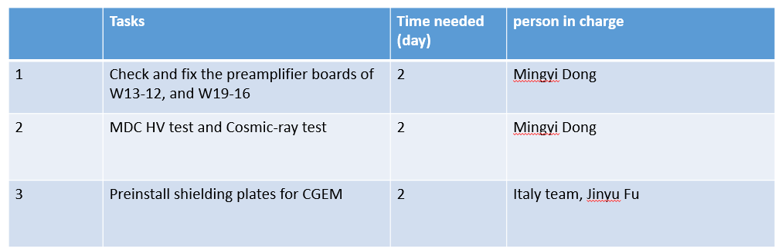

**CGEM installation report: Michela Greco, (**[**Slides**](https://indico.ihep.ac.cn/event/24070/contributions/171506/attachments/83962/106724/CGEM%20operations_27-1%2C%20October.pdf)**)**

**Summary：**

1. BESIII trigger connection to our system: in operation from October 25 after fine-tuning;
2. HV: Few problems due to incorrect cabling have been resolved: all HV sectors are properly switched on for all layers;
3. Grounding is in progress

Copper braid wrapped with insulating tape from the detector to the low voltage crates, from the high voltage crate to the building earth.

1. Connection of optical fibers-eastside-is possible. Length is enough but we have to protect them. Work in progress.

**Plan for next week**

1. I have checked tower21 and 22 by endoscope camera, no particular things were found. If you want to replace the two preamplifier boards, I will have to remove our HV boards and DLVCP.

Mingyi: Yes, thank you very much

1. DAQ/SC : some operation scan start, but we have to coordinate.
2. DAQ: GEMROC/FEB configuration
3. SC: HV preliminary operations
4. GAS: who is in charge of the SC?

Mingyi: Yinhong Zhang is in charge of the gas SC. He have already contacted Giulio.

**Questions:**

Zheng Wang: How is the progress of the gas system?

Xiaolan: Now only one pipe is connected to the CGEM. The CGEM gas for each layer will be separated.

Yinhong: The slow control system will be ready next week.

Mingyi: How is the progress of ordering the mass flow meter for CGEM gas system?

Xiaolan: I need the specification of the mass flow meter for ordering.

Michela: The specification of the mass flow meter has already sent to you by email. But I will check and send it to you again.

**Progress and plan of DAQ and SC: Tingxuan Zeng, (**[**Slides**](https://indico.ihep.ac.cn/event/24070/contributions/171505/attachments/83961/106723/CGEM%20TDAQ%20progress%2020241103.pptx)**)**

**Progress of**  **CGEM DAQ**

* Designed the hardware deployment
* Installed and tested of the New Serial Port Server
* Integration of FEE configuration is almost complete, still some functions that need to be refined with FEE experts.
  + Config GEMROCs in FEM module instead of front readout module.
* Help to run the system to provide trigger signals from EMC.

**Plan for next week:**

* Cabling, 1~2 day
* Adjust software configuration, 1~2 days
  + 1 VME crate -> 2 VME crate
* Begin commissioning with the detector once the system is available for our use.