**BESIII Inner Tracker Upgrade Meeting**

**(Nov.11, 2024) 14:00 - 16:00pm (Beijing Time)**

**Meeting agenda and minutes**

* Indico page: https://indico.ihep.ac.cn/event/24154/
* Participants:
  1. Present in the meeting room

Wang Zheng, Haibo Li, Mingyi Dong, Jing Dong, Zeng Tingxuan, Liangchenglong Jin, Giulio Mezzadri, Fu Jinyu

* 1. Online at ZOOM

Qun Ouyag, Gong Wenxuan, Ma Si, Sheng Dong, Ji Xiaolu, Liangliang Wang, Fei Li, Yinhong Zhang, Linghui Wu, Dai Hongliang, Gianluigi Cibinetto, Michela Greco

**Progress and plan: Mingyi Dong (**[**Slides**](https://indico.ihep.ac.cn/event/24154/contributions/172700/attachments/84501/107788/progress%20and%20plan_20241111.pptx)**)**

**Progress of MDC last week**

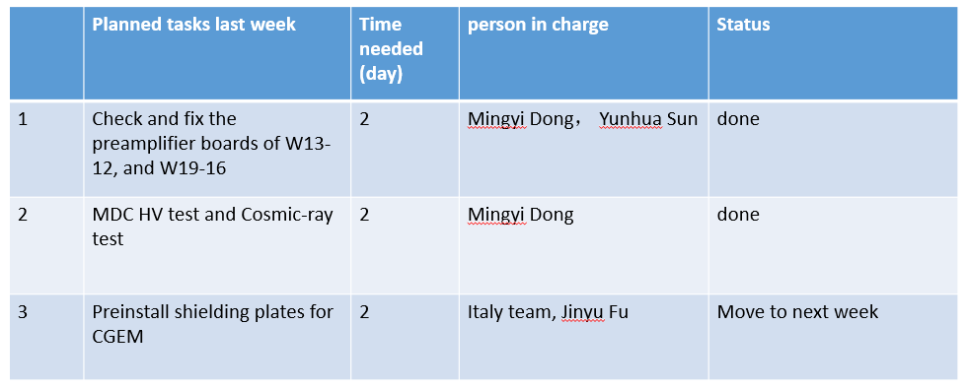

**Summary：**

1. The problematic preamplifier boards were fixed
   1. W13-12 : Removed CGEM boards, disconnected channel 8. This preamplifier board worked well with nominal voltage. And then connected the channel 8. It also worked well with HV
   2. W19-16 : Removed CGEM boards. Found a CGEM screw on this board, which almost touched the resister for HV circuit. Removed this screw, and this board worked well with nominal voltage.
   3. W19-13: Discharge was found during the test. Disconnected channel 6, and this board worked well with nominal voltage
2. All of other layers work stable with operating HV
3. All shielding plates arrived and all components of CGEM HV support structure arrived

**Plan for next week**

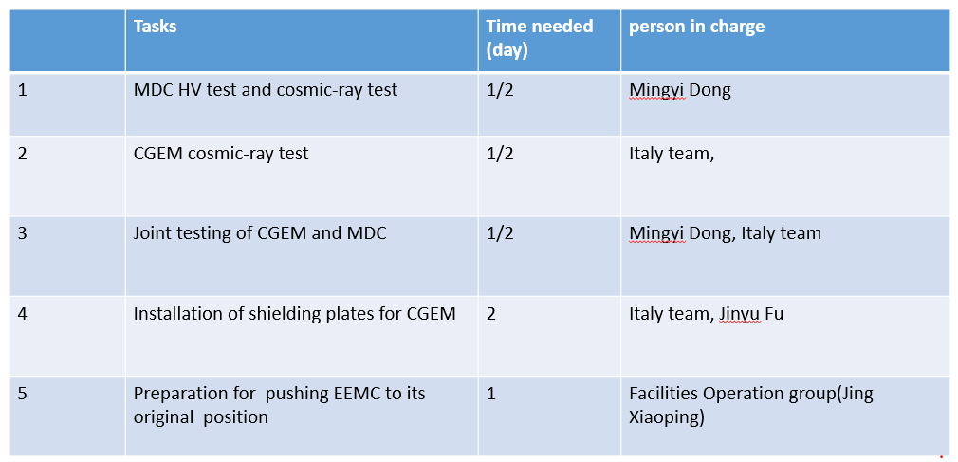

Comments:

Haibo: The joint testing of CGEM and MDC is very important. Some time should be reserved for sufficient testing

**CGEM installation report: Giulio Mezzadri (**[**Slides**](https://indico.ihep.ac.cn/event/24154/contributions/172703/attachments/84507/107796/cgemstatus_111124.pdf)**)**

**Summary：**

1. Grounding

- Copper braid wrapped with insulating tape

from the detector to the low-voltage crates and to BESIII earth

from the high-voltage crate to BESIII earth

from the system fanout to BESIII earth

- Ongoing tests

2. Connection of optical fibers- east side- is possible.

Length is enough but we have to protect them.

- Bought corrugated pipes

- placed in position on Monday 11

- Still needed to connect them on both sides,

Missing one GEM-DC in the VME crate

3. Check of MDC boards

- Tower 21, issue of MDC board (CGEM DLVPCs tower)

-Tower 22, issue to a brass spacer used for CGEM DLVPC (CGEM HV+GNDPC)

- Tower 17, issue of MDC board (CGEM HV+GNDPC)

Long operation, especially for the MDC board in tower 17 due to the very tight space conditions.

Long operation for the cabling of the CGEM DLVPC and HV/GNPCs due to the very tight space conditions;

Some minor problems were recovered.

HV tests underway

**Plan for next week**

1. Outside area

– Mounting HV cable holders

– Mounting LV/Data cable holders

– Preparing cables for EMC pushing and beam pipe insertion

1. Inside the cone:

– Splitting of gas line

– Installing cable holders inside the cone (both west and east).

**Questions:**

1. Giulio Mezzadri: We would like to remove the piece in the right photo, place our holders, and put the piece in the same position as before.

Mingyi: It's okay, but be careful with the pipes and cables fixed to the support structure to be removed

Wang Zheng: Which system do the pipes belong to?

Mingyi: They are gas pipes of MDC

1. Giulio Mezzadri: Shall the CGEM cables follow the shape of the metal parts of EEMC or they can go straight out?

Mingyi: CGEM cables should be placed as close as possible to the metal parts of EMC to ensure installation space for SCQ, and the cables should have a certain degree of bending.

1. Giulio: Is it possible to install the CGEM shielding plate with the EMC in position?.

Mingyi: yes, it is possible, but a specially designed tool is needed to operate and fix the shielding plate.

1. Giulio: Now the trigger is generated by EMC, right? Is I possible to have it from TOF?

Mingyi: Yes. now the trigger is provided by EMC. One trigger module (TOFT) has problem, we are fixing it.