8.6 The Mechanics
8.6.1 The barrel part
(1) Overview and requirements of barrel HCAL
Barrel HCAL is located between magnet and barrel ECAL, which has been shown in Fig.8.6-1 with purple color and a red box. The gap between barrel HCAL and end-cap HCAL is 30mm. Barrel HCAL will be held by two auxiliary rings on both ends. And the auxiliary rings will be fixed with barrel Yoke.
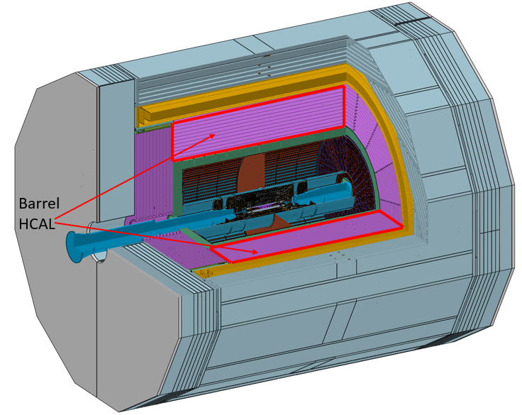
Fig.8.6-1 Location of barrel HCAL
The contour dimension of barrel HCAL has been shown in Fig.8.6-2. The total length is 6460mm except the edge sealings which located in the gap between barrel HCAL and end-cap HCAL. The cross section of barrel HCAL is a regular hendecagon which means barrel HCAL is composed by 16 wedges. The outer hendecagon inscribed circle diameter is 6910mm and the inner hendecagon inscribed circle diameter is 4280mm.
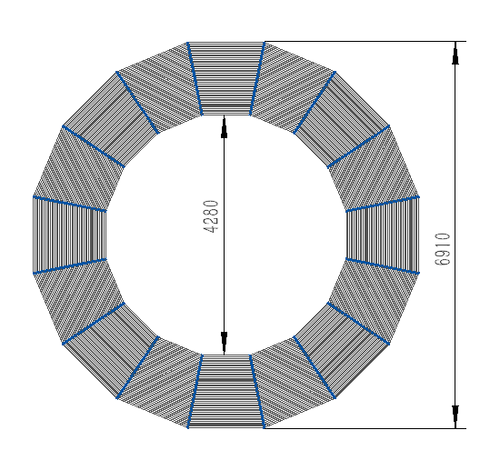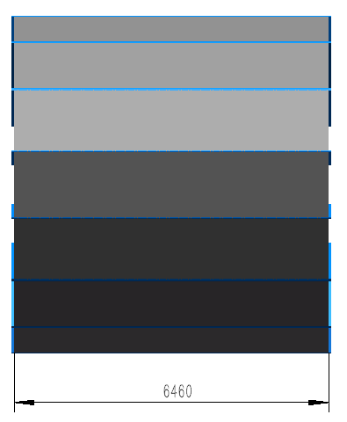
Fig.8.6-2 Contour dimension of barrel HCAL
The requirements for structure are listed here:
- The support structure zone is as low as possible.
- The maximum stress of different materials need to be lower than their allowable stress level.
- The deformation of different materials need to be controlled so that there will be no broken parts under different conditions.
- Outer contour dimension tolerance need to be 0mm to -5mm and inner contour dimension tolerance need to be 0mm to +5mm.
- Collimation accuracy need to be controlled to ±2mm.
- Positioning accuracy need to be controlled to ±0.5mm.
(2) Structure design
a. General structure
Barrel HCAL consists of 16 wedges, the dimension of each wedge is shown in Fig.8.6-3. Each wedge consists of 48 layers of detect module. The cross-section structure of each layer of detect module is shown in Fig.8.6-4.
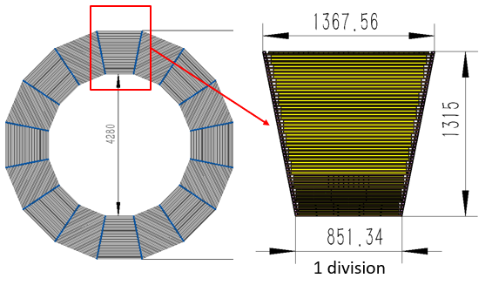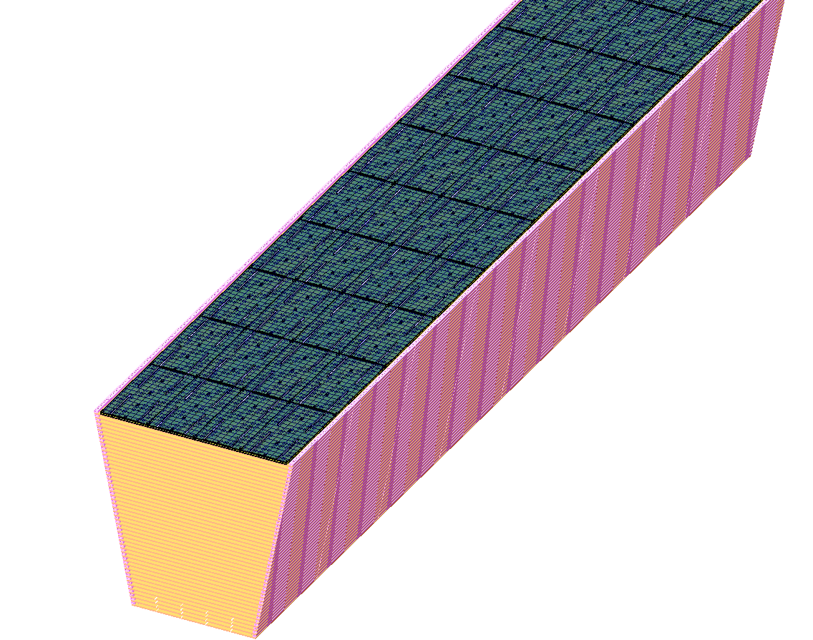
Fig.8.6-3 Structure of each wedge
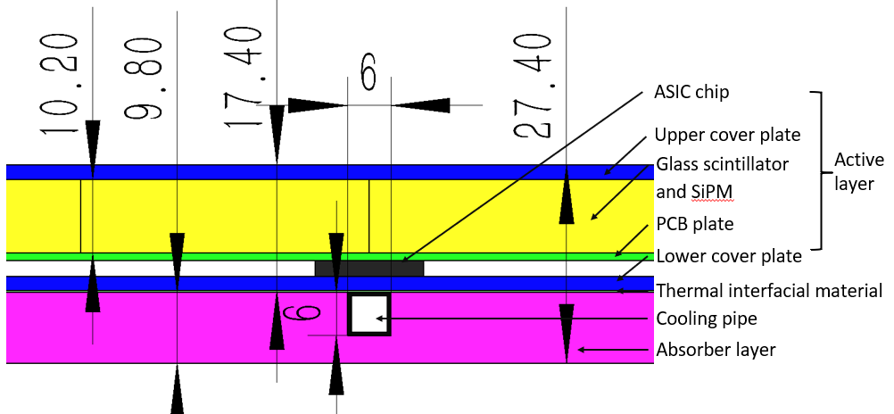
Fig.8.6-4 Cross section structure of each layer of detect module
For each layer of detect module, generally it is composed by one absorber layer and one active layer. But the active layer actually is composed by several active elements. There are three kinds of the elements, the difference among them is the width. The elements dimension and more details can be seen in Fig.8.6-5.
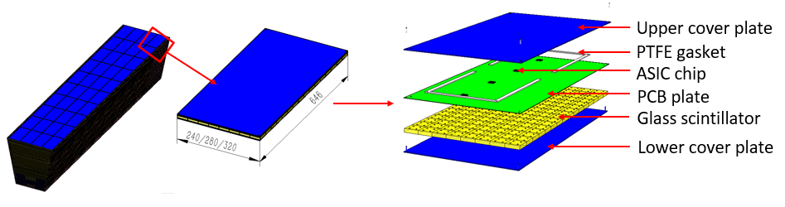
Fig.8.6-5 Elements dimension and more structure details
Each element contains about 128/112/96 cells, cell structure is shown in Fig.8.6-6. It consists of one 40mm*40mm*10.2mm glass scintillator and four 3mm*3mm SiPM.
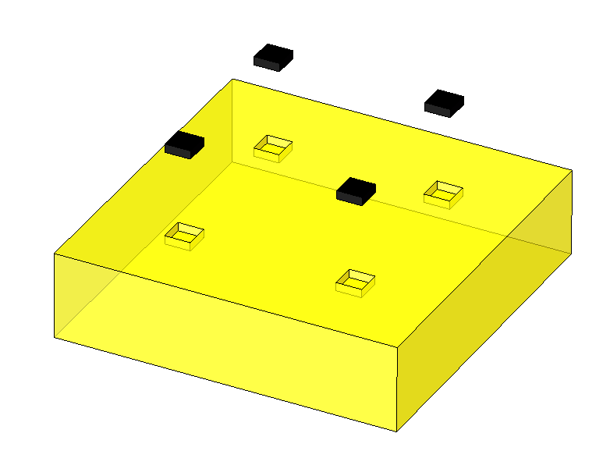
Fig.8.6-6 Structure of one cell
For barrel HCAL, there are totally 200800 cells for each wedge, so the amount of the cell for barrel HCAL is 3212800. The elements amount for each wedge is 1740, for the whole barrel HCAL, the amount is 27840.
Table 8.6-1 lists the weight data. The total weight is about 955 tons.
Items | Weight/wedge (kg) | Weight/barrel (T)
Cover plate | 10287 | 164.6
PCB plate | 390 | 6.2
GS scintillator | 19277 | 308.4
Absorber layer | 27515 | 440.2
Support structure | 1883 | 30.1
Auxiliaries | 350 | 5.6
Total | 59702 | 955.2
b. Connection structure
For each element, the SiPM, ASIC chip and PCB can be regarded as one part. Then a lot of glass scintillators are glued with PCB plate. At 4 corners of the upper cover plate, there are 4 counterbores. At 4 corners of lower cover plate, there are 4 inside thread pipe. For the 4 corner glass scintillators, there is one corresponding drilled hole for each one. Cover plate and other components will be fixed together by 4 M1.6 bolts. The element connection structure is shown in Fig.8.6-7.
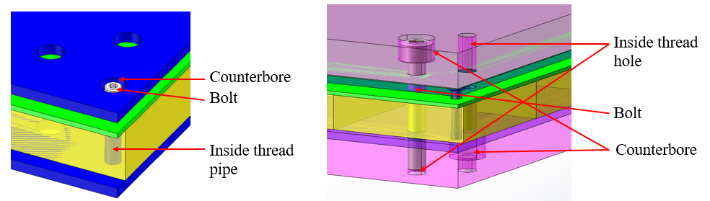
Fig.8.6-7 Element connection structure and element connects with absorber structure
Each element also needs to be fixed with absorber layer during assembling process. From the right picture of Fig.8.6-7, it can be found there is a M5 bolt which can connect the upper absorber layer, the active layer and the lower absorber layer.
The PTFE gasket in Fig.8.6-5 and thermal interfacial material in Fig8.6-4 can be played as buffer layer during assembling procedure.
Between upper and lower absorber layers, there are two support trapezoid beams. The detailed structure can be seen in Fig.8.6-8.
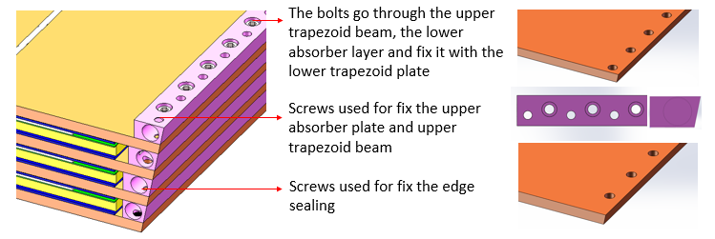
Fig.8.6-8 Connection between two absorber layers
After assembling layer by layer, one wedge will be finished. For the connection between two wedges, the detailed structure can be seen in Fig.8.6-9. They are called edge sealings. There are a lot of counterbores use to connect with trapezoid beams by M8 bolts and M5 bolts are used for connecting edge sealings with absorber layer.
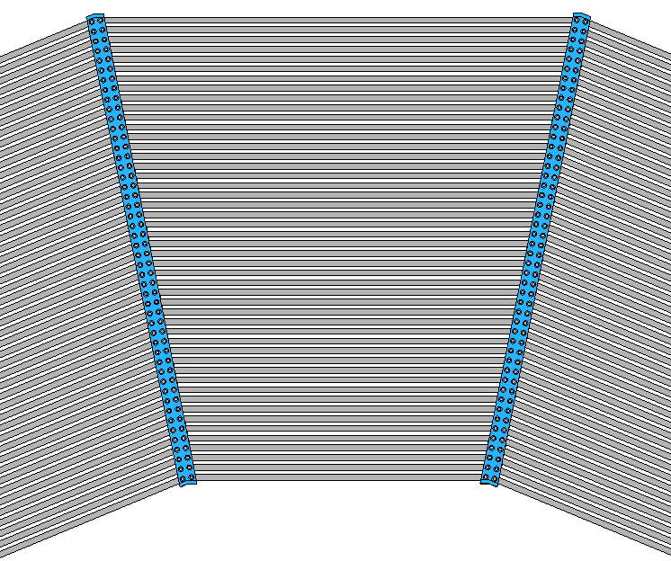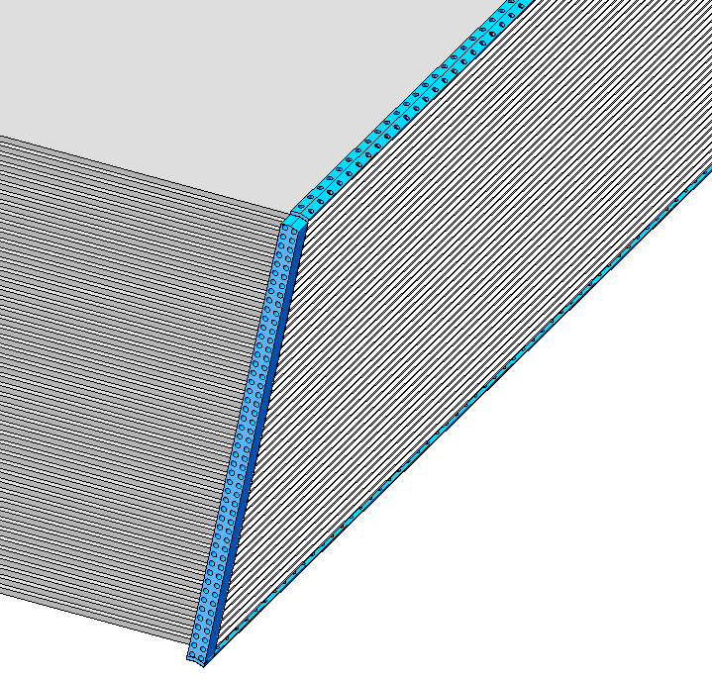
Fig.8.6-9 Connection structure between wedges
c. Interface structure
Barrel HCAL will connect with barrel Yoke by two auxiliary rings. The connection structure can be seen in Fig.8.6-10. The rings will be fixed with barrel HCAL by edge sealings.
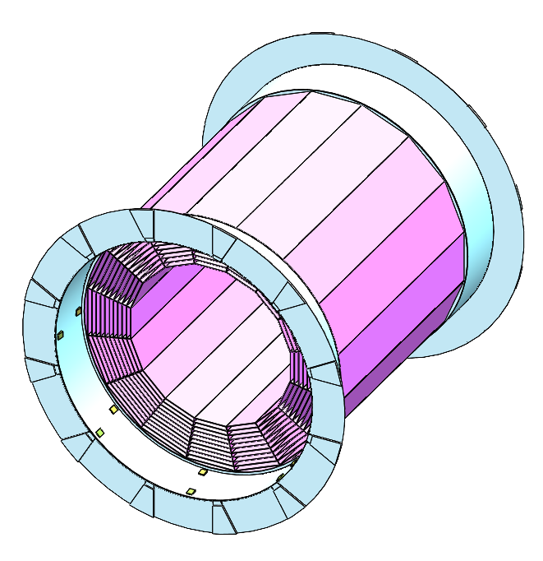
Fig.8.6-10 Connection structure between barrel HCAL and barrel Yoke
(3) Finite element analysis result
a. General structure FEA result
If all the details are input as a model, the mesh quantities will be very huge. So in order to meet the analysis ability of computer, a simplified model has been used. This model just concerns the absorber and support structure. The active layers are just regarded as load which is loaded by absorber. The load actually is like a weight, so the density of absorber material is replaced by equivalent density which concerns all the weight. After simulation, the total deformation result can be obtained from ANSYS. Fig.8.6-11 shows the deformation distribution. And the maximum deformation is about 0.79mm.
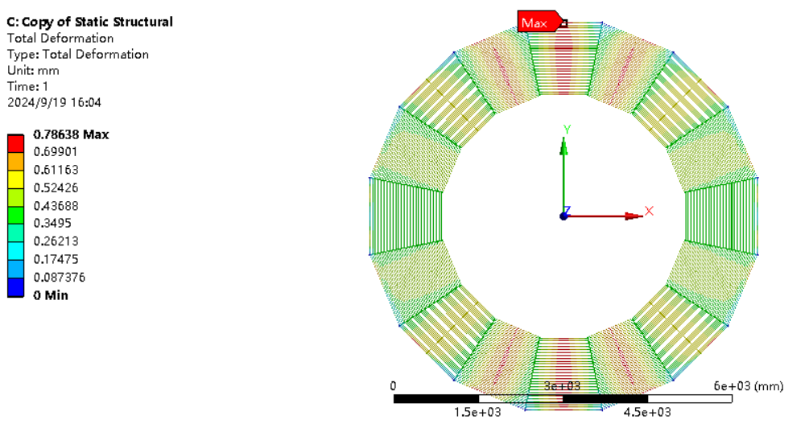
Fig.8.6-11 Deformation distribution of barrel HCAL under self-gravity conditon
The gap dimension will change when it bears the gravity. So we need to know the how much the gap dimension changes and whether it will have some influence on active layer. Fig.8.6-12 shows the deformation of all 48 layers at the same X. It can be concluded that the deformation difference between 48 layer is lower than 0.05mm. Which means if the buffer layer (gasket and thermal interfacial material) can absorb 0.05mm deformation, our structure is safety. The total thickness of gasket and thermal interfacial material is 2.4. So it is feasible for them to deform about 2% (0.05/2.4)
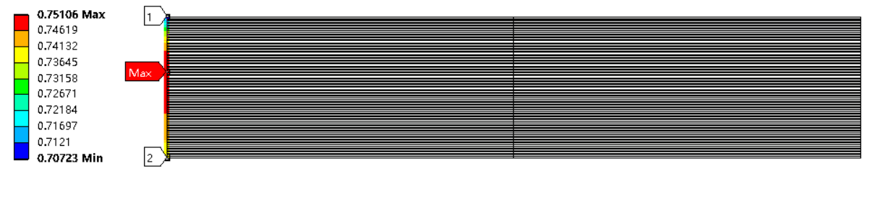
Fig.8.6-12 The deformation of all 48 layers at the same X
The deformation within one layer can be seen in Fig.8.6-13. The result shows deformation difference within 1 layer is lower than 0.7mm. Based on this we need to know when the element is bended and the difference between the lowest point to highest point is 0.7mm, whether the glass scintillator will be broken.
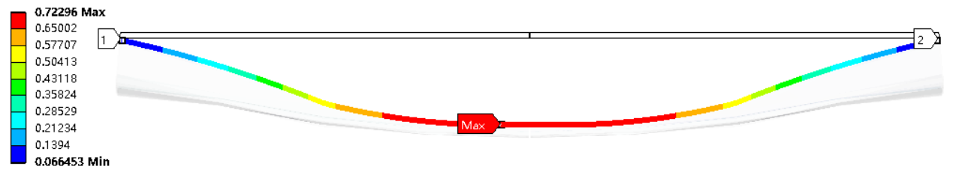
Fig.8.6-13 Deformation within one layer
From the above results, we can conclude that it can meet the requirements for structure.
b. Element FEA result
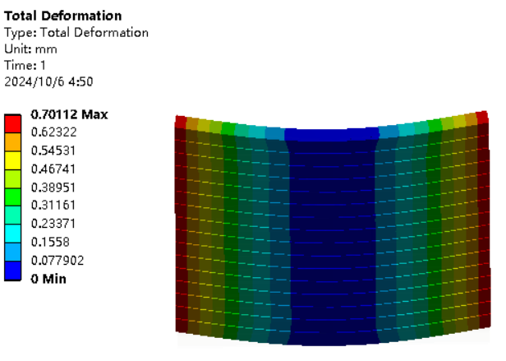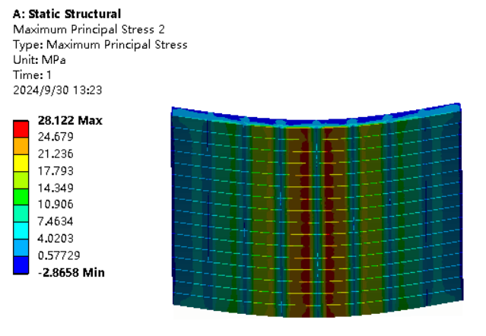
Fig.8.6-14 When the difference between the lowest point to highest point is 0.7mm (left), the stress distribution (right)
Fig.8.6-14 shows the stress to answer the question that when the element is bended and the difference between the lowest point to highest point is 0.7mm whether the glass scintillator will be broken. It can be seen the maximum principal stress is about 28MPa which is lower than its allowable stress 50MPa. So the absorber deformation is acceptable.
Moving condition by manpower also has been studied. Fig.8.6-15 shows the result. Both of the deformation and stress can meet our requirement.
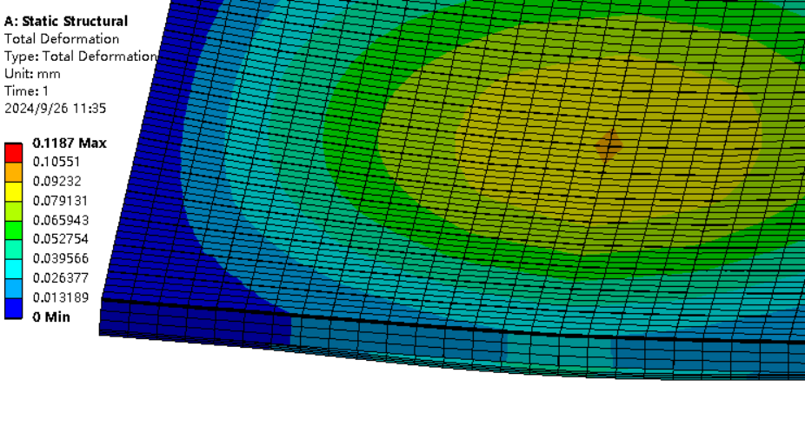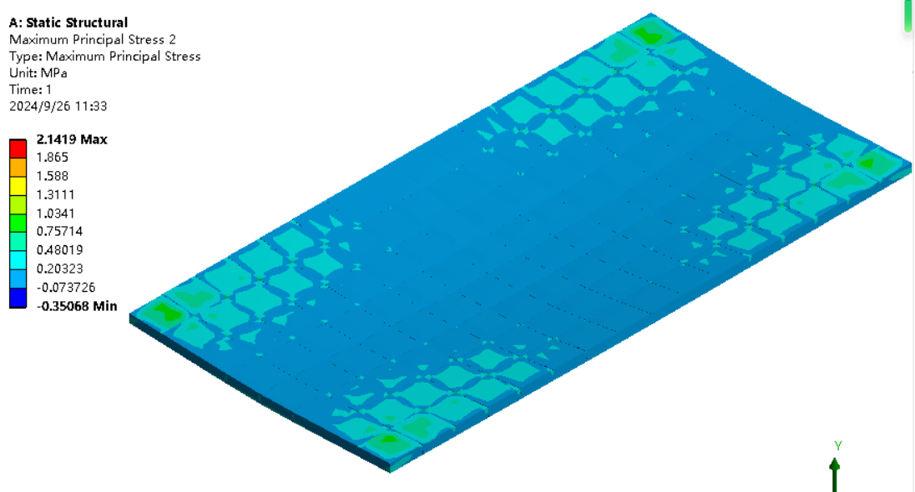
Fig.8.6-15 Moving condition result
(4) Cables routing scheme
Table 8.6-2 shows the quantities and area of the cables. For each elements there are 4 cables. And the diameter of each cable is 2mm. The cables of different elements are seperated and they will not be connected to the neighbour element. Here we just set the 48th layer as an example to show the cable routing which can be seen in Fig.8.6-16. The front and back cable routing scheme is shown in Fig.8.6-17.
Table 8.6-2 The quantities and area of the cables for each wedge.
 | Element quantities/wedge | cable quantities at each end/ wedge | cable area/mm2
1st ~18th layer | 30/layer | 60/layer | 188.4/layer
19th ~48th layer | 40/layer | 60/layer | 251.2/layer
Total | 1740 | 3480 | 10927.2
The assembling procedure can be seen in Fig.8.6-18. If we do like this we can ensure all the cables can be routed out.
8.6.3 Cooling
Cooling structure
For cooling, water cooling structure is chosen. It can be seen from Fig.8.6-4 that cooling pipe is located within absorber layer. Fig.8.6-11 shows the cooling routing schematic diagram for each wedge. More cooling structure for barrel HCAL can be seen in Fig.8.6-12.
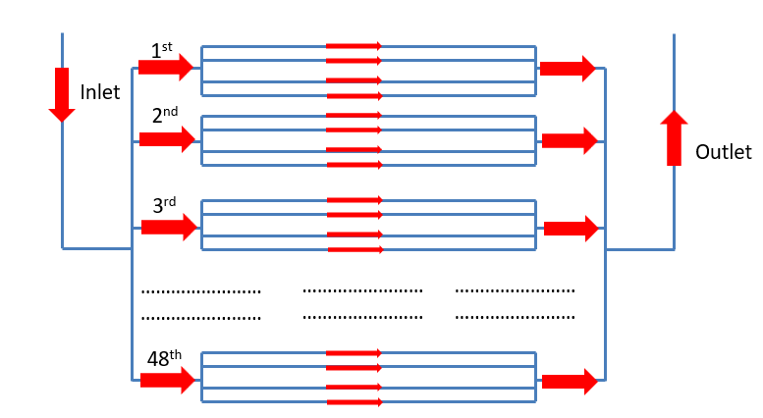
Fig.8.6-10 Cooling routing for each wedge

