**BESIII Inner Tracker Upgrade Meeting**

**(Nov.18, 2024) 15:00 - 17:00pm (Beijing Time)**

**Meeting agenda and minutes**

* Indico page: https://indico.ihep.ac.cn/event/24226/
* Participants:
  1. Present in the meeting room

Wang Zheng, Haibo Li, Mingyi Dong, Zeng Tingxuan, Liangchenglong Jin, Gianluigi Cibinetto, Giulio Mezzadri, Matias melendi

* 1. Online at ZOOM

Qun Ouyag, Gong Wenxuan, Ma Si, Sheng Dong, Ji Xiaolu, Liangliang Wang, Fei Li, Yinhong Zhang, Linghui Wu, Dai Hongliang, Jing Dong, Fu Jinyu, Michela Greco

**Progress and plan: Mingyi Dong (**[**Slides**](https://indico.ihep.ac.cn/event/24226/contributions/173375/attachments/85458/109352/progress%20and%20plan_20241118.pptx)**)**

**Progress of MDC last week**

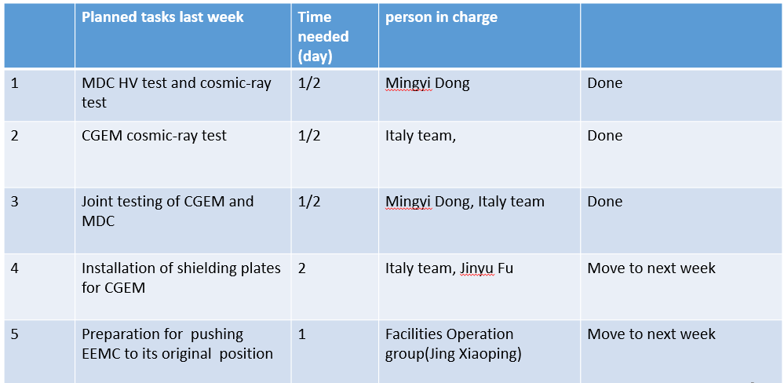

**Summary：**

1. On Nov.12, powered on electronics and HV of MDC and CGEM simultaneously. Both systems could work, but large noise was found in T measurement of MDC.
2. The features of the noise
   1. The noise is mainly in the step part of the drift chamber
   2. The inner layer is the largest, and the outer layer becomes smaller
   3. Noise has a larger impact on time measurement
   4. Noise has a larger impact on the even layers of MDC (readout electronics is at the east end)
   5. Even if CGEM is turned off, there are still several channels with noise
3. Some tests have been done
   1. Grounding test
      1. Change the connection of CGEM ground connection, no big change of noise (Giulio)
      2. Removed the preamplifier of MDC from the “tower”, and disconnected the preamplifier from the “tower” ground. Significant change of noise was found
   2. Test noise with a oscilloscope
   3. Time threshold scan
4. The noise is related to the grounding of CGEM? How to decrease the noise? More tests are needed.

**Plan for next week**

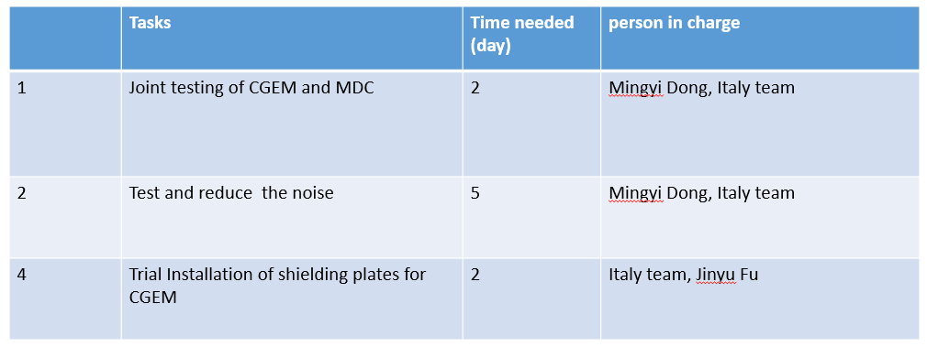

Comments:

More time are needed to solve the noise problem, after discussing with machine people, we plan to change the start date of IP recovery work from Nov. 12 to Nov. 29. (The testing of east SCQ also requires more time)

**CGEM installation report: Giulio Mezzadri (**[**Slides**](https://indico.ihep.ac.cn/event/24226/contributions/173378/attachments/84933/108491/cgemstatus_181124.pdf)**)**

**Summary：**

1. Activities in last week

* 1. Outside area

– Mounting HV cable holders

– Mounting LV/Data cable holders

– Preparing cables for EMC pushing and beam pipe insertion

* 1. Inside the cone:

– Splitting of gas line

– Installing cable holders inside the cone (both west and east)

* 1. We powered on the detector regularly

– everything seems normal

* 1. Powered on together with MDC for the first time, no problem

2. CGEM – MDC noise

* 1. We run few tests on our grounding and on effect of shielding the DLVPC. This is noise on the STEP MDC with almost all the “external” connection disconnected
  2. Test with only few FEB on internal layers power on, accumulated effects of noise were found
  3. Removing the short haul seems to reduce the noise after power on CGEM
  4. Without data short haul no difference between CGEM on and CGEM off
  5. We connected four FEB with four DLVPC outside the cone, also the FEB are outside. Small increase when we power on CGEM
  6. Since yesterday (Sunday) at lunch we disconnected everything from the sockets. CGEM and MDC still connected on the same ground. We are checking where this may happen.
  7. Mingyi and Yunhua connected oscilloscope to a board and we are now able to look at Good channel and Bad channel. Noise seems to be of high amplitude, high frequency, but not continuous (see video)