**BESIII Inner Tracker Upgrade Meeting**

**(Dec.9, 2024) 17:00 - 19:00pm (Beijing Time)**

**Meeting agenda and minutes**

* Indico page: https://indico.ihep.ac.cn/event/24448/
* Participants:
  1. Present in the meeting room

Wang Zheng, Mingyi Dong, Zeng Tingxuan, Liangchenglong Jin, Giulio Mezzadri, Matias melendi

* 1. Online at ZOOM

Qun Ouyag, Gong Wenxuan, Ma Si, Sheng Dong, Ji Xiaolu, Liangliang Wang, Fei Li, Yinhong Zhang, Linghui Wu, Dai Hongliang, Jing Dong, Fu Jinyu, Michela Greco, Gianluigi Cibinetto

**Progress and plan: Mingyi Dong (**[**Slides**](https://indico.ihep.ac.cn/event/24448/contributions/175528/attachments/86042/110280/progress%20and%20plan_20241209.pptx)**)**

**Summary：**

1. After the installation of CGEM, serious noise appeared in the stepped part (Layer 9-20) of the drift chamber.
2. Last Monday, a special meeting was organized and 9 experts were invited to join the meeting on noise issues.
3. After the discussion, the consensus is that the patch cards of CGEM may be the main cause of the noise since they are mounted on the preamplifier “towers” of the MDC. Therefore, it is necessary to shield the patch cards of CGEM and meanwhile improve the shielding of the MDC stepped part.
4. After further discussion and specify the workflow, the related work includes dismounting, adding shielding plates, reinstalling CGEM patch cards, testing, etc., and will be completed on December 23rd.
5. The recovery work of IP will start on Dec.24
6. The accelerator startup time will be postponed from the originally planned January 8th to January 27th
7. The plan was approved by IHEP

**The Detailed plan**

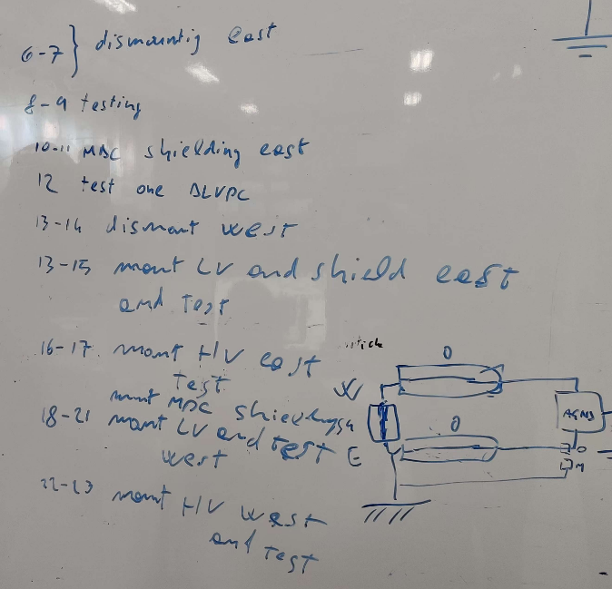

**Testing of the noise: Giulio Mezzadri (no Slides)**

**Summary：**

1. From Dec.6 to Dec.8, we disconnected the connection of CGEM patch cards and removed the patch cards on both sides.
2. After removing the patch cards on the east side, the noise in the even layers of MDC almost disappeared. After removing the patch cards on the west side, the noise of the MDC odd layers almost disappeared. Noise is related to the connection of the patch cards.
3. Even if only one patch card is connected on each side, there will be noise in the corresponding cells of the MDC layer at the corresponding position
4. Connecting one patch card and moving it away from the preamplifier board tower, the noise has not decreased significantly.
5. Connecting one patch card and separating the CGEM LV and signal cables (small cables) from the MDC signal cables, the noise has decreased significantly.
6. Connecting one patch card and shielding the CGEM small cables, the noise has decreased.
7. The baseline noise disappeared again around 13:00-4:30 on Dec.3 (Tuesday), but no related noise sources were found.

**Discussion**

1. The shielding boxes for MDC preamplifiers are producing in the factory. We will get some samples tomorrow ( Dec.10).
2. The drawing of the shielding box for CGEM patch cards will be ready today. After discussion and final confirmation, it will be sent to the factory for manufacturing.