**BESIII Inner Tracker Upgrade Meeting**

**(Dec.23, 2024) 15:00 - 17:00pm (Beijing Time) Meeting agenda and minutes**

* Indico page: https://indico.ihep.ac.cn/event/24610/
* Participants:
  1. Present in the meeting room

Mingyi Dong, Haibo Li，Xiaolan Luo，Zeng Tingxuan, Liangchenglong Jin

* 1. Online at ZOOM

Wang Zheng, Qun Ouyag, Gong Wenxuan, Ma Si, Sheng Dong, Ji Xiaolu, Liangliang Wang, Fei Li, Yinhong Zhang, Linghui Wu, Dai Hongliang, Jing Dong, Fu Jinyu, Michela Greco, Gianluigi Cibinetto，Giulio Mezzadri，Michela Greco，Stefano

**Progress and plan: Mingyi Dong (**[**Slides1**](https://indico.ihep.ac.cn/event/24610/contributions/176772/attachments/86513/111045/progress%20and%20plan_20241223.pptx)**)**

**Progress:**

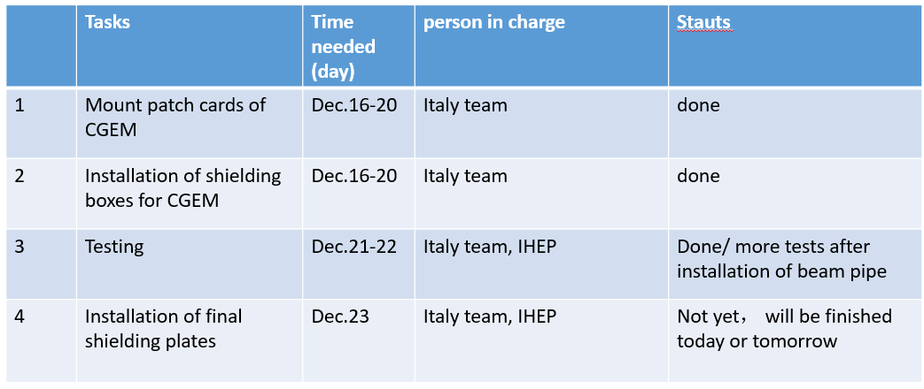

**Plan for this week (**[**slides2**](https://indico.ihep.ac.cn/event/24610/contributions/176772/attachments/86513/111046/Schedule_20241217.pptx)**)**

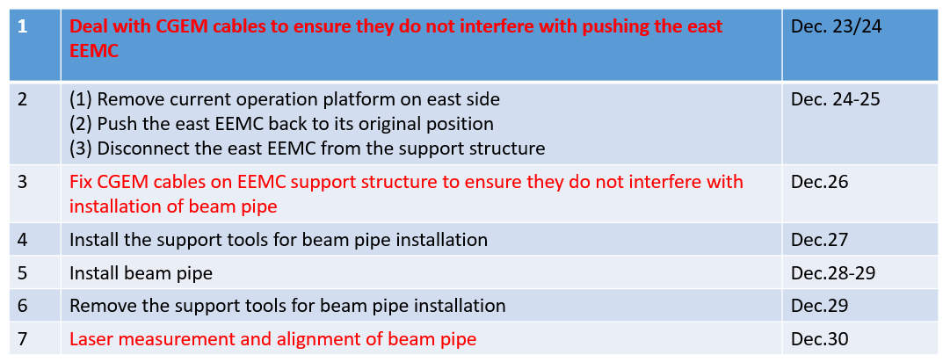

**Summary：**

1. Recovered the CGEM patch cards and installed the shielding boxes for the patch cards from Dec.16 to 20.
2. After the installation of CGEM patch cards and the shielding boxes, cosmic-ray test was carried out, but more tests are needed.
3. Installation of the final shielding plates will be finished on Dec. 23 or 24.
4. As we discussed and planed, due to the project schedule, we will start the recovery work in the IP area from Dec.24

**Progress of CGEM: Gianluigi Cibinetto**

**Summary：**

1. **Shielding Installations:**
   * All MDC and CGEM tower shielding has been installed.
2. **Connection Configurations:**
   * Various connection configurations have been tested. The current configuration minimizes noise for MDC first and then for CGEM.
3. **Noise Status:**
   * With CGEM off, MDC noise is under control according to our checks. However, with CGEM on, the first two step layers are significantly affected.
   * It is important to note that external pickup noise is expected to decrease once the encapsulation doors are closed. However, the noise induced by CGEM remains the primary concern.
4. **MDC Pedestal and Threshold Settings:**
   * It is critical to redo the pedestal and threshold settings for the step MDC now that noise levels have improved.
5. **CGEM Testing Status:**
   * After the additional and unplanned shielding work, CGEM is operational but not fully tested. Extended cosmic runs, as performed in November, have not yet been conducted.
6. **Upcoming Schedule and coordination:**
   * From December 23rd to December 27th, no one from INFN will be at IHEP. I was initially scheduled to go but am unable to travel due to a knee injury.
   * Damiano will be on site starting December 27th. His tasks will include characterizing the detector with cosmic runs and assisting with closing operations.
   * Any operations involving moving, touching, or shielding CGEM components must be discussed in advance with Michela or myself. At least one of us will be available via WeChat at all times.

**Discussion**

1. According to the schedule, the recovery work of the IP area will start. Firstly, in the next few days, we will prepare and install the beam pipe, during which CGEM will have sufficient time for further testing. After installation of beam pipe, the east EEMC will be pulled out again on January 3rd, and it is expected that SCQ will be installed in place on January 9th. During this period, CGEM can still be tested, and if any problems are found, there is a full opportunity to go inside for repairs.
2. Mingyi:

In the past few weeks, due to the installation of shielding boxes for both MDC and CGEM, we did not have the opportunity to test the pedestal and scan the threshold of the MDC stepped part. However, we do have plans to find time for relevant testing during the recovery work of the IP area.

1. Mingyi: In the next few days, CGEM cables should be handled to ensure that they do not interfere with EEMC installation, followed by the installation of beam pipes. Any operations involving moving, touching CGEM components, we will let you know in advance.
2. gg. : It is fine

**Progress of Gas system, Xiaolan Luo (**[**Slides**](https://indico.ihep.ac.cn/event/24610/contributions/176774/attachments/86520/111054/20241223-luoxiaolan.pptx)**)**

Design and installation of the slow control system according to the schematic diagram of the gas system.

1. Local parameter configure and slow control with Siemens Plc system
2. Completed wiring of all modules to local sensors.
3. Waiting to switch the current system to slow control system.
4. Slow control system commissioning needs 1-2days

**Discussion**

gg.: How is the progress of purchasing mass flow meters?

Xiaolan: The order has been placed and it is estimated that these flow meters will arrive in March, 2025