**BESIII Inner Tracker Upgrade Meeting**

**(Dec.30, 2024) 15:00 - 17:00pm (Beijing Time) Meeting agenda and minutes**

* Indico page: https://indico.ihep.ac.cn/event/24747/
* Participants:
  1. Present in the meeting room

Mingyi Dong, Haibo Li， Liangchenglong Jin， Damiano Cabiati

* 1. Online at ZOOM

Wang Zheng, Qun Ouyag, Gong Wenxuan, Ma Si, Sheng Dong, Ji Xiaolu, Liangliang Wang, Fei Li, Yinhong Zhang, Linghui Wu, Dai Hongliang, Jing Dong, Fu Jinyu, Michela Greco, Gianluigi Cibinetto，Giulio Mezzadri

**Progress and plan: Mingyi Dong (**[**Slides**](https://indico.ihep.ac.cn/event/24747/contributions/177690/attachments/86827/111516/progress%20and%20plan_20241230.pptx)**)**

**Progress:**

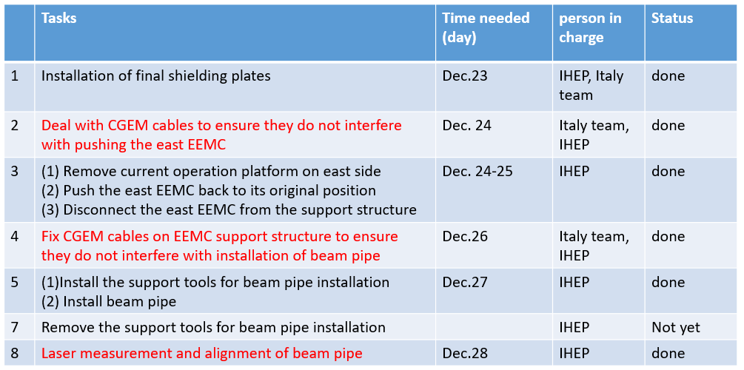

**Plan for this week (**[**slides2**](https://indico.ihep.ac.cn/event/24610/contributions/176772/attachments/86513/111046/Schedule_20241217.pptx)**)**

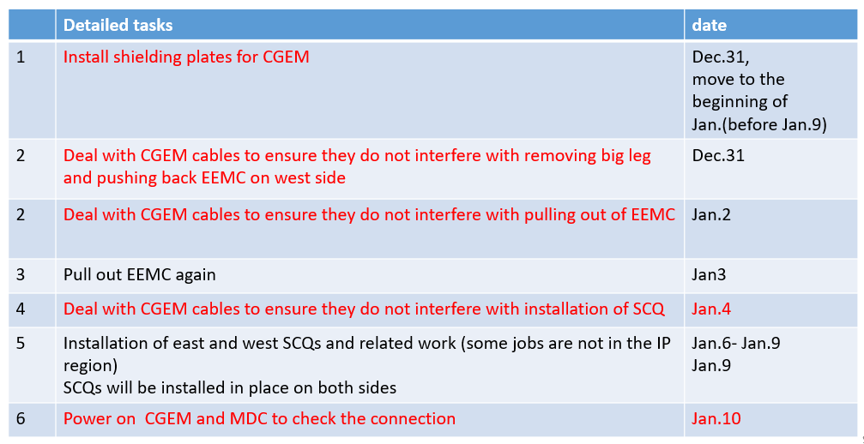

**Summary：**

1. We started the recovery work of IP area as planned on Dec.24

**Discussion:**

1. Damiano: Several abnormal FEBs on east side were found in the tests, possibly due to disconnection at the patch cards.
2. Mingyi: We will remove the shielding plates above the patch cards, and you can check the connection and fix them.
3. Giulio: The installation of shielding plates for CGEM will be moved to next week (before Jan.9).