**BESIII Inner Tracker Upgrade Meeting**

**(Jan.7, 2025) 15:00 - 17:00pm (Beijing Time) Meeting agenda and minutes**

* Indico page: https://indico.ihep.ac.cn/event/24806/
* Participants:
  1. Present in the meeting room

Mingyi Dong， Haibo Li， Liangchenglong Jin， Giulio Mezzadri

* 1. Online at ZOOM

Wang Zheng, Qun Ouyag, Gong Wenxuan, Ma Si, Sheng Dong, Ji Xiaolu, Liangliang Wang, Fei Li, Yinhong Zhang, Linghui Wu, Dai Hongliang, Jing Dong, Fu Jinyu, Michela Greco, Gianluigi Cibinetto

**Progress and plan: Mingyi Dong (**[**Slides**](https://indico.ihep.ac.cn/event/24806/contributions/178265/attachments/87342/112448/progress%20and%20plan_20250107.pptx)**)**

**Progress:**

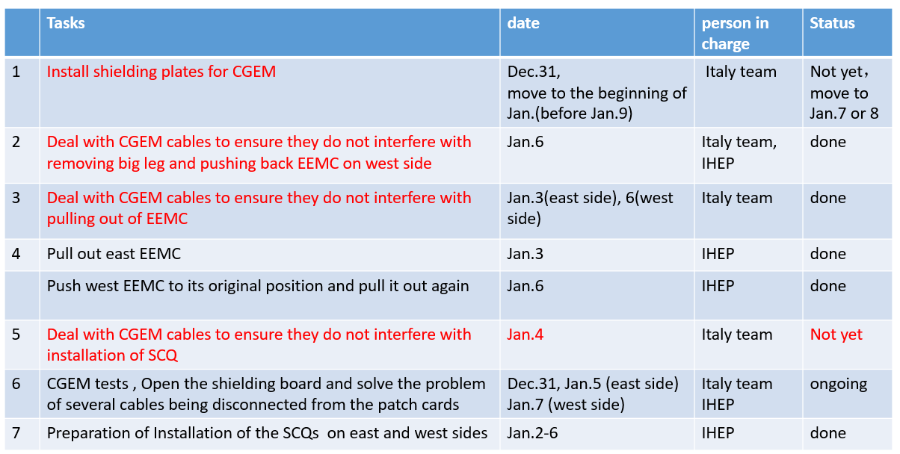

**Plan for this week**

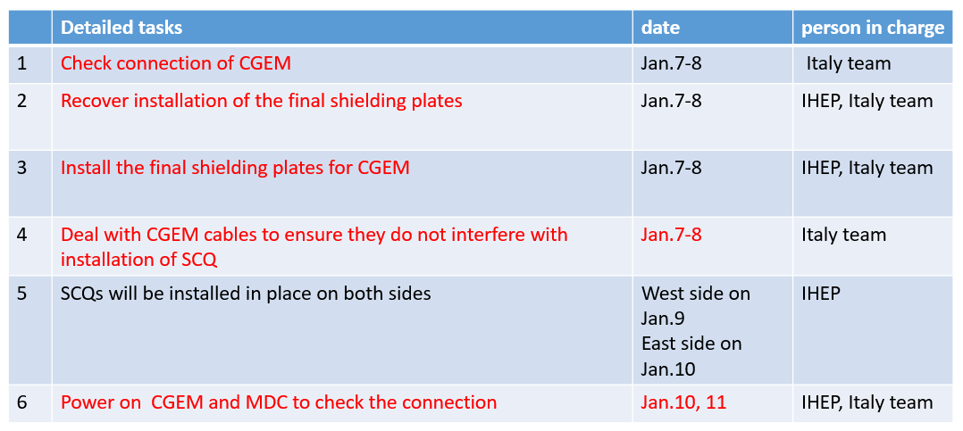

**Summary：**

1. After the installation of shielding boxes for MDC preamplifiers and CGEM patch cards, the base line noise (with CGEM powered off) in stepped parts of MDC decreased, but the noise caused by CGEM (with CGEM powered on) did not change significantly.
2. Before final installation of the final shielding plates and the installation of the SCQ, we will have a Summary and further discussion on MDC noise issues.

**Progress and plan of CGEM: Giulio Mezzadri (**[**Slides**](https://indico.ihep.ac.cn/event/24806/contributions/178266/attachments/86975/111742/cgem_status_07012025.pdf)**)**

**Summary**

1. Thanks for the movement of the CGEM cables for moving EEMC, all the operation were done as smooth as possible.
2. Few TIGERs had smaller issues after the operation, but quickly recovered by Damiano with the help of ChenLong, since some long haul cables were unplugged
3. Discharges on L3:

Several large discharges per hour started from Jan 3 on L3 induction, this will not cause HV TRIP but most likely DAQ will stop. Investigation on going. Investigation is on going

1. Noise issue on L1 east side:

Starting from Dec 30, first run after the operations, we see some huge activity band on L1 east side with the detector off.

**Discussion:**

Giulio: Is there some noise source active on East side and not on the West side?

Mingyi: Almost every equipment is powered off. There should no special noise source on the east side.