**BESIII Inner Tracker Upgrade Meeting**

**(Jan.21, 2025) 15:00 - 17:00pm (Beijing Time) Meeting agenda and minutes**

* Indico page: https://indico.ihep.ac.cn/event/24931/
* Participants:
  1. Present in the meeting room

Mingyi Dong， Liangchenglong Jin， Giulio Mezzadri，Matis Melendi

* 1. Online at ZOOM

Wang Zheng, Qun Ouyag, Gong Wenxuan, Ma Si, Sheng Dong, Ji Xiaolu, Liangliang Wang, Fei Li, Yinhong Zhang, Linghui Wu, Dai Hongliang, Jing Dong, Fu Jinyu, Michela Greco, Gianluigi Cibinetto

**Progress and plan: Mingyi Dong (**[**Slides**](https://indico.ihep.ac.cn/event/24931/contributions/179319/attachments/87594/112811/progress%20and%20plan_20250121.pptx)**)**

**Progress:**

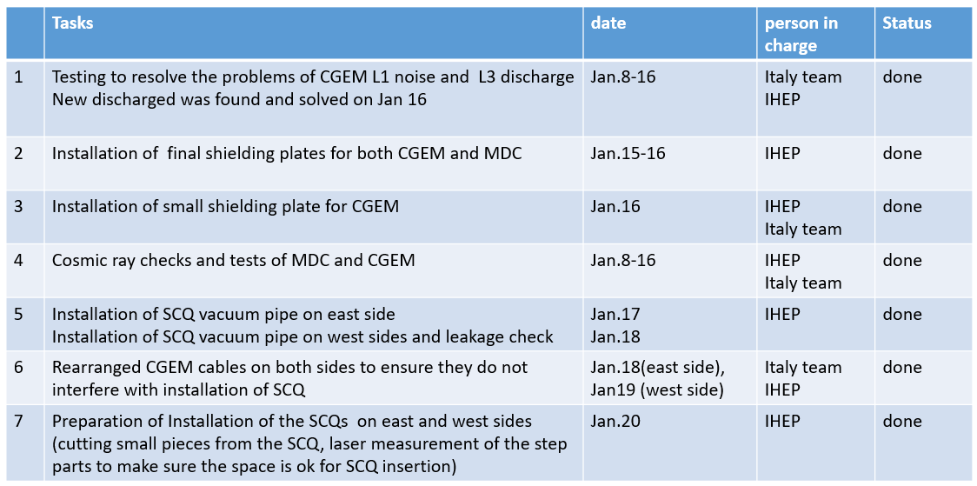

**Plan for this week**

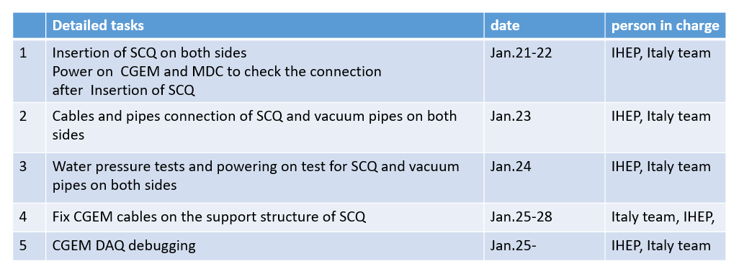

**Summary：**

1. We have finished the installation of final shielding plates for both MDC and CGEM. The machine recovery work in the IP started on Jan. 17
2. The space in the stepped part of MDC was checked. The laser measurement results show that the space is ok for insertion of SCQs.

**Discussion**

1. After the installation of the SCQ, there will no more operation inside the detector. We will have more time to do the DAQ tests. Therefore, we should focus on the CGEM DAQ debugging in the next few weeks. Tingxuan will stay here in Chinese New Year vacation. Experts from Italy group should work together with Tingxuan.

**Progress and plan of CGEM: Giulio Mezzadri**

**Summary**

1. To avoid the disconnection issues, the long haul cables of CGEM were further fixed with cable ties.
2. Discharges on L3:

Several large discharges per hour started from Jan 3 on L3 induction, this will not cause HV TRIP but most likely DAQ will stop. After investigation, we decreased the high voltage by about 40V. It can work stably.

1. Noise issue on L1 east side:

After grounding tests and grounding connection, noise on L1 decreased, but the noise was unstable.