10.6.4 磁体支撑结构

磁力支撑系统用于连接杜瓦和轭铁。主要要求包括两部分。首先，该系统需要使磁铁由轭铁支撑，并且安装和调整要方便。其次，支撑系统需要承受磁体的重力负载以及线圈偏移的负载。

磁体支撑系统的详细设计见图26。轭铁上有12个连接部分，杜瓦上也有12个连接部分。这些连接部分将分别焊接在轭铁和杜瓦上。对于轭铁上的部分，有两个元件，它们之间有100毫米的间隙，用于夹紧位于杜瓦上的支架。它们将通过M56螺栓连接。最终结构如图27所示，螺栓为M56，孔径为62毫米，因此可适应的公差约为3毫米。

已进行不同工况的有限元分析。图28显示了重力作用下支撑系统的变形和应力。表8列出了轭铁侧支撑结构在不同线圈偏移条件下的变形和应力。表9列出了杜瓦侧支撑结构在不同线圈偏移条件下的变形和应力。

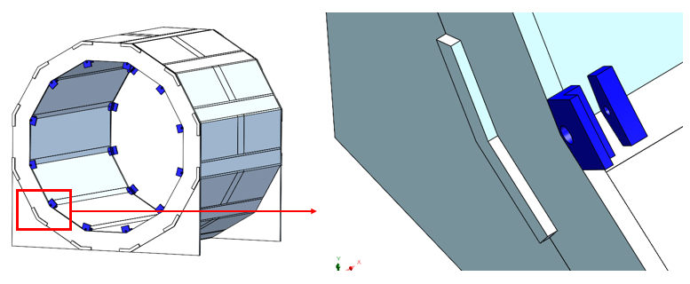

(a) Connection parts located on Yoke

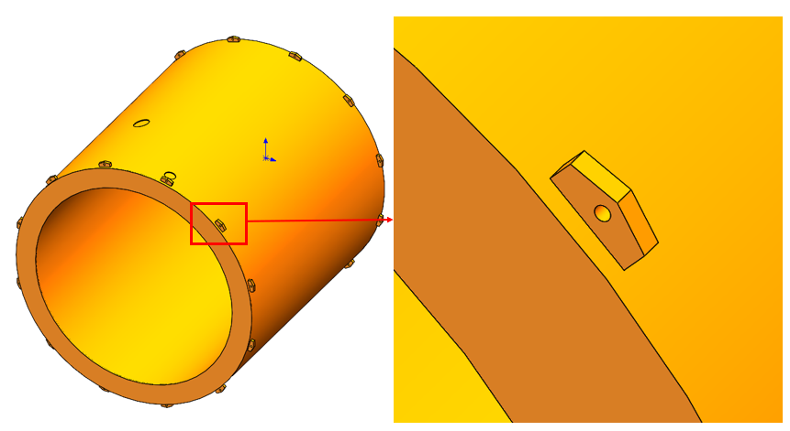

(b) Holders located on vacuum tank

Figure 26 Magnet support system structure

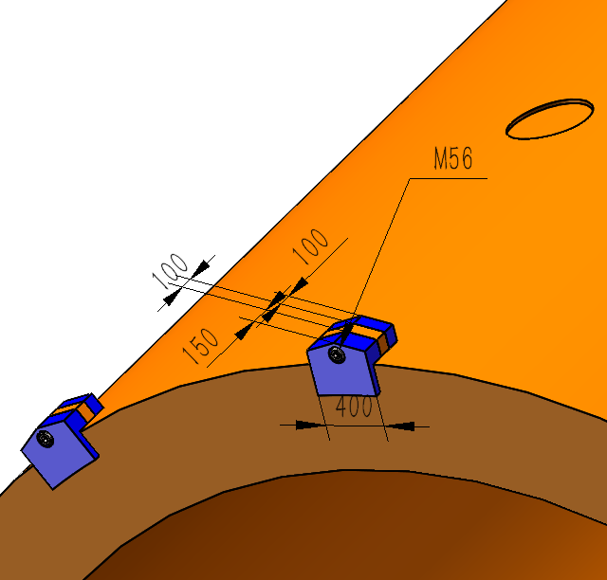

Figure 27 Final connection structure

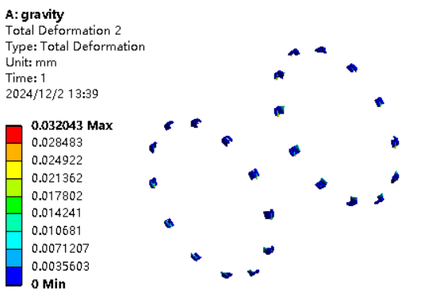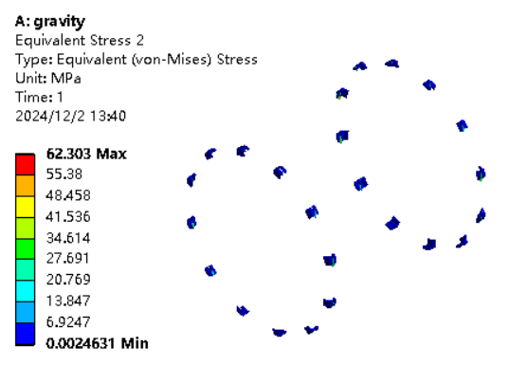

(a) Deformation and stress of support structure located on Yoke

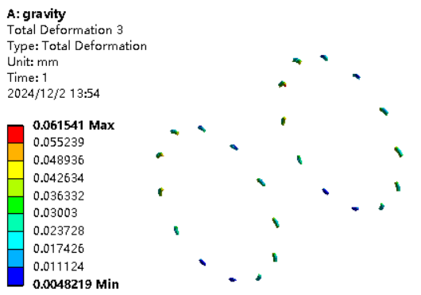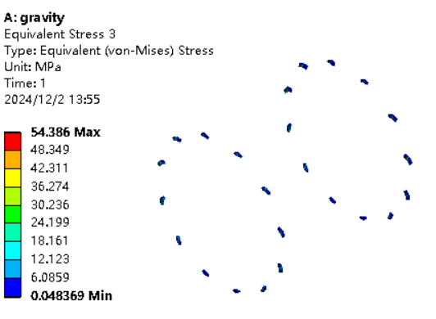

(b) Deformation and stress of support structure located on vacuum tank

Figure 28 Final connection structure

Table 8. Deformation and stress of Yoke support structure under different coil offset conditions

|  |  |  |  |
| --- | --- | --- | --- |
| **Axial displacement (cm)** | **1** | **3** | **10** |
| Deformation (mm) | 0.059 | 0.166 | 0.667 |
| Stress (Mpa) | 61.93 | 71.36 | 278.65 |
| **Radial displacement (cm)** | **1** | **3** | **10** |
| Deformation (mm) | 0.033 | 0.035 | 0.041 |
| Stress (Mpa) | 63.89 | 68.52 | 78.48 |
| **Angular tilt (angle)** | **0.14°** | **0.42°** | **1.41°** |
| Deformation (mm) | 0.038 | 0.056 | 0.091 |
| Stress (Mpa) | 73.93 | 109.24 | 176.82 |

Table 9. Deformation and stress of vacuum tank support structure under different coil offset conditions

|  |  |  |  |
| --- | --- | --- | --- |
| **Axial displacement (cm)** | **1** | **3** | **10** |
| Deformation (mm) | 0.064 | 0.076 | 0.151 |
| Stress (Mpa) | 54.99 | 63.24 | 112.28 |
| **Radial displacement (cm)** | **1** | **3** | **10** |
| Deformation (mm) | 0.063 | 0.067 | 0.077 |
| Stress (Mpa) | 55.46 | 59.48 | 68.13 |
| **Angular tilt (angle)** | **0.14°** | **0.42°** | **1.41°** |
| Deformation (mm) | 0.072 | 0.106 | 0.173 |
| Stress (Mpa) | 61.74 | 87.13 | 138.46 |