- 辐射长度：一个高能电子通过韧致辐射能量损失到1/e所经过的平均路程，公式见下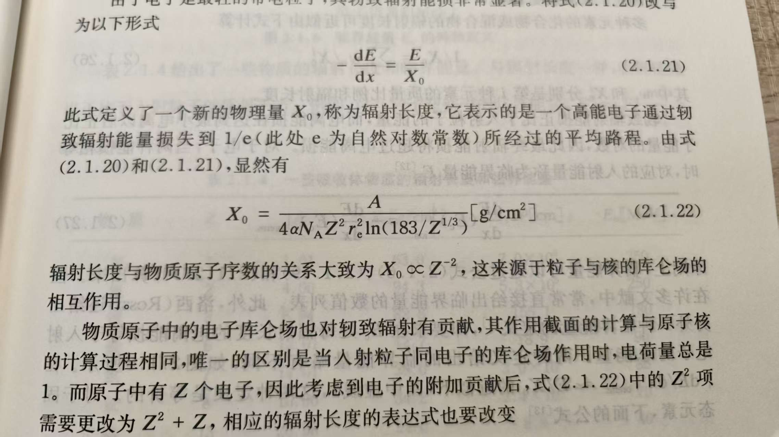核作用长度是描述高能强子与物质发生强相互作用的特征长度，表示高能强子的强度因核相互作用衰减到初始强度的1/e时所穿过的物质厚度。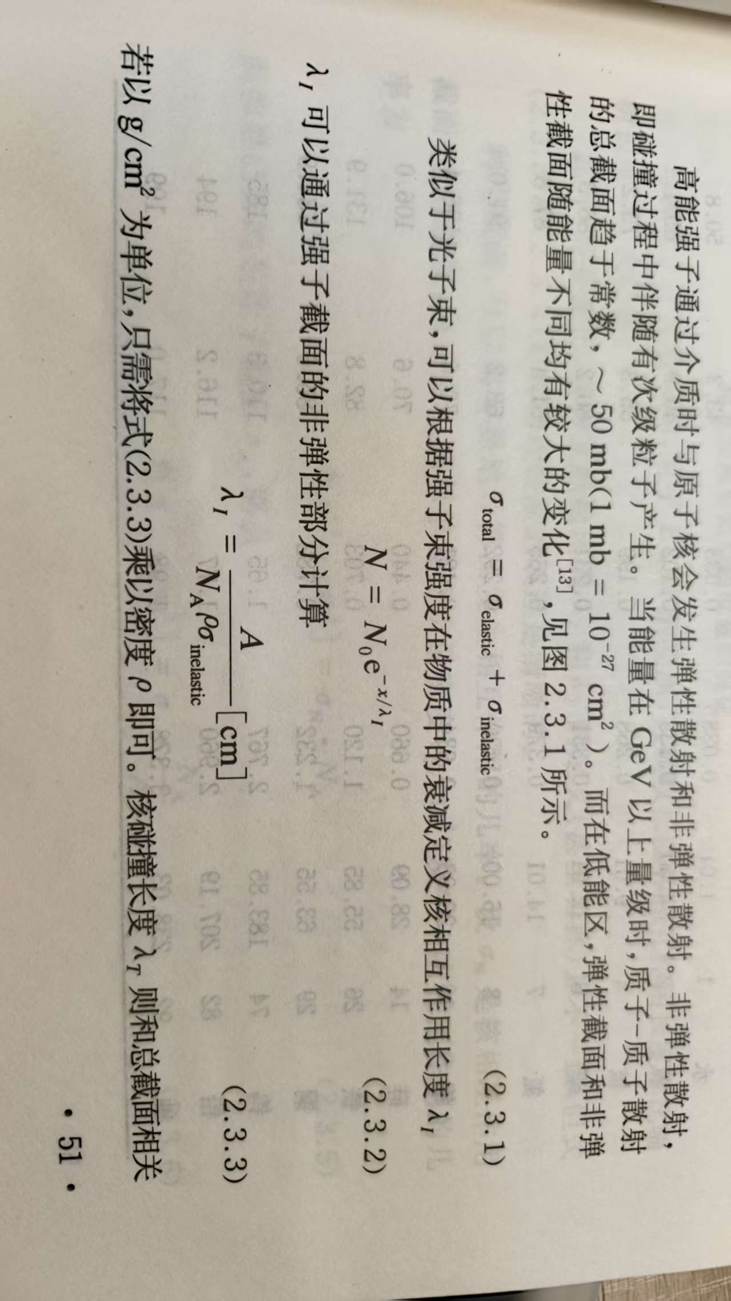
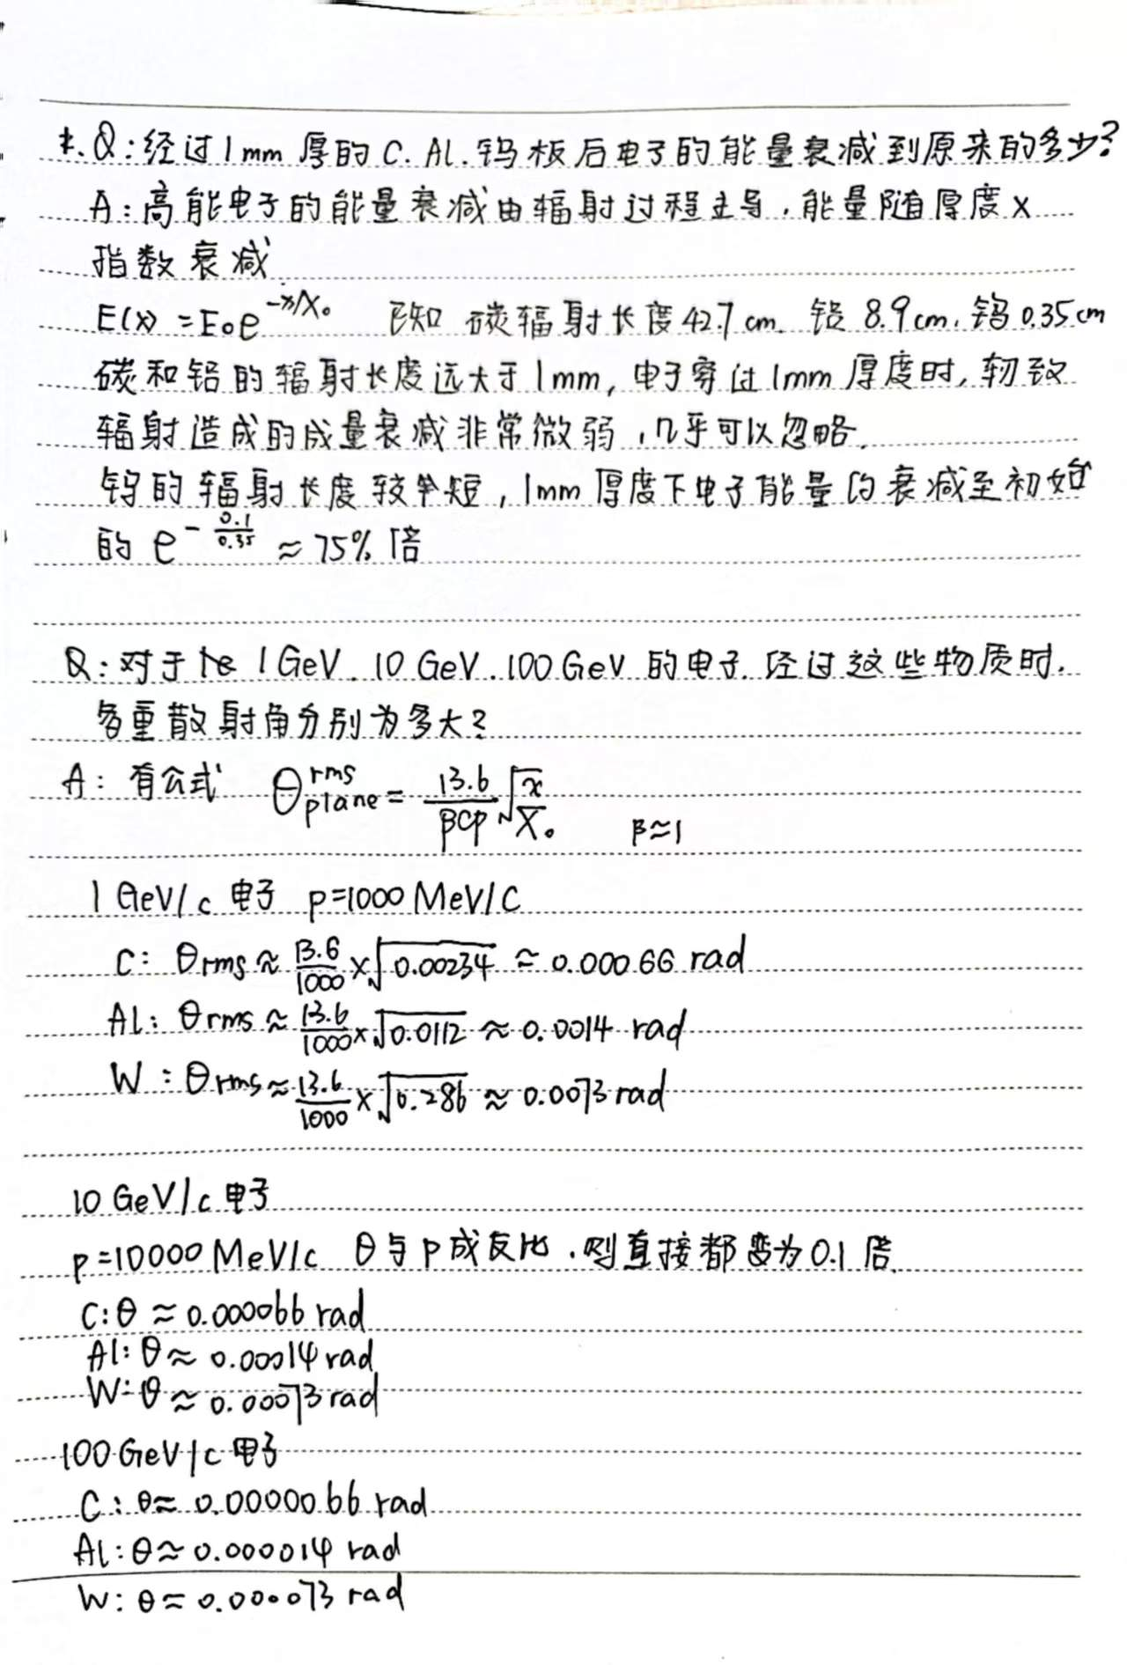当粒子穿越薄的吸收体层时，由于相互作用次数少，能量损失的统计涨落很大，在薄层物质，例如气体中，能损的分布很不对称，更接近于朗道分布而非高斯或者泊松分布；但对于非常厚的吸收层，朗道分布的高段尾部大幅收缩，能损分布可以用高斯分布近似。

第二题
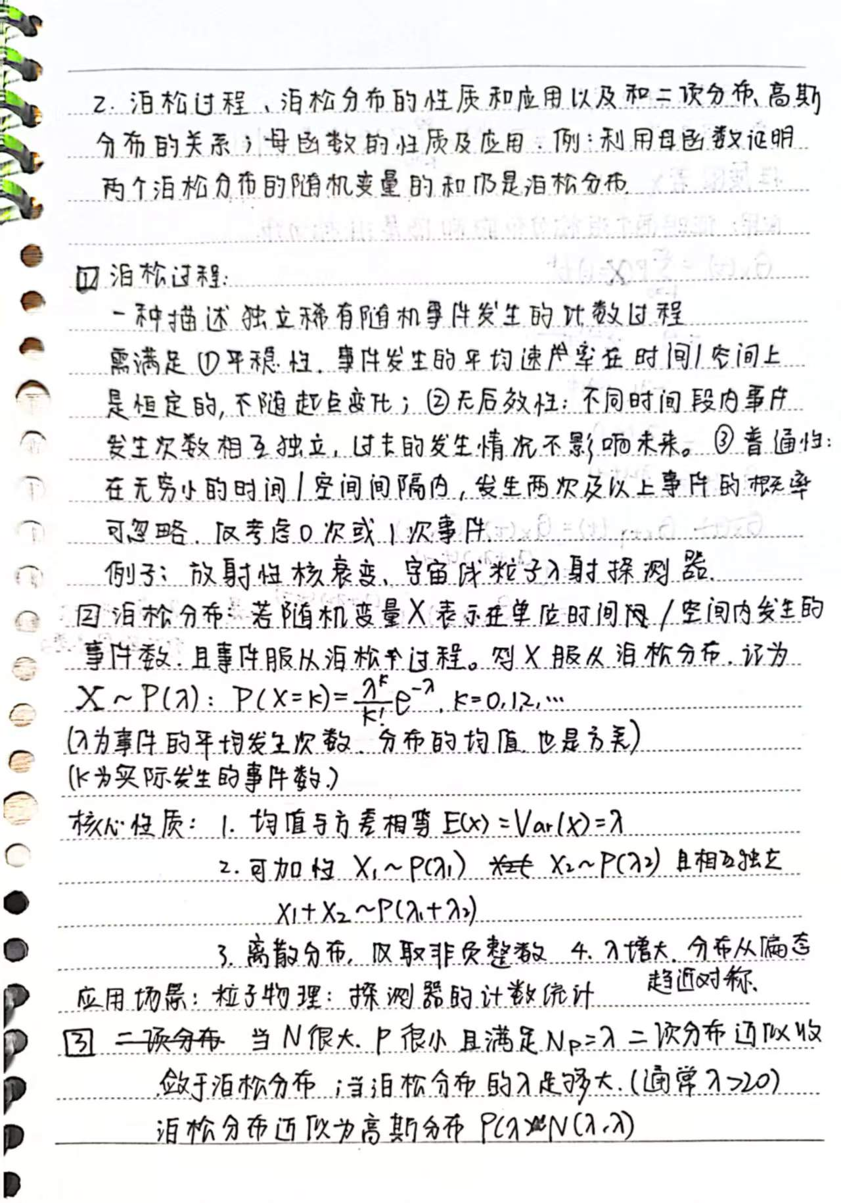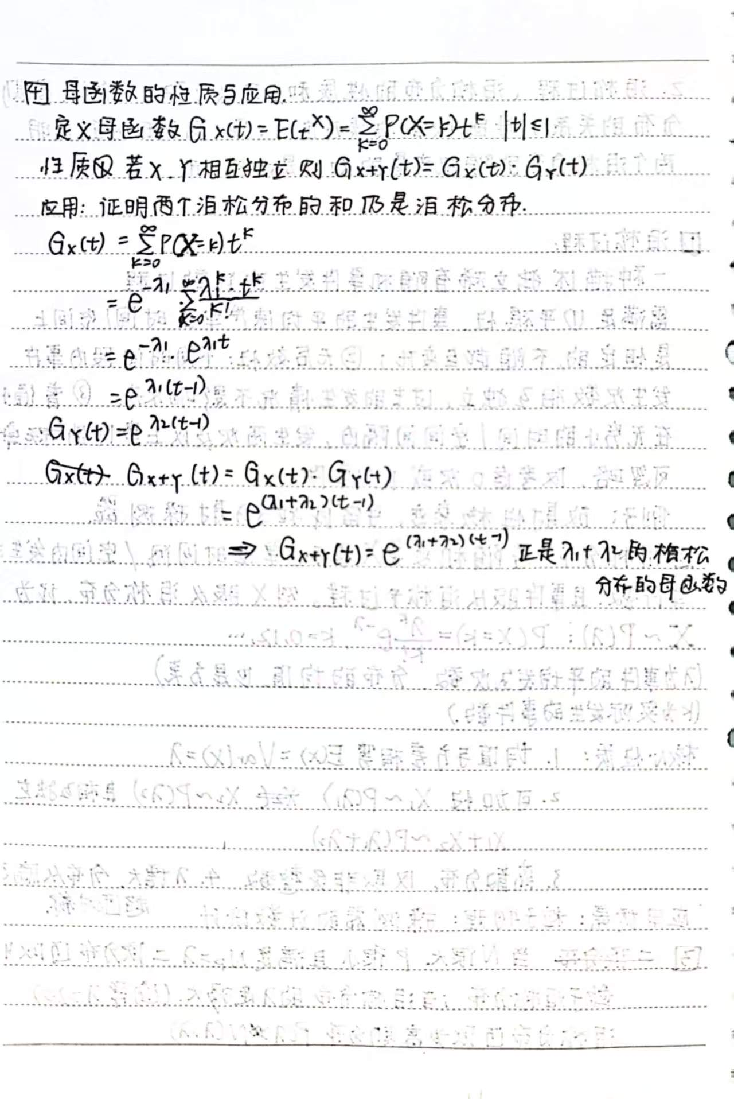

第三题
服从朗道分布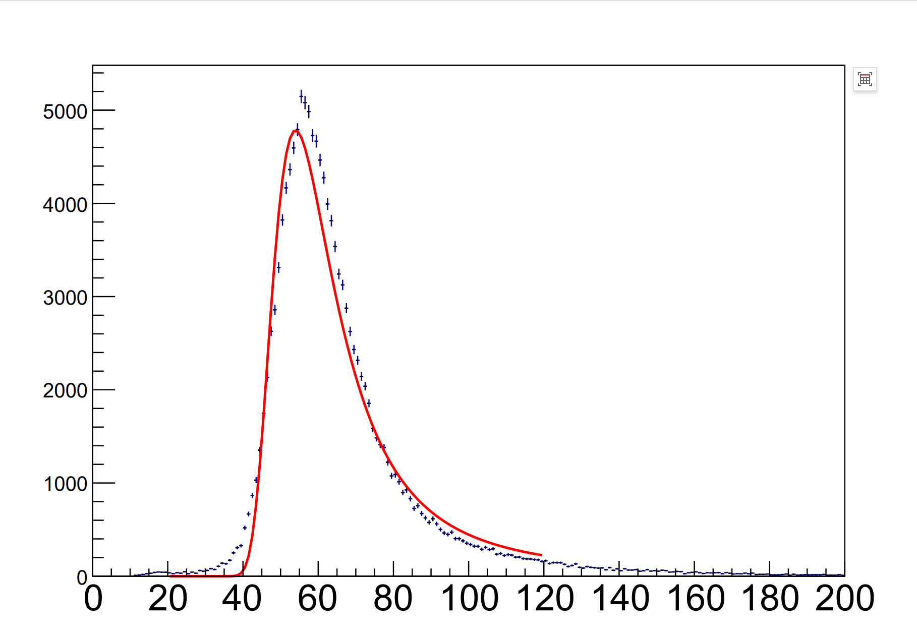
以下是我手敲代码的过程和笔记，效率有点低，下次直接用nano编辑脚本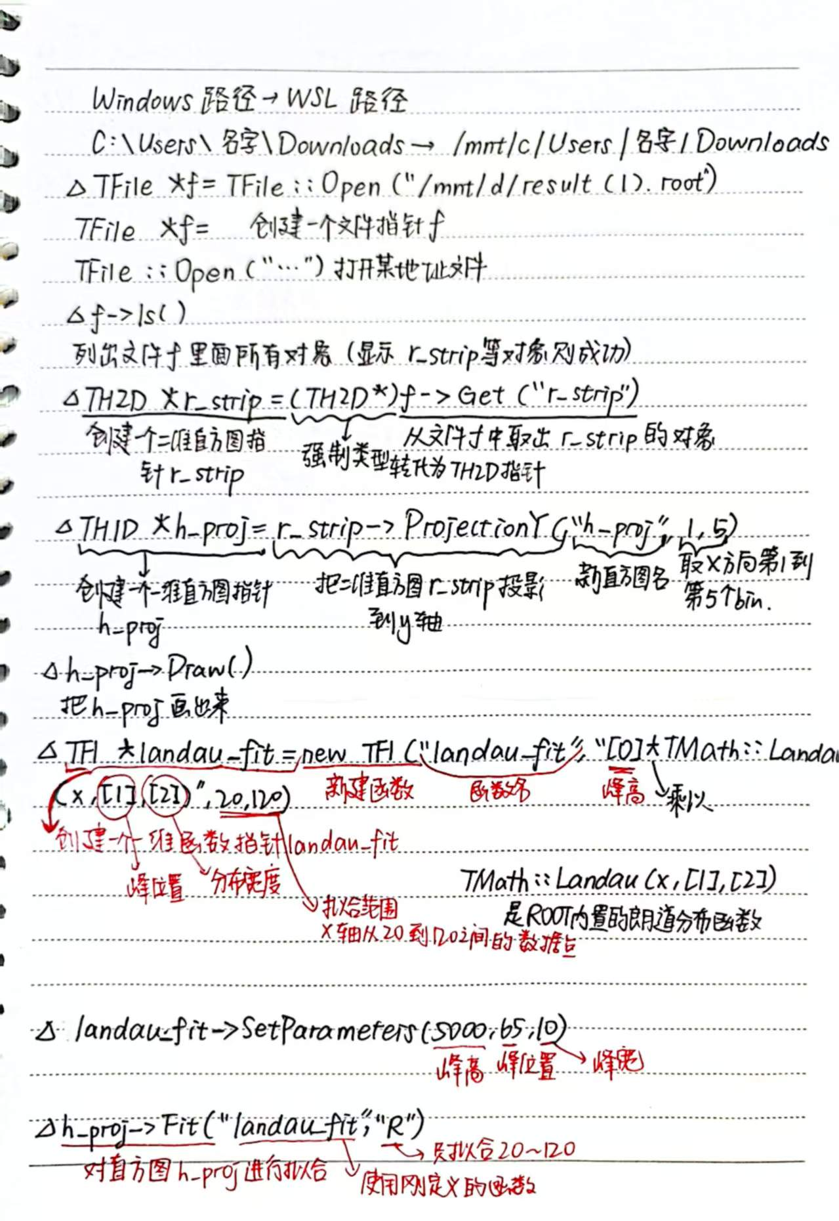
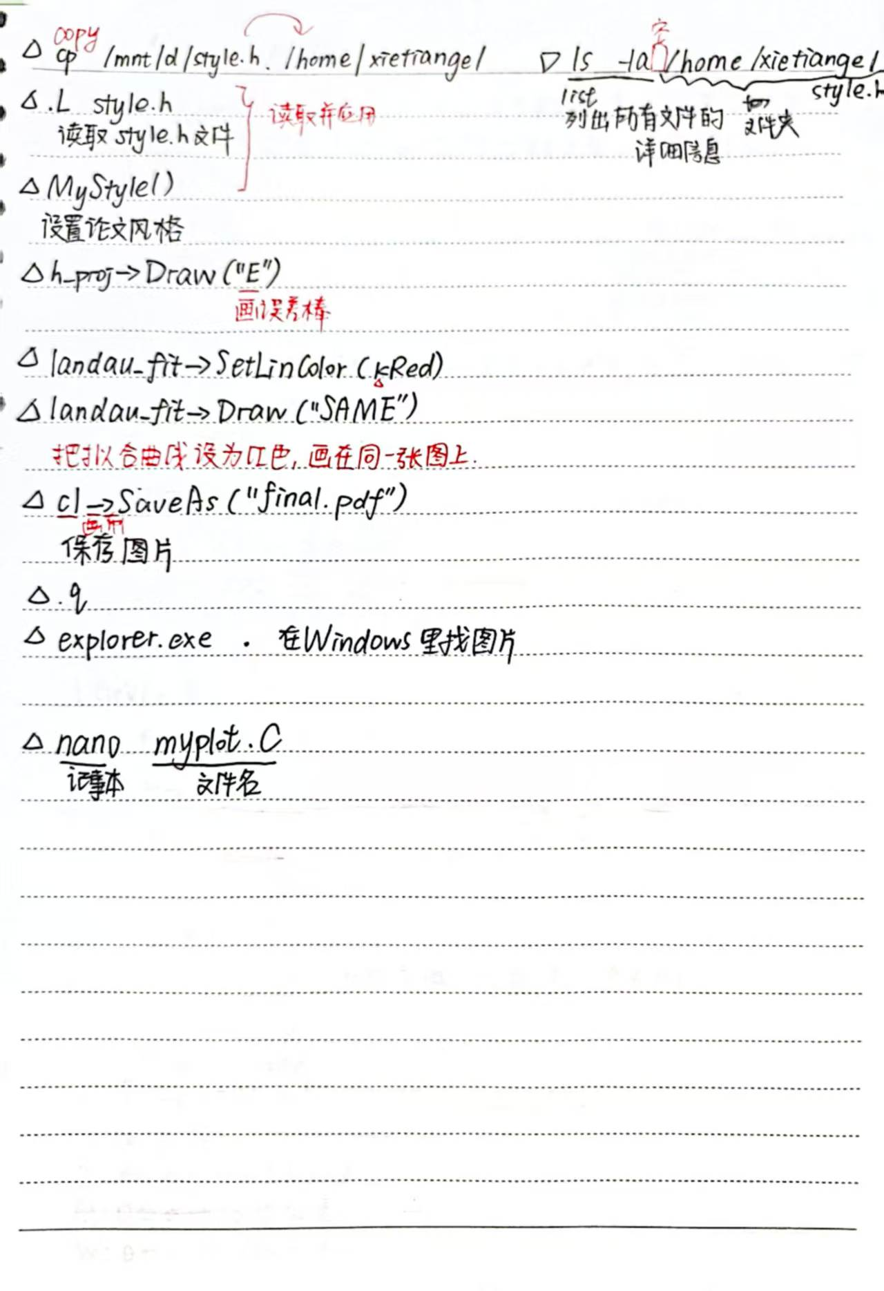 (base) xietiange@LAPTOP-C6DT8GFB:~$ conda activate root_env
(root_env) xietiange@LAPTOP-C6DT8GFB:~$ root
------------------------------------------------------------------
| Welcome to ROOT 6.34.10 https://root.cern |
| (c) 1995-2025, The ROOT Team; conception: R. Brun, F. Rademakers |
| Built for linuxx8664gcc on Aug 01 2025, 09:47:18 |
| From tags/6-34-10@6-34-10 |
| With |
| Try '.help'/'.?', '.demo', '.license', '.credits', '.quit'/'.q' |
------------------------------------------------------------------

root [0] cp /cmd/d/style.h /home/xietiange/
ROOT_prompt_0:2:1: error: expected expression
;
^
root [1] cp /mnt/d/style.h /home/xietiange/
ROOT_prompt_1:2:1: error: expected expression
;
^
root [2] cp/mnt/d/style.h/home/xietiange/
ROOT_prompt_2:2:1: error: expected expression
;
^
root [3] .q
(root_env) xietiange@LAPTOP-C6DT8GFB:~$ cp/mnt/d/style.h/home/xietiange/-bash: cp/mnt/d/style.h/home/xietiange/: No such file or directory
(root_env) xietiange@LAPTOP-C6DT8GFB:~$ cp /mnt/d/style.h /home/xietiange/
(root_env) xietiange@LAPTOP-C6DT8GFB:~$ ls -la/home/xietiange/style.h
error: unexpected argument '-/' found

tip: to pass '-/' as a value, use '-- -/'

Usage: ls [OPTION]... [FILE]...

For more information, try '--help'.
(root_env) xietiange@LAPTOP-C6DT8GFB:~$ ls -la /home/xietiange/style.h
-rwxr-xr-x 1 xietiange xietiange 2575 May 28 22:40 /home/xietiange/style.h
(root_env) xietiange@LAPTOP-C6DT8GFB:~$ TFile *f=TFile::Open("/mnt/d/result.root")
-bash: syntax error near unexpected token `('
(root_env) xietiange@LAPTOP-C6DT8GFB:~$ root
------------------------------------------------------------------
| Welcome to ROOT 6.34.10 https://root.cern |
| (c) 1995-2025, The ROOT Team; conception: R. Brun, F. Rademakers |
| Built for linuxx8664gcc on Aug 01 2025, 09:47:18 |
| From tags/6-34-10@6-34-10 |
| With |
| Try '.help'/'.?', '.demo', '.license', '.credits', '.quit'/'.q' |
------------------------------------------------------------------

root [0] TFile *f=TFile::Open("/mnt/d/result.root")
(TFile *) 0x56e358f1c590
root [1] f->ls()
TFile** /mnt/d/result.root
TFile* /mnt/d/result.root
KEY: TH2D true_fit;1 true_fit
KEY: TH2D true_fit2;1 true_fit
KEY: TH1D chn_dis;1
KEY: TH1D ladder_dis;1
KEY: TH1D angle_dis;1
KEY: TH1D e_dis;1
KEY: TH1D em_dis;1
KEY: TH1D h_end;1
KEY: TH1D chi;1
KEY: TH1D angle;1
KEY: TH1D pos_res;1
KEY: TH2D eta;1
KEY: TH2D cs_all;1
KEY: TH2D r_strip;1
KEY: TH2D f_strip;1
KEY: TH2D strip_num;1
KEY: TH2D eta_pos;1
root [2] TH2D *r_strip=(TH2D*)f->("r_strip")
ROOT_prompt_2:1:25: error: expected unqualified-id
TH2D *r_strip=(TH2D*)f->("r_strip")
^
root [3] TH2D *r_strip=(TH2D*)f->Get("r_strip")
(TH2D *) 0x56e35964b7a0
root [4] TH1D *h_proj=r_strip->ProjectionY("h_proj",1,5)
(TH1D *) 0x56e3593a0090
root [5] h_prog->Draw
input_line_33:2:3: error: use of undeclared identifier 'h_prog'
(h_prog)
^
Error in <HandleInterpreterException>: Error evaluating expression (h_prog)
Execution of your code was aborted.
root [6] h_proj->Draw
ROOT_prompt_6:1:9: error: reference to non-static member function must be called; did you mean to call it with no arguments?
h_proj->Draw
~~~~~~~~^~~~
()
root [7] h_proj->Draw()
Fontconfig warning: using without calling FcInit()
Info in <TCanvas::MakeDefCanvas>: created default TCanvas with name c1
root [8] c1->SaveAs("Primer.pdf")
Info in <TCanvas::Print>: pdf file Primer.pdf has been created
root [9] explorer.exe .
ROOT_prompt_9:2:1: error: expected unqualified-id
;
^
root [10] TF1 *landau_fit=new TF1("landaw_fit","[0]*TMath::Landau(x,[1],[2])",20,120)
(TF1 *) 0x56e35a09a870
root [11] landau->SetParameters(5000,65,10)
input_line_77:2:3: error: use of undeclared identifier 'landau'
(landau->SetParameters(5000, 65, 10))
^
Error in <HandleInterpreterException>: Error evaluating expression (landau->SetParameters(5000, 65, 10))
Execution of your code was aborted.
root [12] landau_fit->SetParameters(5000,65,10)
root [13] h_prog->Fit("landau-fit","R")
input_line_80:2:3: error: use of undeclared identifier 'h_prog'
(h_prog->Fit("landau-fit", "R"))
^
Error in <HandleInterpreterException>: Error evaluating expression (h_prog->Fit("landau-fit", "R"))
Execution of your code was aborted.
root [14] h_proj->Fit("landau_fit","R")
Unknown function: landau_fit
(TFitResultPtr) <nullptr TFitResult>
root [15] h_proj
(TH1D *) 0x56e3593a0090
root [16] landau_fit
(TF1 *) 0x56e35a09a870
root [17] h-proj->Fit(landau_fit,"R")
ROOT_prompt_17:1:3: error: reference to overloaded function could not be resolved; did you mean to call it?
h-proj->Fit(landau_fit,"R")
^~~~
/home/xietiange/miniconda3/envs/root_env/bin/../lib/gcc/x86_64-conda-linux-gnu/14.3.0/include/c++/complex:2586:5: note: possible target for call
proj(const std::complex<_Tp>& __z)
^
/home/xietiange/miniconda3/envs/root_env/bin/../lib/gcc/x86_64-conda-linux-gnu/14.3.0/include/c++/complex:2592:5: note: possible target for call
proj(_Tp __x)
^
root [18] h_proj->Fit(landau_fit,"R")
****************************************
Minimizer is Minuit2 / Migrad
Chi2 = 5103.34
NDf = 97
Edm = 2.0058e-07
NCalls = 114
p0 = 26478.3 +/- 114.985
p1 = 55.1774 +/- 0.0331732
p2 = 5.38488 +/- 0.0205026
(TFitResultPtr) <nullptr TFitResult>
root [19] .L Style.h
Error in <TRint::ProcessLine>: macro Style.h not found in path .:/home/xietiange/miniconda3/envs/root_env/macros
root [20] ls -la /home/xietiange/style.h
input_line_153:2:3: error: use of undeclared identifier 'ls'
(ls - la / home / xietiange / style.h)
input_line_153:2:8: error: use of undeclared identifier 'la'
^
input_line_153:2:13: error: use of undeclared identifier 'home'
(ls - la / home / xietiange / style.h)
^
input_line_153:2:20: error: use of undeclared identifier 'xietiange'
(ls - la / home / xietiange / style.h)
^
input_line_153:2:32: error: use of undeclared identifier 'style'
(ls - la / home / xietiange / style.h)
^
Error in <HandleInterpreterException>: Error evaluating expression (ls - la / home / xietiange / style.h)
Execution of your code was aborted.
root [21] .L Style.h
Error in <TRint::ProcessLine>: macro Style.h not found in path .:/home/xietiange/miniconda3/envs/root_env/macros
root [22] .L style.h
root [23] MyStyle()
root [24] h_proj->Draw("E")
root [25] landau_fit->SetLinColor(kRed)
ROOT_prompt_25:1:13: error: no member named 'SetLinColor' in 'TF1'
landau_fit->SetLinColor(kRed)
~~~~~~~~~~ ^
root [26] landau_fit->SetLineColor(kRed)
root [27] c1->SaveAs("Homework 3.pdf")
Info in <TCanvas::Print>: pdf file Homework 3.pdf has been created
root [28] .q
(root_env) xietiange@LAPTOP-C6DT8GFB:~$ explorer.exe .

