**PREPARING THE SPS complex ALIGNMENT FOR FUTURE LHC RUNS**

P. Bestmann, P. Dewitte, CERN, Geneva, Switzerland

Abstract

The Super Proton Synchrotron (SPS) is the last machine in the LHC injector chain. Operational since 1976 the SPS provides the LHC with a 450GeV proton beam and is not less demanding in terms of alignment than the LHC. At high energy the alignment is playing an even more critical role for the beam orbit, due to the fact that the SPS corrector magnets are designed for only half of the operating energy. Therefore the alignment campaigns are completed by a beam based alignment giving the final corrections for the beam orbit. Like this, the SPS can run with its natural orbit without major corrections.

During the years, ground movements have slowly increased some aperture restrictions, leading to limitations in the performance of the machine. The LHC transfer lines are known to be geologically unstable since their construction.

All these are very good reasons to review the alignment of the whole complex. The LS1 gave the unique opportunity to do this in one single big campaign and to review procedures, techniques and instruments at the same time. This paper will review all the survey activities realised in the SPS complex during LS1 and will present the results of the measurements and alignment campaigns.

## Introduction

The SPS has a circumference of 6.9km and is divided in 6 Sextants with arc and straight sections. A total of 216 resistive quadrupoles and 744 dipoles are the main elements of the SPS.



Figure 1: CERN`s Accelerator Complex

The Long Shutdown 1 (LS1) was initially intended for the upgrade as well as the corrective- and preventive maintenance of the LHC. With the LHC preparing for higher intensities also the injectors are requested to push their boundaries in terms of performance. Within the framework of the LHC Injector Upgrade strategy the first machine upgrades have already been started during the LS1. From the survey point of view the LS1 gave the possibility to improve and correct the alignment of the machine in a much bigger scale than usual.

## SPS ring alignment

### The vertical shape of the SPS is measured and corrected every year during the winter shut-down. The alignment in the horizontal plane is done with a much lower frequency. The last campaign dates back to 2005.

### SPS vertical shape

### The initial levelling measurements started right from the beginning of the LS1 and were done with a Leica DNA03 double run in outward and return. The closing error was 1.1mm for a 6.9 km distance. The datum was fixed using the two deep references in the Long Straight Section LSS2 and LSS5 on two opposite sides of the ring. The 0.4 mm difference between the deep references was averaged.

### The calculations were done as usual with a smoothline approximation which has been used to determine the needed magnet displacements. A total of 92 quadrupole magnets have been realigned in two iterations to get the profile shown in Figure 2. The sextant 6 was treated in a different way due to its particular deviations.

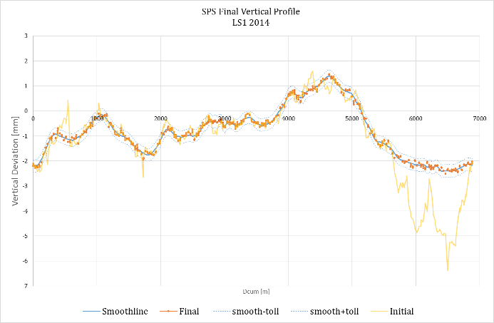

Figure 2: SPS vertical profile before / after LS1

### Sextant 6

Cumulated ground movements due to the LHC tunnel crossing underneath the SPS have built up a sharp excursion of the vertical profile which was limiting aperture and performance of the machine. This excursion was build up slowly over 20 years and the yearly corrections have put all the magnet jacks to their end of range. The Figure 3 is showing the development in the last 30 years. Several corrections have already been done in the past but the ground keeps on moving. It was decided to fully correct this excursion during the LS1 and to shim the magnets in a way to get the jacks back to their centre position, even a bit lower to anticipate the future ground movements. A full sextant of the SPS was concerned including the extraction of the TI2 transfer line to the LHC. The vertical movements to smooth out the excursion were up to 3.5 mm plus another 10 mm shims to put the jacks back in their range. Movements of this amplitude cannot be done with the usual alignment equipment anymore. In addition all magnet interconnections were kept closed which makes this kind of activity even more delicate and needed the support of vacuum and transport teams.

|  |
| --- |
| Figure 3: 30 years of SPS Vertical profile in Sextant 6  The interconnections between the magnets are made with 0.2 mm thick steel bellows and an RF shielding. To keep the interconnections flexible, the shielding is made by small copper fingers sliding on the adjacent beam tube. This system allows transversal as well as longitudinal movements in the range of a few millimetres. But any rotation around the bellow axis bigger than 1 mrad could destroy the bellow and offsets bigger than 3 mm could flip the RF fingers inside the beam tube.  New handling equipment was designed and built to ensure that the interconnections between the magnets were not damaged during this operation. A two actuator hydraulic system with the possibility to balance the volume and pressure between the two actuators was used. During the lifting, the height and rotation of the magnets were controlled with LVDT gauges and digital readouts installed on the movable handling support structures. These support structures were needed to support the magnet during the exchange and shimming of the jacks. |
|  |
| Figure 4: Dipole interconnect handling equipment |

The quadrupoles are supported by three polyurethane jacks. The Polyurethane pieces inside the jacks degrade due to radiation influence. It was decided to exchange all the jacks instead of only re-centring and shimming them.

The dipoles are supported by mechanical jacks without any manual adjustment possibilities. Movements can only be done when the load is transferred to a support structure. About 600 shims have been exchanged to place the jacks in their working range again.

The alignment has been done in three stages due to the fact that all machine elements had to be lifted up without a reference network in the SPS tunnel. The first stage was the realignment of the focussing quads which is basically every second quadrupole. Once they have been lifted up, they were properly realigned in both planes w.r.t. the neighbouring defocussing quadrupoles. As a result every second quadrupole is at the desired new position and the remaining (defocussing) quadrupoles can be aligned to their theoretical position using this time the focussing magnets as reference. The last step was the alignment of the 150 dipoles and other secondary elements w.r.t. the quadrupoles.

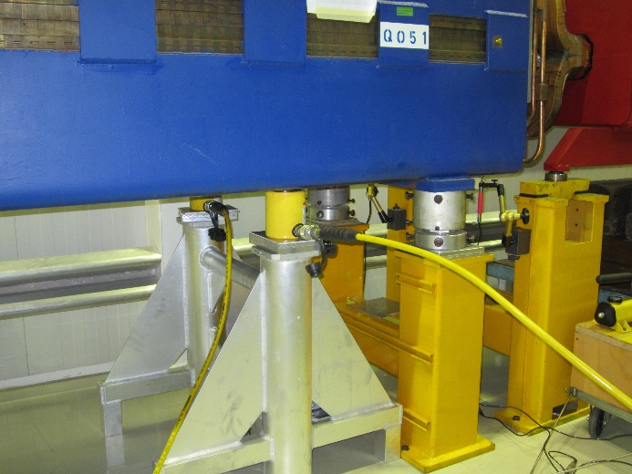

Figure 5: Quadrupole handling equipment

### SPS horizontal shape

The horizontal measurements for the quadrupoles are done using wire offset measurements. The strategy and technique is the same as the one used in the LHC. The wire has a length of 96 m and covers four quadrupoles. The offsets are measured and the wire is moved by one quadrupole. This means that each quad is measured four times, giving excellent redundancy and controlled measurements.

The calculations have been done using the LGC software in one single big adjustment. The datum was fixed using just one point with some radial corridors at the level of the straight sections. This was done to preserve the positions in these regions which are either injections or extractions from other machines, or hosting equipment delicate to move as the acceleration cavities for example. A smooth line approximation was used to determine the magnet displacements. The displacements are calculated and the resulting change of the smooth line is anticipated in order to reduce the iterations. Two iterations are normally enough. Generally the first cluster of displacements is given as relative displacements. These displacements are done in two steps: the first one with the focussing quadrupoles and a second step with the defocussing quadrupoles. The reason to do it in two steps is again to make sure that adjacent magnets are not moved within the same batch. This alignment method guarantees that the calculation of the displacements can be done safely in the right order of displacements. When the results are calculated and confirmed, the second cluster can be displaced.

## Transfert line Alignment

The transfer lines delivering the beam to the LHC are called TI2 and TI8. Both lines are known to be geologically unstable and during the last winter stop in 2012 almost 80% of the TI8 quadrupole magnets had to be realigned in roll angle and vertical direction. This triggered the complete realignment of the TI8 line during the LS1.

### TI8 transfer line

At first the roll angle of the quadrupoles were adjusted and then the levelling measurements using the Leica NA2 optical level were carried out. Due to the important slope of the transfer line, the levelling was done in two steps. During the first step, the reference points in the floor (GGPSOs) were measured in a double run with outward and return measurements from the SPS extraction down to the LHC deep reference in the long straight section 8. The difference of 0.56mm between the two deep references was compensated along the 1.4 km long transfer line. The second step was to measure the quadrupoles w.r.t. the new determined GGPSO reference points. A total of 30 quadrupoles have been realigned in vertical direction before the horizontal measurements could start. This is equal to 38 % as it was expected prior to LS1.

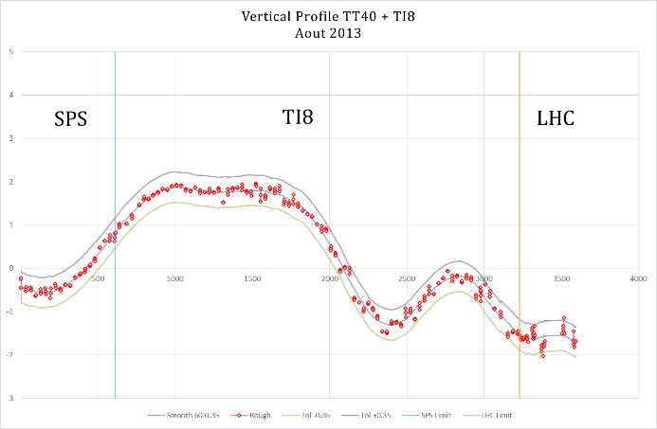

Figure 6: TI8 vertical profile

The baseline for the horizontal alignment was again the use of wire offset measurements. In the case of TI8 some additional AT401 and even T3000 auto collimation measurements have been used to reinforce the wire offset measurements. The strategy for the calculation as well as for the magnet displacement was the same as for the SPS ring. Finally 29 quadrupole magnets have been aligned (some with up to 1.7mm displacements). Afterwards, all dipoles and other secondary elements have been aligned in the vertical and horizontal plane using the quadrupole magnets as reference.

### TI2 transfer line

The TI2 line is a bit more stable, so only the quadrupole magnets have been realigned during the LS1. The levelling measurements have been done with the same strategy as for the TI8. The datum is fixed again on the deep references in SPS and LHC long straight section 2 and the 1.9 mm deviation was compensated along the 1.6 km long transfer line. A total of 41 quadrupoles corresponding to 41 % have been realigned. This includes the extraction from the SPS which was in the centre of the sextant 6. This is the sextant entirely lifted up due to the cumulated ground movements. The first 200m of the TI2 was used to compensate the changes in sextant 6 and so on these 200m all magnets have been realigned in both planes.

The horizontal alignment is again based on stretched wire offset measurements which have been reinforced by AT401 measurements in the extraction and injection regions. 38 magnets have been realigned with displacements smaller than 1mm. This explains why the intermediate components –with a few exceptions- have not been aligned during the LS1.

### TT10 transfer line

The transfer line TT10 is delivering the beam from the PS complex to the SPS complex. The tunnel has been constructed in 1972 and is, with a length of 850 m, one of the shorter transfer lines. Already in the past it showed some cracks at the level of the floor. This time the tunnel showed some serious cracks which are no longer a cosmetic, but a severe stability issue. In addition to the invert heave, the tunnel lining fails showing compression cracks in the crown and tension/shear cracks in the shoulders.

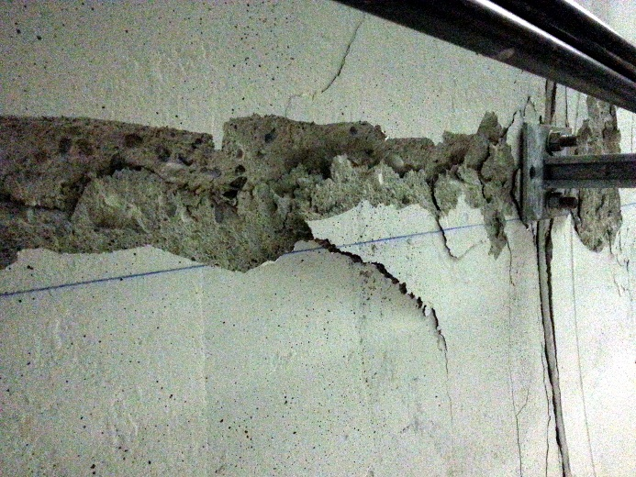

Figure 7: TT10 compression crack on the tunnel crown

It was important to know if the tunnel still kept moving or if all the stress has been released with the cracks. Monitoring profiles have been installed in the concerned area and have been measured regularly using the Leica AT401. In addition, a Laser Scan was done right in the beginning to locate the cracks and to have a base for further analysis.

The profiles have been measured in time intervals ranging from 2 weeks at the beginning to 2 month at the end of the LS1. No significant movements have been observed. In order to reinforce the structure of the tunnel 22 reinforcement steel beams have been installed.

This heavy civil engineering work had to be done without the machine elements in place and so 250m of the TT10 line were dismounted. The machine elements have been measured before and the geometry has been transferred to new reference points below the floor level to protect them from the civil engineering works.

Once the civil engineering work was finished, 53 new reference points have been installed every 15m along the tunnel due to the important slope of 6%. The full set of levelling measurements, wire offset and polygonal measurements using the AT401 have been carried out in order to determine the new network points. Based on this network, the whole TT10 line was realigned in the vertical and horizontal plane.

The network points are playing a particular role for the monitoring of the ground movements in the future. The TT10 tunnel is asking for an independent and absolute geometry control. But, like in the LHC and SPS ring, the magnets will be smoothed using the others magnets as reference independently of the ground movements. Future campaigns will therefore include the network points to monitor the ground movements.

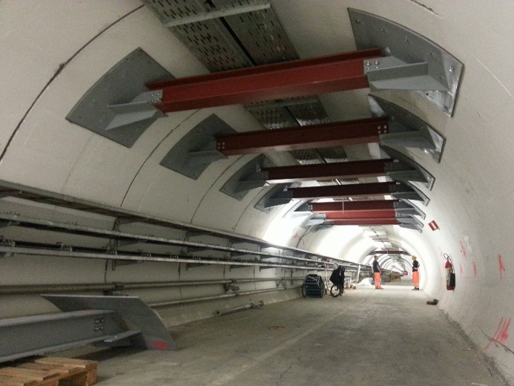

Figure 8: TT10 Tunnel reinforcements

## REINSTALLATION CAMPAIGNS

In addition to the standard activities in the SPS, two large sections of beam line have been removed and aligned from scratch. The reasons are quite different. In the framework of an e-cloud study, 24 magnets (130m of beam line) have been removed from the tunnel during the early stage of the LS1 for a carbon coating of the vacuum chambers.

Before removal of the quadrupoles, their position was transferred to a new installed network of wall brackets. Optical levelling as well as extensive AT401 network measurements have been used to determine this network. One year later the magnets were reinstalled and aligned using the AT401. The control measurements using the stretched wire offsets showed their perfect match with the adjacent magnets. Another example is the cabling campaign in LSS1 where the whole straight section has been removed in order to allow the needed cabling works.

### LSS1 reinstallation

The LSS 1 hosts the beam injection coming from the Proton Synchrotron (PS) through TT10 beam line and the 3 SPS main beam dumps. So the zone became a high radioactive area (High Radiation Area Classification with ambient dose rates exceeding 2mSv/h) with a risk of radioactive contamination. Each year, more and more cables are damaged by radiation. During LS1, a cable campaign was scheduled to change all cables.

An ALARA (As Low As Reasonably Achievable) committee was organized to optimise the work routines to protect the workers during their intervention. The main decision was to remove all beam equipment on the 96m long LSS1.

This was a challenge for the survey team because of the high radiation levels, the LSS1 has not been aligned for almost 10 years. After the equipment removal, we’ll lose all the geometrical references in LSS1 and it was decided to do the measurements in 3 steps:

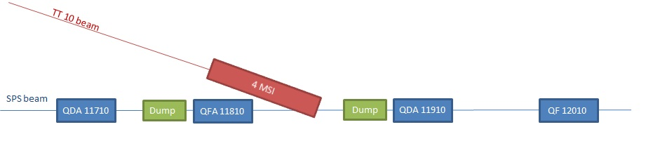

Figure 9: LSS 1 schematic layout

1. Establish a temporary external network and measure the position of the main equipment before removal
2. Aligning the 2 main quadrupole magnets after reinstallation using the external network as reference.
3. Aligning all secondary components using the quadrupole magnets as reference.

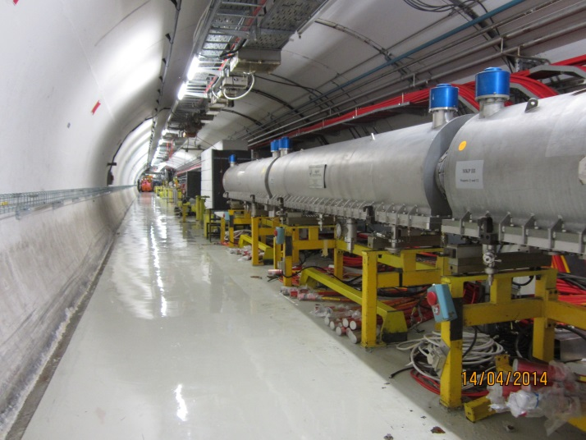

Figure 10: LSS 1 reinstallation

In July 2013, the initial measurements were done. Due to high radiation dose rates and contaminations still present, a work dose planning had to be written to minimize the dose for the survey team. In collaboration with the radiation protection team, four wall brackets and some target holders have been installed in areas where the radiations were acceptable. AT401 network measurements have been used to measure the position of the 4 quadrupole magnets and the key beam elements (two main beam dumps and the MSI magnets making the connection between SPS and TT10). In addition, direct optical levelling was used to determine the wall brackets and the four main quadrupoles in the vertical direction.

One year later, the reinstallation started. The ALARA committee decided to first install the less radioactive equipment and at the end to install the high radioactive equipments like the two beam dumps and the quadrupole magnet QDA 11910. The QFA 11810 quadrupoles magnet was the first magnet installed and it was aligned using direct optical levelling and AT 401 measurements with the external network as well as the QDA 11710 and QF 12010 still in place. All following elements have been aligned with usual alignment method: use of the adjacent quadrupole magnets as planimetric and altimetric references for all secondary elements.

For the last two beam dumps, only the AT 401 was used for the planimetric and altimetric alignment. The beam dumps are motorized to be able to align them without direct contact to the radioactive dump. To further reduce the dose, a remote controlled robot was used for inspection and observation of the spirit level on the beam dumps.

## BEAM BASED ALIGNMENT

The last survey operation before the run period is the beam based alignment. The measurements are done this time by the machine operation team using the beam position monitors around the ring. These are the very final adjustments for the closed orbit at high energy. Starting from about 100GeV the dipole correctors are not strong enough anymore to correct the orbit and the only way for corrections is to move physically the magnets. These movements are stored in the database as voluntary displacements as they improve the orbit. This is done every year before the start up and in 2013 we had cumulated almost 40 magnets with voluntary displacements.

The LS1 was the opportunity to delete them all and to start from scratch with a freshly aligned machine. The beam based alignment is an iterative process. It is an estimation of the best adapted corrector and following this estimation the next quadrupole is displaced in one of the planes to introduce a dipole component, correcting the orbit. This exercise has shown that we find back some old well known candidates with displacements in the same range. This suggests now that there might be a problem with the parameters of this magnet. The number of voluntary displacements is now down to 10 magnets in the horizontal plane and another 10 magnets in the vertical plane. This time the beam based alignment was done using the new Q20 optics instead of the usual Q26 optics. This measured orbit becomes now the reference orbit and is compared all along the run period with the measured orbit. Any change can be a sign of movements or weak magnets.

## CONCLUSION

The LS1 was the unique opportunity to realign almost the whole SPS complex in the vertical and horizontal plane in one single big campaign. Precedent campaigns have taken several shutdown periods to complete. This time, 25 months of work have been squeezed into a period of 14 very intense months. In addition to the well scheduled and planned activities many other people needed our support for their interventions. Some activities like the usual exchange of weak or damaged magnets could be masked by the general alignment campaigns. Others were requesting our direct intervention on short notice with the contractor fully occupied.

The SPS complex was closed the 26th of June on the due date for a period of hardware tests. During the night of the 12th of September the pilot beam was back in the SPS, through the rebuild LSS1 and circulating in the machine. The flat top was reached without any physical correction to the orbit. The 16th and 19th of September the two beam based alignment iterations have been done giving an RMS of 2.36mm in the horizontal and 1.57mm in the vertical plane for the new Q20 optics. This is a very good result and the SPS is ready to deliver beam to the North experimental area, waiting for the LHC to be finished end of this year.

## References

[1] C. Arimatea and G. Roy, “Alignement et surveillance de l’orbite SPS en 2001”, CERN SL-Note-2002-005 MD, Geneva, 2002, CERN, <https://cds.cern.ch/record/702686/files/sl-note-2002-005.pdf>

[2] P. Dewitte, “ LS1 OPERATION DE LISSAGE TT60-TI2”, CERN Measurement Report, Geneva, 2014, CERN, <https://edms.cern.ch/document/1419777/1>

[3] P. Bestmann, “ LS1 OPERATION DE LISSAGE TT40-TI8”, CERN Measurement Report, Geneva, 2014, CERN, <https://edms.cern.ch/document/1419778/1>

[4] C. Podevin, “The smoothing of the SPS Quadrupoles”, CERN Engineering Specification, Geneva, 2009, CERN, <https://edms.cern.ch/document/1012462/1>