Useful information on 2014 ARGO-YBJ general meeting and astroparticle physics workshop
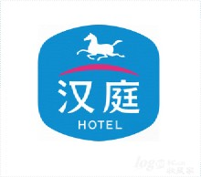

Registration
Date: 19/10/2014
place: HanTing hotel/汉庭酒店成都西南交大店
Address: ErHuan Road 259, JingNiu district, ChengDu, SiChuan / 成都市金牛区二环路北二段259号（距离交大南门左手侧100米左右）

Meeting Room
Place: JingHu hotel, Southwest JiaoTong University /成都市西南交通大学镜湖宾馆
Address:成都市爱华路北一段111号附1镜湖宾馆

Hotel
Name: HanTing hotel
Address: same as registration address
Price is around 180-200 RMB

Traffic to hotel
From airport (ChengDu ShuangLiu International Airport)
One can take taxi, the price is around 80 RMB. One can show the following text to the taxi driver if one need help in Chinese, which means “ I want to visit HanTing hotel around south-west JiaoTong university.”

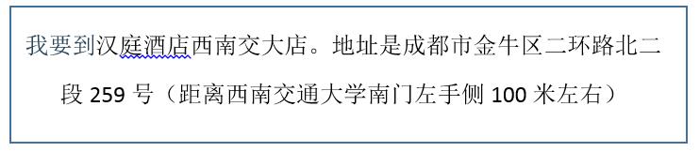

From train station
One can take NO. 36 bus and get off on south station of JiuLiDi Road, it is about 5 stations.
从火车北站乘坐36路公交车，到九里堤中路南站下车，共5站路，下车后往回走到二环路口，右侧即是汉庭酒店成都西南交大店。

Hotel in LhaSa
Name: Tibet Post Hotel /西藏邮政酒店
Address: Beijing road 33, LhaSa, Tibet/西藏自治区拉萨市北京中路33号
Price: 300 RMB per room
Traffic: One can take airport shuttle bus to the destination, and walk 150 meter towards the south direction. One can find theTibet post hotel.

酒店位于拉萨市正中心位置,布达拉宫脚下,客人下飞机出站即可乘民航大吧进城(60KM)，到终点站往南走150米即到我酒店

