Minutes of CEPC Accelerator Physics Meeting
2016.05.20

Place: Room C407, Main Building, IHEP
Convener: Jie Gao
Attendee: Jie Gao, Yuan Zhang, Huiping Geng, Na Wang, Yuanyuan Wei, Yiwei Wang, Dou Wang, Feng Su, Tianjian Bian, Song Jin, Yuansheng Sun, Cai Meng, Dianjun Gong, Hongjuan Zheng
Recorder：Dou Wang
Summary of minutes：
  - Firstly, Prof. Gao reviewed the study of CEPC accelerator design. Then he gave a talk entitled “The advanced partial double ring scheme for CEPC” (IHEP-AC-LC-Note 2016-002, May 20, 2016), to propose for the first time more than two distributed doubles rings in CEPC (say, 6, 8, etc.) , in order to increase the RF efficiency. He expected that with this scheme the rf to beam efficiency could reach more than 80% for 6 partial double rings，and surely higher for more partial double rings. He pointed out that for 6 partial double ring scheme, for example, the needed minimum partial double ring length is 1.2km, which is determined by Z-pole luminosity.
  - Feng Su show that the minimum length for CEPC arc should be 54km due to the requirement of SPPC. So Feng Su and Prof. Gao suggested change the circumference of CEPC from 54km to 60km.
  - Yiwei reported his study progress on CEPC arc design. He has used FODO cell (90 ° /90 °) and non-interleaved sextupole scheme. The DA for on-momentum is good enough (55×55) while the off-mumentum DA need further optimization with more sextupole families.
Prof. Gao suggested Feng Su to add partial double ring based on Yiwei’s arc lattice and meanwhile suggested Tianjian to design another arc independently.
  - Dou reported her newest study about IP betay scan of CEPC PDR FFS with 190kev critical energy. She gave the plot to show the relation between IP betay with sextupole strength.
Prof. Gao suggested Dou make a same scan with 100 kev critical energy.
After the meeting, Prof. Gao suggested Dou to make a parameter table of beta_y=3mm to see the luminosity drop.
  - Yuan Zhang reported his progress on Application of Differential Evolution Algorithm in Future Circular Colliders. The MODE is just a tool, no physics. Physics exist in the definition of objective function. We should continue to find smart objective functions to save time.
  - Huiping Geng reported her progress on pretzel scheme design. She has changed the dispersion suppressor type to see how about the DA. The DA with new dispersion suppressor became worse.
Prof. Gao and Yuan Zhang suggested Huiping to learn Oide’s program from Yiwei and optimize the DA of pretzel scheme directly.
  - Yuanyuan Wei introduced her new study about booster DA. The emittance of her lattice (20 nm) got from Xiaohao is too large to match with CEPC main ring.
Prof. Gao suggested Yuanyuan to design a new booster by herself with 60 ° /60 ° FODO.
  - Tianjian introduced his progress on CEPC booster of low field design of 90° /90° . He has modified his Mathematica Code from thin element to thick element for orbit correction. The DA of booster has reach the design goal after orbit correction with errors and earth field.
Prof. Gao suggested that Tianjian to make similar simulation considering stray fields of 2 Gauss.
The next meeting will be on May 27, 2016.
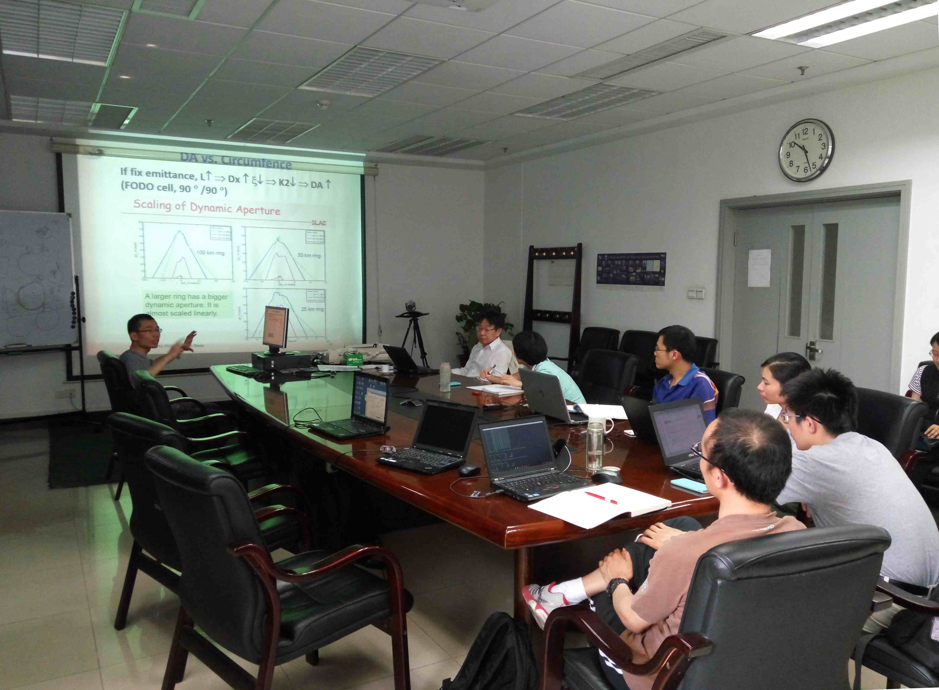
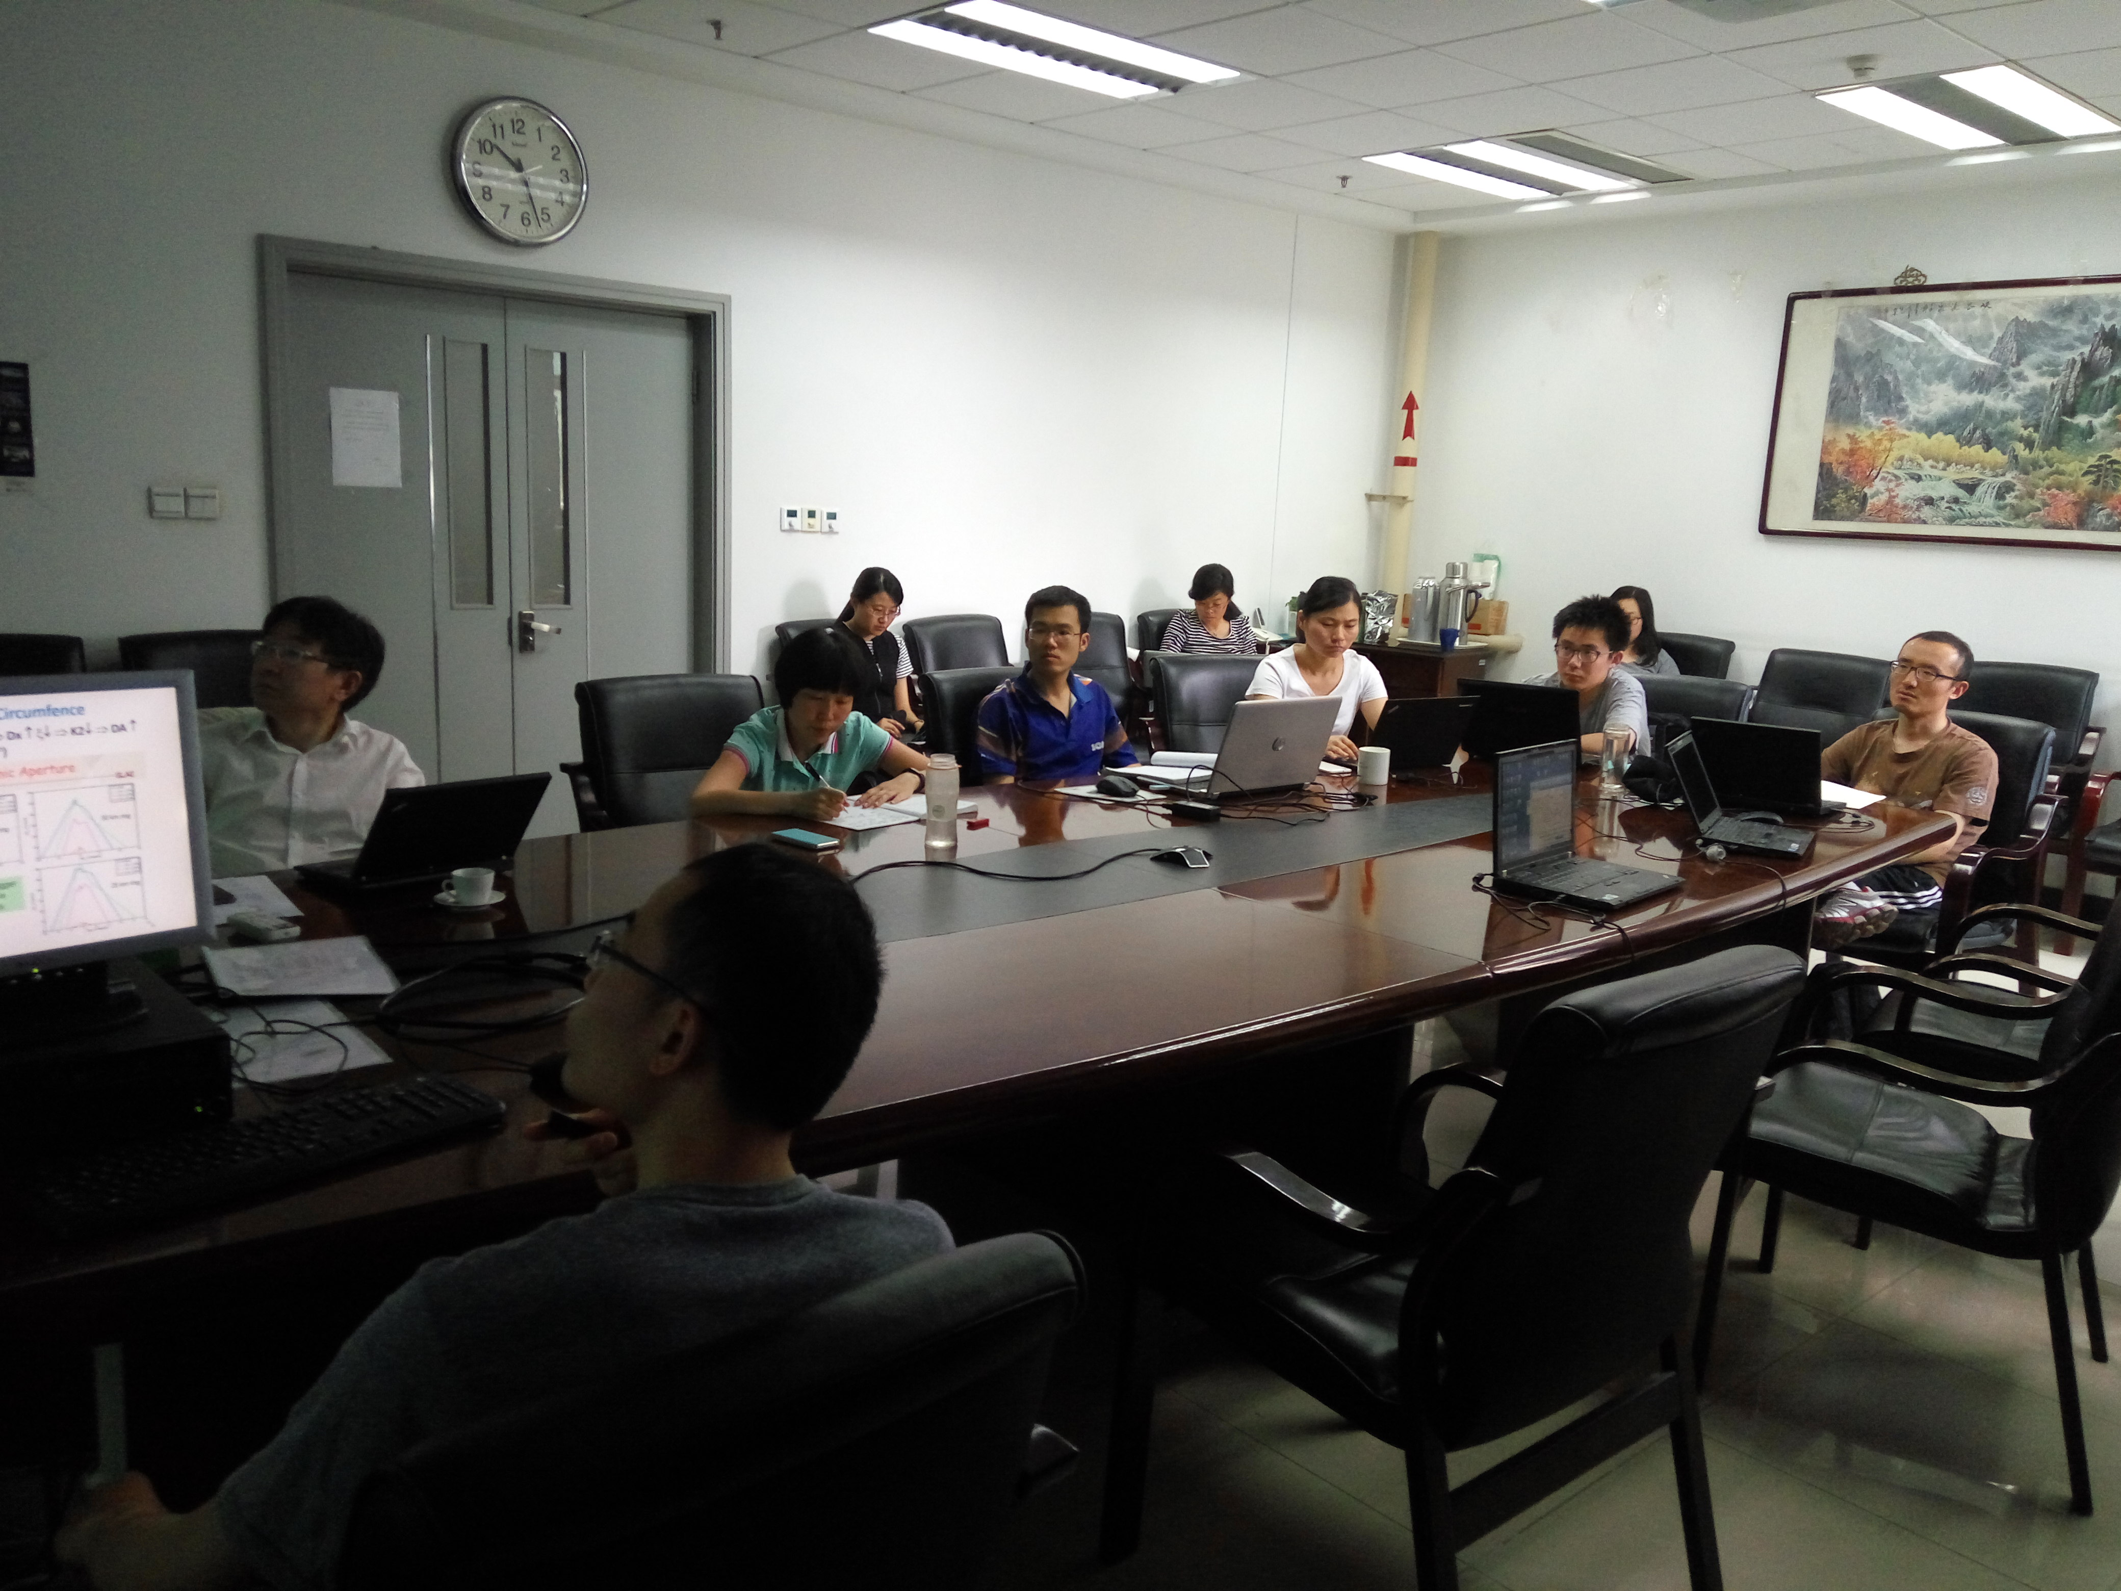

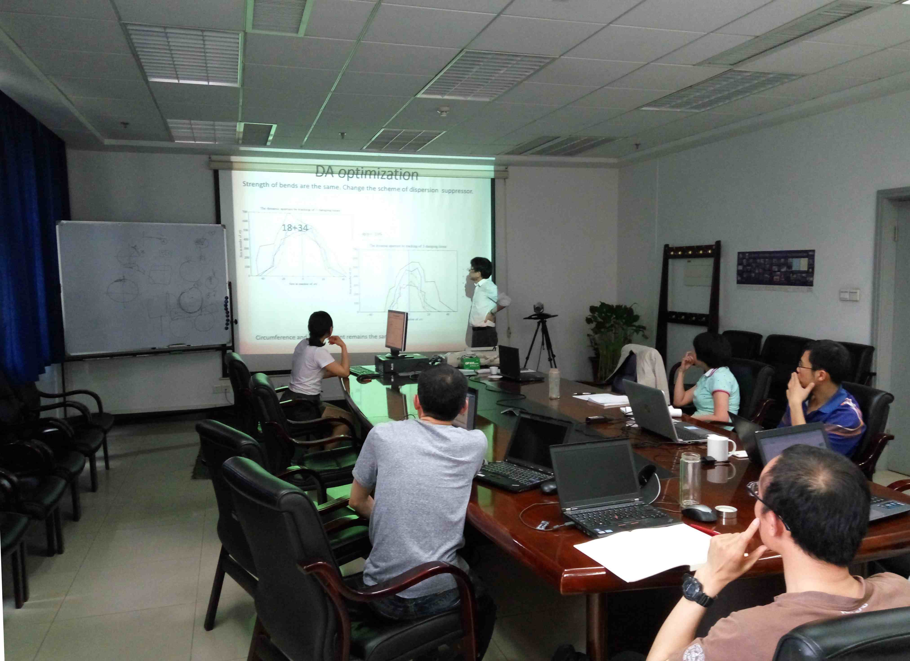

Recorder：Dou Wang
Checkup：Jie Gao

