Minutes of CEPC Accelerator Physics Meeting
2016.06.03

Place: Room C407, Main Building, IHEP
Convener: Jie Gao
Attendee: Jie Gao, Chuang Zhang, Zhenchao Liu, Jiyuan Zhai, Song Jin, Yuan Zhang, Huiping Geng, Na Wang, Yuanyuan Wei, Yiwei Wang, Sha Bai, Feng Su, Dianjun Gong, Dou Wang, Tianjian Bian, Cai Meng, Jin Wu
Recorder：Dou Wang
Summary of minutes：
  - Firstly, Zhenchao Liu gave a report about CEPC APDR SRF considerations. The key points are:
    - The 8-double ring seems available when using the same parameter as PDR(V_{RF}=3.62GV)
    - The phase region is from 35.2-33 degree for bunches in a bunch train.
    - The RF to beam efficiency is almost 100% and the bunch energy is constant.
  - Dou reported her progress of IP betay scan in CEPC PDR FFS.
    - For lower betay* (<1.4 mm), the sextupole strength keep constant because the chromaticity of FD is dominant.
    - Enlarging betay*, we need stronger sextupoles.
    - There is potential to get sub-mm betay* and hence increase luminosity further.
  - Yiwei reported his study about Lattice design for CEPC PDR. He pointed out that the emittance growth of ARC+PDR comes from septum of the partial double ring. Prof. Gao indicate that Yiwei’s work are very important and suggested that starting from this moment Su Feng to study with Prof. Wen Kang to find out the minimum beam center serration between two partial double rings.
  - Feng Su reported his study about CEPC Partial Double Ring Lattice Design and DA Study. He also studied the reason of emittance growth and got the same conclusion as Yiwei. Meanwhile he tested DA optimization code Pylatt on IHEP computer cluster.
  - Tianjian Bian reported his progress about CEPC main ring arc design. The key points are:
    - 6 fold lattice has been designed and the emittance is 2.3nm.
    - He used 8 sextupole families and two tune shift variables. The resulted 2rd chromaticity is 270 and the 3rd chromaticity is 199.
  - Jin Wu reported his progress on CEPC pretzel scheme. He has learned how to design pretzel for CEPC with Huiping’s help.
  - Yuan Zhang introduced his progress on DA Optimization.
    - SuperKEKB DA has been improved after IPAC16.
    - The DA optimization code MODE has been updated. SAD and MADX has been combined, so that it is easily to call different codes to calculate objection function.
    - Test this new code on BEPCII.

  - Prof. Gao indicated that we arrived at the moment that we need suitable computing capacity, and he will ask IHEP direction to help to find the resource for CEPC DA optimization works.

The next meeting will be on June 17, 2016.
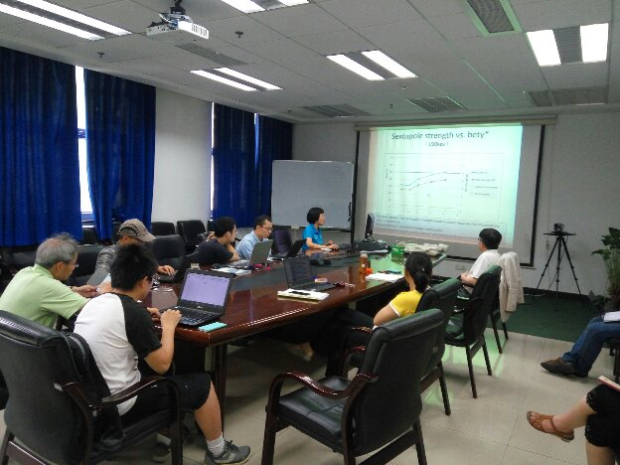

Recorder：Dou Wang
Checkup：Jie Gao
2016-06-03

