Minutes of CEPC Accelerator Physics Meeting
2016.07.22

Place: Room C407, Main Building, IHEP
Convener: Jie Gao
Attendee: Dou Wang, Zhenchao Liu, Song Jin, Na Wang, Yuanyuan Wei, Yiwei Wang, Sha Bai, Feng Su, Tianjian Bian, Dengjie Xiao, Cai Meng

Recorder：Dou Wang
Summary of minutes：
  - Firstly, Zhenchao Liu gave a summary about CEPC APDR SRF analysis. The key points are:
    - CEPC APDR SRF Design was shown. RF efficiency can reach 100% by voltage adjusting and phase adusteing.
    - Cavity requirement: V_{b} is 9.14MV with a 1.37deg. phase shift in a bunch train of the APDR H low power of 8 ring case.
    - CEPC SRF of 2PDR&DR: Both cases working at CW mode, so the RF parameters are the same.
  - Dou gave a report about APDR parameters with cavity voltage and phase adjusting. The luminosity will be reduced by 3.5% for 6 ring scheme and 2.4% for 8 ring scheme. Also she tried to optimize the off-momentum DA for PDR with more sextupole families.
  - Yiwei reported his study about Lattice design for CEPC PDR. He found the sextupoles in present PDR lattice don’t help much to the 1st order chromaticity correction, i.e. can’t make local correction. He will use more sextupole families in ARC.
  - Yuanyuan Wei introduced her progress of DA optimization on CEPC booster with MOGA.
  - Jin Wu gave a report about CEPC pretzel design. He add constraints for the sextupole polarity in the lattice and he rematched the lattice inside 1/4 arc.
  - Feng Su talked about the “CEPC Partial Double Ring Lattice Design and DA Study” and “SPPC Parameter Choice and Lattice Design”. The key points are:
    - CEPC PDR ARC Length Consideration. 60 km circumference is the minimum value for SPPC to get 70 TeV energy. 80 km circumference is the minimum value for SPPC to get 100 TeV energy.
    - CEPC PDR Lattice Redesign and Consideration. Use defocusing quadrupole instead of septum to control the emittance growth.
    - CEPC PDR DA Study. He tested DA optimization code Pylatt on IHEP computer cluster with 500 cpu.
    - A first Dynamic Aperture study and the preliminary DA is showed and it seems not too small. 126 sigma at IR.
  - Tianjian Bian reported his progress on CEPC main ring. He has finished the chromaticity correction until the 3rd order. He is writing his own code in order to control 4th order chromaticity.
  - Dengjie Xiao reported his studies about CEPC Damping Ring and DA tracking. He has learned about the damping ring physics and tested his own code to get dynamic aperture by Madx.

The next meeting will be on July 29, 2016.

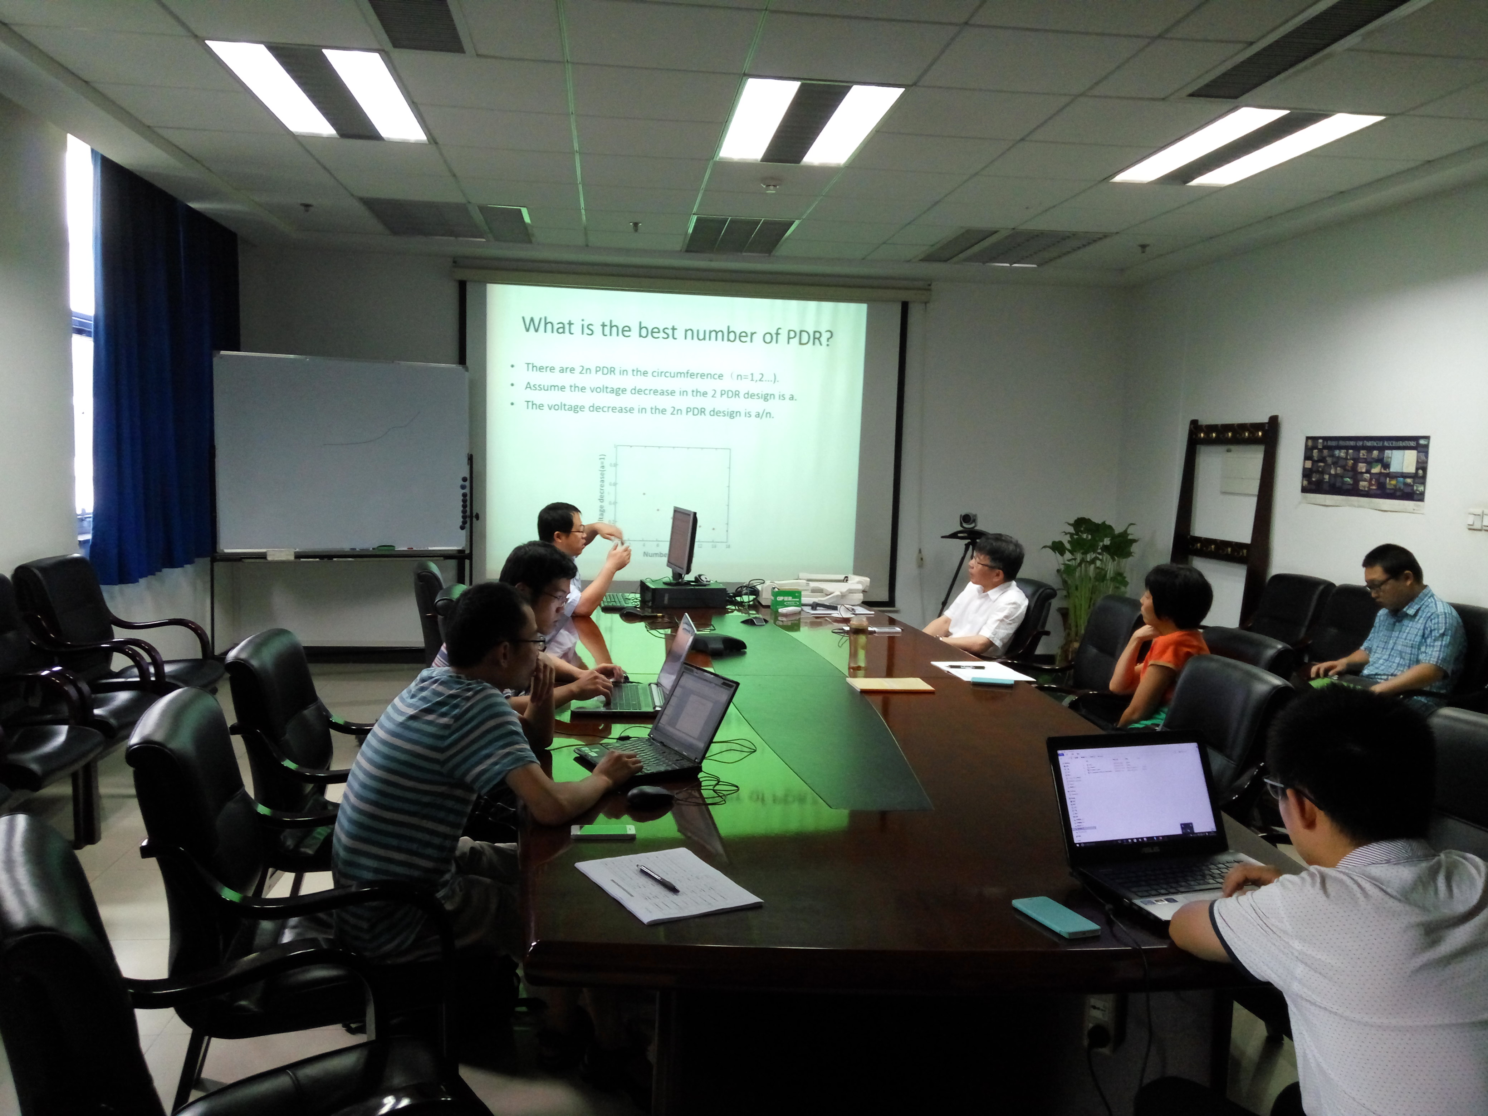

Recorder：Dou Wang
Checkup：Jie Gao
2016-07-22

