Minutes of CEPC Accelerator Physics Meeting
2016.07.15

Place: Room C407, Main Building, IHEP
Convener: Jie Gao
Attendee: Dou Wang, Zhenchao Liu, Song Jin, Na Wang, Yuanyuan Wei, Yiwei Wang, Sha Bai, Feng Su, Tianjian Bian, Dengjie Xiao,Cai Meng
Recorder：Dou Wang
Summary of minutes：
  - Firstly, Dou gave a report about APDR parameters with cavity voltage and phase adjusting. The luminosity will be reduced by 3.5% for 6 ring scheme and 2.4% for 8 ring scheme.
  - Tianjian Bian reported his progress on CEPC main ring. He has finished the chromaticity correction until the 3rd order. He is writing his own code in order to correct higher order chromaticity.

The next meeting will be on July 22, 2016.

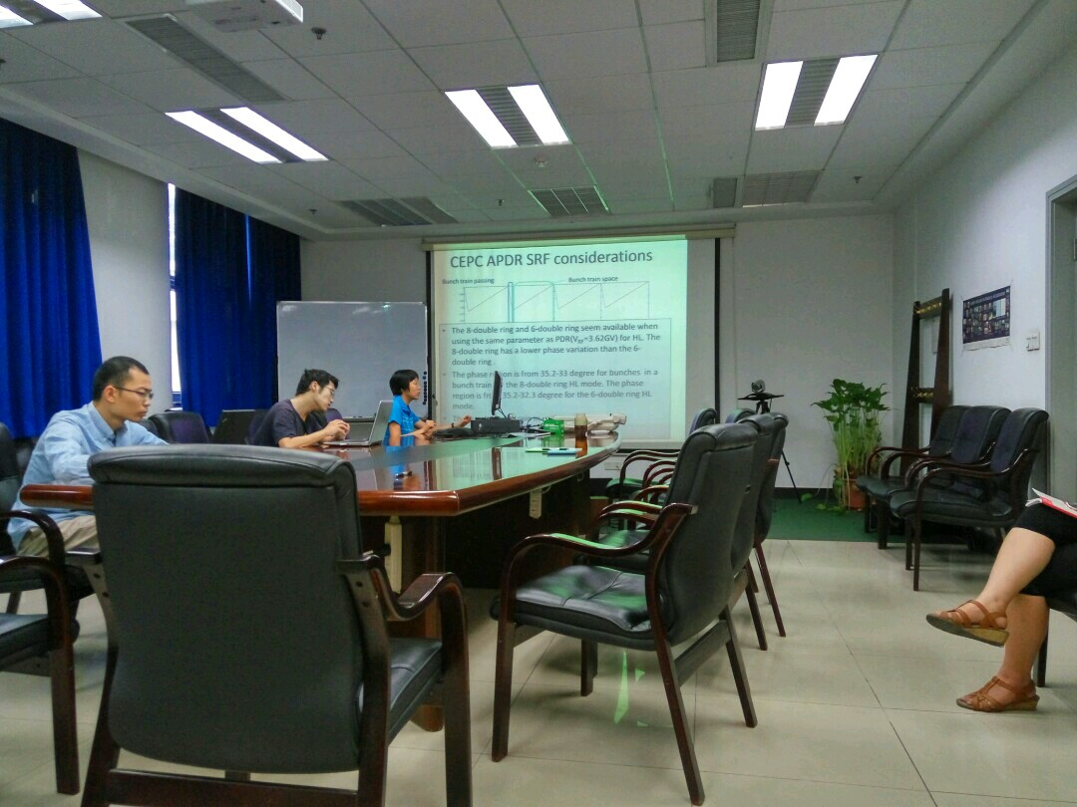

Recorder：Dou Wang
Checkup：Jie Gao
2016-07-15

