**Minutes of CEPC Accelerator Physics Meeting**

2016.07.29

**Place**: Room C407, Main Building, IHEP

**Convener**: Jie Gao

**Attendee**: Zhenchao Liu, Song Jin, Na Wang, Yuanyuan Wei, Yiwei Wang, Sha Bai, Feng Su, Tianjian Bian, Dengjie Xiao, Yuan Zhang, Cai Meng

**Recorder**：Sha Bai

**Summary of minutes：**

Firstly, Prof. Jie Gao gave a brief summary of the important academic things recently, including: the BEPCII project is applying for the 2016 highest science and Technology Award; the ICFA newsletter (lattice part) finishing; the presentation arrangement of CEPC-SppC study group meeting in September 2-3; the program platform to build for dynamic aperture optimization finishing; It has been approved of Fragrant Hill conference and keynote speech has been fixed, etc.

Following are the nine talks summary:

* 1. Zhenchao Liu instead of Dou Wang gave a report about APDR parameters with cavity voltage and phase adjusting. She calculated the bunch length error, piwinski error, RF voltage error, and luminosity error with RF phase adjustment in both H-high luminosity, H-low power and Z design of CEPC partial double ring. The BS life time with RF phase adjustment will be lower than the requirement, reduced by 37% for 6 ring and 30% for 8 ring in the H-low power design.
  2. Yiwei reported his study about Lattice design for CEPC PDR. He tried 2, 4, 8, 24 families of sextupoles in the ARC to optimize dynamic aperture, and he found that the horizontal DA increase but vertical DA decrease as he mainly optimize horizontal DA vs energy spread. Next step he will try to do optimization in both horizontal and vertical DA.
  3. Yuan Zhang reported the MODE development and some try based on it. High parallel MODE is implemented and he begin to use MODE to do some matching, parameter scan or optimization.
  4. Feng Su reported the CEPC Partial Double Ring Lattice Design and DA Study. After optimization of nonlinear driving term, with 96 family groups of sextupoles, the dynamic aperture is (60σx, 813σy); while with only 2 family groups of sextupoles, the dynamic aperture is (45σx, 780σy).
  5. Tianjian Bian reported his progress on CEPC main ring. A code which compute the driving terms and dynamic aperture is in the developing process. The result is matched with madx and lego very well. The Galib library is linked.
  6. Na Wang gave a report about CEPC impedance and instabilities. She calculated the ion instabilities based on H-High luminosity design, including the rough estimation of the limiting current of the electron beam and emittance growth due to the fast beam-ion instability etc. The transverse and longitudinal impedance and wake simulated with ABCI code by Gong Dianjun are also shown.
  7. Sha Bai gave the summary talk of the error study and MDI. The DA after orbit correction is developing with the new version of SAD and 13T compensating solenoid is under designing, which is to shorten the length of compensating solenoid to avoid influence on Lumical.
  8. Cai Meng reported his studies on CEPC injector beam dynamics. The capture RF system of positron for CEPC, according to scale, the gradient can be 20MV/m.

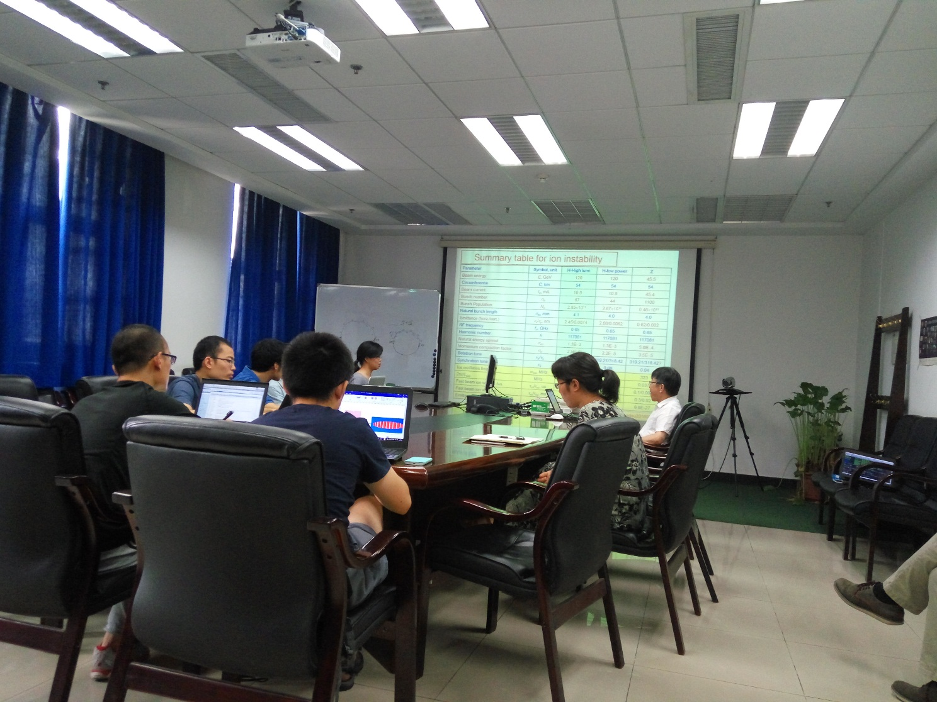

Recorder：Sha Bai

Checkup：Jie Gao

2016-07-29