Preliminary Calibration of Spherical Proportional Counter for Low Energy nuclear recoils

Haiqiong Zhang 1,2 Zhimin Wang 2 Charling Tao3,4 Changjiang Dai2,3

Ning Zhou3 Yi Tao3 Ruoqing Liu3 Chenyang Tang3 Changgen Yang2

1 University of Chinese Academy of Science, Beijing, China

2 Institute of High Energy Physics, Chinese Academy of Sciences, Beijing 100049, China

3Tsinghua University, Beijing 100084, China

4 Marseille Particle Physics Center (CPPM), Maseilles 13233, Francetute of High Energy

[wangzhm@ihep.ac.cn](mailto:wangzhm@ihep.ac.cn)

**Abstract.** Neutrino physics and dark matter detection are frontier topics of current particle physics. Good rock shielding, ultra low background and ultra low energy threshold are key factors to detect signals successfully from neutrino and WIMPs scattering in underground experiments. Thus, a novel large volume spherical proportional counter has been set up in IHEP, which adopted an ultra small front-end capacitor with ultra low energy threshold (few keV) and a single center dynode that creates a strong radial electric field. This simple and robust structure enable the signal to be read out through a single electronic channel. Charges deposited in the gaseous vessel, drifting to the central electrode followed by amplification and collection. In the preliminary calibration of the prototype, it can not only detect but also identify the alpha and neutron particles precisely. The pretest results and performance of the detector reveal its possible application for future neutron background, neutrino and dark matter measurement.

**Keywords:** gas detector, SPC, rare events, low energy threshold, detector calibration.

1. Introduction

Rare events detector with ultra low background, ultra low energy threshold and relatively large target mass for neutrino[1], Weakly-Interacting-Massive- Particle(WIMP)[2]and axion[3] detection, is the frontier topic of current particle physics field. The traditional approach to detect these rare events usually involves tons of liquid scintillator[1], liquid argon[4] and crystals[5] detector underground with complex structure and instrumentings. Although producing the tiny (few hundreds of eV) nuclear recoils by neutrino-nuclues coherent interaction is a standard process, it has never met the demand of current detectors’ sensitivities. Therefore, a novel concept about spherical proportional counter(SPC) has been put forward for low energy nuclear recoils. And the first prototype characterized with good energy resolution, high gain and robustness was build in Saclay[6-7]. Supported by Saclay, Tsinghua and IHEP, another SPC prototype is running in IHEP. In this paper, some preliminary calibration results of SPC are presented.

As the design concept shown in Fig.1, the gas detector consisting of two concentric balls works at proportional counting pattern. The inner solid one at high potential is supported by a copper bar as a collection pole while the external sphere connecting to the ground tightly encloses the target gas inside as the drift volume. In the sealed mode, the spherical vessel is vacuumized first and then filled with gas of a certain pressure and composition. The primary ionization electrons produced in the drifting region drift towards the inner ball running as the anode. And then the avalanche starts when these electrons reach a distance of a few mm from the anode which produces the intense electric field.

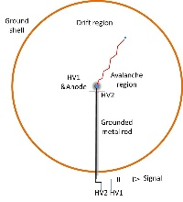

**Fig. 1.** The overall structure and detecting principle of SPC

1. Experiment setup

### A real detector prototype, including a large external copper vessel as well as a inner copper ball (Fig.2), has been built at IHEP. The spherical vessel, 1.3m in diameter and 6mm in thickness, is filled with a gas mixture at a pressure from 0.05 to 0.2 atm after well vacuumized (up to 10−5 Pa). The small ball (14mm in diameter), acting as both an electrode with positive high voltage and a proportional amplification counter, is fixed in the center of the vessel by a copper rod with an umbrella displayed as right panel in Fig.2. This simple and robust structure enables the signal to be read out through a single electronic channel with a charge sensitive preamplifier wherever the nuclear recoils take place. To protect the charge sensitive preamplifier and provide low energy threshold, a decoupling capacitor, which depends on the radius of spherical vessel and the small inner ball (described in equation(1))[8], is equipped in the electronic structure. However, this capacitor is mainly determined by the radius of the anode ball since the radius of the spherical vessel is really much larger than that of the small copper ball. When r2=7mm, the decoupling capacitor is much less than 0.1pC, suggesting the extraordinarily low electronic noise.

 (1)

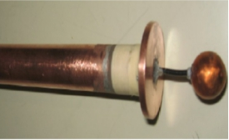

**Fig.2.** left panel is the prototype of SPC built in IHEP;right panel is the supported structure, umbrella and inner-ball

### Considering the heterogeneity of the electronic field, the supported structure was studied before operation. As shown in Fig.3.a and Fig.3.c, the ideal spherical symmetry electronic field is distorted and the electronic field simulation exhibits that 1/3 detector volume is covered with electronic field, resulting in inhomogeneity gain. Comparing with the simplest structure, an additional umbrella locates at the upper of the inner ball. Fig.3.b and Fig.3.d demonstrate that the umbrella can uniform the electronic field to a large extent. And the supported structure and umbrella are presented in Fig. 3.d.

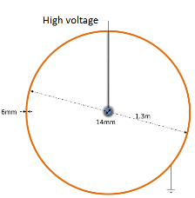 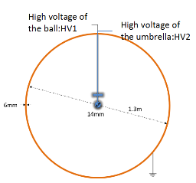 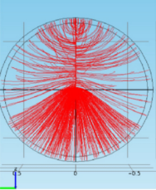 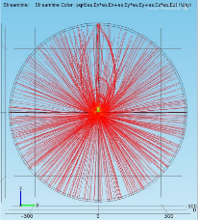

d

c

b

a

**Fig.3.** a panel is the simpled without umbrella structure; b panel is the electronic structure adding umbrella; c panel is the electronic field corresponding with a panel; d panel is the electronic field corresponding with b panel;

1. Experimental results
   1. Detector response

In the experiment, the SPC will be filled gas with designed component, proportion and pressure for specified detection goal. Herein, inactive gas (Ar (98%) + CH4 (2%)) was selected in the condition of 5000 Pa or 20000 Pa for the preliminary test of prototype. First of all, alpha from radon of 232Th decay chain was utilized as the source to calibrate the detector response. As presented in Fig.4, the signal is decoupled firstly from the HV and, amplified by a charge sensitive amplifier, and then recorded to computer by a 2 MHz sampling ADC in 2 ms window per trigger, where the trigger is generated by amplitude discrimination online. All the following analysis is based on the record waveform data (Fig.4) including amplitude, charge and time information.

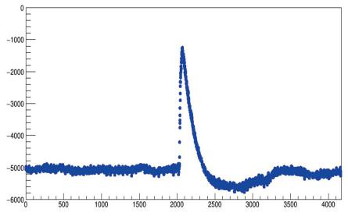

**Fig.4.** signal pulse of the prototype with alpha source.

* 1. Detector calibration

Detector calibration is the best way to have insight into the energy response with different radiation source and varied particle energy. To better understand the overall properties of the detector, charged(alpha) and uncharged particles (neutron) are included in the experiment.

3.2.1 Alpha

220Rn from 232Th decay chain is a desirable option for alpha calibration because of in gas, limited lifetime as well as stable final state. After hours of the 220Rn gas filled in the detector, the system in the detector will be in balance that there will only be 212Pb alive with 11 hours half-life and generate daughter isotopes continuously in the next few days, where we can get the mono-energetic alphas: 6.2 MeV from 212Bi, 8.9 MeV from 212Po, and the combination energy ( 11.4 MeV ) of Beta ( 2.5 MeV ) from 212Bi and alpha from 212Po.

The detector is configured with 20 kPa and HV1/HV2=3450V/800V for possible alpha scale, and the threshold is set to be 1500 ADC. The data are recorded few hours later after 220Rn filling .

Fig. 5 shows the comparison in the pulse rise time and amplitude (energy) of background (without source) and source. The source peaks are clear on rise time and amplitude spectrum. In the 2D graph of rise time VS amplitude with the source as in Fig. 5, the structure is clearer where it is possible to get better energy measurement with rise time cuts as shown in Fig. 6. From the Fig. 6 we can calculate the alpha energies of 6.2MeV and 8.9MeV while the combination energy(11.4MeV) can not be seen for the limited size of the spherical vessel. Concurrently, a sharp structure emerges around 6000 ADC on amplitude spectrum, which is consistent with electron assumption, confirming an accurate identification with alpha.

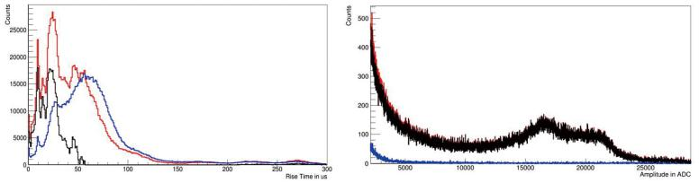

**Fig.5.** Left panel is the rise time distribution of the signal; right panel is the amplitude spectra (red: background; blue with alpha source; black: pure source with background subtracted).

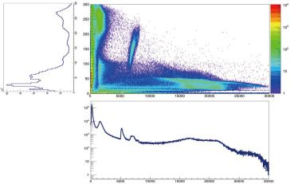 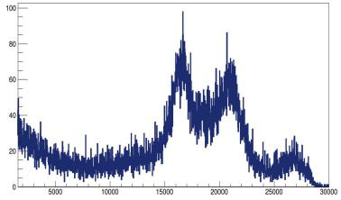

**Fig.6.** Left panel is the 2D graph of pulse rise time and ampli-tude with the alpha source; right panel is amplitude spectrum with rise time cut [25, 30] *s* for alpha.

3.2.2 Neutron

Helium is normally used for neutron calibration while for neutron detection in this experiment, SPC with N2 and Ar + CH4 mixture is proposed [15] Ar(89%) + N2(6%) + CH4(5%) and HV1/HV2=3600 V/360 V, under threshold 900 ADC and 15 kPa are configured on the prototype. Here the 252Cf source is adopted for calibration.

From Fig.7 left and middle panel, it is obvious that the rise time of neutron events is very fast, and a mono-energy peak appears on the amplitude spectrum around 12400 ADC as shown Fig.7 right, corresponding to thermal neutron around 625 keV. A new way is proposed to detect neutron instead of Helium.

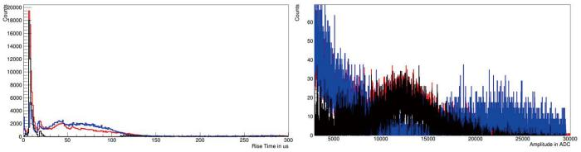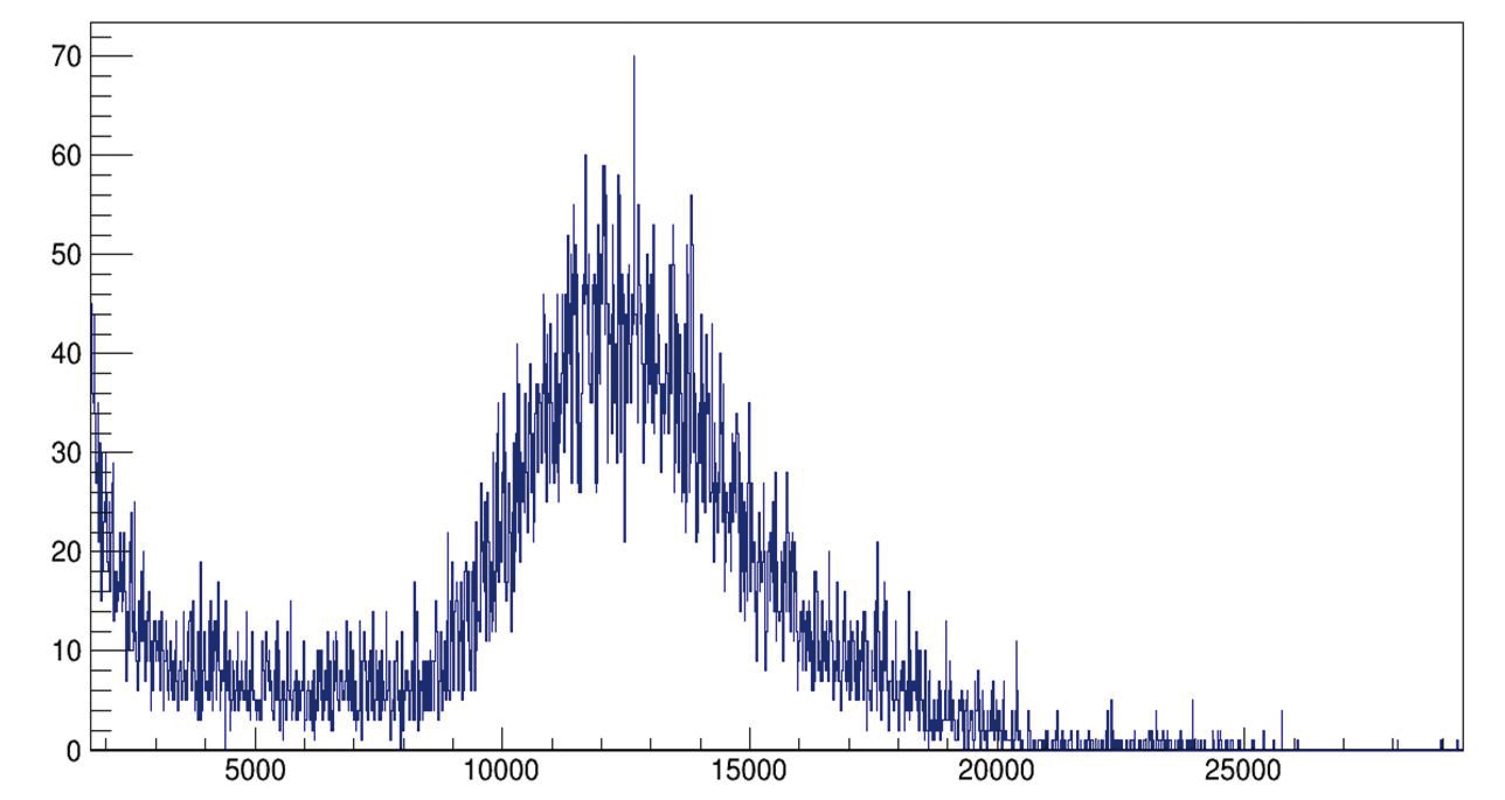

**Fig.7.** Left panel is the rise time distribution of the signal; middle panel is the amplitude spectra (red: background; blue with alpha source; black: source with background subtracted); right panel is Amplitude spectrum after rise time cut [30, 60] *s* for neutron.

1. Conclusion

The prototype of SPC for rare event physics has been set up and the first test with alpha and neutron source shows that low electronic noise makes the detector capable of detecting so low energy particles (in the few keV energy region), making it a possible candidate for low energy nuclear recoils. At the preliminary calibration, it can detect the alpha and neutron clearly and show particle identification ability as well. Besides, simple design and a simple electronic channel for a large volume with large target masses make the prototype more superior than other detector with complex structure. Even though the threshold can not reach eV energy region at this time as the results shown by Scalay before[6], we are carrying out further studies to achieve the goal.

References

1. An F et al, Neutrino Physics with JUNO, J. Phys. G, 36:030401 (2016).
2. He Yu, Lin Wen-bin, Research progress on dark matter model based on weakly interacting massive particles, Chinese Astronomy and Astrophysics, 41(2), 149-181(2017)
3. Guo-Chin Liu, Kin-Wang Ng, Axion dark matter induced cosmic microwave background B modes, Physics of the Dark Universe, 16, 22-25(2017)
4. K.Arisaka, P.Beltrame, C.W.Lam et al, Studies of three-stage dark matter and neutrino observatory based on multi-ton combination of liquid xenon and liquid argon detectors, Astroparticle Physics , 36(1), 93-122(2012)
5. C.Cuo, X.H.Ma, Z.M. Wang.:Neutron beam tests of CsI(Na) and CaF2(Eu) crystals for dark matter direct search, Nuclear Instruments and Methods in Physics Research A , 818, 38-44(2016)
6. I.Giomataris and I.Irastorza, A novel large-volume spherical detector with proportional amplification read-out,Jinst, 3, P09007 (2008)
7. E.Bougamont, P.Colas, Low energy investigation and applications with the spherical TPC, J.Phys Conf.Ser, 309, 012023(2011)
8. ]S Andriamonje and S Aune, Spherical TPC development and trends,J.Phys,Conf.Ser, 179,012003(2009)