Innovative design and construction technique for the Cilindrical GEM detector for the BESIII experiment

A. Amoroso^{5,10}, M. Alexeev^{5,10}, R. Baldini Ferroli^{1,3}, M. Bertani³, D. Bettoni², F. Bianchi^{5,10}, A. Calcaterra³, N. Canale², M. Capodiferro³, V. Carassiti², S. Cerioni³, JY. Chai^{1,7,5}, S. Chiozzi², G. Cibinetto², F. Cossio^{5,10}, A. Cotta Ramusino², F. De Mori^{5,10}, M. Destefanis^{5,10}, J. Dong¹, F. Evangelisti², R. Farinelli^{2,8}, L. Fava^{5,11}, G. Felici³, E. Fioravanti², I. Garzia^{2,8}, M. Gatta³, M. Greco^{5,10}, CY. Leng^{5,7}, L. Lavezzi^{1,5}, H. Li^{5,10}, M. Maggiora^{5,10}, R. Malaguti², S. Marcello^{5,10}, M. Melchiorri², G. Mezzadri^{2,8}, M. Mignone⁵, G. Morello³, S. Pacetti⁹, P. Patteri³, J. Pellegrino^{5,10}, A. Pelosi,³ A. Rivetti⁵, M. D. Rolo⁵, M. Savriè^{2,8}, M. Scodeggio^{2,8}, E. Soldani³, S. Sosio^{5,10}, S. Spataro^{5,10}, E. Tskhadadze^{3,6}, S. Verma⁸, R. Wheadon⁵, L. Yan⁵

¹Institute of High Energy Physics, Chinese Academy of Sciences, Beijing, China; ²INFN, Sezione di Ferrara, Italy; ³INFN, Laboratori Nazionali di Frascati, Frascati (Roma), Italy; ⁴INFN, Sezione di Perugia, Perugia, Italy, INFN, Sezione di Roma, c/o Università La Sapienza, Roma, Italy; ⁵INFN, Sezione di Torino, Torino, Italy; ⁶Joint Institute for Nuclear Research (JINR), Dubna, Russia; ⁷Politecnico di Torino, Dipartimento di Elettronica e Telecomunicazioni, Torino, Italy; ⁸Università di Ferrara, Dipartimento di Fisica, Ferrara, Italy; ⁹Università di Perugia, Dipartimento di Fisica e Geologia, Perugia, Italy; ¹⁰Università di Torino, Dipartimento di Fisica, Torino, Italy; ¹¹Università del Piemonte Orientale, Alessandria, Italy

Email: amoroso@to.infn.it

Abstract. Micro Pattern Gas Detectors are very light and radiation hard instruments adopted in high energy physics to measure the particle properties: position and momentum.
Through high electric fields it is possible to use the Gas Electron Multiplier (GEM) technology to detect the particles and to exploit the hits properties to construct a large area detector, such as the new Inner Tracker (IT) of BESIII. The state of the art in the GEM production allows to create very large area GEM foils (up to 50x100 cm2) and thanks to the small thickness of these foils it is possible to shape them to the desired formas the new Cylindrical Gas Electron Multiplier (CGEM) is then proposed.
The innovative construction technique adopting as support the Rohacell, a PMI foam, will give solidity to cathode and anode with a very low impact on material budget. The entire detector is sustained by permaglass rings glued at the edges. These rings are use to assembly the CGEM together with a dedicated Vertical Insertion System and moreover therey host the On-Detector electronic. The anode has been improved w.r.t. the state of the art through a jagged layout that minimizes the inter-strip capacitance.
The mechanical challenge of this detector requires a precision of few hundreds microns in the whole area.
We provide an overview of the construction technique and of its validation of this technique by mean of the realization of the CGE-IT and its first tests.
These activities are performed within the framework of the BESIIICGEM Project (645664), funded by the European Commission in the action H2020-RISE-MSCA-2014.
Keywords: GEM, Gas Detector, BESIII.
- The CGEM-IT Project
The existing Inner Tracker detector of the Beijing Spectrometer III (BESIII) [1], the Main Drift Chamber (MDC), is showing aging effects due to the high luminosity reached by the Beijing Electron Positron Collider II (BEPCII).
The proposed solution of a new IT consists of three layers of cylindrical triple-GEM detector (CGEM). Each layer is composed by five concentric electrodes: the cathode, three GEM foils, and the anode (Fig. 1). The spacing between the cathode and the first GEM foil (conversion gap) is 5 mm, while all the other gaps are 2 mm.
Each GEM foil is made by a thin Kapton foil of 50 μm, copper clad on each side, with a high surface density of holes [2]. The holes have a bi-conical structure with external (internal) diameter of 70 μm (50 μm). A voltage of around 270V (in ArIso) is applied between the two copper sides in order to produce a strong field in the holes, of the order of 54 kV/cm, which multiplies the number of electrons produced by a charged particle crossing the detector. The triple-GEM configuration allows to reach high gains minimizing the discharge probability.
Due to the limited space available in the inner part of the BESIII spectrometer, the mechanical design of the detector must be very compact and properly suited, including the on-board electronics.

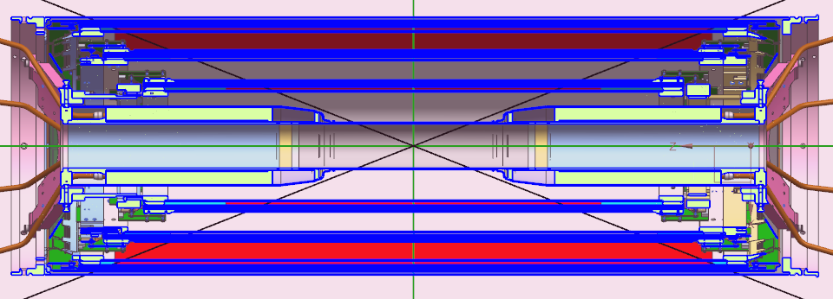
Fig. 1. CGEM detector into the BESIII spectrometer. The three CGEM layers are blue.
- New Development Feature
To ensure the low material budget requested for the BESIII inner tracker the anode and cathode supports are made with Rohacell, a low density foam that ensures, temperature resistance up to 220°C. The closed cell structure, makes Rohacell foam ideal for high performance sandwich structures combining low multiple scattering and rigidity properties.
The cylindrical layout is given by permaglass rings glued on the edge of the electrodes. They provide the design gaps between the different GEM foils. The rings are shaped as well for the gas system and as support structure for a complete chamber.
Each CGEM layer is designed to provide two spatial coordinates. The anode collects data for x and v coordinates (skewed of about 46°, -31°, and 33°, for the three chambers respectively), allowing to disentangle multiple hits scenarios. An innovative Jagged Strip anode layout, with x strip pitch shrinked in coincidence of v strip crossings allow to reduces the inter-strip capacitance of about 30%.
Due to the expected high signal rates the ASIC technology must be exploited. A new ASIC chip named TIGER (Torino Integrated GEM Electronics for Readout) is being developed for the electronic readout.
The innovative features introduced by CGEM-IT project are shown in Fig. 2.

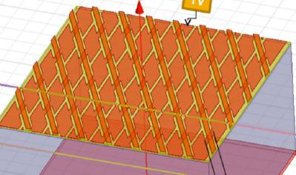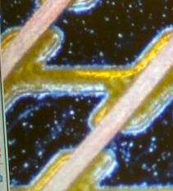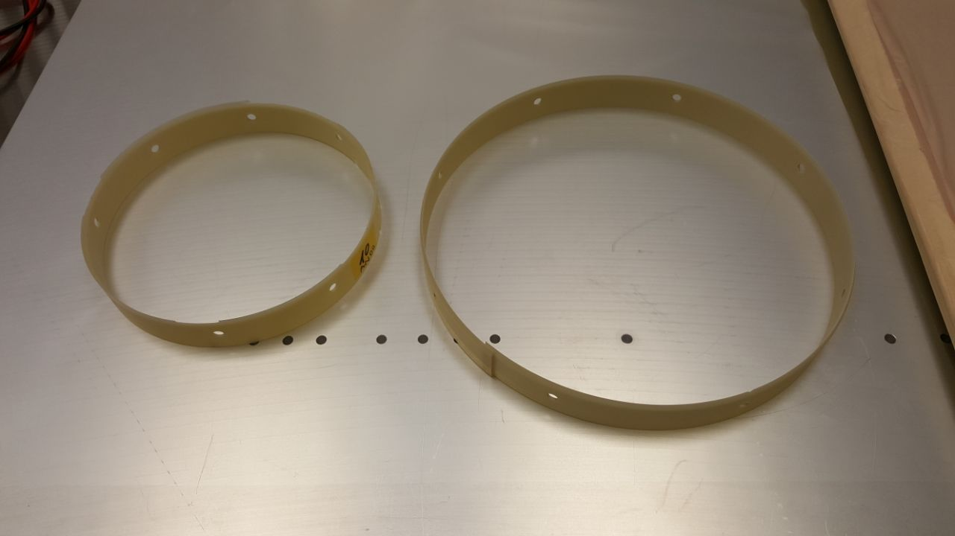
Fig. 2. Innovative features introduced within CGEM-IT project. Right: permaglass rings. Center: schematic view of the coordinates setup. Left: Jagged strip anode layout.
- Construction technique
The KLOE-2 experiment has developed a special assembling technique, in order to obtain cylindrical GEM electrodes [3]. The maximun dimension of a Kapton foil is 60cm: this dimension is not enough to cover the surface required for CGEM layer 2 and 3 of CGEM-IT project. In this scenario, two GEM foils are glued together on a plane to obtain a single larger foil. To glue the GEM foils ee decided to use Araldite-103, a multip theurpose, two component, room temperature curing, transparent liquid adhesive of high strength.
A small quantity of glue (1.5mm strip) on the overlap area (2.8mm) gives safety margin to prevent that the glue pours out from the overlap region on the sensitive area. In order to ensure a uniform pressure on the glued region, a vacuum bag is applied. To reach the glue full curing 24 hours are needed.
Separately for each one of the three layers, the GEM foils are cylindrically shaped on an aluminum mandrel coated with a 400 nm thick Teflon film, which provides a non-sticky, low friction surface. The two Permeglass rings are glued on the edges of the electrode and the foils are glued on their opposite side. Finally, the mandrel is inserted on a vacuum bag until the complete curing of the glue.
The cathode and the anode are constructed with a similar procedure, but using the Rohacell as support structure.
The final assembly is performed using a Vertical Inserting Machine (Clessidra) and the assembly of the five electrodes proceeds from the outermost electrode (the anode) to the innermost one (the cathode). Thanks to the Teflon surface, the cylindrical electrode can be easily extracted from the mandrel. The extraction procedure operated with the “Clessidra” is shown in Fig. 4.

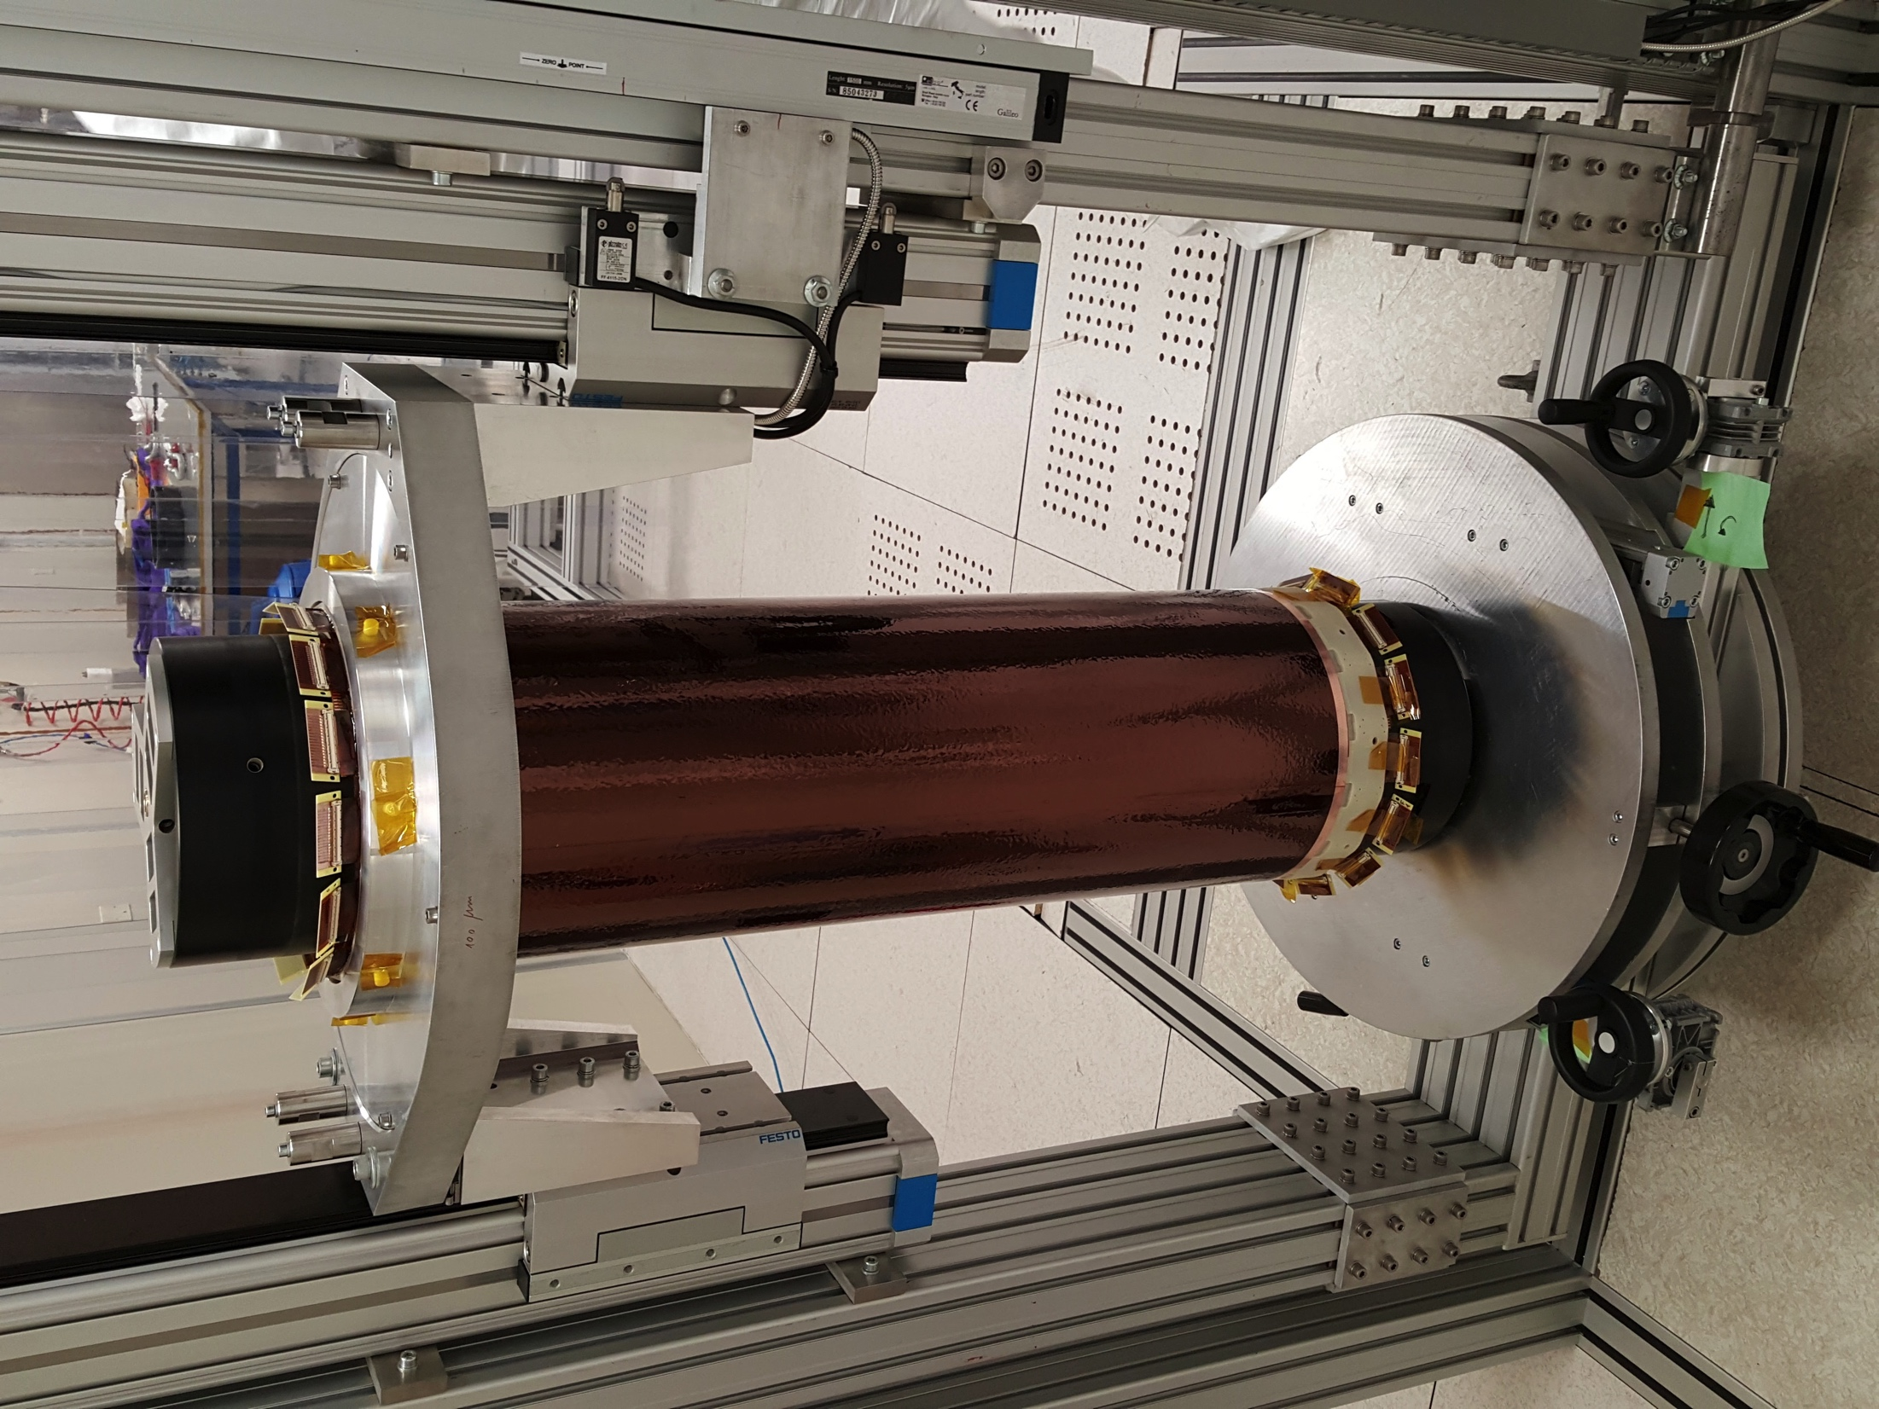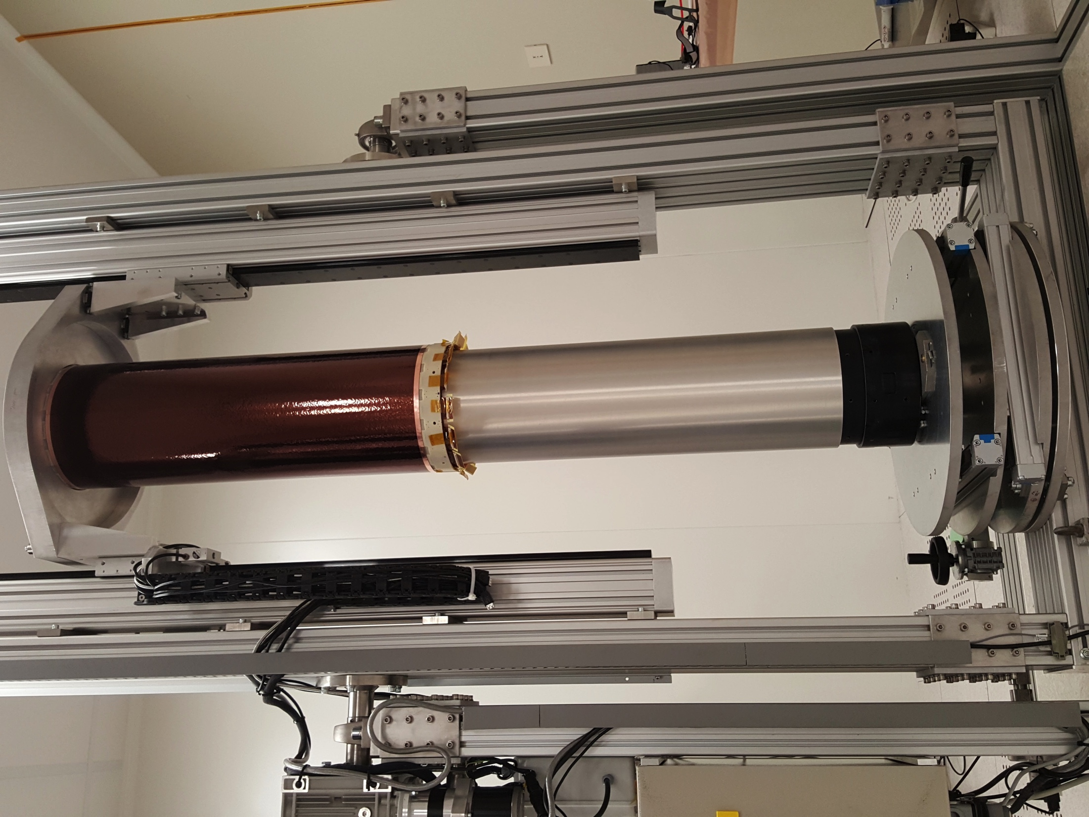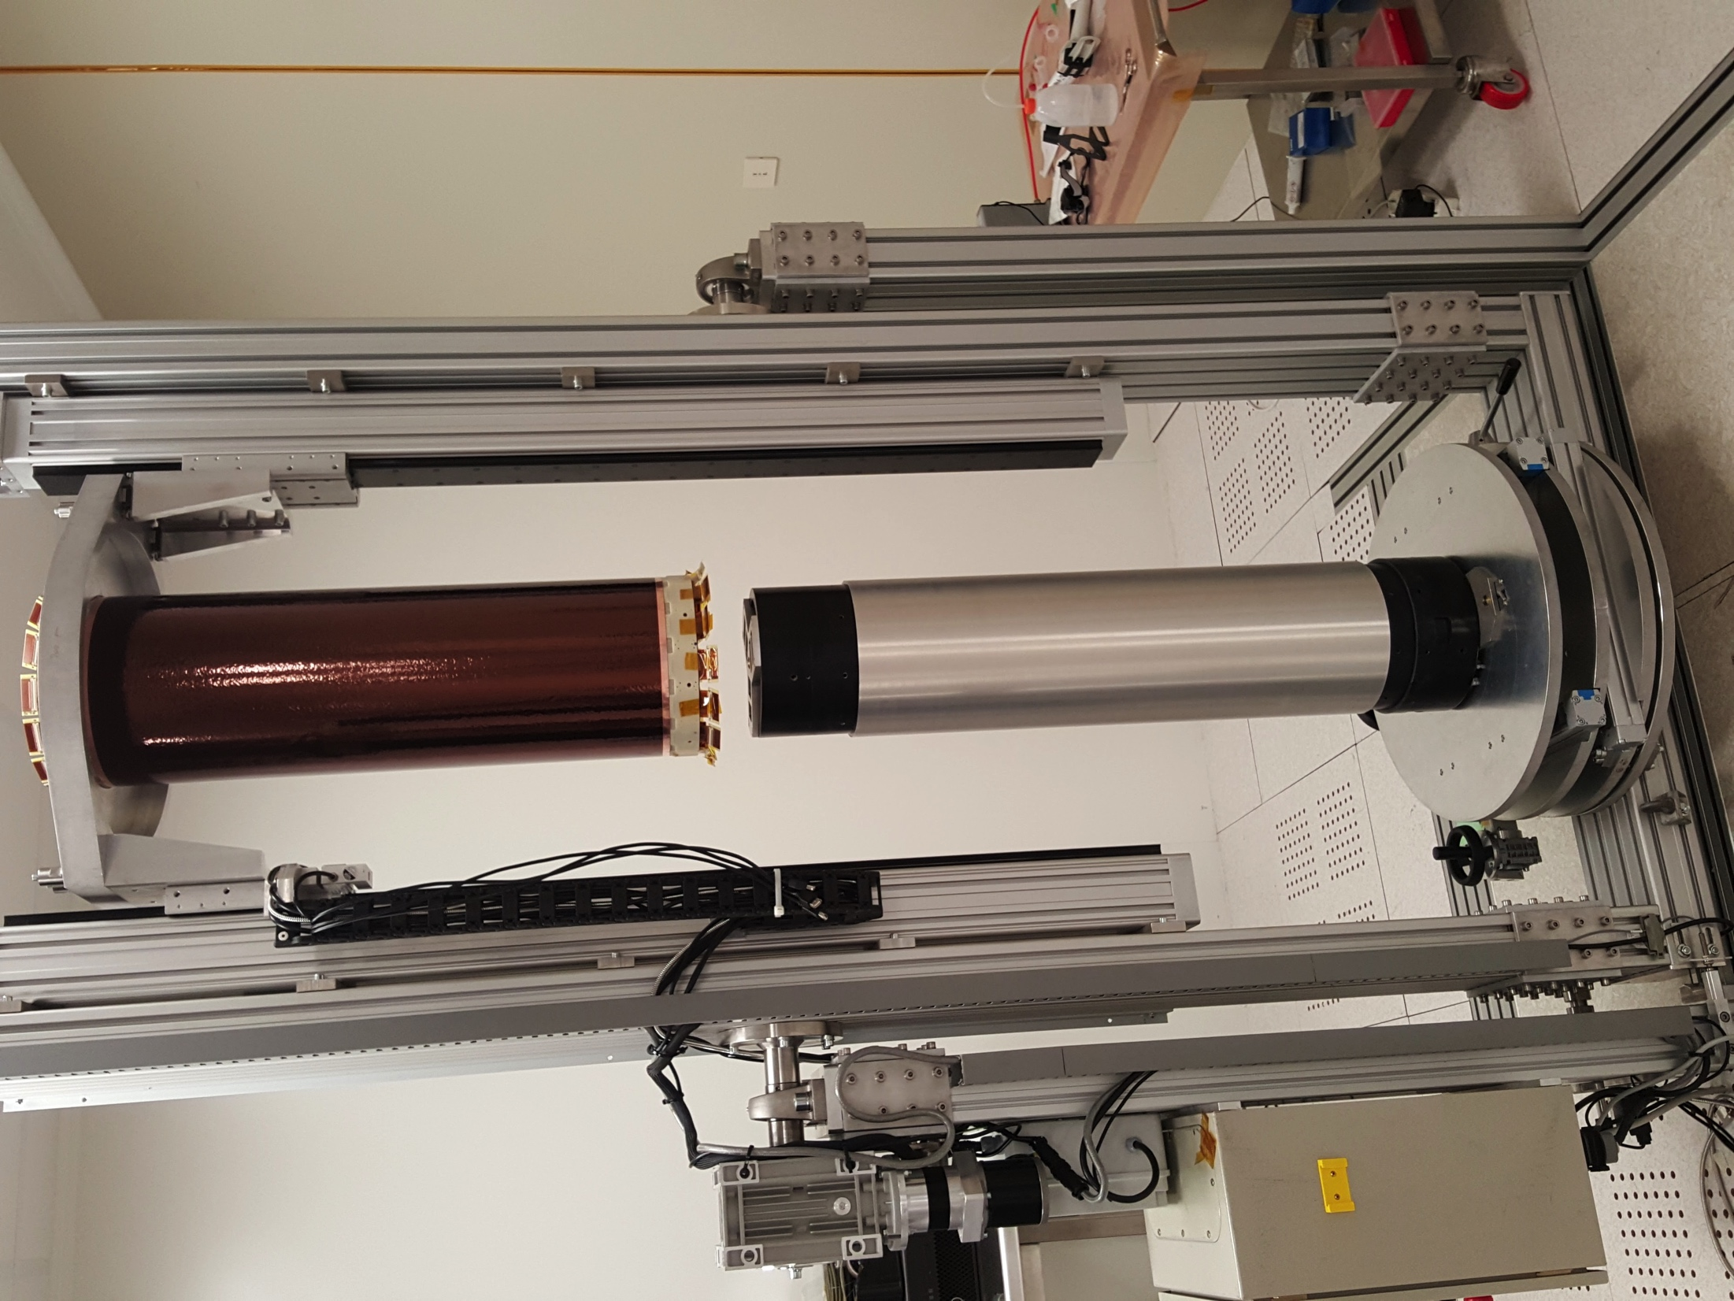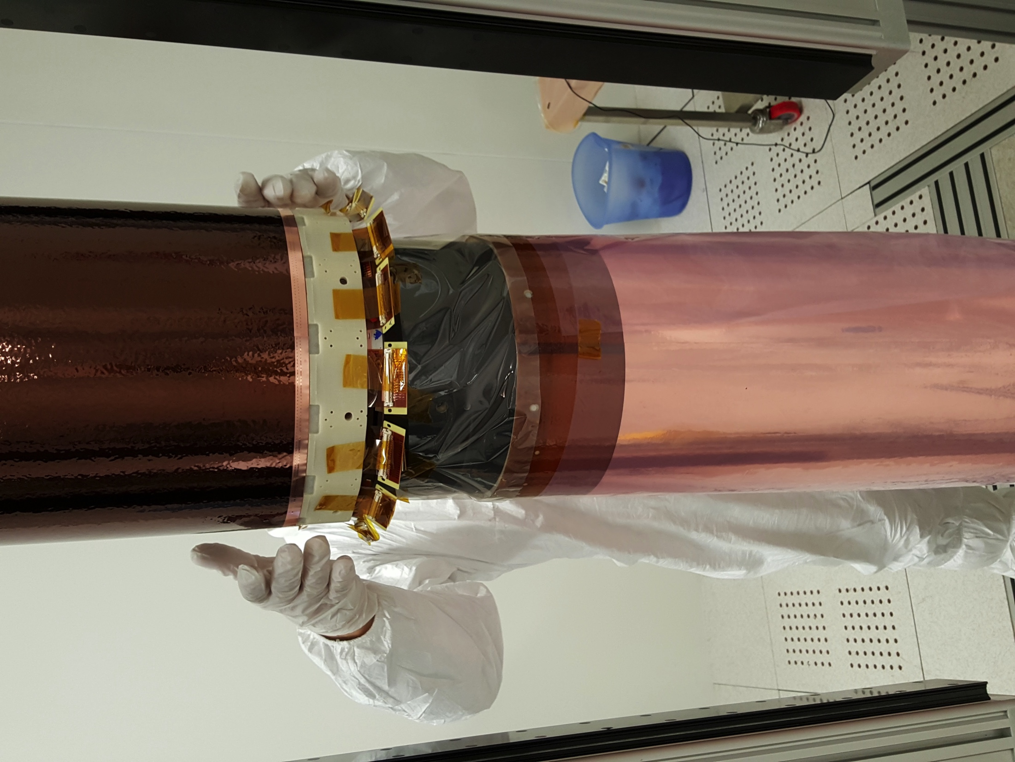
Fig. 3. Assembly procedure with the Vertical Inserting Machine
- Conclusions

A new CGEM construction procedure was discussed. Such new technique involves the use of ROAHCELL foam, permaglass rings and the dedicated onboard electronics. The construction of the full-size layer 2 prototype and of the layer 1 were already complete and the latter being now tested with beam at the CERN H4 beam test facility.

References
[1] BESIII Coll., The construction of the BESIII experiment, NIMA 598 (2009).

[2] F. Sauli, NIMA, 386:531, (1997).

[3] F. Archilli et al. , arXiv:1002.2572 (2010).

