The Status of the Batch Test of 20 inch MCP-PMT
Feng GAO^{,2,3},Sen QIAN^{,2}, Zhe NING^{1,2}, Yinghong ZHANG^{1,2}, Guorui HUANG⁴, Dong LI⁴, Ling REN⁴, Shulin LIU^{1,2}, Jianning SUN⁴, Shuguang SI⁴, on behalf of the MCP-PMT workgroup
¹ Institute of High Energy Physics, Chinese Academy of Sciences, Beijing 100049, China
² State Key Laboratory of Particle Detection and Electronics, Beijing 100049, China
³ University of Chinese Academy of Sciences, Beijing 100049,China
⁴ Nanjing, North Night Vision Tech. Ltd., Nanjing 211106, China
* Corresponding author Sen QIAN, qians@ihep.ac.cn
Abstract. JUNO need the high performance large area detector with 18,000 PMTs, which have large sensitive area, high quantum efficiency, high gain and large peak-to-valley ratio for good single photoelectron detection. Researchers at IHEP, Beijing have conceived a new concept of MCP-PMT several years ago. The small MCP units replace the bulky Dynode chain in the tranditional large PMTs. After three years R&D, a number of 8 inch prototypes were produced and their performance was carefully tested at IHEP in 2013 by using the MCP-PMT evaluation system built at IHEP. The 20 inch prototypes were followed in 2014, and its’ performance were improving a lot in 2015. The PMT mass production and batch test system were ran in 2017 achieving quick test of all performance for every PMT instead of sampling. The batch test equipment was characterized by fast batch testing capability, high automation with high integrated process, and high test efficiency.
Keywords: MCP-PMT, Batch test
- Introduction
Based on the cathode non-transfer equipment and high quantum efficiency technology, 20 inch MCP-PMT (Microchannel Plate) with bialkali photocathode and multiplier structure of two-stage MCP was produced [1]. This high detection efficiency (DE) 20-inch MCP-PMT meet the requirements for JUNO (Jiangmen Underground Neutrino Observatory)[2], and get the 75% order of the JUNO-PMT in 2015.
The characteristics of the photocathode was carefully studied by measuring the I-V curves, the quantum efficiency (QE) vs. wavelength, and by mapping the QE for 20 inch photocathode. Charge spectra of single photoelectrons were measured by the PMT evaluation system in our lab in the Institute of High Energy Physics,China[3-5].
The PMT production line was operated in 2016 and 30 pic PMTs could be produced per day. According to the requirement of the JUNO, each production PMT must be carefully tested. The batch test system has been designed and finished in 2017. The batch test equipment was characterized by fast batch testing capability, high automation with high integrated process, and high test efficiency.
- The MCP-PMT Batch Test
The batch test system need test about 15,000 PMTs for JUNO with high test efficiency, and every tube need to test carefully. The measurement methods and the One-PMT test platform for single PMT has be introduced[3,4]. The batch test system is realized to test the large number of PMTs fast and successively, which can not be operated by increasing the number of the unit of the One-PMT test platform.
The characteristics of one 20 inch PMT is categorized to two parts, the parameters of photocathode and performance of the anode part. So, the batch test system is designed including three part: photocathode test subsystem, the anode test subsystem and database as shown in Fig.1.

Fig. 1. The testing information of PMT in the batch test system.
Photocathode performance is tested within a current mode including the QE@410nm, QE vs. Wavelength (QE-λ), and the mapping of the QE uniformity. The anode performance is tested in the pulse mode, which including the SPE charge spectra, the gain vs. high voltage settings for the MCP assembly,the ranges of gain linearity and the dynamic range, the timing characteristics of output signals and the transit timing spread (TTS)[6].
At the same time, a database has also been established[7], thus the PMT batch test data can be updated, tracked, recorded, queried in time. And the data could be shared between partners and help to check out the performance of PMTs in mass production process.
- The result of the 20 inch MCP-PMT in the batch test
A lot of MCP-PMTs produced by the mass production process have been tested within the batch test system, and all the result of the parameters were recorded in the database.
Table 1. shows the typical test data of the 20 inch MCP-PMT parameters. The batch test system with fast batch testing capability could meet the mass production requirements.
parameters |  | Typ. | Unit | Test time
Cooling time |  |  |  | 12hours
Cathode | QE@400nm | 26 | % | 30min
 | Spectral response | 300-700 | nm | 30min
 | Non-uniformity | 6 | % | 30min
Anode | Relativity CE | 98 | % | 10min
 | SPE P/V | 8
 | Gain | 1E7
 | After pulse rate | 0.5 | % | 10min
 | Non-uniformity | 6 | % | 10min
 | Anode dark rate | 30 | KHz | 10min
Time | TTS (top point) | ~20 | ns | 10min
 | Rise time | 1.4 | ns | 5min
 | Fall time | 23 | ns
Table 1.Typical data of the 20 inch MCP_PMT parameters of MCP-PMT

Fig. 2 are the histograms of 300 pic 20 inch MCP-PMTs’ QE and Peak to Valley rate. The result follow a normal distribution. The mean of the QE and Peak to Valley rate are 28% and 8 respectively.
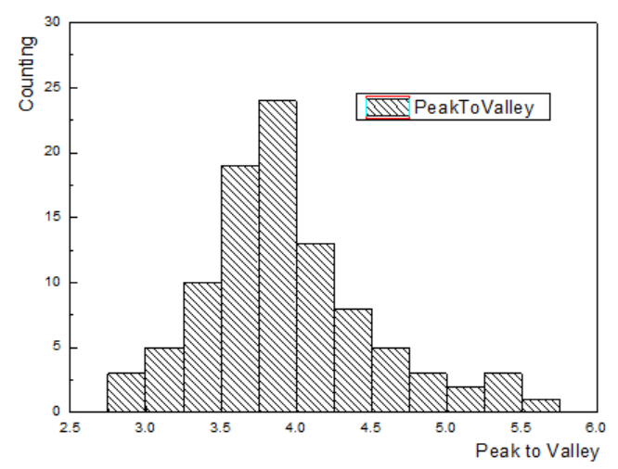
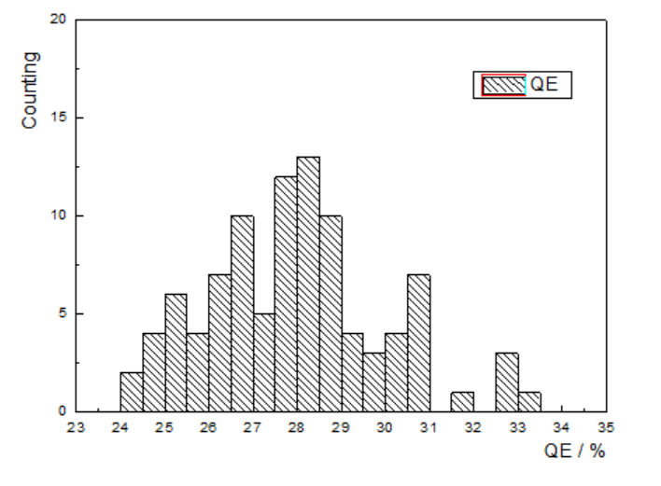
Fig. 2. The histograms of QE and Peak to valley rate of 300 pic 20 inch MCP-PMT.
The MCP-PMT was characterized by the high gain, low noise, high collection efficiency, high peak to valley ratio of SPE, good cathode uniformity, low after pulse ratio.
- Time characteristics of the 20 inch MCP-PMT
As shown in the Table.1, the TTS of the 20 inch MCP-PMT is up to 20ns from the 12 ns data of the primary design prototypes [3]. TTS is larger due to the change of the collection, the photocathode and technics of MCP. The reflection photocathode has been added based on the transmission. The photoelectrons inside the MCP-PMT is from the transmission photocathode and the reflection Photocathode, thus the trace of the photoelectrons emitted and the flying time is different.
For the MCP multiplication system, it can be divided two parts: the 70% area of channels and the 30% area electrode of surface. For the normal MCP, only the channels could generate the second electron, but the surface of the electrode will absorb the second electron. For the new type of MCP used in the 20 inch prototypes, all the channels and surface of the electrode could generate the second electron as the Fig. 3 b, but this two part electron do not match in time of arrival in the anode. So the new MCPs made the detection efficiency of the PMT larger but the TTS also worse.

- Acknowledgments
The MCP-PMT development project has been partially supported by the Strategic Priority Research Program of the Chinese Academy of Sciences (Grant No. XDA10010400) and the National Natural Science Foundation of China (Grant No.11175198 and No.11475209 and No.11675205 and No.11675196).

References
- Yifang Wang, Sen Qian: A new design of large area MCP-PMT for the next generation neutrino experiment, Nucl. Instr. and Meth, A 695, 113-117(2012).
- Yu-Feng Li: Unambiguous determination of the neutrino mass hierarchy using reactor neutrinos, Physical Review D 88, 013008(2013).
- Jingkai Xia: A performance evaluation system for photomultiplier tubes, JINST 10, P03023(2015) .
- Feng Gao, Sen Qian: Status of the large area MCP-PMT in China,Proceedings of Science (ICHEP2016), 264 (2016).
- Yaping Chang, Sen Qian.: The R&D of the 20 inch MCP-PMTs for JUNO, Nucl. Instr. and Meth, A 824, 143-144 (2016) .
- Jingkai Xia, Sen Qian: Research on time response of photomultiplier tubes (EPS-HEP2015), 241 (2015).
- Yawen Li, Zhe Ning: A database with the Ionic platform, NUCLEAR TECHNIQUES (the Chinese Version) 40, 4(2017).

