Fine-Pixel Detector FPIX Realizing Sub-Micron Spatial Resolution Developed Based on FD-SOI Technology

Daisuke Sekigawa1, Shun Endo1, Wataru Aoyagi1, Kazuhiko Hara1,2, Shunsuke Honda1, Toru Tsuboyama3, Miho Yamada3, Shun Ono3, Manabu Togawa3, Yoichi Ikegmi2,3, Yasuo Arai3, Ikuo Kurachi3, Toshinobu Miyoshi3, Junji Haba3 and Kazunori Hanagki3

1 University of Tsukuba, IPAS, 1-1-1 Tennodai, Tsukuba 305-8571, Japan

2 University of Tsukuba, CiRfSE, 1-1-1 Tennodai, Tsukuba 305-8571, Japan

3 High Energy Accelerator Organization (KEK), IPNS, 1-1 Oho, Tsukuba 305-3256, Japan  
hara@hep.px.tsukuba.ac.jp

**Abstract.** A Fine-PIXel detector (FPIX) with a pixel size of 8×8 m has been developed using 0.2 m fully-depleted silicon-on-insulator (FD-SOI) technology. With four FPIXs placed in a 120-GeV proton beam, the residual to reference track showed a Gaussian spread as small as 0.63 m when three FPIXs other than the one under investigation were used to reconstruct the track. The point resolution corresponds to 0.59–0.83 m. This is the first result showing that a sub-micron spatial resolution can be achieved by semiconductor detector.

**Keywords:** sub-micron spatial resolution, semiconductor detector, SOI pixel detector

1. Introduction

The precise detection of charged particle trajectory has always been in demand for high-energy experiments and breakthroughs in precision tracking was made possible by the introduction of new technologies. Multi-wire chambers developed by Charpak *et al* were a monumental development [1], ultimately achieving a spatial resolution of the order of 100 m. Then, semiconductor–based detectors have been also developed [2]. A resolution of the order of 10 m has been achieved with semiconductors, even in large-scale systems such as in the LHC ATLAS experiment [3]. Recently several devices have been evaluated, under the constraint of achieving a resolution close to 1 m [4], [5]. Semiconductor devices with sub-micron spatial resolution should be realizable by further improving the devices, but may in some instances be limited by physical processes such as -ray contributions [5].

Monolithic pixel devices are attractive candidates for various aspects of particle detector application. They are not subjected to the same geometric manufacturing constraints as hybrid pixel devices, e.g., metal bumps which limit their pixel size typically to 50 m [3]. We are developing fully depleted silicon-on-insulator (FD-SOI) monolithic pixel devices that utilize the Lapis 0.20-m technology [6].

The application of SOI technology towards the development of precision particle detectors has been realized through various improvements. Among the most important was the introduction of a buried p-well (BPW), which is typically tied to a p-type pixel node for n-type substrates. The BPW successfully suppresses the back-gate effect by shielding the electric field from the back-bias [7], [8]. The remaining major issue was the resistance to the total ionization dose (TID) effect. Since the SOI FETs are fully covered in oxide, the accumulation of positive holes affects FET operation. We overcome this issue by innovating double-SOI wafers [9] in which the second active Si layer is used to compensate the TID effect by establishing a negative voltage [10]. The second layer is also effective in reducing the cross-talk, which is essential for implementing digital functionality within the on-pixel circuit [11].

After successful iterating developments, we began to develop a pixel detector dubbed the SOI sensor for Fine measurement of Space and Time (SOFIST) [12] for the ILC experiment [13] which took full advantage of the FD-SOI device characteristics. A fine-pixel detector (FPIX) has been designed to demonstrate the excellent spatial resolution achievable with the SOI monolithic pixel and to demonstrate the TID suppression effect in the double SOI [14]. Four FPIX detectors were used as a precision tracker in the SOFIST testbeam. We investigated whether semiconductor devices with a pixel size of 8×8 µm could achieve sub-micron scale spatial resolutions.

1. Design of FPIX and FNAL Testbeam

The FPIX has a 128×128 matrix of 8×8 m pixels, comprising an 1x1 mm active area set in a chip size of 2.9 mm square. Each pixel contains six FETs, including two for input protection and two for a voltage reset switch, to send out the analog signal. The signals are extracted in rolling-shutter mode and digitized by external 12-bit ADCs set in a SEABAS2 board [15]. There are eight parallel readout lines, thus each ADC handles signals of 16 (of the 128) columns × 128 rows. Our scan time was 280 ns to allow each signal to be digitized by the ADC at a frame rate of 1 kHz.

We evaluated the tracking performance of four single SOI FPIX devices of FZ p-type substrates (20 kcm, 500 m thickness) subjected to a 120 GeV proton beam at Fermilab. Our setup is illustrated in Fig. 1. The fourth FPIX was placed farthest at the extreme distal location downstream to facilitate replacement with the double SOI FPIX (p-type 1 kcm, 300 m thickness) which had been irradiated to 100 kGy.

The digitized signals for the four FPIXs and two SOFISTs were stored in six SEABAS2 boards and read out upon receiving a trigger generated from a scintillation counter 3×3 mm and an ATLAS pixel detector with an FE-I4 readout chip [16]. The FE-I4 generated a Region-of-Interest output with its area limited to 1.5 mm square around the FPIX sensitive area. The trigger was vetoed by any OR of the six SEABAS2 busy signals, and the readout sequence was resumed when all the boards were ready. The data acquisition system was constructed using a software framework developed to handle multiple modules with least increase in the readout time [17].

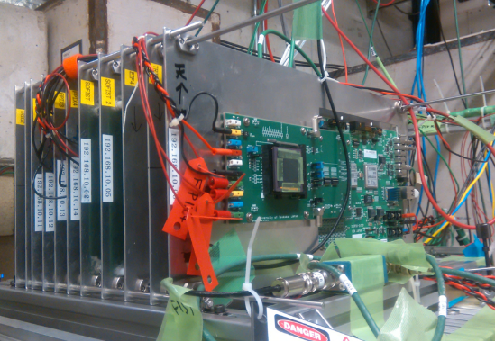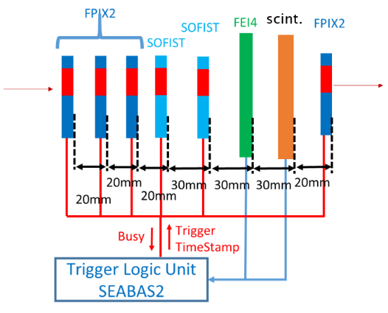

Fig. 1. Setup at FNAL test beam facility. (Left) View from the downstream. All components were mounted on Al plates of the same size aligned using linear bushings. (Right) Relative positions of the detectors along the beam direction. Data stored in the readout SEABAS boards were sent to a PC through individual LAN cables.

1. Tracking
   1. Pixel response and clustering

The nominal bias voltage during the test was -70 V. Figure 2a shows the distribution of single pixel ADC Qmax with the maximum count per event for the 2nd FPIX. A peak corresponding to proton passage is clearly recognizable. We then evaluated the charge sum Qsum in 7×7 pixels about the pixel with the maximum charge with Qmax>200 ADC. Figure 2b shows the correlation between Qsum and the cluster size, i.e., the number of pixels with charge exceeding Qsum/49. On average the cluster size is 12, meaning that the charge spread is typically 3×4. Thus, we used a size of 5×5 for the clustering.

The cluster size spread is barely dependent on the bias voltage. We took data for the bias from -4 to -140 V. The cluster size becomes slightly wider for the bias settings of -9 V and -4 V; 5×5 clustering is adequate for all bias settings.

Fig. 2. (a) ADC distribution Qmax of the pixel with the maximum count in an event. (b) Charge sum Qsum in 7×7 pixels about Qmax vs number of pixels with Q> Qsum/49. Bias= -70V.

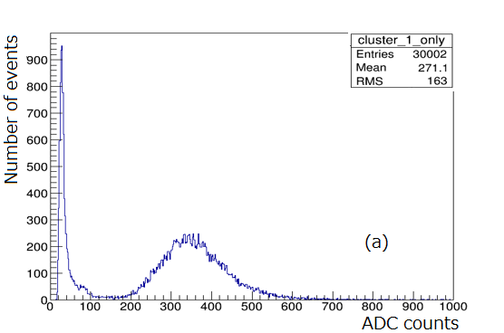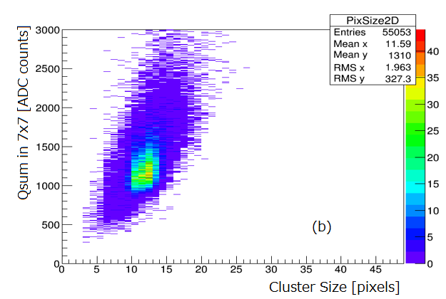

* 1. Bias dependence of the cluster charge

The 5×5 cluster charge distributions at -4 and -140 V are shown in Fig. 3. The most probable values (MPV) were extracted by fitting a Gaussian convolved Landau function to the distributions. Figure 3 also shows the MPVs as a function of square root of the bias voltage. As the bias is increased, the MPV increases linearly with square root of the bias voltage, which is explained by the increase of the depletion depth. The depletion depth calculated from the wafer resistivity is ~400 m at the maximum bias voltage of -140 V.

The pedestal distribution was measured from the beam data. The noise was extracted by fitting a Gaussian function to the pedestal distribution, which resulted in 3.13±0.18 ADC for the 2nd FPIX. The noise measured under the off-beam condition was 2.0±0.3 ADC. By choosing 3.13±0.18 ADC noise, we obtained a signal-to-noise ratio S/N of 343±20 at -70 V where the noise N is of a single pixel. The S/N is 69±0.4 when we take the noise is of 5×5 cluster charges.

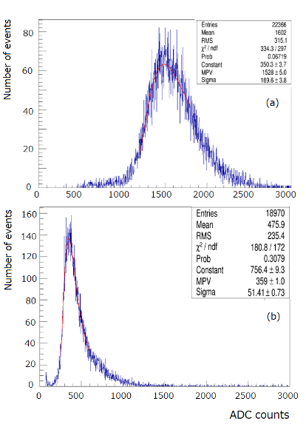 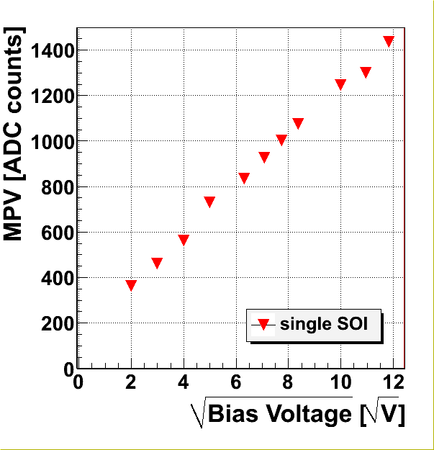

Fig. 3. Cluster charge distribution at bias voltage of (a) -140 V and (b) -4 V. (c) Most probable value of the cluster charge as a function of the square root of the bias voltage.

* 1. **Tracking** and hit residuals

The average number of clusters found in an event was 1.8 with an rms spread of 2.0 for the largest beam intensity of 300k hits/spill measured by the beamline wire-chambers, where the beam spill was 4.2 s long. Figure 4a shows the correlation between the 2nd and 3rd X-hit positions. As many of the points are random combinations of the hit points spreading over the region, the correlation resulting from the correct hit points is clear. After performing detector alignment and confirming the square sum of the hit residuals to the straight line reconstructed using four FPIXs is less than 30 (m)2 in X and Y coordinates, we obtain the X2 and X3 correlation shown in Fig. 4b. Only correct combinations corresponding to the tracks are retained. Note that correct combinations in bottom-left area are lost due to the limited coverage of the other two detectors.

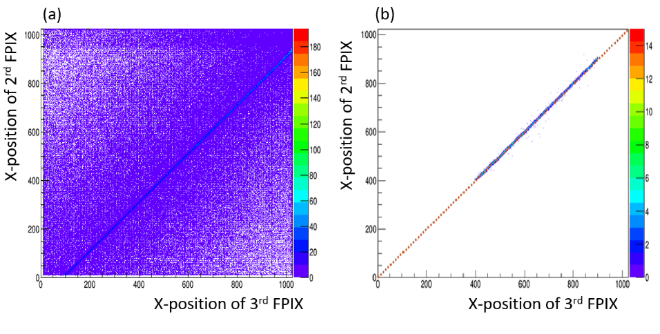

Fig. 4. (a) Correlation between 2nd and 3rd X hit points (no selection is applied), (b) Same as (a) but after alignment and requirement on residual sum (see text) are applied.

* 1. Spatial resolution

Figure 5 shows the X residual distributions to the track reconstructed using the three FPIXs other than the one under investigation. The hit positions are simply the average position weighted by the charge. Although the observed residual spreads differ as the relative positions are different, the 2nd and 3rd FPIXs show a residual spread smaller than 1 m. Similar plots of the Y coordinate are shown in Fig.6.

As the measured residual spreads are a quadrature sum of the intrinsic spatial resolution and the track uncertainty, we estimated the intrinsic resolution by assuming that the four FPIXs have the same intrinsic resolution. Under this assumption, the track uncertainty at specific z position can be expressed in term of the intrinsic resolution and the geometrical z positions of the detectors. The correction factors (meas/intr) are 1.34, 1.22, 1.17 and 5.08 for the cases where the 1st to 4th FPIXs, respectively, are under evaluation. The measured residual sigma and extracted intrinsic resolution are summarized in Table 1.

**Table 1.** Measured residual spread and evaluated intrinsic resolution. Units: m.

|  |  |
| --- | --- |
|  | 1X 2X 3X 4X |
| Meas. residual | 1.077±0.009 0.880±0.008 0.864±0.008 4.15±0.05 |
| Intrinsic resolution | 0.80±0.01 0.71±0.01 0.73±0.01 0.82±0.01 |
|  | 1Y 2Y 3Y 4Y |
| Meas. residual | 0.931±0.008 0.730±0.006 0.839±0.007 4.05±0.05 |
| Intrinsic resolution | 0.69±0.01 0.60±0.01 0.70±0.01 0.80±0.01 |

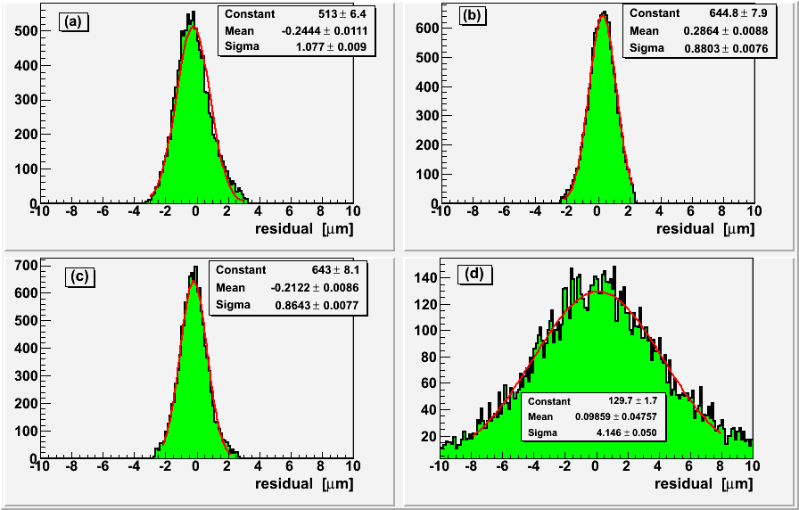

Fig. 5. Residual distributions in horizontal direction to the track reconstructed using the three FPIXs other than the one under investigation for (a) 1st FPIX, (b) 2nd FPIX, (c) 3rd FPIX and (d) 4th FPIX. X-axis is in micrometers

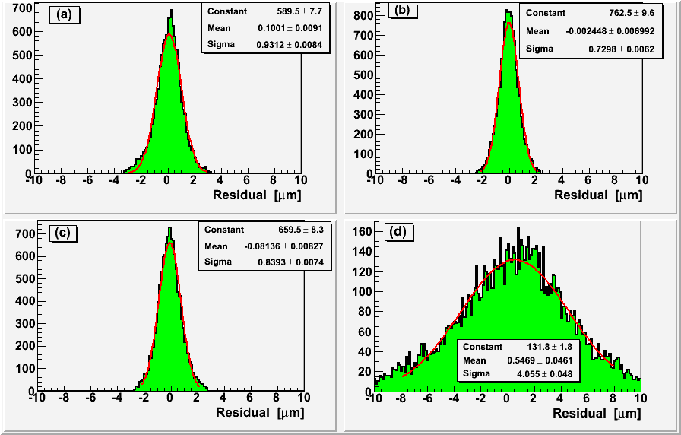

Fig. 6. Residual distributions in vertical direction to the track reconstructed using the three FPIXs other than the one under investigation for (a) 1st FPIX, (b) 2nd FPIX, (c) 3rd FPIX and (d) 4th FPIX. X-axis is in micrometers

1. Summary and discussion

The calculated intrinsic resolutions are not identical and depend on the detector under evaluation. However, the values are similar in a certain range, hence, we can conclude that a sub-micron spatial resolution is achieved with the SOI semiconductor detector.

The beam incident angle could affect the spatial resolution, but no obvious dependence was identified from the data. Most probably, the alignment is not completed yet, meaning that the intrinsic resolution should be better and close to the best value of ~0.60 m.

In Fig. 7, the spatial resolutions from Ref. [4], [5] are compared with the obtained values as a function of S/N. The present data points are shown separately for the X and Y coordinate values with averages taken as the central values and the differences from the maximum and minimum values indicated by the error bars.

The pixel sizes are shown in the figure. The present data points seem to lie on a smooth curve extrapolated from the results of Ref. [4]. It is interesting to investigate whether the present 8 m pixels exhibit a better resolution than that of 13.75 m pixels in Ref. [5] at reduced S/N values. This can be verified from the data obtained at reduced bias voltages.

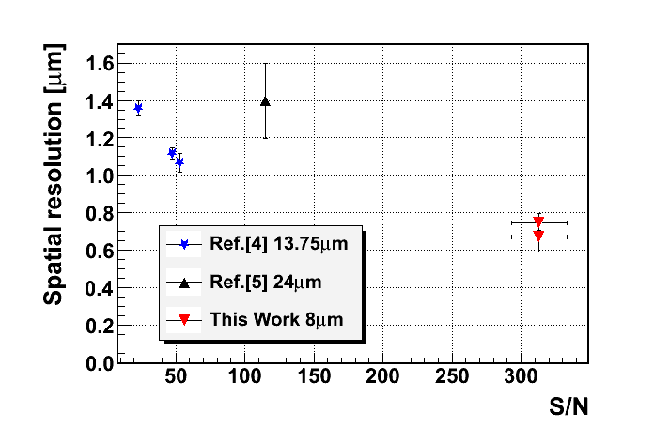

Fig. 7. Comparison of the spatial resolution with that in previous works. S/N is calculated as the cluster charge divided by single pixel noise. Ref. [4] uses the average charge (typically 10% larger than MPV charge) for the signal S, while the others use the MPV charge.

Acknowledgements

The authors would like to acknowledge the valuable advice and great work by the personnel of LAPIS Semiconductor Co., Ltd. The present work was supported by JSPS Grant-in-Aid for Scientific Research on Innovative Areas (No. 25109006), the Japan/US Cooperation Program in the Field of High Energy Physics and KEK Detector Technology Project. This work was also supported by VLSI Design and Education Center (VDEC), the University of Tokyo in collaboration with Synopsys, Inc., Cadence Design Systems, Inc., and Mentor Graphics, Inc. The fruitful operation of the testbeam would have not been possible without help of the FNAL Testbeam Facility team (FTBF, coordinated by Dr. M. Rominsky) and excellent beam provided by the FNAL accelerator team.

References

1. [Charpak, George: "Nobel Prize in Physics 1992"](Charpak,%20George:%20%22Nobel%20Prize%20in%20Physics%201992%22), <https://www.nobelprize.org/nobel_> prizes/physics/laureates/1992/.
2. Aad, G *et al*., J. Instruments 3 P07007 (2008).
3. Kemmer, J., Nucl. Instr. Meth. A226, p89 (1984).
4. Battaglia, M. *et al*., Nucl. Instr. Meth. A676, p50 (2010).
5. Boront, M. *et al*., IEEE TNS 62-1, p381 (2015).
6. Lapis Semiconductor Co., Ltd., <http://www.lapis-semi.com/en/>.
7. Arai, Y. *et al*., Nucl. Instr. Meth. A636, S31 (2011).
8. Kochiyama, M. *et al*., Nucl. Instr. Meth. A636, S62 (2011).
9. Okihara, M. *et al*., "Lapis SOI Pixel Process", talk given at Int. Workshop on SOI Pixel Detector (SOIPIX2015), Sendai, Japan, June (2015): [arXiv:1511.05224](https://arxiv.org/abs/1511.05224) [physics.ins-det].
10. Honda, S. *et al.,* Proc. Of Sciences, PoS (TIPP2014) 039.
11. Lu, Y. *et al.,* "An SOI pixel sensor with in-pixel binary counters”, these proceedings.
12. Ono, S. *et al.,* "A monolithic pixel sensor with fine space-time resolution based on Silicon-on-Insulator technology for the ILC vertex detector”, these proceedings.
13. ILC Technical Design Report 2013: <https://www.linearcollider.org/ILC/Publications/>

Technical-Design-Report.

1. Hara, K. *et al*., "[Development of Fine Pixel Detector for HEP Experiments Based on Innovative Double SOI Technology](http://www.nss-mic.org/2015/program/ListProgramDB.asp?session=N3C3)", talk given at IEEE&MIC, San Diego, USA on Nov. 4 (2015).
2. ATLAS Collaboration, "[ATLAS](http://www.nss-mic.org/2015/program/ListProgramDB.asp?session=N3C3) Insertable B-Layer Technical Design Report", CERN-LHCC-2010-013 (2010).
3. Nishimura, R. *et al.,* "[Development of fast readout system for counting-type SOI detector ‘CNPIX1’](http://www.nss-mic.org/2015/program/ListProgramDB.asp?session=N3C3)", these proceedings.