Minutes of CEPC Accelerator Physics Meeting
2016.08.26

Place: Room C407, Main Building, IHEP
Convener: Jie Gao
Attendee: Jie Gao, Yuan Zhang, Dou Wang, Huiping Geng, Na Wang, Yuanyuan Wei, Yiwei Wang, Sha Bai
Recorder：Dou Wang
Summary of minutes：
  - Firstly, Dou gave a report about design study progress of CEPC damping ring for positron. She has made some primary consideration for damping ring. Also she has give a real lattice design of DR. The extraction beam parameters fulfill the requirement of CEPC positron injector.
  - Dou gave a report about APDR parameters with cavity voltage and phase adjusting. The luminosity will be reduced by 3.5% for 6 ring scheme and 2.4% for 8 ring scheme. Also she tried to optimize the off-momentum DA for PDR with more sextupole families.
  - Yuan Zhang gave a report about CEPC PDR DA optimization with his own code MODE. He has used a whole lattice including FFS and Bypass from Dou. He tried the knob in arc and IR separately and has increased the bandwidth from 0.5% to 1.2%. This kind of study is going on.
  - Yiwei reported his study about DA optimizaiton for CEPC PDR. A lattice of the whole ring (ARC(no bypass)+PDR+IR(no crab)) fulfilling the design parameters is ready. He has increased the bandwidth from 0.8% to 1.4%. Further optimization with more sextupole families is going on.
Prof. Gao suggest Yiwei to reduce the critical energy in IR.
  - Huiping reported her progress on pretzel design. She used Yuan Zhang’s code MODE to optimized single ring lattice (without IR). DA at 2% energy deviation has been increased from 4sigmx to 15sigmx.
  - Sha Bai introduced her progress of PDR DA after orbit correction. Dynamic aperture can almost be recovered after orbit correction for most seeds. The error from multipoles has not much effect on dynamic aperture.

The next meeting will be on September 9, 2016.

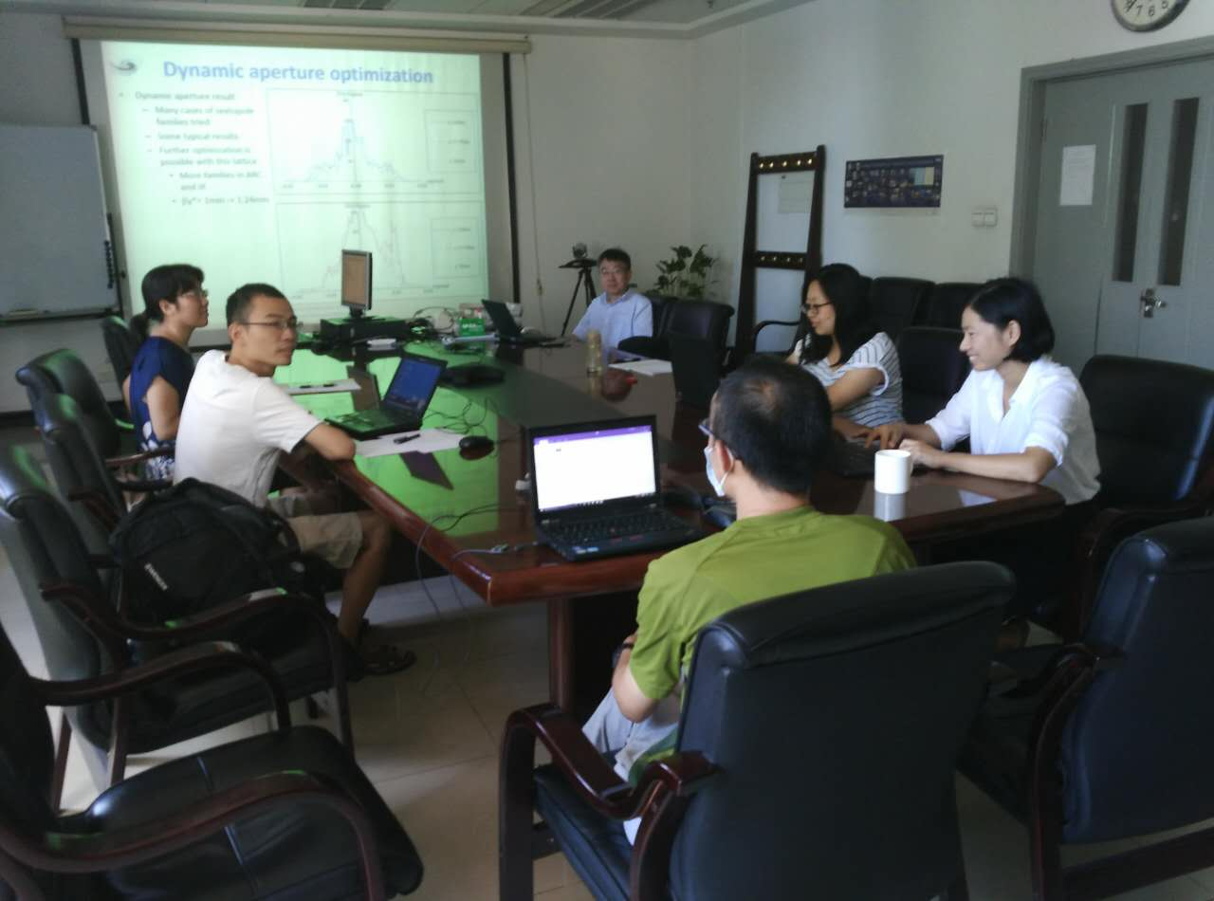

Recorder：Dou Wang
Checkup：Jie Gao
2016-08-26

