Minutes of CEPC Accelerator Physics Meeting
2016.09.30

Place: Room C407, Main Building, IHEP
Convener: Jie Gao
Attendee: Yuan Zhang, Huiping Geng, Dou Wang, Yiwei Wang, Sha Bai, Feng Su, Tianjian Bian, Yuansheng Sun, Song Jin
Recorder：Dou Wang
Summary of minutes：
Firstly, this meeting goes on the reports in the startup meeting in Qinghua University for National Key Programme for S&T Research and Development
  - Su Feng reported about CEPC Partial Double Ring Lattice Design and DA Study. He explained the reason why we need to change the circumference of CEPC from 54km to 61km.
  - Huiping reported her progress on pretzel scheme. She inserted 3mm FFS in single ring lattice and used Yuan Zhang’s code MODE to optimized DA. After optimization energy acceptance reach to 1.4% and on momentum DA is 14sigma.
  - Tianjian introduced the design goal of CEPC booster and the study status. Also he reported his study about CEPC main design and preparation of DA optimization code.
  - Sha Bai reported about CEPC main ring magnets’ error effect on DA and MDI issues. Multipole errors reduce DA a little bit, but not much. It seems to have not much effect on DA, especially of off-momentum DA.
  - Yuan Zhang gave a report about simulation check of CEPC new parameters with 61km circumference. He found a strong bunch lengthening due to beamstrahlung at W and Z poles. We need careful check and discussion on the results.
  - Dou Wang gave a review of CEPC new parameters including Partial double ring and single ring scheme. After discussion, we collected two comments for single ring scheme: 1) larger emittance coupling will increase the vertical emittance and hence make DA optimization more difficult. 2) beamstrahlung beam life time of new parameter is a little shorter than the one in PreCDR.

The next meeting will be on October 14, 2016.

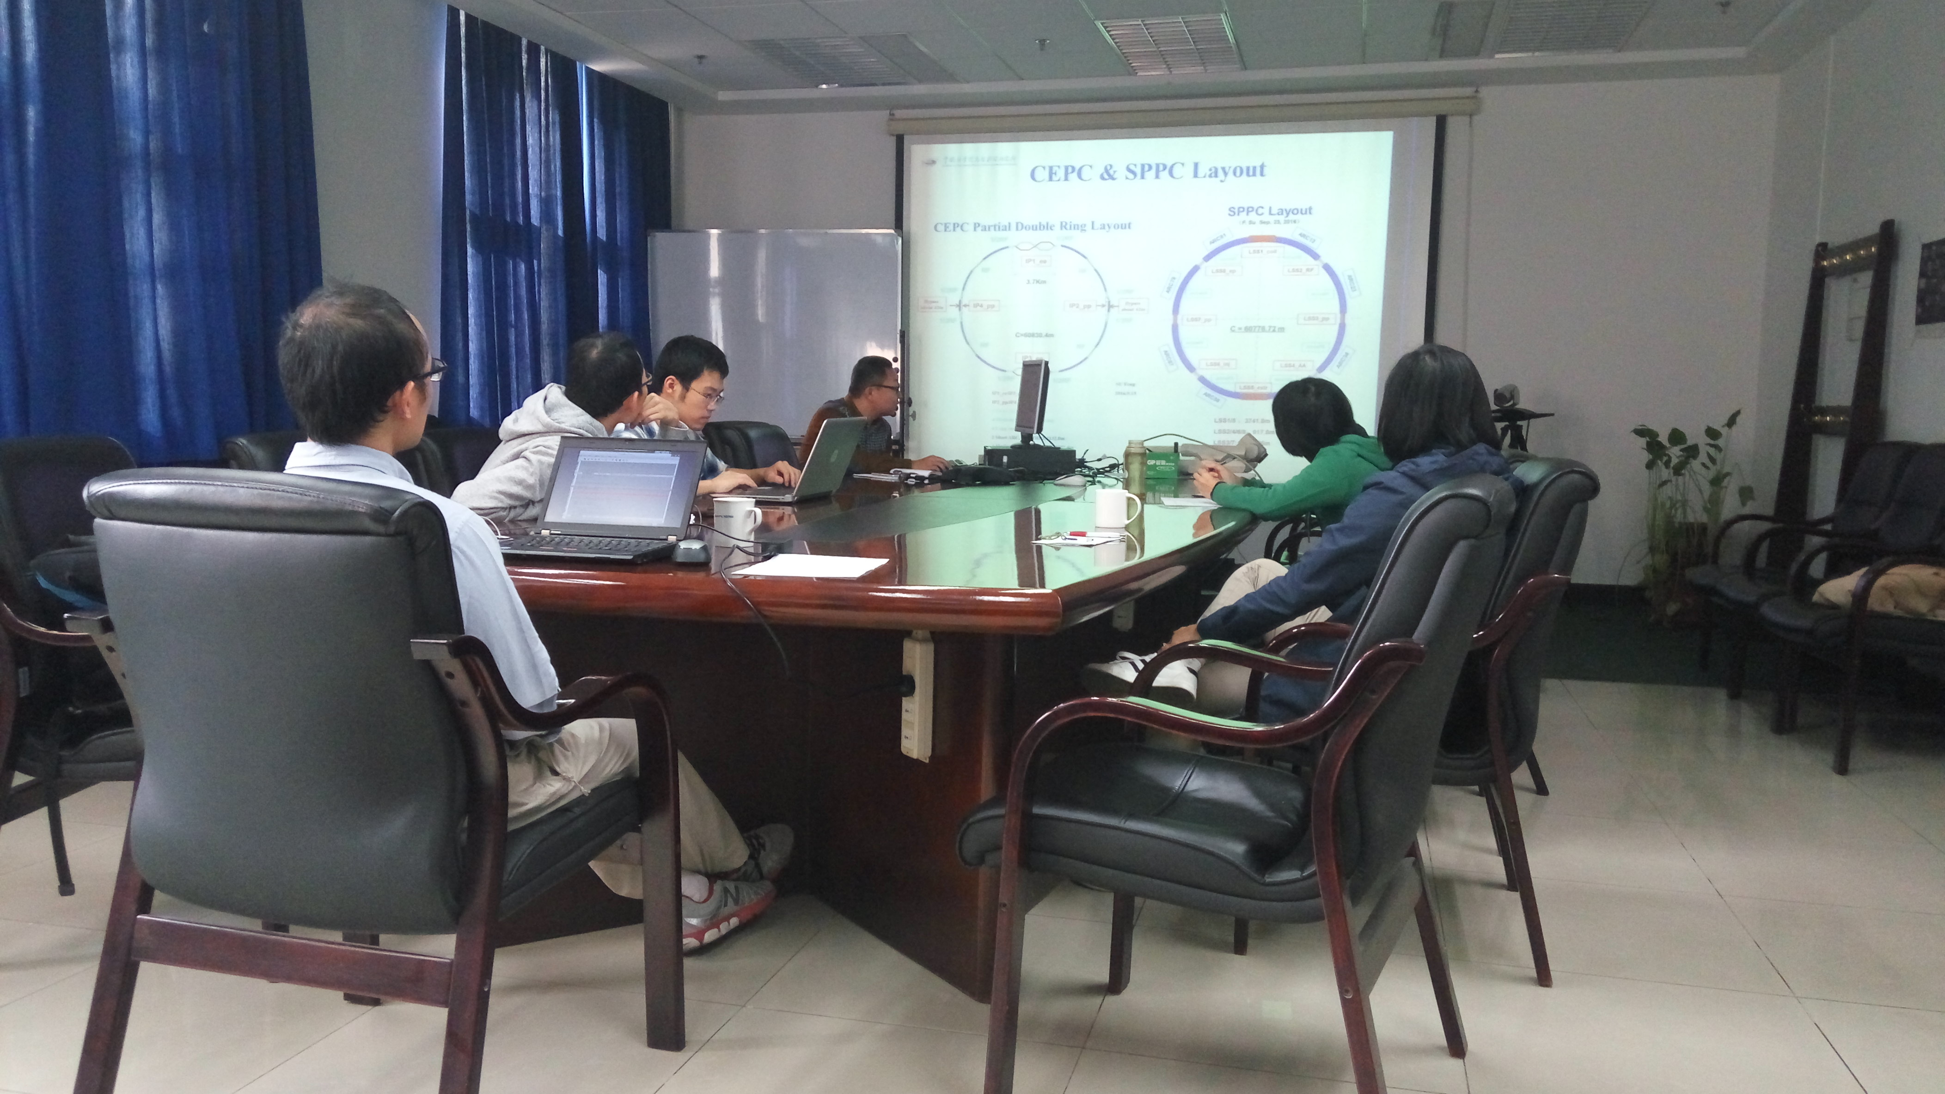

Recorder：Dou Wang
Checkup：Jie Gao
2016-09-30

