Minutes of CEPC Accelerator Physics Meeting
2016.10.14

Place: Room C407, Main Building, IHEP
Convener: Jie Gao
Attendee: Jie Gao, Xinchou Lou, Chuang Zhang, Yuhong Zhang (JLAB), Yuan Zhang, Huiping Geng, Cai Meng, Dou Wang, Yiwei Wang, Sha Bai, Feng Su, Tianjian Bian, Yuansheng Sun, Jin Wu, Song Jin
Recorder：Dou Wang
Summary of minutes：
  - Firstly, Dou reported her study about CEPC parameter optimization and lattice design. Key points are as follows:
    - The parameters of W and Z has been modified to solve the problem of bunch lengthening of beamstrahlung.
    - Change RF voltage of damping ring from 1.1MV to 1.8MV in order to get required energy acceptance.
    - Primary design for bunch compressor has done.
    - Check Yiwei’s lattice and get larger DA by a little shorter bunch length.
    - Calculate the synchrotron radiation critical energy and spectrum for all CEPC dipoles as the input to protecting group.
  - Yiwei introduced a new FFS design. He tried to reduce critical energy under 100 kev by cancel CCX section and meanwhile lengthen CCY section.
  - Yuan Zhang gave a report about Analysis of Chromaticity of Dou’s lattice WD-PDR4. He used three different method to calculate the 2nd order vertical chromaticity and pointed out it is the main reason for bad off momentum DA. Also he tried to cancel the 2nd order vertical chromaticity with sextupole and octupole at different locations.
  - Su Feng reported about CEPC PDR/APDR/DR Lattice Design and DA Study. After fine tuning of lattice layout, for the first time, he gave the DA results for APDR and DR Lattice.
  - Tianjian reported his progress about CEPC main ring study. He has checked Yiwei’s lattice and suprisely he found the DA result from AT is much better than the one from SAD. We will check the difference of these two popular code carefully and try to make a judge.

The next meeting will be on October 21, 2016.

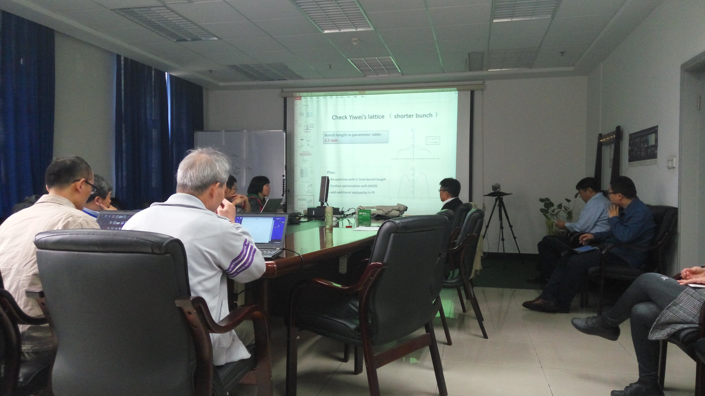

Recorder：Dou Wang
Checkup：Jie Gao
2016-10-14

