Minutes of CEPC Accelerator Physics Meeting
2016.10.21

Place: Room C407, Main Building, IHEP
Convener: Jie Gao
Attendee: Jie Gao, Yuan Zhang, Huiping Geng, Cai Meng, Dou Wang, Yiwei Wang, Sha Bai, Feng Su, Tianjian Bian, Yuansheng Sun, Jin Wu, Song Jin
Recorder：Dou Wang
Summary of minutes：
  - Firstly, Yiwei reported about CEPC mainring lattice and DA study. He tried to constraint the first order chromaticity and the deviation of optics function.
Prof. Gao suggested Yiwei to add crab waist in FFS first before further optimization.
  - Yuan Zhang gave a report about simulation check of CEPC new W/Z parameters with 61km circumference. He found the bunch lengthening due to beamstrahlung has been solved. But the luminosity of Z pole parameter has much difference with simulation results. We need careful check and readjustment on the Z parameter.
  - Huiping reported her progress on pretzel scheme. She tried to use sextupoles and quadrupoles at the same time to optimized the DA. Still need some time to get better result.
  - Su Feng reported about CEPC PDR/APDR/DR Lattice Design and DA Study. He tried to use Yongjun’s code to optimize the DA of PDR.
  - Tianjian introduced the design goal of CEPC booster and the study status. Also he reported his new developed code on DA optimization (Moola：Modular&parallel Optics Optimization for Lattice). He has used Moola on HEPS lattice and the DA of HEPS has been increased by about 3 times.
  - We made a discussion about the sawtooth effect to DA. We plan to study the sawtooth effect and get a clear idea of this effect on CEPC soon.
Yuan Zhang volunteered to take charge of this study with his student Jin Wu.

The next meeting will be on October 28, 2016.

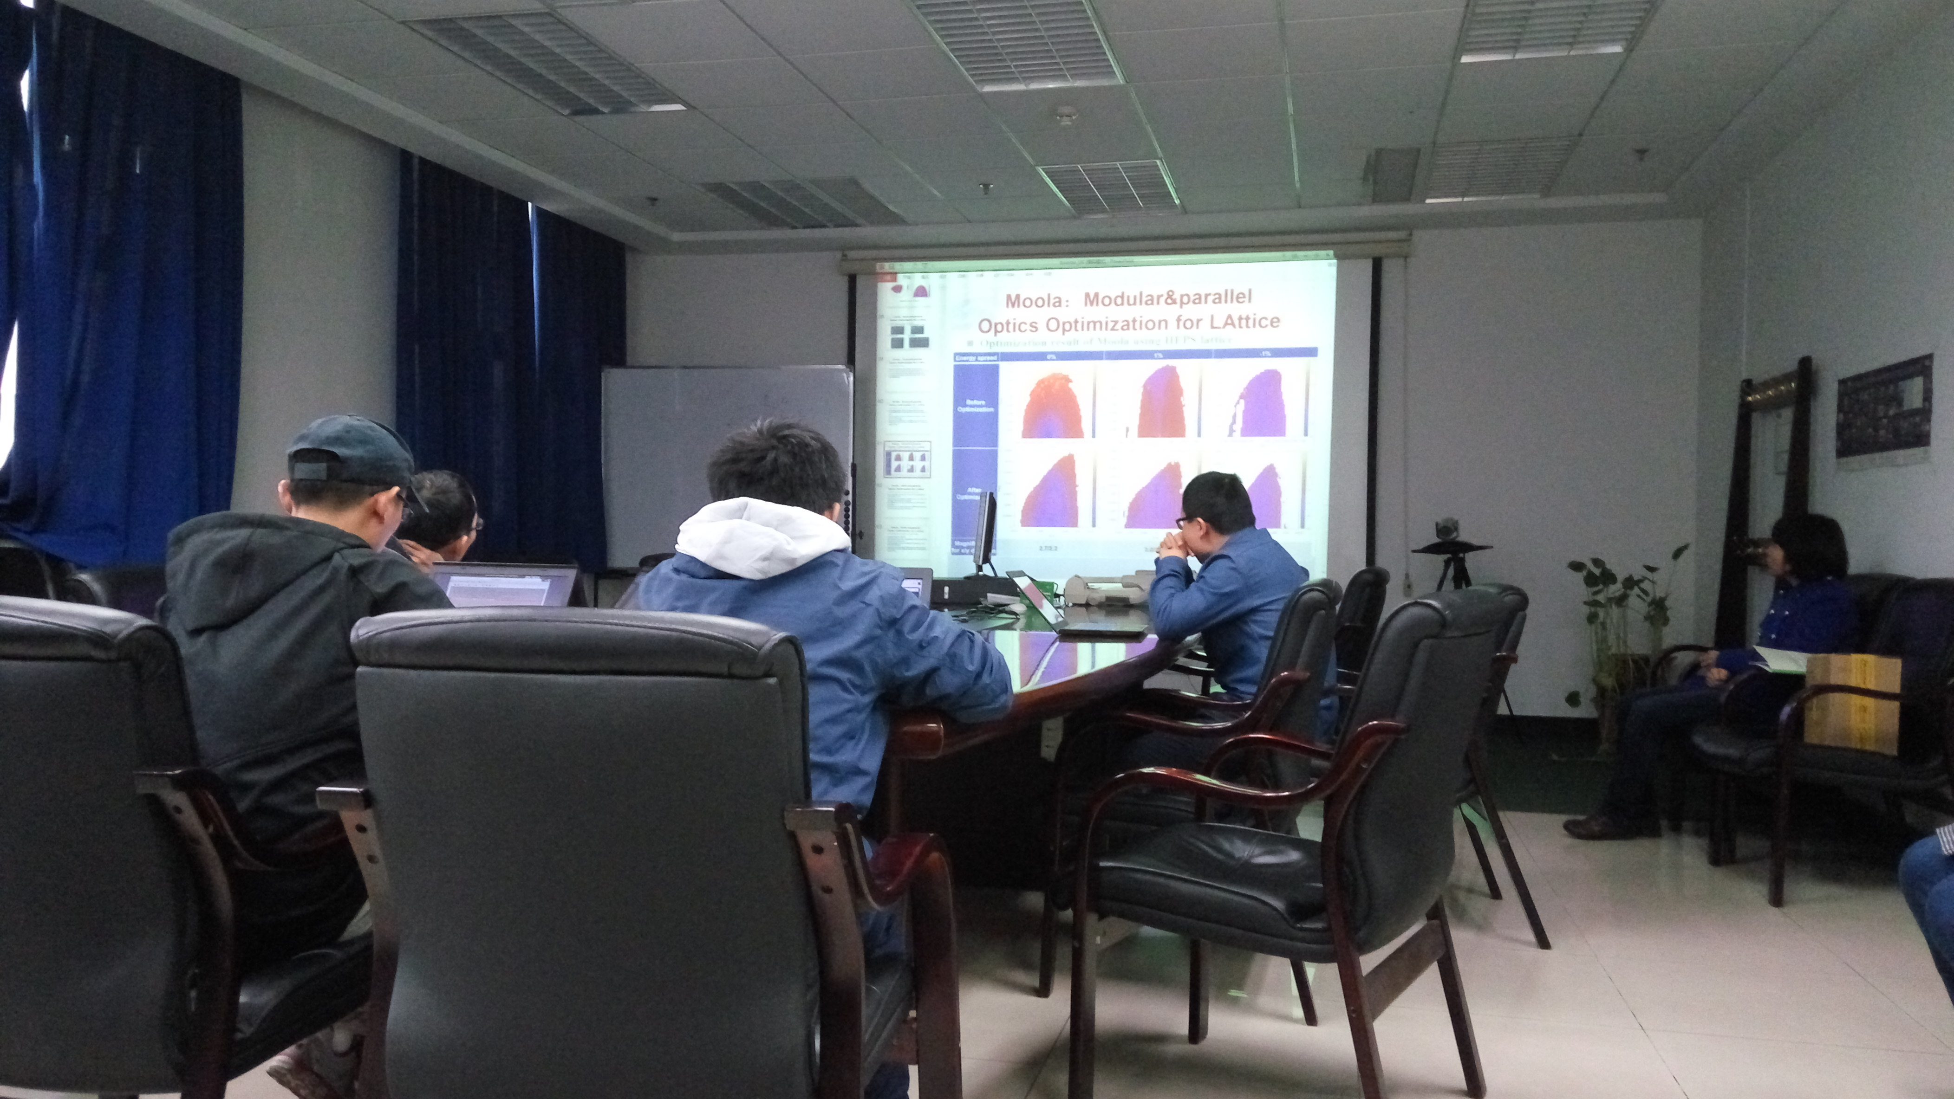

Recorder：Dou Wang
Checkup：Jie Gao
2016-10-21

